The Plastic Hike passes through Olhão
in Algarve · 17-10-2020 12:00:00 · 0 Comments
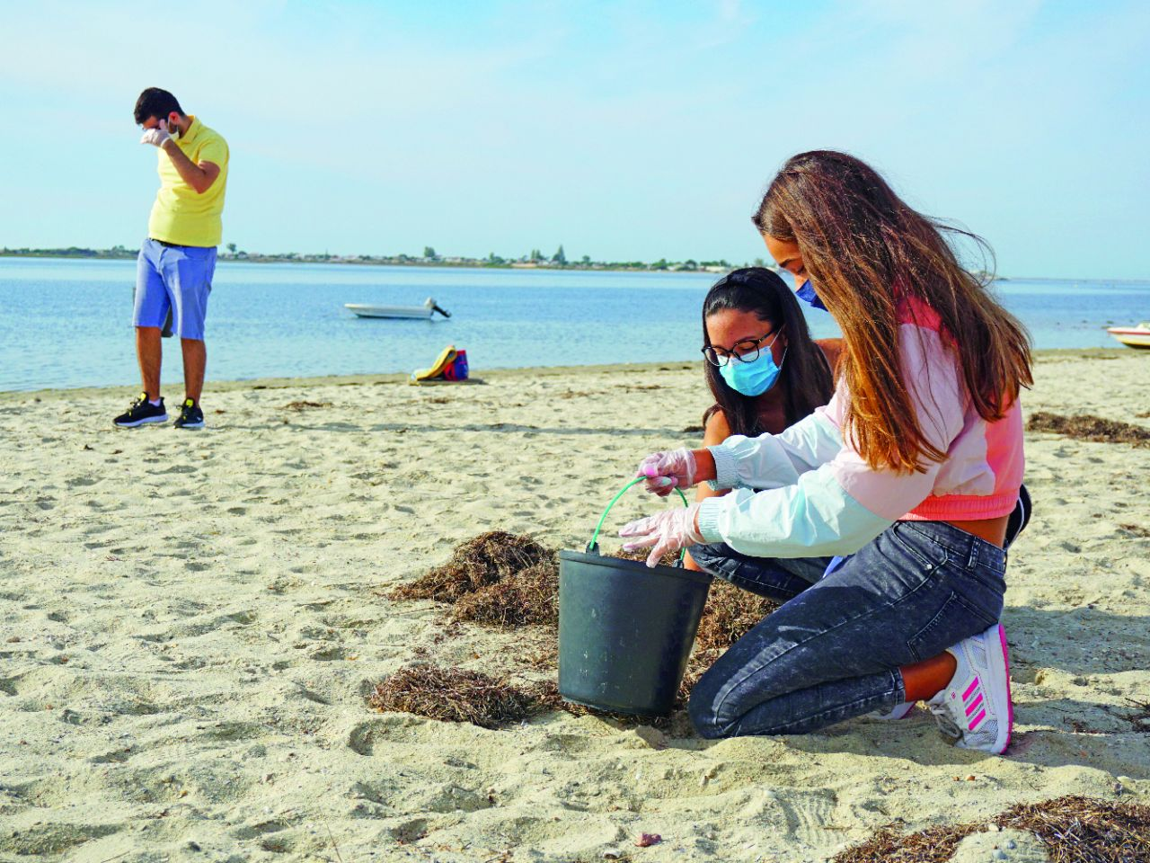

About 20 students from the Dr. Alberto Iria Schools participated, at Praia dos Cavacos, in the initiative The Plastic Hike, which passed through Olhão with the support of the Municipality, integrated into the Escola Azul project.
A German biologist is travelling the 832 kilometres of the Portuguese coast by foot for 60 days, to collect the garbage he finds on the beaches. The tour aims to raise awareness of the problem of plastic, particularly in the oceans and beaches, and to appeal to environmental awareness and the adoption of more sustainable practices by those who come across the initiative. Everywhere he goes, Andreas Noe challenges volunteers to join this mission,
From Foz do Minho to Vila Real de Santo António, the objective of this adventure, which counted on the participation of young people from Olhão, is to warn of the importance and urgency of reducing the use of plastics whose percentage of recycling is just over 10 percent.
The biologist's journey through Portuguese lands is being recorded and will later be used to produce a documentary.
As for the waste collected this by Alberto Iria's students at Praia dos Cavacos, the garbage will be made available to plastic artists, who will convert them into works of art.
The Portugal News, in Algarve · 17-10-2020 12:00:00

