EU4ALGAE – WG2
TEMPLATE Sub-group on Circular economy
Outcome O6 | Circular economy | Starting Date | 12/03/2023
Registered contributors | Frédérique Ferey (CO2)  Laura Monteiro (A4F / water)  Need expert / leader on bioremediation | 1st draft expected for | 1st week of May

OBJECTIVE
Need to identify barriers for using waste streams for producing microalgae (CO2, nutrients, water, economics, …)

CONTENT
List what is allowed to be use in terms of waste streams (wastewater, flue gas…) + link with targeted market
What do we need to improve ? What about carbon credits ?
Is using waste streams cost effective (economics compared to conventional production) ?

Introduction

If (micro)algae are envisaged as a tool of huge potential to sustainably remediate waste streams in the future, it is mandatory to completely change the mindset versus this biomass:
- Bioremediation of waste streams means Million tons and/or m³ of exhausted flows to upcycle
- Mass markets are mandatory to absorb the so-produced (micro)algae biomass
- Feed, food and high-value products cannot be targeted due to market unacceptance for such products issued from secondary streams
- The produced biomass itself is the unavoidable power of (micro)algae bioremediation because it is a recoverable product, and could balance the upcycle treatment price where competing technologies represent only a cost.
Therefore even if the global value chain of (micro)algae for bioremediation is neither ready nor economically viable yet, hindering its high potential as a means for upcycling secondary industrial streams in a near future should be prevented.

Need of a market able to absorb the volumes & associated logistic & premium price due to sustainable product
- BioFuels, BioPlastics
- Biotertilisers: the link with feed & food is closer and needs investigation

Choice on autotrophic vs heterotrophic production on bioremediation purpose of liquid streams seems still open. To remediate CO2 gas streams, PBR of high density should be favored.
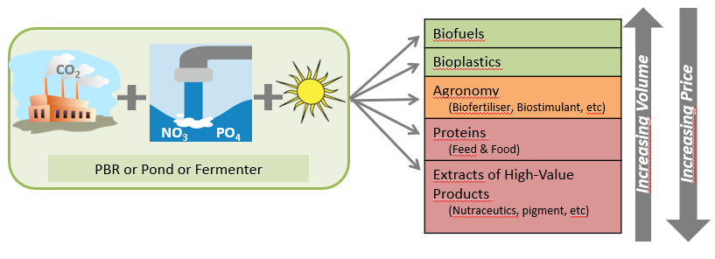

Quality of wastes streams

Each waste stream candidate for bioremediation by the use of microalgae growth has its own specification and should comply with its own regulation (regional, national, european) on quality criteria and contaminant limits. Therefore a good practice to assess the feasibility of microalgae bioremediation should follow the steps represented here below.
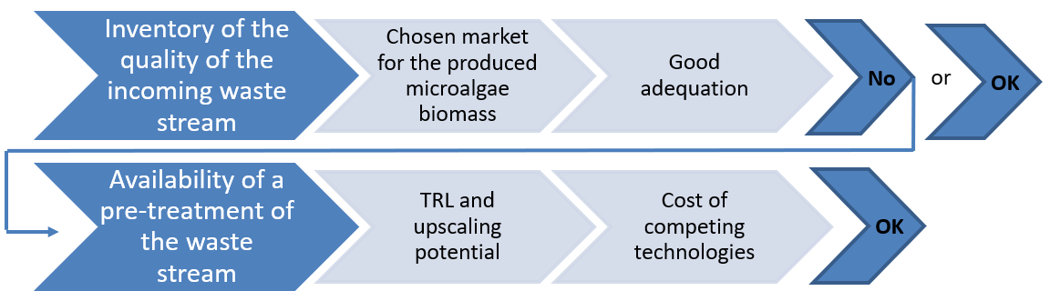

Waste stream
CO₂ flue gas | Industrial wastewater | Urban waste water | Manure
Quality of the waste stream to upcycle
The quality of flue gas strongly depends on the type of industry and energy source  A - As received  Frequent contaminants are SOx, NOx, dust, heavy metals  B - CO₂ previously separated from flue gas  Remaining contaminants in 0.1% scale  C - CO₂ food grade complies with standard xxx | The characteristics of industrial wastewaters are highly variable, depending on the type of industry.  Might contain toxic compounds.  A - Agro-industrial waste and wastewaters  B - Orange peel; coffee waste  and beer manufacturing wastes | Might contain heavy metals, microcontaminants (e.g., pharmaceuticals, persistent chemicals as PFAs.), microplastics.
Markets
Biofuels / bioplastics / biofertilizers
If a stricter quality of the waste stream is required for the targeted market, which kind of pre-treatment would be needed and at which TRL?
Do competing technologies exist for the same waste stream upcycling, and at which cost?

Blocking point(s) for upscale to industrial facility

1 - Quality of produced biomass
Which quality is really needed if feed & food markets are not addressed?

2 - Market & economics
Emphasize on explanation of the premium price (circular economy between industries, upcycling of by-products, commodity products that do not offer today any sustainable alternative) especially for JetFuel as an example of the more mature market to come

3 - European regulation
FRANCISCO GABRIEL ACIEN FERNANDEZ:
“The major limitation is regulation because the waste declaration avoids the reuse of waste streams. If the waste declaration is removed it would be possible to use it. However, still, some additional limitations remain because in some applications the use of residuals to produce biomass is not allowed, as in the feed sector. The only option is for materials/chemicals and agriculture-related applications, of course also biofuels but it is not economically feasible at this moment.”
Key question: would the waste streams (gas/liquid) be concerned by the end of stream regulation if a new product is produced?

