Study to investigate state of knowledge of deep sea mining

Inception report under FWC MARE/2012/06 – SC E1/2013/04

Client: DG Maritime Affairs and Fisheries

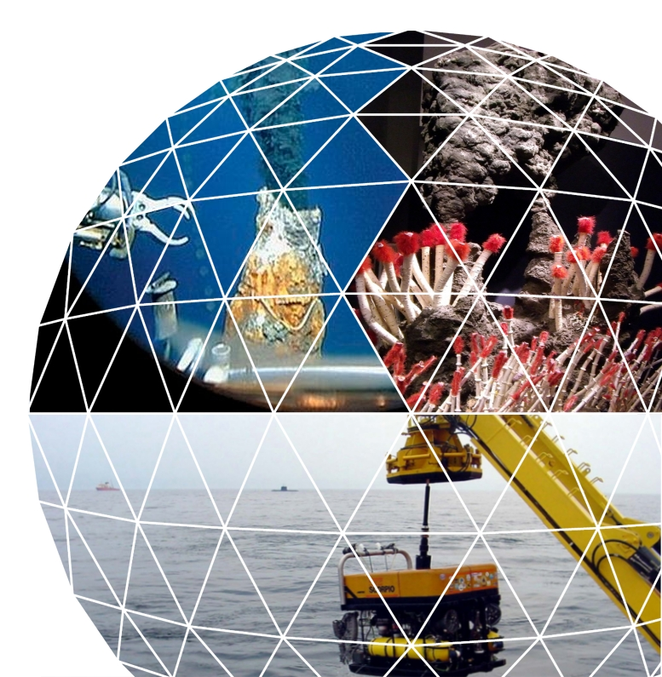Rotterdam/Brussels,

17 January 2014

Client: DG Maritime Affairs and Fisheries

Brussels/Rotterdam, 17 January 2014

About Ecorys and Consortium Partners

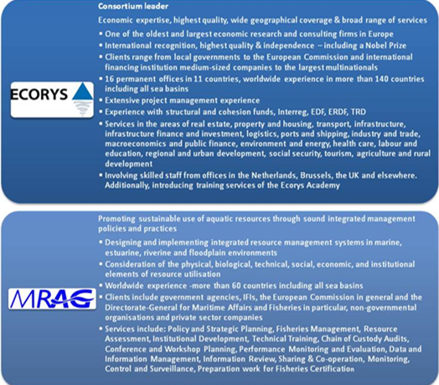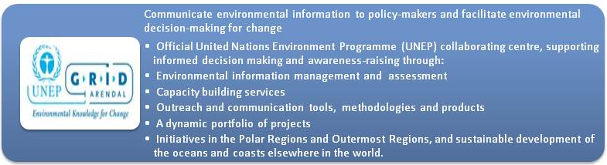

Consortium Lead Partner

ECORYS Nederland BV

P.O. Box 4175

3006 AD Rotterdam

The Netherlands

T +31 (0)10 453 88 00

F +31 (0)10 453 07 68

E fwcbluegrowth@ecorys.com

Registration no. 24316726

www.ecorys.com

1 Introduction 5

1.1 Background and scope of the study 5

1.2 Main types of marine mineral deposits in the deep sea 5

1.3 Purpose of this inception report 6

2 Approach and elaboration of tasks 8

2.1 Approach and tasks 8

2.2 Task 1: Technology Analysis 9

2.2.1 Aim 9

2.2.2 Activities 9

2.2.3 Approach 9

2.2.4 Task Output 17

2.3 Task 2: Economic Analysis 17

2.3.1 Aim 17

2.3.2 Activities 17

2.3.3 Approach 18

2.3.4 Output 28

2.4 Task 3: Legal Analysis 28

2.4.1 Aim 28

2.4.2 Activities 28

2.4.3 Approach 28

2.4.4 Output 30

2.5 Task 4: Geological Analysis 31

2.5.1 Aim 31

2.5.2 Activities 31

2.5.3 Approach 31

2.5.4 Output 35

2.6 Task 5: Project Analysis 35

2.6.1 Aim 35

2.6.2 Activities 35

2.6.3 Approach 36

2.6.4 Output 38

2.7 Task 6: Environmental Analysis 38

2.7.1 Aim 38

2.7.2 Activities 38

2.7.3 Approach 39

2.7.4 Output 44

2.8 Task 7: Preparing the public consultation and website 44

2.8.1 Aim 44

2.8.2 Activities 44

2.8.3 Approach 44

2.8.4 Output 45

3 Organisation and work plan 46

3.1 Timeline and main milestones 46

3.2 Work plan 49

3.3 Deliverables 51

Annex A Draft Questionnaire

Annex B Draft Consultation Paper

# Introduction

## Background and scope of the study

The Commission is preparing an communication and a related impact assessment on seabed mining with the intention to ensure that EU Member States and stakeholders are able to capitalise on the potential of seabed mining to generate sustainable growth and jobs.

Marine mining and deep sea mining are part of the EU`s Blue Growth strategy under the thematic area of marine mineral resources. According to the Communication[1], up to 10% of global production of minerals such as cobalt, copper and zinc could come from the ocean floors by 2030, providing global annual turnover of up to €10 billion.

The primary goal for the European Union is to identify the economic feasibility and environmental impact of accessing and extracting deep sea minerals deemed strategic, as well as to ensure the competitive position of European stakeholders.

The main purpose of this study is to feed information, data and specific examples into the impact assessment to substantiate the options of the impact assessment and support any final recommendations.

This study looks to collect all available information – as accessible – on the technology, the economic, legal, geological, environmental and social factors that are relevant for deep sea mining operations. Consequently, the study focuses on the operations that are being planned or are being carried out as opposed to presenting general discussions on deep sea mining.

## Main types of marine mineral deposits in the deep sea

Three main types of deep sea mining will be assessed in the study, these are:

* Polymetallic nodules;
* Polymetallic sulphides; and
* Cobalt-rich crusts.

At the Kick-off meeting the Steering Group has suggested to consider to add the category of Rare Earth sediments as a fourth category to the study scope.

Based on our inventory and expert assessment, however, it is concluded that rare-earths are mainly relevant as a by-product from other deep-sea mining operations in the above three categories. Although it cannot be excluded there is hardly any knowledge on the possibility to mine rare earth elements in a separate operation Although a Japanese study[2] is available that indicates to the availability of enhanced deposits of rare earths in part of the Pacific, this work has not been verified by other research. The low REE concentrations that were found in comparison to land based sources will make is very difficult to built an economic case. In addition the environmental impact of "open cast" mining large areas of seabed (which can be up to 70 meters thick) could be enormous. Therefore it is unlikely that deep sea mining for the sole purpose of rare earths will happen in the foreseeable future and certainly not before significant amount of research is done to define the potential resource and environmental impact[3].

A short description of the three major types of marine mineral deposits is presented below[4]:

##### Polymetallic nodules

Polymetallic nodules (or manganese nodules) are rock concretions on the sea bottom formed of concentric layers of iron and manganese hydroxides around a core. They form on the vast deep water abyssal (deep sea) plains, in deep ocean basins far from land, at depths between 4.000 - 6.500 meters. The chemical composition of nodules varies according to the kind of manganese minerals and the size and characteristics of the core. Polymetallic nodules typically contain manganese, iron, silicon, aluminium, nickel, copper, cobalt and rare earth minerals;

##### Polymetallic sulphides

Polymethallic sulphides (or seafloor massive sulphides) can be found in hydrothermal vents, which in turn are found in regions of tectonic interest, including along mid-ocean ridge systems, volcanic arcs and back arc systems between 1.000 – 5.000 meters. Polymetallic sulphides contain sulphides and concentrations of metals including copper, lead, zinc, gold and silver.

##### Cobalt crusts

Cobalt crusts (also known as ferromanganese crusts) usually grow on hard rock surfaces on seamount flanks, ridges and plateaus at water depths that vary from 400 meters to 7 kilometers, but most can be found at water depths of 800 – 2.200 meters. The crusts occur almost everywhere there is an exposed sediment-free rock surface. Cobalt rich crusts can contain metallic and rare earth elements such as titanium, cerium, nickel, platinum, manganese, phosphorus, thallium, tellurium, zirconium, tungsten, bismuth and molybdenum. The Arctic and Antarctic seamounts are the most promising places to find cobalt crusts. They are not extracted commercially at the moment.

## Purpose of this inception report

This inception report is submitted following an official kick-off meeting with the Commission Services held on the 17th of December 2013. During this meeting, a number of issues were addressed of which the implications are reflected in this inception report. These include:

* Project timeline and deadlines: submission of this inception report was agreed for 17th January and an inception meeting is scheduled thereafter on Monday 27th January. Implications on other deadlines and deliveries as well as detailed planning per task are presented in this report;
* The focus of the study shall remain on exploring the potential of European stakeholders while taking into consideration the political sensitivity of sea-bed mining, particularly in relation to areas beyond national jurisdiction;
* Potential spill-over impacts of sea-bed mining and the use of technology and results in other areas such as biotechnology will also be considered within the context of the study but will not be a focal point of analysis;
* It was agreed that the study will elaborate shallow water mining issues, although this topic will be included in the stakeholder consultation;
* For the public consultation, a draft questionnaire of approximately 20 questions and a consultation paper will be submitted together with the inception report. These are included in annex 1 of this report;
* The public stakeholder consultation will be open to everyone to participate. The Commission`s IPM tool will be used in this respect. The study team will be primarily responsible for notifying stakeholders and promoting the consultation and the Steering Committee has agreed to supply all relevant and necessary contact details. The study team will first map relevant networks and then make a selection of whom to approach. A first long list of stakeholders and a proposal of questions is drafted in the inception phase and will be shared with the Steering Committee for comments and additions;
* The social impacts (governance related issues) of deep sea mining are added to the scope of work and is included as part of the environmental task.

The purpose of this report is to provide an update on the preliminary work that has been carried out within the context of the study as well as to present an up-to-date workplan and timeline. Additionally this inception report will clarify some of the task specific activities, taking into consideration the above agreements made with the Steering Committee during the Kick-off Meeting.

Moreover, the inception report contains a more detailed planning and draft set-up of the workshops to be organised and potential stakeholders to be contacted.

# Approach and elaboration of tasks

## Approach and tasks

The approach to this evaluation is built up around a number of specific tasks:

* Task 1: Technology Analysis;
* Task 2: Economic Analysis;
* Task 3 Legal Analysis;
* Task 4: Geological Analysis;
* Task 5: Project Analysis;
* Task 6: Environmental Analysis;
* Task 7: Preparation for public consultation.

Task numbers correspond to those in the Tender Specifications. It is noted that Tasks 7 (public consultation preparation) and 8 (dissemination) have been merged into one Task.

The inception phase, of which this report is the main result, precedes the above tasks and includes a first elaboration of the tasks including a draft consultation paper and questionnaire under task 7.

Most of the tasks will be carried out simultaneously. This is necessary because information resulting from the analysis is expected to be exchanged between the project teams. The interrelation between the tasks is presented in the figure below.

Figure 2.1 Interrelationships between the tasks



The following section further elaborate the individual tasks and the specific activities that will be undertaken as part of each task.

## Task 1: Technology Analysis

### Aim

The aim of the technology analysis task is to identify and describe the value chain of deep sea mining from extraction to refining. A value chain analysis will be followed that takes into consideration separate options for processing, and include both land and sea-based processing technologies.

### Activities

The following activities will be carried out under task 1:

1. Literature review;
2. Development value chain concepts: our approach for this will be to design one ‘aggregate’ value chain in the form of a ‘toolbox’, from which sub-chains for particular types of deposits or segments can be drafted;
3. Description of the proposed value chains and technology;
   1. Identify technologies used and who provides them;
   2. Assess differences from land-based technologies;
   3. Identify which technologies require further development and how they should be prioritised;
   4. Identify the existence of skills base in Europe for the manufacturing of the applications necessary for mining as well as for their operation;
4. Preliminary technology analysis, including assessment of technology gaps, added value to EU economy (e.g. job creation);
5. Submission of interim report 4 months after the contract has been signed; and;
6. Organisation of a workshop to present the (draft) interim report.

### Approach

The methodology for Task 1 has commenced with a literature review which will be further advanced in the period to come and complemented with an assessment and expert opinion of the technologies currently available or foreseen for deep sea mining. Following on from the assessment of published information a value chain concept has been developed (see below) which will be further elaborated and tailored to the various segments to be covered (crusts, nodules, and sulphides).

It is noted that information on the technology state of play and on-going research and development is found mainly at two categories of sources: scientific research (universities, including through work funded by the EU FP) and industry players, with also cooperation models between the two. To some extent industry may consider their data confidential, though several large players appear very active in marketing their technologies and have shown willingness to share information and data already in the Blue Growth study and through other platforms.

As there may be industry bias in data gathered on stages of development (and associated costs, necessary in task 2), our scientific partners from TU Delft will assist in judging the information and providing views over realistic levels of development and outlooks on trends therein.

#### Value chain

Within the value chain concept of deep-sea mining, several stages from exploration to sales can be identified.

In principle, each value chain of DSM consists of the following main steps:

1. Exploration stage;
2. Demonstration and extraction stage;
3. Pre-processing and temporary storage;
4. Transportation and storage stage;
5. Processing stage;
6. Distribution and sales (this stage will be excluded from the analysis).

##### Exploration

In the exploration stage, a variety of techniques is used to locate mineral deposits and assess their characteristics. After mapping areas of deposits e.g. using multi-beam echo sounders (side-sonars) and deep-tow sonars[5], camera surveys and sampling are used to find nodules and assess their composition and density. The World Ocean Review 2010 presents a schematic overview (shown below) of the technologies expected to be relevant for the different types of mineral deposits and currently used in the exploration phase[6].

Figure 2.2. Exploration technologies for several types of mineral deposits

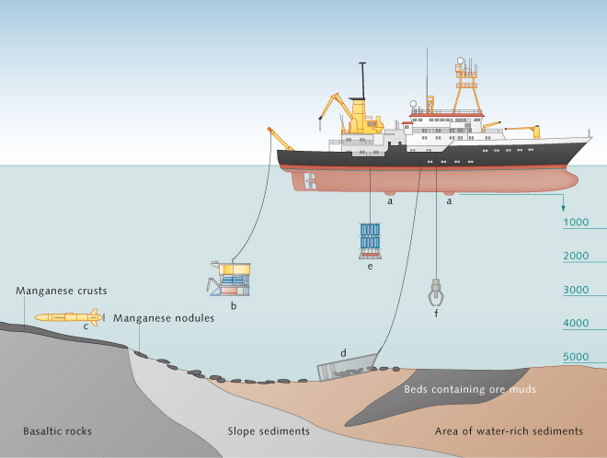

a) Depth profile using echo-sounder; b)ROVs for sampling and image taking; c) AUVs to take samples, echo, and pictures at the sea-floor; d) Large net construction to take samples by dredging the sea-floor; e) Multirosettes to take water samples at different depths; f) Grab arm to take individual samples

##### Demonstration and extraction

In this stage, first small-scale extraction is initiated and technologies tested; after which full scale extraction may take place trough several types of Remotely Operated underwater Vehicles (ROVs), cutters and risers are used to carry the ore from the bottom up to the surface. The technologies for extraction vary per type of deposit.

##### Pre-processing and temporary storage

Depending on the extraction technologies used, distance to shore and volumes, the sediment may be dewatered at the ship or platform and the fines can be recovered by cyclones. The lifted water can be returned into the water column. When the extraction sites are located on a long distance from shore, adequate storage on a platform is required as to manage the logistics process.

##### Transportation, handling and storage

The (partially processed) commodities must be shipped to the processing locations on land. It depends on the type of commodities, quantities and distances to cover what type of ships are required. Those vessels might be ‘traditional’ bulk carriers used for the shipment of minerals mined on land, or alternatively they could be the same vessels also used to extract the ores, in such case Hayden (2004) argues that price for shipping will be a key condition for where mining activities will first take place. The only known vessel under construction to cater to the specific needs of deep sea mining is built by the Kiel-based ship-yard Harren and Partners in Germany.[7] At €127 million, the vessel constitutes a major budget post in deep sea mining ventures.

Like all commodities being shipped, also deep-sea minerals need to be unloaded from the vessels and (temporarily) stored at the same location of the processing site or maybe within strategic depots in ports.

##### Processing

Due to the large quantities of ore, and – in some cases – complex chemical process involved, processing will most likely take place on-shore.[8] Several techniques for processing e.g. manganese nodules have been suggested. In general two techniques have been tested: hydrometallurgy, where the metals are separated with acids (hydrochloric or sulphuric) or basic reagents (ammonia), and smelting.[9] The extent to which these processes differ from the processing of land-based minerals will depend on sediment characteristics and will be further analysed in this task.

##### Distribution and sales

This is the final stage of the value chain and the least related to purely deep-sea mining. From a technology perspective, this stage is also not very relevant. However, it is a value added phase in terms of economic value. In many cases it will not be different from the distribution and sales of land-based minerals.

In addition, each stage needs upstream and downstream services to be delivered and certain framework conditions are in principle required in order to allow DSM to take place. However, it is the combination of several important (external) factors such as mineral type, depth, distance and commodity prices which determine the type of technologies to be used and in the end the exact structure of the value chain. Based on the literature so far reviewed and the initial inventory of technologies made in the inception phase, a schematic overview of all possible stages, services and conditions is presented in the figure below. Also the critical factors identified in relation to each of the phases are presented.

Several value chain variations can be identified, depending on a variation in the size of critical factor parameters and differences in techniques applied. Within the project we will further analyse the stages, their associated technologies as well as their applicability to each of the sediment categories defined.

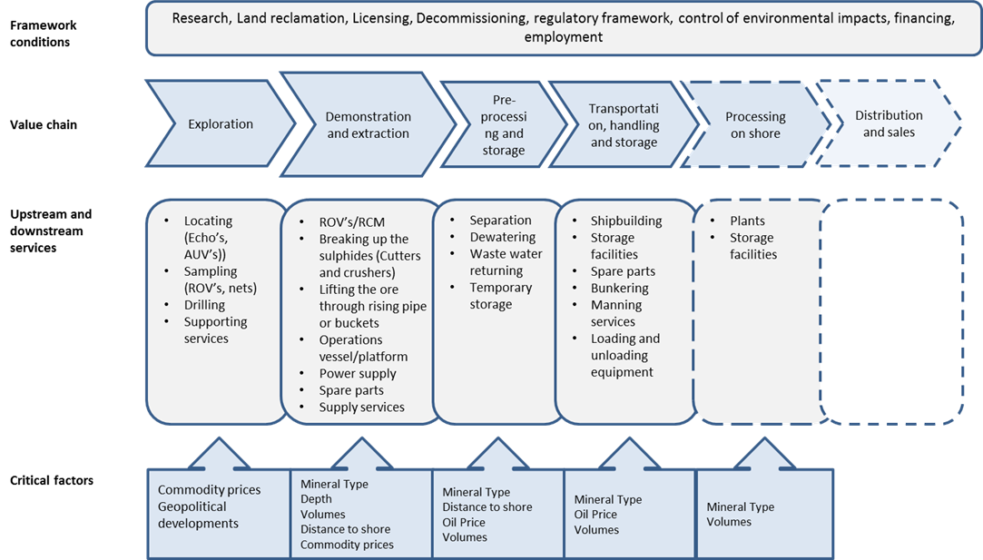

For each link in each value chain that we have identified, the following sub-tasks will be conducted:

* Assessment of technologies currently used and available, including comparison (where possible) with land-based mining techniques;
* Identification of companies developing and providing these available technologies;
* Identification of which technologies require further development, i.e. assessing the stages of development of the various available technologies;
* Ranking technologies in terms of likelihood of application for each of the sediment categories and prioritisation of technologies requiring further development. A priority list will be set, based on criteria including economic, environmental and social aspects; and
* Identification of skill requirements for the manufacturing of DSM technologies in the EU.

#### Overview of extraction technologies

The type of extraction technologies used will depend on the type of minerals to be mined. We summarize the main technologies (expected to be) used per type of mineral. Most technologies distinguish 1) driving body’s 2) crushers and 3) lifting systems.

##### Polymetallic Nodules

For nodule mining, no new mining systems/concepts appear to have evolved since the '70s. Concept systems of seafloor nodule miners still under serious consideration are (Chung, 1996)[10]:

* The remote-controlled, self-propelled miner (RCM) system (Active system). The RCM system proposes an integrated, fully automatic position control. It is propelled and manoeuvred by Archimedean screws (Hein *et al*, 2013)[11];
* The tow-sled (TS) system (Passive system). This system is traditional, simpler in design and can be mechanically more reliable, but is much lower in mineral-recovery sweep efficiency than the RCM system, primarily because of difficulties in maintaining the desired miner track-keeping.

Slurry of nodule-water mixtures can be vertically transported by one or two pipe-lift (hoisting) systems: the hydraulic system and pneumatic (or airlift) system. Mechanical systems are not reviewed. The important parameters are size and optimum concentration of nodules and sediments, their geometry, abrasion, wear, etc. (Chung, 1996).

For these operations, continuous power supply and adequate storage space for nodules will be required on the platform, as the mining sites lie several thousand kilometres (2000-6000 km) away from possible landing sites for these ores, involving 5-15 days of travel time (at 10 knots speed) for the transport vessels besides loading / unloading time (for ores, spares, fuel, manpower and provisions) during each visit to the mining platform (Sharma, 2001)[12].

##### Polymetallic Sulphides

Seafloor Massive Sulphides (SMS) deposits present several challenges for extraction technology. First, the ore body is comprised of a combination of loose material such as fallen chimneys, and solid fused minerals such as re-crystallized sulphides and deposition layers. Second, the seafloor terrain may be rugged due to tectonic activity.

Extracting the ore body, while minimizing environmental impacts, will require a combination of technologies working in stages. As currently envisaged, an SMS extraction device would be divided into three components (Birney *et al*, 2007)[13]:

* drive body,
* ore crusher; and
* ore lifter.

The process of extractive technology uses a drum cutter for breaking up the SMS. The SMS ore with its associated sediment will be transported through a riser pipe up to the ship where it will be dewatered. The ore would then be transported to shore and waste water slurry would be returned to a currently undetermined location (Birney *et al*, 2007).

A good example is the Nautilus project. If deep sea mining becomes a reality in the Solwara 1 and the Solwara 2 deposits, mitigation measures will be required to address environmental impacts of water use and discharge, water quality, noise and vibration, sedimentation and dewatering (Gena, 2013)[14].

Extraction technology for SMS has been adapted from that used in deep-ocean petroleum operations, such as seabed pipe trenching operations, and from offshore placer diamond mining, the latter of which is being adapted from shelf-depth operations to deep-water operations (Hein *et al*, 2013).

The proposed SMS extraction device can be divided into three components:

1) **Drive Body**: Nautilus has proposed the use of two 1,000 hp ROVs fitted with drum cutters originally used in terrestrial coal extraction. The ROV crawls over the seafloor on tracks “after one track length (the ‘miner’) has made a flat ‘road’ to operate on” (Birney *et al*, 2007). A different solution may be the use of 7 m diameter rotating cutter heads originally designed for ocean diamond mining operations. The cutter heads are mounted on a flexible drill string and could be used to clear loose material to create a flat surface (Birney *et al*, 2007). These ROVs will be powered electrically from an anchored platform, each mining 200 tons per hour. ROVs operate on an electric-to-hydraulic conversion system. Typically electric-hydraulic conversion is not very efficient, but modern ROVs compensate for this by “the ability to locate very powerful but compact hydraulic motors right where the power is needed (Birney *et al*, 2007).

2) **Ore Crusher**: Currently, there are two designs for breaking up the sulphides: 1) A cutter drum used for coal mining applications, and 2) three-head rotational cutters used for ocean diamond mining. Cutting teeth on the drum cutter are designed to minimize the production of ultra-fine particle and optimized to produce particles averaging 50 mm in size and as large as 70 mm. Natural particle sizes of the minerals in the ore depend on the formation processes and can range from 10 to 600 microns, though larger sizes can form when “early-formed minerals are continuously re-crystallized by hydrothermal reworking” (Birney *et al*, 2007).

3) **Ore Lifter:** The SMS ore will then be lifted to the platform and prepared for transportation to a processing plant. Currently, two methods are proposed. One is a riser pipe using cold deep-sea water as a transport fluid. The ore is then “dewatered” and the fines recovered by cyclones. Lift water is then returned to a (currently undetermined) location in the water column. A depth of 500 m was suggested by Nautilus. This method is appropriate for extraction scales in excess of a few million tons per year. Extraction cycle periods for a 2 million ton deposit are estimated at a year. A different method, originally designed for crustal mining, is a “wire-line-bucket method”, which uses big buckets connected in series by a wire. This more conventional method is appropriate when the scale is less than a few millions ton per year (Birney *et al*, 2007).

The current mining method proposed by Nautilus Minerals has never previously been implemented in the mining world. Although Nautilus Minerals is planning to utilize existing technologies, the economics of this type of mining method is still uncertain.

##### Cobalt-rich crusts

The technology required for mining of ferromanganese crusts is much more complicated than would be required for the recovery of polymetallic nodules. Whereas nodules are discrete, small, entities which merely require lifting from soft sediment layers, crusts are more or less firmly bonded to their substrate rock and would require breaking from it. They have a knobbly surface texture when in slow moving water; although the crusts that form on the summit edges of seamounts in faster currents may be smoother (Halbach *et al.* 1989) and this could have consequences for their ability to be broken up mechanically during the mining process. Any method which brought substrate to the surface along with crust would result in much depleted ore grade.

The mining of crusts would probably include at least five stages: fragmentation, crushing, lifting, pick-up and separation (Hein 2000).

A number of different methods for implementation of these different stages have been suggested, although none have so far been built (Erry *et al*, 2000).

* A bottom-crawling vehicle attached to a surface mining vessel by means of a hydraulic pipe lift system and an electrical umbilical. The mining machine is self-propelled at about 20 cm/s and has articulated cutters that would allow crusts to be harvested while minimizing the amount of substrate collected. Suction dredges then move the fragmented material into a gravity separator before lifting to the mining vessel;
* A continuous line bucket system could be used where crusts are only loosely attached to the substrate rock;
* Water-jet stripping of crusts;
* In situ leaching techniques;
* Heavy duty rollers to crush crusts and separate them from the substrate.

**Technology analysis**

Strengths and weaknesses of all identified technologies will be analysed within the broader context of EU policy. Some of the most important factors to analyse include the following:

* Job-creation potential of DSM technology;
* Added value of DSM technology development to the EU economy (including a discussion of costs of the technology);
* Existing gaps in the development of DSM technology and how the EU’s role can be advanced (e.g. to fill these gaps);
* Priorities of the EU at the moment in terms of technological innovation generally, and specifically concerning DSM;
* Identify the market situation by assessing the most important researchers (e.g. corporate, public-sector, academic, etc.); and
* Identify and analyse the role of patents and the current situation from the viewpoint of main stakeholder groups.

The analysis will be structured as follows:

* Identification and presentation of an overall list of technologies;
* Screening of each of the technologies and scoring against a pre-defined set of criteria (e.g. development stage, technical feasibility, environmental impacts, possibly costs. This information will then also feed into tasks 2 and 6);
* Linking technologies to types of minerals, based on physical selection factors (e.g. soil density, depth, weight);
* Eventual show stoppers if applicable.

Use will be made of information gathered in task 4 (geological analysis) with regard to sediment locations and characteristics and of task 5 (project analysis) concerning technologies tested and trialled.

The preliminary findings of this task will be summarised as part of the interim report which will be submitted four months following contract signature. Findings of the interim report and further analysis will be discussed at the workshop which is expected to be organised within one month following the submission of the interim report.

#### International Workshop

As part of this task an international workshop will be organised. Within the workshop a group of around 20 to 30 industrial and scientific experts are invited to Brussels for a one day consultation with interactive sessions. With the findings at hand from the interim report, the workshop allows the consortium to cross-check their results with these experts. Furthermore, the expert’ views can enrich the study with new findings, ideas and recommendations. Liaison with task 6 environmental analysis is made in view of the workshop to be organised under that task during the same period.

##### Objectives

Several objectives for the workshop to be held are considered and should be further reflected upon. The following list will probably be amended over time, as new insights and priorities will be retrieved over time.

However, the workshop would be important to:

1. Present the interim findings of the study so far and retrieve feedback;
2. Gain insights in areas where so far data and literature has been not available (to cover gaps);
3. Retrieve ideas and brainstorm with several cross-functional and cross-sectorial experts on several issues identified;
4. Prioritise development paths, problems to overcome, research areas, etc;
5. Incorporate economic, legal and environmental issues from this study as well based on the results of the respective task at the time of the workshop;
6. Think of the position and potential of Europe as supplier, knowledge base, producer, consumer, facilitator for DSM

The key topics to discuss and workshop agenda will be drafted in further detail on the basis of the technical analysis findings and presented in draft to the Commission services for discussion and feedback.

##### Potential participants

The consortium thinks it is important to have a balanced selection of participants for the workshop. Therefore, we will identify experts and stakeholders through the following stakeholder matrix, up to a maximum of 25-30. We have already identified some potential experts and industry players.

Table 2.1. Stakeholder matrix with proposed industry stakeholders and expert companies

|  |  |
| --- | --- |
| Cross-sectorial | |
| **Deep-sea mining** | **Land-based mining** |
| Cross-functional | **Research** | Netherlands Deep Sea Science & Technology Centre (NL), Geomar (GE), JPI Oceans (EC), NOC Southampton | TU Delft (NL) |
| **Surveying and exploration** | Nautilus Minerals (UK/US), Ocean Floor Geophysics, Lockheed Martin (UK) | Northern Minerals |
| **Extraction/Processing** | Neptune Minerals (CAN) | Technip (FR), Halliburton, Tasman metals |
| **Transport and vessels** | IHC Merwede (NL), Harren (GE) | Vale (BR) |
| **Legal** | Fenners Chambers (UK), Institute of Maritime Law Southampton (UK) |  |
| **Standards and licensing** | Bureau Veritas (US) |  |
| **Policy** | DG MARE/ DG ENTR / DG ENV, possibly member state representation |  |
| **Associations** | World Ocean Council, International Marine Minerals Society |  |

##### Preliminary agenda

The workshop approach would be an interactive one, where one-way presentations are mostly limited. Instead, the stakeholders will be put together in groups and through several assignments they would be in a way forced to be creative and to think out-of the box through solutions.

The following agenda is a first idea of how to structure one full day.

8.45 *Welcome Coffee*

9.15 Presentation of the study and interim outcomes – followed by discussion

10.30 *Break*

10.45 First break out-session on Technologies (4 groups each to discuss 4 distinct topics)

12.15 Plenary present findings of break-out sessions

13.00 *Lunch*

14.00 Second break-out session on challenges and investment prioritization

15.30 *Break*

15.45 Plenary presentation of second break-out session and plenary discussion on EC involvement and follow up recommendations

17.00 – 18.30 *Networking drink*

Each break out-session is hosted by a study-representative who will moderate and a rapporteur will take notes of the ideas brought forward.

### Task Output

* + 1. Description of value chain from extraction to refining;
    2. List of technologies available for each component of the value chain and their main characteristics and unknowns;
    3. Specification of value chain for the four main deposit categories identified;
    4. Presenting the above findings as part of the interim report;
    5. Organisation of an international workshop to present draft findings of the task;
    6. Complementing the interim report with the workshop findings and provide this as input to the final report.

## Task 2: Economic Analysis

### Aim

The economic analysis aims to present an overview on the economic viability – including associated costs and benefits- of possible deep sea mining projects (where this task will make use of the information collected under task 5).

#### Economic viability will be defined by a list of criteria that will reflect on the associated costs of extraction, the value of natural resources as well as the sustainability of conditions. Furthermore possible implications on world market prices caused by a new source of supply will be addressed. Will deep sea mining develop into a typical boom-bust industry?

### Activities

The activities under this task include:

1. Assessment of relevant commodity markets (workings, pricing)
2. identifying and drawing up criteria to determine economic viability;
3. producing a simple economic model to assess the profitability of deep sea mining operations;
4. preparing three case studies (one for each type of mining) to assess possible future consequences of commercial operations;
5. indicating scenarios where seabed mining could become strategically important for Europe; contrasting the costs and economic implications of seabed mining with alternative methods for obtaining the minerals including some variables of land-based mining and recycling;
6. Assessing

In deviation to the ToR an assessment of commodity markets[15] is moved to the top of the list of activities as the analysis of commodity markets and the role creating an enhanced insight in specific commodities will feed in different other tasks and is an important contextual factor in determining the economic feasibility.

### Approach

The economic analysis will build upon the available literature as well as the integration of the information coming from the other tasks, including the technology assessment (task 1), geological analysis (task 4) and the environmental analysis (task 6). At the same time this task might feed back to the other tasks in determining what criteria might be assessed to establish economic viability. In addition interviews are foreseen with key stakeholders and experts.

#### A. Commodity market analysis

The development of demand and supply for commodities is one of the main components in determining the economic viability of deep sea mining.

With regard to revenue, a separate analysis will be presented on the expected global demand for the various types of minerals (separately addressing the category of rare earth elements), the working of commodity markets and resulting prices for minerals and metals that are mined in the deep sea (see text box 4.2). This will not only address the resulting prices (including existing forecasts and historic volatility) but also create an understanding of the underlying drivers and the possible implications of price volatility on the development of deep-sea mining (stable growth vs boom and bust). The potential responses of land-based mining will also be addressed, notably if these are restricted to a limited number of players (e.g. China) possibly in regulated market (state involvement in land-based mining). This task also includes the assessment of the potential implications on commodity prices of an increased supply of minerals/metals from deep sea mining.

This analysis will put deep-sea mining quantities and costs into perspective with the markets of mined minerals. It will thus provide an overview of these markets, along three major points:

* first, it will suggest a grouping of materials and describe the main players along the value chain from ore body to refined mineral;
* second, it will look at the markets and price building mechanisms for refined metals and at the main factors impacting availability; and
* thirdly, it will sketch different futures for the developments of accessibility and prices, and derive their implications for the economic viability of DSM.

Note that the second and third point can be related to the criteria for critical raw materials as defined by the European Commission (2010), namely economic importance and supply risk[16]. The European Commission (EC) has identified a list of 14 critical raw materials of which deposits and production are concentrated in countries outside the EU[17]. The commodity market analysis will cover economic importance (factors influencing demand) and describe the supply structure and market organisation, whereas the third point will take a more big cycle view of supply risk.

In addition to a plain description of the market environment that deep sea miners are expected to meet, this task is also concerned with interactions of the current market situation with deep sea mining as a potential new player on the supply side. If DSM produces sufficiently large quantities in a more cost-efficient way than land based mining , this can have an impact on prices (up to the extent to turn mining unprofitable) as well as on overall supply risk.

##### Background: grouping of materials, value chain and market structure

This section will provide a general market-based categorization of minerals and a general overview of the typical value chain and market structure.

###### Grouping of materials

Based on their market characteristics, the minerals relevant in DSM can be grouped into four main types and one extra category.

Table 2.2 Suggested market grouping of materials

| Type | Examples relevant in DSM | Price mechanism, transparency |
| --- | --- | --- |
| Precious metals | Gold, silver | Well established and transparent markets. Prices especially for gold often not clearly linked to demand and supply |
| Platinum group metals (PGM) | Platinum | Prices set by sales offices of major producers |
| Base metals | Copper, nickel, zinc | Prices linked to varying supply and industrial demand, traded at London Metal Exchange (LME) |
| Minor metals / by-products | Cobalt, molybdenum, manganese | Often mined as a by-product and thus lower price elasticity of supply; smaller quantities than base metals; most not traded at LME (exception: cobalt, molybdenum) |
| Rare earths (light, heavy) | Tbd | Not publicly traded |
| *Steel raw materials* | *Cobalt, manganese, molybdenum, nickel, zinc* | *Demand heavily influenced by steel industry* |

Source: Ecorys based on <http://metals.about.com/od/investing/a/Metal-Markets.htm>, Dunbar (2012), <http://www.infomine.com/investment/industrial-minerals/>

Clearly there are some overlaps between these categories – particularly, rare earths could also be classified as minor metals, and all steel raw materials appear in other categories as well – but this grouping is useful to quickly identify market forces at play. Steel raw materials are good to keep in mind because of the major forces influencing their demand.

###### Selecting most relevant commodities

The chemical composition of deep sea minerals shows a wide variation in types of minerals and elements that occur in deep sea deposits[18]. In that respect is is relevant, within the above grouping of commodities (elements/minerals/metals) to select the most relevant ones. This selection is based on a number of criteria:

* **Revenue potential**: what is the (known) deposit size and their composition and, given current market prices of the minerals concerned, what would be the magnitude of revenues from eventual extraction;
* What is the **availability and accessibility** of the minerals found in the respective sediment categories? E.g. if a mineral is abundantly available from easily accessible land-based sources it may be less likely to be extracted commercially from the sea bed than if it is very scarce or if demand is rising much faster than supply. Such questions may in particular apply to critical raw materials. Three sub-criteria are defined:
  + Scarcity: how much of the mineral is known to be in land-based resources that can be exploited (e.g. that is accessible);
  + Geopolitical context: to what extent is supply restricted to small numbers of (unstable) countries (this can be based on the critical raw materials list);
  + Demand/demand development: to what extent does current supply match current demand and what is the expected development of demand (e.g. fast growth vs stable demand over time);
* **Competitiveness** against land based supply and costs: if there are plenty of easily accessible onshore resources and exploitation costs of these are relatively low and sea bed mining will thus not likely be attractive from this point of view.

A expected first listing of expected relevant commodities (minerals) to be included in the study is presented below.

Table 2.3 Initial list of minerals to be retained

| Commodity (mineral) |
| --- |
| Manganese |
| Copper |
| Nickel |
| Cobalt |
| Zinc |
| Titanium |
| Lithium |
| Gold |
| Silver |
| Platinum |
| Thallium |
| Molibdenum |
| REE |

###### Value chain

For the major precious and base metals, the value chain from mine to buyer will be presented in a simplified way. In general, in case it doesn’t own the smelter or refinery itself, the mining company is paid the metal content of the concentrate or impure metal it supplied, minus treatment and refining charges. Smelters additionally pay for by-products (see category of minor metals above), whose supply thus depends on the supply of the main base metals. The price received by the miner is agreed to be at a fixed date in the future, shifting the price change risk to the mining company.

From this we can conclude that miners are mainly affected by:

* Commodity market prices;
* Market price volatility.

Section 0 discusses the influencing factors for prices and volatility in more detail per material.

###### General market structure of mineral mining companies

This section will give a first overview of the general market structure of mineral mining companies, to be detailed on a substance level in the following chapter. This will include

* Information on the typical size and vertical integration of mining companies: The ‘majors’ represent about 83% of the total value of all non-fuel minerals production, whilst the remaining 17% is accounted for by about 1000 medium sized and small companies.”[19];
* The importance of state-owned mining and the most relevant states active in it.

Figure 2.3 Share of state companies in metal mining over time



Source: ICMM (2012), InBrief: Trends in the mining and metals industry. Mining’s contribution to sustainable development.

##### Price building and market organisation per material

This chapter will first provide an overview of supply and demand in action. Structured along the groups described above, we will list the main suppliers (mining countries or recycling sources), demand sources (industries, products) and other factors influencing price or accessibility per material. A template of a summary table with one example can be seen below.

Table 2.4 Example table main producers and demand factors for selected commodities

| Material | Main suppliers (countries), recycling share (if applicable/ available) | Demand sources (industries, products), substitution possibilities (if applicable/ available) | Other factors influencing price or accessibility |
| --- | --- | --- | --- |
| **Precious metals** |  |  |  |
| Gold | China (13%), Australia (9%), USA (9%)[20] | Jewellery, IT, renewable energy, *finance (note: much of this is not involving physical transactions)* | Economic stability/ uncertainty, inflation, interest rates… |
| … | … | … | … |

In addition to the summary table, per material we will outline the market forces in more detail. These will cover the following elements:

* Supply:
  + Market concentration and ownership structure (private/state-owned, number of players, vertical integration);
  + Geographical concentration;
    - Political and economic stability of producing countries;
    - Trade distortive measures: quantity restrictions are the most important factor influencing prices and accessibility; but tariffs or export bans on unrefined ores[21] can play a role too;
* Demand:
  + Past development of relevant industries;
  + Volatility of demand;
  + Substitutability of the material;
* Supply and demand interaction[22]:
  + Price elasticity of supply (e.g. low in case of by-products) and demand (e.g. high for base metals);
  + Market transparency;
* If useful and relevant: provide price statistics and describe underlying events in a “case study” style[23].

The sub-chapters will also add the perspective of DSM. They will

* look at the general potential for DSM to influence the markets and contribute to price changes;
* look at volatility in the markets and what this can mean for a potential Deep Sea Mine;
* investigate the reasons for observed volatility and the potential of DSM to change this. For example, if price volatility is due to uncertainty because of unpredictable behaviour of supply from politically unstable countries, supply from deep sea mining can potentially introduce more price stability. If on the other hand sudden increases in demand for new high tech products are causing the volatility, the supply side will have less of an impact.

##### Scenarios for prices and accessibility

Based on the above information a number of scenarios will be sketched for the developments of particular demand industries, mining supply, or geopolitical relationships. The materials for which scenarios are developed will be chosen based on their peculiarities in these price and accessibility influencing factors. In addition, their relevance in DSM will be taken into consideration, as well as the potential of DSM to change the market. These scenarios can then be combined with cost scenarios for DSM, resulting in several possible outcomes for the future with differing likelihood.

**B. Criteria to determine economic feasibility**

An important step in the economic analysis is to *determine the criteria that impact on the economic viability* of deep sea mining.

In effect this determines the structure of the economic model, even though this may need to be simplified due to limitations in data availability or because certain criteria are intrinsically hard to model (e.g. commodity price volatility, geopolitical developments). Nevertheless these criteria are also important to identify as this will influence investment decisions.

In this perspective it is important to split economic feasibility criteria in:

* Components that can be included in the economic model; and
* Other criteria that influence the economic feasibility.

##### Economic model criteria

Based on the value chain components as identified under task 1 the components of an economic model can be determined. The scheme shown on figure 2.4 depicts the main elements that are expected to determine the economic viability of deep sea mining. It also gives an impression on the sources of information that will be used to establish what are essential parameters and the approximate values for these parameters.

Figure 2.4: Main elements to determine the economic viability of deep sea mining

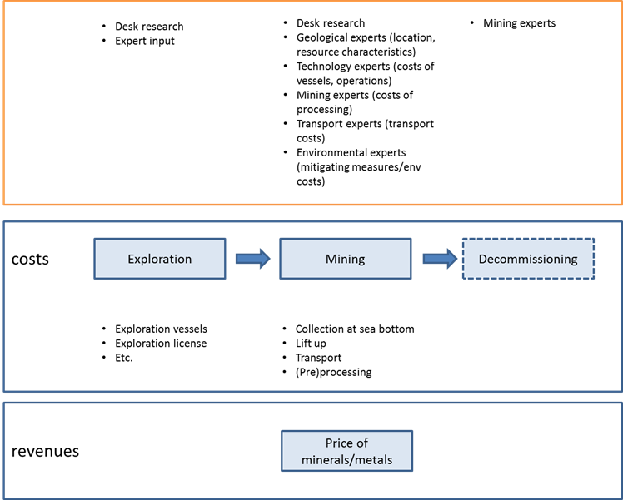

The structure follows the stages and processes that are relevant for deep sea mining, as shown also under Task 1, thus comprising the full value chain. In doing so we start by looking at a life cycle approach, not only including the mining and processing operation itself but also including the exploration stage and decommissioning stage. Whereas it is unclear at this moment whether decommissioning is important for deep sea mining, it is a considerable cost factor in land mining.

In addition to the above factors, output parameters will be defined to measure the economic feasibility. Typical output parameters are rate of return, net present value and/or cost/benefit ratios. Various sources are being used for this. They include both an analysis of previous studies on the feasibility of deep sea mining but also direct input from the various other tasks in the study (e.g. technology costs).[24]

##### Other criteria that influence the economic feasibility

Other criteria mainly include investment risks and financing requirements. Both are closely linked. I**nvestment risks** are related to the uncertainties in deep sea mining which can include technology issues (using partially unproven technologies) but also uncertainties on the amount of metals that can be mined as exploration activities at the sea bottom might not give the full picture. At the same time investment risks can also include revenue risks, such as commodity price uncertainty and volatility but also the possibility for large players to exert an influence on the price by influencing the demand. Other risks, as apparent from the current Nautilus project are political uncertainties to the extent that it may influence licensing of activities or have other impacts on deep sea mining operations. Related to the risk profile is the length of the concession as it determines the time slot in which income can be generated.

As mentioned above **financing** is the “other” significant criterion that impacts on economic feasibility. The higher the risk the higher the investment premium (and resulting increase of the rate of return) that will be required by private investors or the amount of venture capital or government guarantees vis-à-vis regular loan finance. Related to this is the size of the investment capital that needs to be mobilised. Deep sea mining operations require significant financing, in particular in the infant stages, which may run into amounts of €1 billion Euro.

**C. Setting up an economic model**

Based on the information available, a simple economic model will be built, aimed at supporting the assessment of future mining operations. The final list of criteria will also feed into the parameters of the model. This model will be developed in a Microsoft Excel environment. It will be kept relatively simple to avoid a black box character and to determine the most important parameters. Where possible, separate components of the value chain will be modelled separately. It is understood that also economic analyses on deep sea mining have been conducted by others, and – if these can be obtained – these will be used as input to the model set-up and summarised as part of this task’s reporting.

The assigned model calculates the internal rate of return (IRR) taking into account the complete DSM trajectory, from extraction from the seabed to revenues from refined metals. Starting point for the model is a venture start-up with one onshore processing plant and one mining vessel, which could operate with a variable number of ROVs collecting minerals from the ocean floor. This will be expanded with other mining technologies that are identified under task 1. Based on the capacity of the mining operation the model decides on the size of the onshore processing unit (if offshore (pre)processing needs to be included as a step in the model this will be added.

Although mining operations will follow a same basic structure, clear differences may exist between mining polymetallic nodules, polymetallic sulphides and cobalt-rich crusts. These will be elaborated in different sub-models where relevant.

Figure 2.5. Overview of the main components of the preliminary Ecorys DSM- econometric

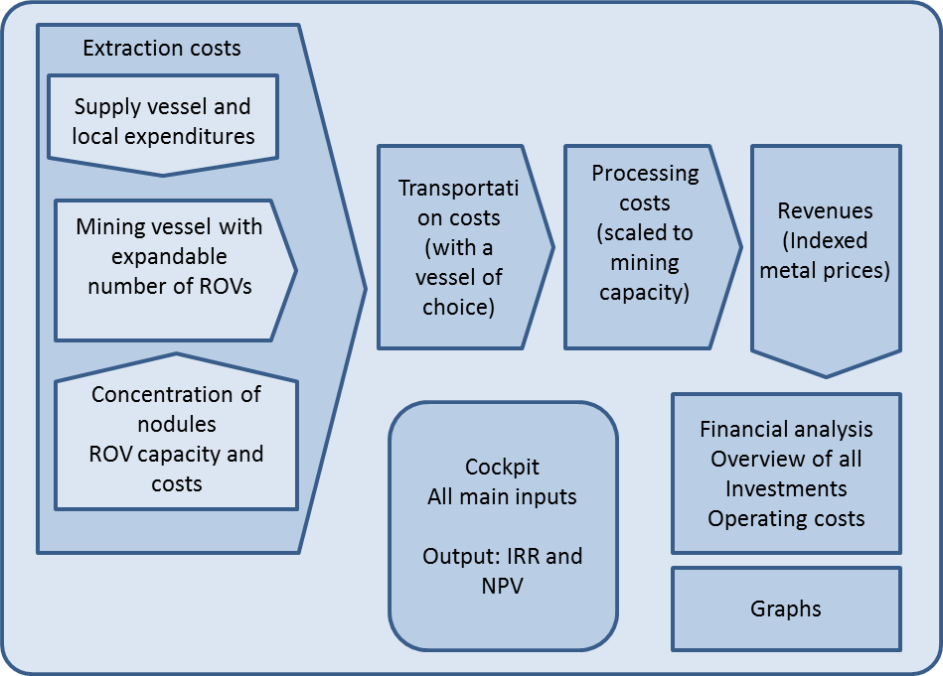

The model as described above functions as a starting point, and can be adapted to calculate the IRR of larger ventures with more mining vessels. In addition a decision still needs to be made whether it is relevant to include exploration activities in the assessment of the economic viability.

Key elements of the economic model include:

##### Mining capacity and extraction costs

In this part of the model costs of retrieving nodules from the ocean floor to the bunker of the mining vessel are calculated. An important variable is the concentration of nodules in tonnes per square kilometre. We assume that a mining vessel could operate with an increasing number of ROVs. In this way we are able to simulate a step-by-step expansion of the mining capacity of the vessel, based on a learning curve coming from experiences with the first ROVs.

ROVs are defined in terms of capacity and costs. Energy consumption is included as a separate input variable. We assume that every ROV has his own crew on board of the mining vessel.

The mining vessel is defined in terms of investment - and operation costs. An important aspect of the mining vessel is the size of the bunker capacity of the vessel (in tonnes). The optimized needed capacity should be tuned on the size of the bulk carrier that is used during operations.

In addition to the ROVs and the mining vessel the costs of the vertical lift and (pre)processing are included.

The assumption in the model is that nodules are grained and dried on board of the mining vessel and loading of the bulk carrier will be done by cranes. The mining vessel is expected to stay in the mining area while crew is traveling to- and from a nearby (small) harbour with a supply vessel. This part of the operation could have positive effects on the local economy and therefore we will calculate these local expenditures separately in the model.

##### Transportation costs

As already explained in the former section the bunker size determines the size of the transportation vessel. The user of the model is able to choose the most appropriate vessel type (Handymax, Panamax, or Capesize) in order to come to the most optimal IRR. The model calculates the number of bulk carriers needed to empty the bunker of the mining vessel in time, dependent on the travelling time to the processing plant. The distance from mining area to processing plant is one of the important variables.

##### (Metallurgical) processing costs

We assume that the processing plant will be constructed as part of the venture. The plant is an expensive part of the total investment. The size of the plant is determined by the maximum ore production of the mining vessel(s). The investment cost of the plant are calculated by scaling from a plant with a capacity of 1,5 Mton/year. The extraction efficiency could be given for every metal. Tailings of the process are assumed to be disposed of against a price per ton.

##### Revenues

This part of the model is fed by the commodity price development. Its start from the the quantity, abundance, grade and composition of ores/nodules to be mined and resulting outputs (per unit of operation). To determine the eventual revenue the model uses the metal prices of 2013 as base input and the corresponding price scenarios as developed under the commodity analysis.

##### Financial analysis

In this part of the model all financial figures are combined to present an overview of all investments, loans for financing and the operating costs. The main output of the model is generated in this sheet. The internal rate of return of the project (IRR), before tax and depreciation, and also the net present value of the project (NPV), including depreciation.

##### Graphs

This section of the model will presenting graphs to provide for a better understanding of the results of the model. An example graph on the operating costs per year is presented in figure below.

##### Cockpit

We will develop the model in such a way that it can be governed by non-experts by simply changing input variables in the Cockpit. In the cockpit all main inputs can be adjusted and outputs are presented in the form of the IRR and NPV values. The cockpits provide you with the possibility to design the project by adding ROVs or mining vessels in project years of choice. Also you could define labour costs and personnel for all offshore operations.

Figure 2.6. Operating costs of the project, divided in cost for extraction (mining), transportation and onshore processing.

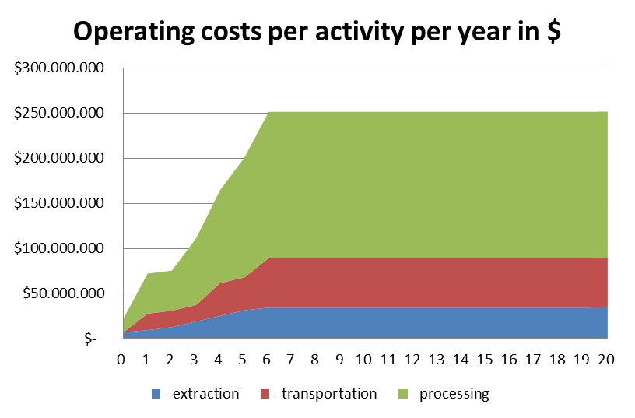

The economic model, once validated in the case studies, will also be used in the determination of a map layer on economic viability. The output parameters in these map layers will be expressed in a simple colour coding scheme indicating the economic viability potential (no hard indicators can be provided as this will be also determined by exogenous parameters, in particular commodity prices).

**D. Case Studies**

Once the functioning parameters of the model have been established and agreed upon with the Commission services, three case studies will be prepared – for all three main mining operation types – to establish possible scenarios for future large-scale mining operations. The location of the case studies (where mining takes place) will closely follow trends that can be observed in currently existing license and prospective license areas.

In these case studies the economic feasibility will be calculated under three different commodity price scenarios, which will be based on existing commodity price forecasts. Based on this various additional sensitivity and break-even analysis can be applied determining the necessary conditions for the commercial viability of deep sea mining operations. These break-even analyses can be applied on all elements of the economic model as indicated above, and can also be used to determine the most critical parameters. Specific break-even analyses will be carried out on resource characteristics and commodity prices.

#### E. Strategic importance of seabed mining

In this part of task 2 scenarios are developed where seabed mining could become strategically important for Europe. This contains two elements:

* + A comparative analysis of the costs and economic implications of seabed mining with alternative methods for obtaining the minerals including land-based mining and recycling;
  + A qualitative review of other strategic criteria which may determine demand for dee sea mining.

##### Comparative Analyses

To assess the comparative economic feasibility of deep sea mining vis-á-vis alternative methods for obtaining metals and minerals, a high level comparison will be made with recycling techniques and land-based mining techniques. A similar life cycle cost approach over the whole value chain will be used as for deep sea mining. In addition, attention is paid to potential reserves and supply characteristics of other technologies.

##### Other strategic considerations

The final part of this task is a description of considerations other than economic that might influence decisions to become involved in seabed mining. Typical aspects to be included in this analysis are:

* + Security of supply;
  + Diversification of supply;
  + Safeguarding key enabling technologies and critical raw materials;
  + Protecting critical sectors and infrastructure;
  + Stockpiling;
  + Long term reserve planning (securing future opportunities);
  + Risk moderation (on supply); and
  + Geopolitical considerations.

### Output

1. Determining criteria for the economic viability of projects including strategic scenarios and alternative methods;
2. Economic model on profitability; and
3. Three case studies assessing impacts of commercial scale activities.

## Task 3: Legal Analysis

### Aim

The terms of reference call for a description of the legal framework governing deep-sea minerals exploration and extraction and exploitation, including environmental impact assessments, at three separate levels: international law, European Union law and national law.

### Activities

The study is to examine the applicable legal framework in four different, yet inter-linked, spatial and jurisdictional contexts:

1. within the exclusive economic zones (EEZs) and continental shelves of EU Member States;
2. within the EEZs and continental shelves of overseas countries and territories (OCTs) of the Member States;
3. within the EEZs and the continental shelves of at least five other countries in which mining activity is already taking place or the results of underwater surveys have been promising;
4. areas beyond national jurisdiction.

Moreover, significant similarities and differences between the different regimes are to be analysed.

### Approach

The legal framework for deep-sea mining derives from the law of the sea and in particular the United Nations Convention on the Law of the Sea (‘UNCLOS’)[25]. In accordance with UNCLOS the continental shelf of a coastal State extends 200 nautical miles (nm) from the baseline from which the territorial sea is measured, or ‘to the outer edge of the continental margin’ (article 77). In other words, in some circumstances a coastal State may be entitled to claim an outer continental shelf that extends beyond 200 nm from the baseline. The relevance of the continental shelf regime to deep-sea mining is that a coastal State enjoys exclusive ‘sovereign rights’ for the purpose of exploring and exploiting minerals and other non-living resources of the seabed and subsoil (article 77). These provisions underpin the rights of coastal States under scenarios (a) to (c) above.

The reference scenario (d) is to the ‘Area’, which is defined in article 1(1) of UNCLOS as ‘the sea-bed and ocean floor and subsoil thereof beyond the limits of national jurisdiction’. The regime for the exploitation of the resources of the Area is set out in Part XI of UNCLOS, as supplemented by the Agreement relating to the Implementation of Part XI of the United Nations Convention on the Law of the Sea of 10 December 1982,[26] whereby all rights in the resources of the Area are vested in mankind as a whole, on whose behalf the International Seabed Authority (‘ISA’), an autonomous international organisation, organizes and controls access to those resources. Under the auspices of the ISA a number of normative instruments (rules, regulations and procedures) to regulate prospecting, exploration and exploitation of marine minerals in the Area, which together comprise the ‘Mining Code’, have been adopted to date[27].

However, beyond these provisions, a number of other instruments of international law are also relevant or potentially relevant to the issue of deep sea-mining, including the Convention on Biological Diversity and various conventions adopted within the auspices of the International Maritime Organisation, are relevant to the topic of deep-sea mining both within the Area and within areas under coastal State jurisdiction. In the case of EU Member States, and in certain but not all cases their overseas countries and territories EU law also applies. However in all cases, in other words as regards EU Member States and other, ‘third’, countries the primary regulatory frameworks for deep sea-mining, both within and beyond areas under national jurisdiction are created at the level of national law. In this connection it is to be noted that the ISA website contains (at <http://www.isa.org.jm/en/mcode/NatLeg>) a database of national legislation with respect to activities in the Area (although some of the legislation contained in the database also applies to mining activities within national jurisdiction of the coastal State concerned).

In terms of the methodology, as set out in the proposal this task will be undertaken primarily on the basis of an analytical review of the relevant legal instruments, including the Mining Code, relevant case law (in particular the Advisory Opinion rendered by the International Tribunal on the Law of the Sea ‘Responsibilities and Obligations of States Sponsoring Persons and Entities with regard to Activities in the Area) as well as relevant literature as contained in reports, text books and specialist journals such as the *International Journal of Marine and Coastal Law*.

As also set out in the proposal a limited number of interviews will also be undertaken in person or by telephone, including with the Legal Office of the ISA, as well as relevant services within the European Commission (including DG MARE and DG ENV) and other non-governmental stakeholders.

Turning to the specific coastal State jurisdictions to be considered, as regards the EU Member States it is proposed to focus on those that have continental shelf (or EEZ) claims that are capable of supporting deep sea mining or which have experience in this sector.

In the proposal the following countries were suggested: France, Germany, Greece, Spain, Portugal, Italy, and the United Kingdom. However, according to a *note verbale* dated 22 March 2013 on the ISA website from the Embassy of France in Jamaica (the ISA’s headquarters are in Kingston Jamaica) draft legislation was not likely to be adopted by the end of 2013. While we will therefore continue to monitor the situation with regard to France we propose instead adding Belgium (which has notified the adoption of relevant legislation to the ISA) to the original list as well as the other countries originally proposed: Germany, Greece, Spain, Portugal, Italy, and the United Kingdom.

As regards the OCTs, which are listed in Annex II of the Treaty on the Functioning of the European Union, these have constitutional ties with Denmark (Greenland), France (New Caledonia and Dependencies, French Polynesia, French Southern and Antarctic Territories, Wallis and Futuna Islands, Mayotte, Saint Pierre and Miquelon) the Netherlands (Aruba, Bonaire, Curaçao, Saba, Sint Eustatius and Sint Maarten) and the United Kingdom (Anguilla, Cayman Islands, Falkland Islands, South Georgia and the South Sandwich Islands, Montserrat, Pitcairn, Saint Helena and Dependencies, British Antarctic Territory, British Indian Ocean Territory, Turks and Caicos Islands, British Virgin Islands and Bermuda).

With regard to third countries we propose examining the relevant national legislation of Canada, China, Fiji, Japan, Papua New Guinea and the United States of America. In each case we will analyse national legislation applicable to deep-sea mining in areas within and beyond the relevant jurisdiction. As described in the proposal in order to gather and analyse the necessary information we will make use of a team of correspondents working from a common checklist/terms of reference.

#### Implementation steps

The implementation of this task will take place in the following stages.

##### A. Preliminary analysis

Under this heading a literature review and preliminary analysis will be undertaken of: (a) the relevant provisions under international and EU law; and (b) readily accessible national legislation (including that contained on the ISA database) pertaining to deep-sea mining in the Area as well as in areas under national jurisdiction. This exercise will both inform the overall direction of the study and facilitate the scoping of the activities of the national correspondents.

##### B. Preparation and circulation of questionnaire to national correspondents

A standard questionnaire will be prepared and submitted to the national correspondents to complete the process of data collection in order to inform a comparative analysis of national approaches.

##### C. Interviews

A series of interviews will be held in person or by skype/telephone with a selected number of stakeholders including relevant Commission services (such as DG ENV and DG MARE), the ISA Legal Office and selected environmental non-government organisations (such as Pew Environmental Trusts, Greenpeace and WWF).

##### D. Completion of analysis

The analysis of international and EU law will next be completed followed by a comparative analysis of different approaches in national legislation.

### Output

1. Preliminary assessment of legal framework relevant for deep sea mining in the interim report; and
2. Full assessment of the legal framework in the final report.

## Task 4: Geological Analysis

### Aim

The aim of the geological analysis is to establish an overview of the location and geological controls of deep-sea marine mineral deposits. These include manganese nodules occurring on the seabed of the abyssal plains, cobalt-rich ferromanganese crusts that are associated with the flanks of old volcanic seamounts, and massive sulphides that form in volcanically active areas along mid-ocean ridges and at submarine volcanoes related to subduction zones.

The task aims to identify the variety of seabed types that contain deposits for the three main types of minerals as well as to provide deposit-related information on their local geological environment, composition (grade and tonnage; resource potential) as well as other available metadata related to these deposits such as the type of instrumentations that have been used for surveying and a measure on how much information is available and of what quality the data is. Important information on the presence of marine protected areas, the existence of exploration or mining licences will be collected and included in the data compilation. We envision to produce kml-files based on this information providing an overview by location, including relevant economic viability (cost) estimates that come from other work packages.

### Activities

The following activities are undertaken under Task 4:

1. Comprehensive overview of world wide sites that have been subject to surveys for the three main types of mining activities:
   1. Including abyssal plains, oceanic ridges and seamounts;
   2. Indicating the availability of the surveys and the interoperability of the data;
2. Suggestions for prioritising future mapping and sampling efforts;
3. Visualisation of findings by creating map layers showing:
   1. Likely mineral deposits;
   2. Surveyed mineral deposits;
   3. Seabed mining projects;
   4. Economic viability of the projects (based on criteria identified under Task 2; and
4. Delivering the map in a form suitable for integration into the EMODnet and for public viewing.

### Approach

#### Describing geological locations

The three main types of deep seafloor resources are found in distinct and different geological environments.

Manganese nodules are mineral concretions made up mainly of manganese and iron oxides with minor additions of copper, nickel, and cobalt as the main metals of economic interest. Manganese nodules lie directly on the soft sediment and can be as small as golf balls or as big as large potatoes. The nodules occur over extensive areas of the vast, sediment-covered, abyssal plains of the global ocean in water depths of 3,000 to 6,500 metres. Nodule grades are rather homogeneous with respect to their copper, nickel, and cobalt content, but the nodule density is very variable and can reach up to 75 kg per m2, however averages of 15 kg per m2 are more common. The manganese and iron minerals in these concretions precipitate from the surrounding water either hydrogenetically (minerals precipitate from cold ambient seawater) and/or diagenetically (minerals precipitate from sediment pore waters – that is, seawater that has been modified by chemical reactions within the sediment). Manganese nodules grow extremely slow with only a few tens of mm per million years. Manganese nodules have a large resource potential due to the large area they cover (9 million km2 in the Clarion Clipperton zone) and their respective grade (3 % combined copper+nickel+cobalt plus trace concentration of a variety of elements used in emerging technologies).

Table 2.5: Overview of deep-sea mineral commodities.

|  |  |  |  |  |
| --- | --- | --- | --- | --- |
| **Commodity** | **Geological setting** | **Water depth** | **Metals of interest** | **Resource potential** |
| Manganese nodules | abyssal plain | 3,000m - 6,500m | Cu, Ni, Co, REE, Mo, Li, Y, (Mn) | high |
| Ferromanganese crusts | old volcanic sea mounts | 800m - 2,500m | Co, Ni, Cu, REE, Mo, Y, Te, (Mn) | high |
| Massive sulphides | spreading ridges, active volcanoes | 300m - 5,000m | Cu, Zn, Au, Ag,  (Bi, Cd, Ge, Ga, In, Se, Sn, Te) | medium |

The second resource, ferromanganese crusts, occurs in yet another geological setting as they are associated with old, submerged seamounts. On the slopes of submarine mountains around the world, metal-rich particles precipitate out of the cold seawater, in which they are dissolved at very low concentrations, to form thin crusts on rocky surfaces. The crusts are commonly called ferromanganese crusts, reflecting the fact that their major constituents are iron and manganese, although a host of other minerals occur in them in smaller amounts, including cobalt – which is why they are also often called cobalt-rich crusts or cobalt-rich ferromanganese crusts. Ferromanganese crusts are partially made up of valuable cobalt, nickel, and manganese. Additionally, crusts are seen as a potential source of the rare-earth elements and other in-demand metals that are increasingly used in high technology and green technology industries. As for manganese nodules these ferromanganese crust have a large resource potential due to their abundance and the large areal coverage.

Seafloor massive sulfides are deposits of metal-bearing minerals that form on and below the seabed as a consequence of the interaction of seawater with a heat source (magma) in the subseafloor region. Therefore they only occur in volcanically active parts of the ocean. These can be spreading ridges along which new oceanic crust is produced or at active submarine volcanoes that are related to subduction zones; e.g. the submarine “Ring of Fire”. During this process, cold seawater penetrates through cracks in the sea floor, reaching depths of several kilometers below the sea-floor surface, and is heated to temperatures above 400°C. The heated seawater leaches out metals from the surrounding rock and exits as so-called „black smokers“ at the seafloor. Such deposits have been found in water depth between 300 m and 5,000 m. Depending on their geological setting these sulfides can contain abundant copper and zinc as major constituents as well as minor concentrations of gold, silver and various other elements that are used for modern technologies. While the number of discoveries of such hydrothermal systems and associated massive sulfide occurrences is steadily rising, most of these deposits are small in size and tonnage of contained metal. Only a few of the deposits that have been found to date are of economic interest, but exploration technologies are still lacking to identify inactive deposits, which are the prime target for exploration, during regional surveys. There is, therefore, potential for important discoveries in the future.

#### Mapping

The main part of the project will be the compilation of relevant site-specific data on the various known mineral occurrences based largely on scientific literature. This information will include data on their distribution as well as geological information relevant for their economic potential such as their water depth, host rocks and the contained resources (type of metals, metal grade, distribution, tonnage, number of analyses, methods used for analyses, etc). As stated above, the metals that can be found in these resources may vary. This is especially true for seafloor massive sulphides, where the regional geology (e.g. host rock composition, water depth, magmatic input) plays an important role for metal enrichment (see Figure 1).

Figure 2.7: Variability of metal content (% by weight) as well as gold content in massive sulphides from selected geological settings

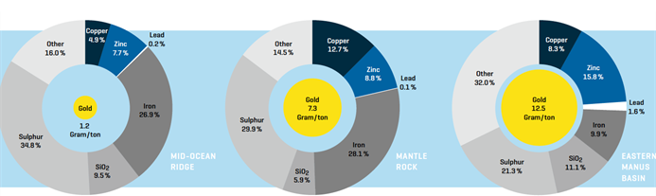

The information provided for this new database will include metadata identifying the quality of the data, as this is of fundamental importance for any assessment of their resource potential. Where available the project team will use existing databases such as the InterRidge vents database version 2.1 for seafloor massive sulphides (Beaulieau et al., 2013), which the project team also initiated. Although published as recently as 2011, the information in this database is 5 years out of date and we will update this data by new information from various sources (e.g. own cruises, recent scientific publications) providing a more up-to-date status. At the same time information about grades and tonnage and geological information will be added from publically available sources (scientific paper). Entirely new databases have to be set up for manganese nodules and ferromanganese crusts. The information for these two commodities will be collected from scientific publications.

The figure below illustrates a possible site-specific kml-file (® Google Earth) as one of the products related to this Task. Information given in the white box of the image is for one site (Semyonov-5; Mid-Atlantic Ridge) is provided through the InterRidge database 2.1 (published in 2011). Note, that this database is outdated and that important geological information but also data about chemical composition, tonnage, survey types and quality of the data are missing and have to be added during this project. Information about the resource potential of these sites CAN NOT be gathered from this database in its present stage.

Information on existing exploration license areas in the exclusive economic zones of countries will be collected from company reports and will be digitized (gathered in Tasks 4 and 5). The information for mineral occurrences in the “Area” can be digitized from information available at the International Seabed Authority (ISA, Jamaica).

Figure 2.8: Example of a possible site-specific kml-file (® Google Earth)

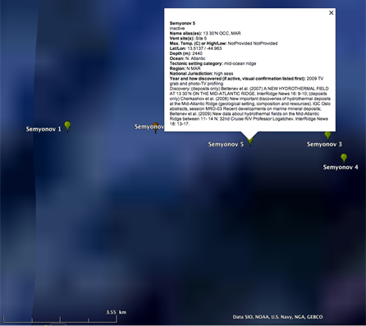

The map libraries will also include global and regional spatial geological data such as topography (predicted topography from satellite altimetry and ship-based bathymetry; Becker et al., 2009) as well sediment thickness and the age of the ocean crust. The latter two can be obtained from NOAA, the National Oceanic and Atmospheric Administration in the United States. Information relevant to the geological setting of the commodities, such as the location of plate boundaries (edited by us from a digital library published by Bird et al., 2003) and the location of seamounts (“The Global Seamount Database”; Kim and Wessel, 2011) will also be added. This data forms the base layers in a uniform ArcGIS format as this information is crucial for the evaluation of the resource potential of selected regions and to provide information on prospective areas. Non-geological information impacting resource potential will be made available through separate layers and will include environmental data (regional bio-geographical provinces, the location of existing and proposed Marine Protected Areas (information gathered from public sources in Task 4) and jurisdictional information such as the Exclusive Economic Zone boundaries (public sources; e.g. Vlaams Instituut voor de Zee (VLIZ), version 7) and proposed continental shelf extensions (UNEP; Grid-Arendal).

The final product of the geological analyses will be a series of kml-files providing site-specific information for each of the three mineral resources (manganese nodules, ferromanganese crusts, and massive sulphides) for easy use and distribution. Additionally, regional databases and maps will be queried to produce regional maps of high resource potential for each of the three mineral commodities and/or to show where more work is needed to provide enough information on resource potential.

Since this is a global and regional overview we will gather all information (individual points of interest, lines or polygones with their respective latitude and longitude) into an ArcGIS-system and display them as basemaps. From this georeferenced database we will later export the resource information into a scalable digital map base such as kml-files for use with Google Earth®. For regional maps we will query the individual base layers that are collected as stated abnove. For instance plotting all seamounts with a minimum altitude between 800 m and 2,500 m (the water depth where ferromanganese crusts with interesting metal grades occur) on oceanic crust with an age above 30 million years (it takes time to grow these crusts) will be querying three layers – those with topographic information, the database of seamounts, and the layer containing information on the age of the oceanic crust. This query will provide aereal maps of potential ferromanganese crust formation in the world oceans. Information on the other mineral resources can be obtained by similar queries.

Table 2.6 Activities under task 4 and data collection methodology

| **Task 4- Geological analysis** | **data availability** | **data collection method** | **expect additional information from other team members** |
| --- | --- | --- | --- |
| Site-specific information on mineral occurrences worldwide | Partially available for sulphides; needs to be collected from publications and reports; especially for nodules and crusts | entries into database | UNEP (extended continental shelf data; ferromanganese crust and manganese nodule sampling sites) |
| Regional geological information on seabed typology (abyssal plains, oceanic ridges and seamounts; age of the crusts) for the relevant areas of deposits | good; from public databases | transformation to GIS for querying | none |
| other information and availability to create the map layers for integration into EMODnet | Partially available; | digitizing from existing reports | UNEP (marine protected areas) |

### Output

1. Site-specific kml-files (one each for the three main commodities; manganese nodules, ferromanganese crusts, massive sulphides) containing information on the location of known mineral occurrences (incl., water depths, survey types and quality of the data, size, grade, tonnage, etc);
2. Area maps suggesting prioritized areas with resource potential (one set for each resource) and/or lack of data for prioritizing future mapping and sampling efforts.

## Task 5: Project Analysis

### Aim

The aim of Task 5 is to identify all relevant projects related to seabed mining currently on-going or in the planning phases. Activities assessed will include exploration, extraction, processing and related transport activities, as shown in the value chain presented under task 1.

While the specification calls for the inclusion of all shallow mineral mining operations including those that are in the planning phase, we suggest including only those shallow water operations that are related to polymetallic nodules, polymetallic sulphides or cobalt-rich crusts (such as gold or diamond) and exclude aggregates mining.

### Activities

Activities carried out under this task include:

1. Overview of global deep sea mining operations including exploration, extraction, processing and transport activities as well as shallow mining operation related to the three main types of minerals. Specific activities include:
   * Identification of consortia members for all projects and description of their contribution using the value chain analysis defined under task 1;
   * Reporting on the progress- to-date of the projects identified ;
   * Listing possible obstacles by the projects (as available through information exchange and literature sources);
   * Identification of public and private financing (lending and equity); and
   * Indicating whether the project relate to EEZs or ABNJ;
2. Summarising for all nations identified as supporting or hosting deep sea mining projects, their involvement (including countries outside of the EU (as available through information exchange and published sources);
3. Mapping deep sea mining activities worldwide and delivering them in a format suitable for inclusion in the EMODnet portal and for public viewing (mapping methodology will be aligned with mapping of geological and environmental factors, see task 4).

Please note that some of the information requested under this task might be considered confidential (especially in the case of third country involvement such as China or Russia). It cannot be fully guaranteed that all information on these projects can be made available.

### Approach

The project analysis will rely on information sourced through various sources including available literature, interviews and email/telephone exchanges with relevant stakeholders. Some information might also be available in news sources and study reports.

#### Building a project catalogue

As a first step in the project analysis a project catalogue will be established which aims to create an overview of all currently planned deep sea mining (exploration and exploitation) activities.

This catalogue will be built up first from the list of licenses granted by ISA, supplemented with additional licensing information on activities in EEZs. The following table presents a recent overview of the countries and companies that hold exploration licences. Information in the table was taken from a recent USGS[28] report and updated with more recent news from the International Seabed Authority and other online sources[29],[30] .

Table 2.7: Deep-ocean mineral contracts

| **Entity** | **Deposit type** |
| --- | --- |
| **States/state agencies** | |
| China | Nodules, sulphides, crusts |
| France | Nodules, sulphides |
| Germany | Nodules, sulphides |
| India | Nodules |
| Japan | Nodules, crusts |
| Korea | Nodules, sulphides |
| Russia | Nodules, sulphides, crusts |
| Belgium | Nodules, sulphides |
| Inter-ocean metals Nodules (Bulgaria, Cuba, Czech, Poland, Russia, Slovak) | Nodules |
| **Companies** | |
| Chatham Rock Ltd. | Phosphate |
| Namibian Marine Phosphates Ltd. * | Phosphate |
| Diamond Fields International Ltd.** | Metalliferous mud |
| G-TEC Sea Minerals NV | Nodules |
| Nauru Ocean Resources | Nodules |
| Tonga Offshore Mining *** | Nodules |
| UK Seabed Resources Ltd. **** | Nodules |
| Marawa (Kiribati) | Nodules |
| Bluewater Minerals | Nodules, sulphides |
| Korea Institute of Science and Technology | Nodules, sulphides |
| Nautilus Minerals Sulfides | Sulphides |
| Neptune Minerals Sulfides | Sulphides |

*\*Joint venture with UCL Resources Ltd., Mawarid Mining and Tungeni Investments c.c.*

*\*\*Joint venture with Manfa International.*

*\*\*\*Wholly owned subsidiary of Nautilus Minerals.*

*\*\*\*\*Wholly owned subsidiary of Lockheed Martin UK Holdings Ltd.*

According to the USGS report exploration contracts granted by January 2013 cover an area of 1,843,350 km2 of the seabed. About 50% of these contracts have been granted by coastal States for operations within their respective EEZs, and the remainder by the International Seabed Authority in areas beyond national jurisdictions[31]. At the end of 2013 in Fiji alone 18 new exploration licenses were granted to Nautilus Minerals of Canada, Bluewater Minerals Australia and to the Korea Institute of Ocean Science and Technology.

There is a continuous change in the number of projects. It is our understanding that some of the exploration licences are going to expire in 2014 and new licences are also being granted. Therefore within the project we will study the most recent and on-going projects and derive information on them in project fiches. Information collection will include contacting stakeholders via email as well as by phone. Relevant stakeholders are the International Seabed Authority as well as research centres, governments, mining companies and enterprises.

#### Project fiches

Information on projects in the project analysis is expected to result in a project fiche comprising a 2-3 page description of a selected set of main projects (on-going and planned), including the following details:

* Project description including location (EEZ or ABNJ) and size of location;
* Project leader;
* Project members;
* Project timeline- progress to date;
* Type of material;
* Expected revenues (kg of material)
* Type of contract (exploration, extraction)
* Possible obstacles encountered; and
* Sources of financing.

We realise that some of the information on on-going projects might be deemed confidential, therefore we expect possible limitations to the extent of information that might be accessible for example with regard to project financing. Were relevant, for EEZ activities in countries where information is difficult to obtain joint country fiches might be produce sketching a more aggregate overview of activities within a specific country.

Information from the legal analysis of Task 3 is expected to provide a contextual background on the regulative elements and reporting and other requirements that might be imposed on the projects identified.

### Output

1. Overview of stakeholder involvement in worldwide seabed mining – catalogue and project fiches;
2. Summary of third country involvement (particular attention to Brazil, India, China, Korea, Australia); and
3. Mapping of seabed mining activities worldwide and delivering in a suitable format for inclusion into EMODnet (aligned with mapping work under task 4).

## Task 6: Environmental Analysis

### Aim

The aim of Task 6 is to provide the European Commission with a detailed assessment of the possible environmental implications of deep-sea mining activities. These environmental impacts are analysed in the context of relevant legislative frameworks and thereby provide an overall assessment on possible barriers and further development.

### Activities

The following activities are going to be carried out under Task 6:

1. Compiling existing information on environmental impacts of deep-sea mining including:
   * Review of relevant available literature;
   * Creating an inventory of impacts on descriptor criteria and indicators (as per the MSFD) related to pressure characteristics, (and if available) management and mitigation practices;
   * Distinguishing between impacts common to all three types of deep-sea mining (polymetallic nodules, polymetallic sulphides and cobalt-rich crusts) and specific ones;
   * Where necessary distinguishing between pressures and associated impacts incurred during prospecting, exploration, extraction and processing phases;
   * identifying gaps in current knowledge and creating an inventory of specific additional research needs;
2. proposing a roadmap towards sufficient assessment of impacts in order to define operational targets for good environmental status;
3. compile existing information on environmental monitoring techniques:
   * review literature;
   * create an inventory of existing methods;
   * identify shortfalls and create an inventory of additional research needs;
4. contrast and compare deep-sea mining with land-based methods and recycling for the entire value chain;
5. preliminary analysis of the activity will be reported in an interim report, which will be submitted 4 months after the signing of the contract;
6. organisation of an environmental impacts workshop for experts (including industry representatives, geologists, biologists, economists, environmentalists, engineers) to share methodologies and guidelines on how to evaluate impacts on GES descriptors, especially to fill the gaps previously identified.

### Approach

In comparison to land-based operations, deep-sea mining activities, for the most -part have relatively site-specific activities. The potential impacts of deep-sea mining will vary between the four main types of deposits currently of interest: polymetallic sulphides, manganese nodules, manganese crusts and rare earth-rich metalliferous sediments.

Mining of sulphides will leave permanent ecologically and physically disturbed areas at the site with a surrounding area likely affected by debris plumes. Mining of manganese nodules will remove nodules that support animal life thus reducing the biodiversity of the original benthic community. Mining of cobalt-rich crusts involves a removal process that scrapes the crust off the underlying rocks thus destroying any attached life forms; debris plumes caused by the mining would also affect surrounding habitats. Mining of metalliferous sediments would destroy the habitats of organisms living on or within the sediment; it could also create plumes of metalliferous material that could affect the surrounding area and beyond.

Beyond the seabed mine site itself, deep-sea mining activities described above have additional environmental considerations that need to be taken into account. The process of lifting the material from the seabed to the sea surface can lead to accidental discharge of metal-rich material into the broader water column thus affecting the benthic and pelagic marine life over a much larger geographic area than the actual mine site. Dewatering processes, if conducted at sea, can also lead to surface water discharge and water column contamination.

For sulphides, concentration of desired material could potentially be done at sea with the waste material returned to the seabed mining site; failure of the reverse flow system could lead to accidental discharge of metal-rich material into the broader water column affecting marine life over a large area.

Once on shore, processes and associated environmental impact are essentially the same as for relevant land-based mining operations (post-mining phases).

The methodology under Task 6 will include the following tools:

* desk-based research;
* interviews;
* international workshop for stakeholders ; and
* analysis of questionnaire results.

Data of more appropriately relevant information and knowledge will be gathered from existing sources and collated into a succinct narrative. The only exception to this for Task 6 relates to the identification of gaps in current knowledge leading to the creation of an inventory of specific additional research needed. For this, we proposed to conduct a survey of experts.

**Compiling information on impacts**

Implementation of this task will commence with desk based research to assess literature including published studies, reports, statistics as well as interviews and reports of stakeholders active in the field of deep-sea mining. The research will address the three types of deep-sea mineral deposits in the context of several indicators such as benthic community structure, pelagic species (and the relevant unknowns), sensitivity, light, noise, turbidity, genetic resources, recruitment, etc. Relevant information relating to sand and gravel extraction will also be taken into consideration and integrated into the final analysis.

Through the literature review we aim to draw a comprehensive overview on the environmental impacts of the three different types of mining and would identify the key impacts by size of area and/or possible size of population affected.

A number of impacts are expected to be identified as a result of the literature review and the interview process. An inventory of these impacts will be compiled and inter-linkages to MSFD descriptors and indicators will be highlighted.[32] The compilation of the inventory will be based on a number of essential data sources such as the Nautilus EIA[33], NGO documents, relevant publications from the International Seabed Authority, dredging guidelines, research publications etc.

The final output of the findings is expected to be summarised in a table format similar to table 4 below. Further explanation will be provided on the impacts relevant for the specific types of ores and the phases of operation during which the impacts occur.

Table 2.8: Template for the inventory of impacts

|  |  |  |  |  |  |  |
| --- | --- | --- | --- | --- | --- | --- |
| **Impact** | **MSFD descriptor relevance** | **Type of mining** | **Impacted Area** | **Duration** | **Recovery** | **Relevance for land based mining** |
| Defining the impact | GES descriptors 1-11 | Nodules/ sulphides/ manganese crusts | Deep-sea/water column/air/surface layer | Long term/short term | Slow/rapid | High/moderate/ low/very low |
|  |  |  |  |  |  |  |
|  |  |  |  |  |  |  |

As part of this inventory, we will seek to distinguish as much as possible between impacts relevant to specific mining activities from those more generic ones (such as the type of seabed removal process specific to sulphides, nodules, crusts and sediments) from those more generic ones (such as seabed to surface lifting systems).. Criteria affecting the relevance of the impact for a specific mining activity may include:

* Exploration and mining footprint;
* Technology involved;
* Waste nature and volume;
* Community perception;
* Ecosystem services;
* Distance from shore;
* Environmental conditions especially current regime;
* Seafloor morphology;
* Seabed sediment physical and geochemical properties;
* Processing options;
* Value of resource and safety; and
* Commonness (or rarity) of affected life both on site and at neighbouring locations

In order to distinguish between pressures and associated impacts during the prospecting, exploration, extraction and processing phases of deep-sea mining we intend to draw on ISA reports and data for nodules. Finally, to identify gaps regarding current knowledge on impacts, we will use desk-based research, interviews and round table meetings at the international workshop as well as additional communication with stakeholder via emails or face-to-face meetings.

The possible social impacts linked to any environmental degradation caused by deep-sea mining activities are for the most part unclear at this stage since no actual deep-sea mining operation has taken place. The consequences to coastal habitats (of which coastal communities depend on) of habitat destruction on the deep-sea bed and/or the remote deep-sea bed are likely minimal in the short term. However, our knowledge of long term impacts between habitat systems is extremely limited. Social impacts of environmental impacts such as accidental discharge in the water column could have potentially disastrous consequences affecting food security, and local livelihoods in especially sensitive places like small island states. Additionally, potential impacts related to processing (or pre-processing) plants in coastal areas will also be considered especially in the context of more remote parts of the world where experience in environmental management may be lacking.

**Roadmap to identify operational targets for Good Environmental Status**

Based on the impacts identified a roadmap will be proposed containing the necessary steps to identify operational targets for *Good Environmental Status* (GES).[34] The roadmap is expected to include a sequence of activities such as data gathering and transparency in reporting as well as to highlight the establishment of conservation areas where mining activity should be prohibited (by reviewing different assessment tools such as Marxan) taking into account EU and international legislation on MPAs. An example Table of this information is shown below.

One element of the roadmap will be to establish indicators to assess operations. These indicators will be important as they will serve the purpose of establishing what deep-sea mining locations can be considered to have Good Environmental Status. These indicators can build on benthic and pelagic indicator models already adopted taking into consideration that none of the existing indicators have been ‘tried and tested’ yet.

Information for the compilation of the roadmap will build on published sources and stakeholder interviews. The interviews will identify where processes and techniques differ and will establish points where no information is currently available.

Table 2.9: Proposed template for preliminary roadmap on operational targets for GES

|  |
| --- |
| **Step 1: Gathering raw data on deposits and ecology** |
| Description: |
| Cost and benefit estimation: |
| Recommendations for implementation: |
| **Step 2: Transparency of information exchange** |
| Description: |
| Cost and benefit estimation: |
| Recommendations for implementation: |
| **Step 3: Common indicators for technology assessment** |
| Description: |
| Cost and benefit estimation: |
| Recommendations for implementation: |

We expect that the proposed roadmap will remain a “dynamic” document that allows for the incorporation of new findings.

Once we have identified basic environmental impacts and prepared a roadmap to measure operational targets, the next step will be to monitor the operations. In order to establish monitoring criteria we will assess the tools that are currently available for the review and monitoring of the environmental impacts.

**Review and inventory of monitoring techniques**

Seabed mining operators are obliged to satisfy best environmental practices and to provide the regulatory authority with reporting/monitoring information confirming that best practices are being applied.[35]

The regulatory authority then needs to verify that the monitoring measures are in place and that the mining operator is adhering to the best environmental practices. In order to achieve this baseline surveys will be needed prior to mining activities. In order to establish what constitutes as baseline ESONET/EMSO/EuroSITES outputs can be assessed and updated taking into consideration new developments and information.

Monitoring will be needed during the mining activity to assess the extent of impacts as well as once mining has ceased to determine recovery. A set of monitoring techniques needs to be in place to fulfil these requirements. These monitoring techniques may include:

* National and international legislative framework;
* Monitoring surveys;
* Setting environmental performance targets;
* Reporting requirements;
* Quality control scheme (ecological-technological); and,
* Third-party independent assessment etc.

The technologies used to monitor also include seabed sampling and taxonomic assessment of species as well as physical monitoring devices such as instrumented moorings, Autonomous Underwater Vehicles, ROV and remotely piloted aircraft. We will collect information on the availability and relevance of these techniques, create an inventory and highlight any gaps in knowledge or accessibility of information.

**Comparison with land-based mining**

We intend to further contrast the impacts of seabed and land-based mining from an environmental perspective, although we must note that due to the diversity of ores accessed through land based mining we expect to capture only those impacts that are relevant for deep-sea mining operations (excluding aggregates).

Some initial contrasting between seabed and land-based mining includes the differences in geographic areas affected and by proxy, the biodiversity in those areas. Due to the need for large volumes of non-ore bearing material to be moved to gain access to desired material, land-based mining is by its very nature an activity that alters large land areas.

It will be important to contrast ideas related to the extent of environmental impact that could be caused by sea-bed mining activities as these tend to very from smaller net effect on biodiversity to broad spatial and enormous ecological impacts (e.g. sulphide mining can create plumes of toxic material that could travel hundreds of kilometres). One key caveat is contrasting environmental quality: can it be argued that the environmental quality of one ecosystem is more important than that of another?

In the end, it will be important not to assess the impact of different forms of mining separately, but rather holistically (and perhaps even inclusive of all human activities that have important surface-area footprints (e.g. forestry, agriculture, bottom trawls fisheries). If a country has a mining portfolio, from an ecosystemic perspective, the cumulative environmental impact of that portfolio is inclusive of all mining activities regardless of whether they are above or below the waves deep-sea.

**Workshop**

Findings of Task 6 will be discussed at the international environmental workshop which is expected to be held shortly after the interim report for Task 6 has been submitted. Timing of the event will take into consideration the date proposed for the technology analysis as we aim to align the two events and hence make use of the presence of experts and stakeholders. The workshop will provide an opportunity to discuss the Task results and validate its findings in light of on-going exploration work.

*Participants*

Stakeholders invited to the workshop will include those involved in deep-sea mining as well as environmental NGOs and academia. Furthermore, the international workshop is expected to feed further information as thematic sessions are organised on the topics of:

* Direct and indirect environmental impacts;
* Land-based mining contrast;
* Transparency of operations and ways to achieve it; and,
* Possible criteria for operational targets on Good Environmental Status.

A preliminary list of invitees includes:

* Pacific Islands Applied GeoScience Commission (SPC/SOPAC);
* International Seabed Authority;
* Duke University's Nicholas Institute for Environmental Policy Solutions;
* Minerals Policy Institute;
* University of Hawaii;
* Deutsche Gesellschaft für Internationale Zusammenarbeit (GIZ ); and
* UNEP`s Freshwater and Marine Ecosystems Branch.

*Agenda*

A draft agenda and the draft final list of invitees will be shared with the Commission for reflection prior to the workshop. It is likely to include a number of interactive sessions allowing for stakeholders to exchange ideas about key environmental concerns and possible future scenarios.

### Output

1. A review in the form of a fully-referenced technical report, submitted at an interim stage after 4 months and finalised (incorporating workshop findings, feedback from stakeholders as well as comments and requests from the European Commission) following the project deadline of 9 months. The report will summarise existing information on the environmental impacts of deep sea mining including:
   1. benthic species associated with the 3 types of deep sea mineral deposits, benthic community structure, pelagic species, sensitivity, light, noise, turbidity, genetic resources, recruitment;
   2. an inventory of impacts with reference to relevant MSFD descriptor criteria and indicators;
   3. Impacts associated with exploration and mining footprint, technology involved, environmental uniqueness and rarity, waste nature and volume, community perception, ecosystem services, distance from shore, environmental conditions especially current regime, seafloor morphology, seabed sediment properties, processing options, value of resource and safety;
   4. monitoring techniques, establishing baselines for monitoring and technical methodologies for sampling, surveying and measuring change in deep seafloor ecosystems;
   5. Results of an exchange with DSM stakeholders (via interviews or mini-survey) to be conducted, to identify gaps in the current knowledge of impacts and create an inventory of specific additional research needed;
2. A roadmap on compiling operational targets for GES (see description above);
3. A workshop on environmental impacts (see description above).

## Task 7: Preparing the public consultation and website

### Aim

The public consultation process is an essential element for gathering data as well as stakeholder perspectives on the potential benefits as well as the concerns associated to deep-sea mining. Our proposed public consultation seeks to collect information from wide network of stakeholders on some of the key questions. The aim is to provide information such that the Commission may to gain insight into the development of the sector in order to identify its impacts and associated costs and benefits for relevant stakeholders.

### Activities

The activities of this Task have commenced following contract signature and include:

1. Preparation of a questionnaire for public consultation (draft version annexed);
2. Preparation of a draft consultation paper;
3. Mapping all relevant stakeholders and EU community related organisations;
4. Informing stakeholders at regional and national level;
5. Mobilising stakeholders; and
6. Setting up website using the maritime forum, supporting the dissemination of information about the project and inviting feedback.

### Approach

A questionnaire with a maximum of 20 questions – in addition to basic information questions – will be compiled to address stakeholders involved or affected by deep-sea mining. The questionnaires will be structured in such a way as to derive the information most relevant to stakeholders` perspectives and involvement. As requested by the European Commission at the kick-off meeting the questionnaire will be applicable to stakeholders from the public as well as the private sector, including, ministries, NGOs, research centres and enterprises. Once approved, the questionnaire will be translated to an on-line format using the European Commission`s IPM tool. A draft version of the questionnaire and the consultation paper is attached as an annex to this report.

The relevant stakeholder group will be mapped in the first two months of the project. As agreed at the kick-off meeting the Steering Group will provide inputs to the stakeholder list. Preliminary work on compiling a list of stakeholders have begun and a number of relevant actors have been identified- including research centres, national authorities and private enterprises. This draft list of stakeholders will be sent to the Commission Services to request further contacts. Following additional inputs received from the Commission, this stakeholder list will be finalised.

The final stakeholder list will include research entities/academia active in the field, marine mineral resources data owners and data providers, mining and maritime authorities with competences on seabed mining, industry technology providers, mining companies, etc. The inventory will be made on the basis of lists of registrations at ISA, parties active in EU research projects, academic entities identified through publications, and contacts known among the consortium. This step is to be concluded prior to the consultation to ensure wide mobilisation of relevant stakeholders during the public consultation process.

Once the public consultation has gone live stakeholders listed in the database will be notified via email and requested to contribute to the consultation. The email will provide further information regarding the purpose of the consultation and contain a direct link to the consultation webpage. In case of no-response a reminder email will also be sent.

### Output

1. Draft questionnaire;
2. Draft emails to stakeholders (for consistency); and
3. Draft consultation paper.

# Organisation and work plan

## Timeline and main milestones

The following table present deliverables and submission dates in chronological order.

Table 3.1: Timeline and main milestones and deliverables

| **Task** | **Deliverable** | **Deadline** | **Date** | **Notes** |
| --- | --- | --- | --- | --- |
| **Task 0: Inception** | Inception report | 2 weeks after kick-off meeting | **17 January** | The inception report will include a detailed workplan, more information about the methodology, information available and possible knowledge gaps. It will also including a draft of the questionnaire and the consultation paper. |
| Inception report meeting | 4 weeks after contract signature | **27 January** | This meeting will discuss the inception report, specifically the planning, methodology, questionnaire and consultation paper. |
| **Task 7: public consultation** | Questionnaire and consultation paper | 2 months after contract signature | **17 January** | 1 questionnaire of a maximum of 20 questions and a consultation paper of maximum 4 pages will be prepared. The questionnaire will focus on current developments in DSM, stakeholder opinions of the state of play and future prospects (including technology, legal background, access to finances etc.) and associated impacts (including social and environmental impacts). |
| **Task 7: public consultation** | Website | 2-3 months after contract signature | **Until 28 January** | A website using the maritime forum for promoting the public consultation and for inviting feedback will be set up. |
| **Task 1: technology analysis** | Interim report | 4 months after contract signature | **Until 28 March** | The interim report will include almost-final versions of the analysis on tasks 1, 3 and 5 and a summary of progress and unexpected difficulties for the other components. |
| **Task 3: legal analysis** | Interim report |
| **Task 5: environmental analysis** | Interim report |
| **Task 1: technology analysis** | Workshop | 5 months after contract signature | **Until 28 April** | The findings of the interim report (task 1) will be discussed with 25-30 industrial and scientific experts (commercial, academic and public sector stakeholders involved) in a one day workshop in Brussels. The results of the workshop will be included in the final report. |
| **Task 5: environmental analysis** | Workshop | The findings of the interim report (task 5) will be discussed with 25-30 experts (private enterprises, NGO and academia) in a one day workshop in Brussels. The workshop will focus on methodologies and guidelines on how to evaluate impacts of GES descriptors. The results of the workshop will be included in the final report. |
| **Tasks 1-7** | Presentation of preliminary results | 4-6 months after contract signature | **Until 28 May** | The findings of the interim report will be presented to DG MARE and other stakeholders in up to 3 presentations in Brussels. The results of the presentations i.e. the feedback of DG MARE and other stakeholders will be included in the final report. |
| **Task 4: geological analysis** | Draft map layers | 6 months after contract signature | The draft map layers will show possible and surveyed mineral deposit, deep sea mining projects and economic viability. |
| **Tasks 1-7** | Draft final report | 7 months after contract signature | **Until 28 June** | The draft final report will summarise the findings of the project thus far, provide a summary on the methodology used in the individual tasks and include all diagrams and tables used in the analysis. Information deemed confidential will be provided in separate annexes. |
| **Tasks 1-7** | Presentation of results | 8 months after contract signature | **Until 28 July** | A power point presentation for stakeholders will be submitted to the Commission on the study findings as presented in the draft report. The presentation will have a maximum duration of 30 minutes. |
| **Tasks 1-7** | Final report | 9 months after contract signature | **Until 28 August** | The final report of maximum 200 pages and final map layers will be delivered to the Commission. |

## Work plan

A workplan of tasks is presented below highlighting the scheduling and complementarity of activities.

The table below shows the planning for this project, including the main milestones. The blue bars depict the time that is planned to be spent on the different tasks (dark blue) and sub-tasks (light blue).

For three tasks (1 technology, 3 legal and 6 environmental), delivery of preliminary results at the end of Month 4 is required in the tender specifications. We understand that this means that preliminary findings and conclusions are presented, and after receiving feedback from the Steering Committee as well as from the workshop participants (for tasks 1 and 6), finalisation of the tasks will be done in the subsequent period and final results are included in the (draft) final report.

Following on the interim report, two workshops (for tasks 1 and 6) and up to three presentations will be held and their results will be incorporated into the final report, together with the results of the other tasks.

The main milestones are depicted with the green boxes representing meetings, workshops and presentations and the red boxes representing reports. The orange bars represent the process preceding some deliverables, as indicated in the Terms of Reference.

Table 3.2 Project workflow



## Deliverables

The following deliverables are foreseen to be submitted following the inception stage:

1. Draft questionnaire and consultation paper

A draft questionnaire and consultation paper is submitted as an annex to this inception report. The questionnaire addresses stakeholders representing public and private entities and provides information on the developments of deep sea mining and its impacts.

1. Presentation of interim reports on the technology, legal and environmental analyses

An interim report presenting the preliminary findings of Tasks 1, 3 and 6 will be submitted to the Commission four months after contract signature. The report will provide an overview of the methodology used in the tasks and present preliminary analysis results.

1. Presentation of preliminary results (up to three presentations in Brussels)

A maximum of three presentations on the key figures and results of the interim reports will be given to the Commission and other stakeholders – as identified by DG MARE, in Brussels.

1. Draft map layers

Draft map layers containing geographic coordinates and draft findings will be delivered to the Commission 6 months after contract signature.

1. Draft final report

Seven months following contract signature, a draft final report will be submitted to the Commission Services. The draft final report will summarise the findings of the project thus far, provide a summary on the methodology used in the individual tasks and include all diagrams and tables used in the analysis. Information deemed confidential will be provided in separate annexes.

1. Presentation of the draft final report to stakeholders

A power point presentation for stakeholders will be submitted to the Commission on the study findings as presented in the draft report.

1. Final report

Following the receipt of Commission comments on the draft final report, a final report will be submitted, in Microsoft Word and PDF formats, which will address any comments received from the Commission. The main text of the report will contain all key findings and analysis whereas supplementary tables and diagrams will be placed in an annex. The main text of the final report will not exceed 200 pages. Tables and data will be delivered also in Microsoft Excel or Access formats.

The final report will be submitted within nine months following contract signature and will include separately map layer files developed.

P.O. Box 4175

3006 AD Rotterdam

The Netherlands

Watermanweg 44

3067 GG Rotterdam

The Netherlands

T +31 (0)10 453 88 00

F +31 (0)10 453 07 68

E netherlands@ecorys.com

**W www.ecorys.nl**

1. COM(2012)494
2. Kato Y. et al, (2011), Deep-sea mud in the Pacific Ocean as a potential resource for rare-earth elements. In Nature Geoscience 4, 535-539.
3. It is noted that in the MIDAS project some work on this field will be done and results may confirm or adapt this knowledge in the next 2-3 years.
4. University of Southampton (2012). ‘*A Concept for Seabed Rare Earth Mining in the Eastern South Pacific’*. The LRET Collegium 2012 Series, Volume 1.
5. ISA (2006a) Polymetallic nodules. Available at <http://www.isa.org.jm/files/documents/EN/Brochures/ENG7.pdf>
6. World Oceanic Review, 2010. *Marine minerals and energy.* Available at <http://worldoceanreview.com/en/wor-1/energy/> [Accessed on 26 July 2013].
7. Hayden, David (2004) Exploration for and Pre-feasibility of mining Polymetallic Sulphides - a commercial case study. David Haydon, Nautilus Minerals Ltd. ISA Workshop presentation 2004.
8. Hayden, David (2004) Exploration for and Pre-feasibility of mining Polymetallic Sulphides - a commercial case study. David Haydon, Nautilus Minerals Ltd. ISA Workshop presentation 2004.
9. ISA (2006a) Polymetallic nodules. Available at <http://www.isa.org.jm/files/documents/EN/Brochures/ENG7.pdf>.
10. **Chung, J.S., 1996.** Deep Ocean Mining: Technologies Manganese Nodules and Crusts, *International Journal of Offshore and Polar Engineering,* Volume 6 (4), pp. 244-254
11. **Hein, James, R., Mizall, Kira, Koschinsky, Andrea, Conrad, Tracy A., 2013**. Deep-ocean mineral deposits as a source of critical metals for high- and green-technology applications: Comparison with land-based resources, *Ore Geology Reveiws*, Volume 51, pp. 1-14
12. **Sharma, R., Nagender Nath, B., Parthiban, G., Jai Sankar, S., 2001**. Sediment redistribution during simulated benthic disturbance and its implications on deep seabed mining, *Deep-Sea Research II*, Volume 48, pp. 336-3380
13. **Birney, K., Griffin, A., Gwiazda, J., Kefauver, J., Nagai, T., Varchol, D., 2007.** *Potential Deep-Sea Mining of Seafloor Massive Sulfides: A Case Study in Papua New Guinea*, Bren School of Environmental Science & Management.
14. **Gena, Kaul. 2013.** Deep Sea Mining of Submarine Hydrothermal Deposits and Its Possible Environmental Impact in Manus Basin, Papua New Guinea, *Proceedings Earth and Planetary Science*, Volume 6, pp. 226-233,
15. Including the eventual assessment of the potential implications on commodity prices of an increased supply of minerals/metals from deep sea mining.
16. See also European Commission (2013): Raw materials, sustainable supply in the EU, available at <http://ec.europa.eu/enterprise/policies/raw-materials/sustainable-supply/>
17. This list is currently being updated
18. For example in the overview of Hein (Hein et al 2013, table 3) over 70 elements are distinguished.
19. European Commission (2008), Commission Staff Working Document accompanying the Communication from the Commission to the European Partliament and the Council: The Raw Materials Initiative – Meeting our Critical Needs for Growth and Jobs in Europe
20. J.R. Hein et al. (2013), p. 4
21. As recently announced by the Indonesian government, see <http://www.benlineagencies.com/news_view.php?id=164>
22. Note that this section is in particular related to the proposed categorization of materials based on their market characteristics.
23. In this respect also use can be made of past price developments as e.g. represented by the Mundi metal price index)
24. See for example Menard & Frazer (1978) Yamazaki (2008) Soreide et. Al. (2001); Andrews et al. (1983), Charles et al (1990), Egorov et al (2012)
25. United Nations Convention on the Law of the Sea, Montego Bay, 10 December 1982. In force: 16 November 1994, 1833 *United Nations Treaty Series* 396.
26. New York, 28 July 1994. 33 *International Legal Materials* 1309 (1994).
27. Decision of the Assembly of the International Seabed Authority regarding the amendments to the Regulations on Prospecting and Exploration for Polymetallic Nodules in the Area (ISA/19/A/9); Decision of the Council of the International Seabed Authority relating to amendments to the Regulations on Prospecting and Exploration for Polymetallic Nodules in the Area and related matters (ISA/19/C/17); Decision of the Assembly of the International Seabed Authority relating to the regulations on prospecting and exploration for polymetallic sulphides in the Area (ISA/16/A/12/Rev.1) and Decision of the Assembly of the International Seabed Authority relating to the Regulations on Prospecting and Exploration for Cobalt-rich Ferromanganese Crusts in the Area (ISA/18/A/11).
28. Hein et al (2013): Deep-ocean mineral deposits as a source of critical metals for high- and green-technology applications: Comparison with land-based resources
29. Pacific Islands report (2013): 18 Deep-Sea Mining Prospecting Licenses Approved By Fiji http://pidp.eastwestcenter.org/pireport/2013/December/12-13-03.htm
30. Papua New Guinea Mine Watch: <http://ramumine.wordpress.com/tag/bluewater-minerals/>
31. ibid
32. European Commission (2012): Good Environmental Status (GES) of the Marine Environment, available at <http://ec.europa.eu/environment/water/marine/ges.htm>
33. EIA Report for the Nautilus (2013): available at <http://www.environment.gov.ck/attachments/article/110/Nautilus%20Resort%20EIA%20Report.pdf>
34. Based on Member States` agreement
35. ISA (2011): Environmental Management Needs for Exploration and Exploitation of Deep-sea Minerals, ISA technical study No 10, available at <http://www.isa.org.jm/files/documents/EN/Pubs/TS10/TS10-Final.pdf>