WORKING GROUP 2 - STATUS

MICRO-ALGAE PRODUCTION

JUNE 2023

*Jean Paul Cadoret - EABA*

**SUBTASK 1 – MARKET REASEARCH**

**SUBTASK 2 – ALGAE for FOOD**

**SUBTASK 3 – ALGAE BIOBANKS**

**SUBTASK 4-– CLARITY on ORIGINS, HEALTH BENEFITS, IMPACTS….**

**SUBTASK 5 – REGULATION FOR ONLAND PRODUCTION**

**SUBTASK 6 – CIRCULAR ECONOMY**

**SUBTASK 7 – PRODUCTION SYSTEMS**

**SUBTASK 1 – MARKET REASEARCH**

|  |  |  |  |
| --- | --- | --- | --- |
| **Outcome O1** | Communication – Market | **Starting Date** | 12/03/2023 |
| **Registered contributors** | **Arnaud Grisard** (Market)  **Sylvia Flush** (Species portfolio) | **1st draft expected for** | 1st week of May |

|  |
| --- |
| **OBJECTIVE** |
| Provide a better view of the market   * what can we do with which type of algae produced in the EU ? * Complete document with a list the different types of production systems versus species * Versus outside the EU ? |

|  |
| --- |
| **CONTENT** |
| List all micro-algae species commercialized in the EU / what type of production system used / for what market  For each add Illustrations : photos of species and of the different productions systems / indicate countries, names of companies  Compare with other countries : species not found in the EU which are produced in large volumes / for which sector (i.e what are we missing in terms of market) |

12p document which overlaps with other sub-tasks. Need dispatching and synthetising

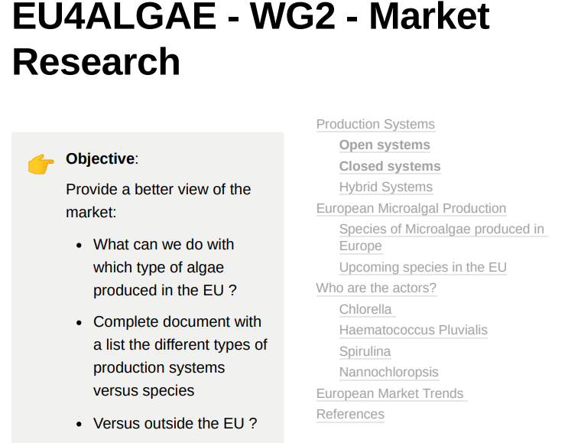

**SUBTASK 2 – ALGAE for FOOD**

Leader: Hywel Griffiths

Combined with WG3 (Food led by Vitor Verdehlo) => [About the Platform (eaba-association.org)](https://naff.eaba-association.org/about)

**SUBTASK 3 – ALGAE BIOBANKS**

|  |  |  |  |
| --- | --- | --- | --- |
| **Outcome O3** | Biobanks | **Starting Date** | 12/03/2023 |
| **Registered contributors** | **Jean Paul Cadoret, Monique Ras, Adrien Vincent** | **1st draft expected for** | 1st week of May |

|  |
| --- |
| **OBJECTIVE** |
| Identify and map algae biobanks on the European continent |

Overlap with WG1 (led by Adrien Vincent) still in progress

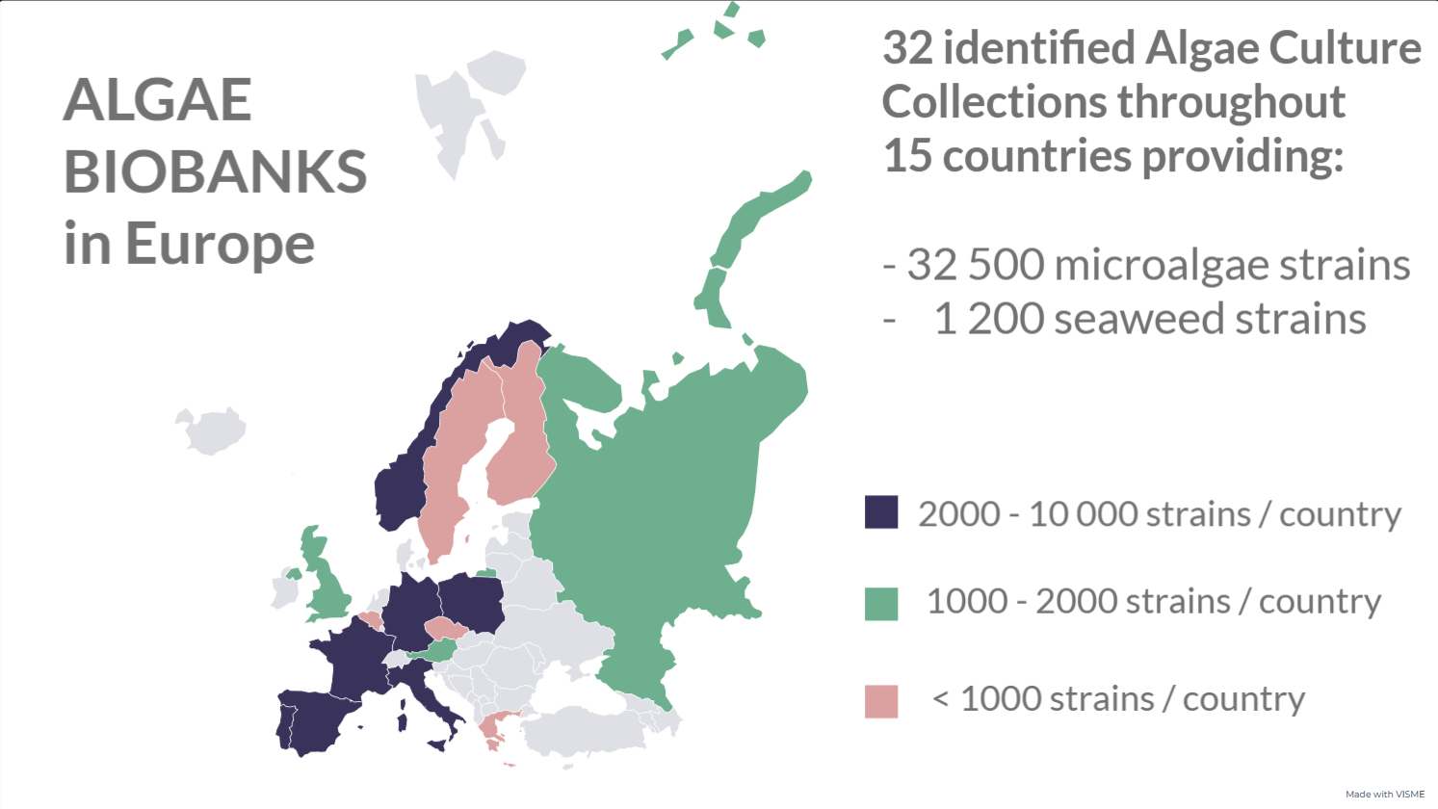

View interactive map : <https://my.visme.co/view/4dv6817j-algae-biobanks-in-europe>

**SUBTASK 4-– CLARITY on ORIGINS, HEALTH BENEFITS, IMPACTS….**

|  |  |  |  |
| --- | --- | --- | --- |
| **Outcome O4** | Communication – Clarity on quality | **Starting Date** | 12/03/2023 |
| **Registered contributors** | Leader : **Sylvio Mangini**  **Johanne Jelnes**  **Monique Ras (impacts)** | **1st draft expected for** | 1st week of May |

|  |
| --- |
| **OBJECTIVE** |
| Need to improve clarity & transparency on the production of micro-algae in the EU : origin, organic label, environmental impact, health values… |

|  |
| --- |
| **CONTENT** |
| List all micro-algae species found on the EU market   * For each identify origins of the biomass (country or region) and the existing types of labels (organic EU, organic non-EU,…etc) * for each specie : a nutrition fact sheet (health values, nutritious compounds…)   List potential environmental impacts when producing micro-algae :   * identify the most impacting practices/inputs => what could be the alternatives to reduce impact ? |

Extensive regulation aspect by Sylvio – need to synthetise + inputs by Johanne and Monique in progress.

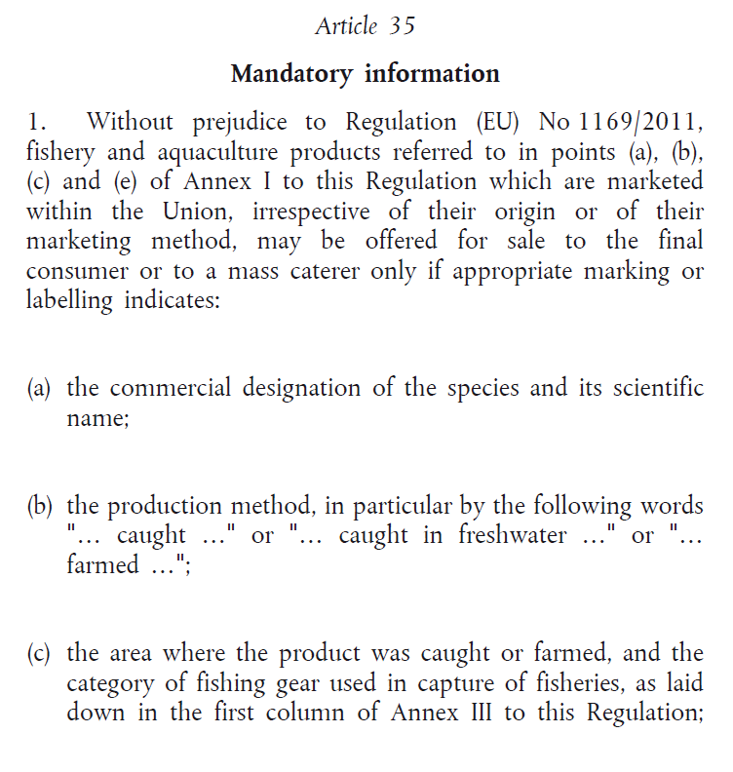

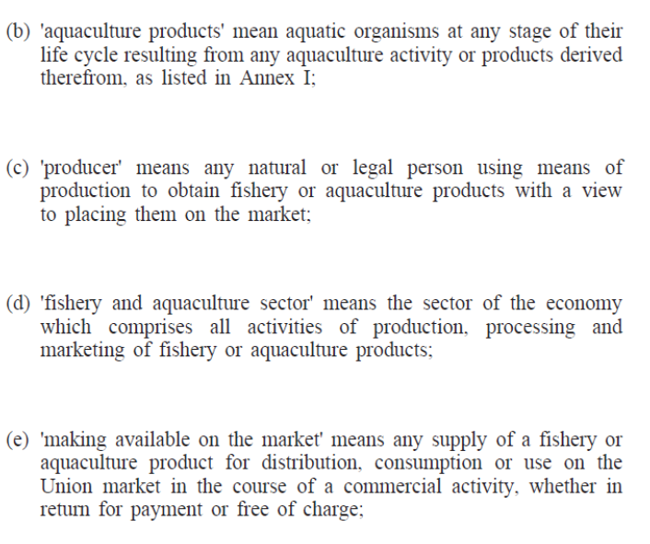

**SUBTASK 5 – REGULATION FOR ONLAND PRODUCTION**

|  |  |  |  |
| --- | --- | --- | --- |
| **Outcome O5** | Regulation for on-land production | **Starting Date** | 12/03/2023 |
| **Registered contributors** | **Boris Brüllmann** (regulation)  **Need contributors** | **1st draft expected for** | 1st week of May |

|  |
| --- |
| **OBJECTIVE** |
| The reassessment of the equivalences regimes with countries outside Europe (and within) |

**Germany:**

* Access to land

Microalgae production plants cannot be built everywhere in Germany due to certain restrictions. For instance, it is generally not possible to construct them in nature reserves, national parks, or drinking water protection areas. Similar to any construction project, building applications need to be submitted and compliance with land use plans is required. Typically, existing microalgae production facilities are located on horticultural land, farms, industrial areas, or at research sites. Some microalgae varieties can be considered an extension of conventional agriculture rather than a replacement due to their growth characteristics. Therefore, desirable locations for microalgae production facilities are those that do not compete with conventional agriculture or horticulture such as house roofs, facades, water surfaces, deserts, or barren areas. Even for small tubular photobioreactors on house facades in Germany, a significant amount of paperwork is required before permission is granted, including fire safety assessments for tubular material.

* Infrastructure

Various types of microalgae production plants are constructed depending on the local climate and available resources. Open-air basins are common in warm countries, but they are rare in Germany due to its cooler climate. Typically, microalgae production in Germany takes place in closed greenhouses or under foil coverings. Recently, closed greenhouse basin systems have been built in several locations, including Neustadt-Glewe, Rockstedt, Ahlen, Gönnebek, Reidling, and other places. Additionally, tube photobioreactors are also being newly built in Germany, such as in Burgscheidungen last year. It is assumed that all of these projects have received the necessary permits before construction.

* Effluents….etc

There are strict legal requirements in place regarding wastewater. These requirements are established through various federal and state ordinances, which include the Brandenburg Water Act (BbgWG), the Brandenburg Municipal Wastewater Ordinance (BbgKAbwV), the Wastewater Discharge Act (AbwAG), the Water Resources Act (WHG), and the Ordinance on Requirements for the Discharge of Wastewater into Waters (AbwV). For example, in the state of Brandenburg, these ordinances must be followed when dealing with wastewater.

**SUBTASK 6 – CIRCULAR ECONOMY**

|  |  |  |  |
| --- | --- | --- | --- |
| **Outcome O6** | Circular economy | **Starting Date** | 12/03/2023 |
| **Registered contributors** | **Frédérique Ferey** (CO2)  [Laura Monteiro](mailto:laura.monteiro@a4f.pt) (A4F / water)  Need expert / leader on bioremediation | **1st draft expected for** | 1st week of May |

|  |
| --- |
| **OBJECTIVE** |
| Need to identify barriers for using waste streams for producing microalgae (CO2, nutrients, water, economics, …) |

| **CONTENT** |
| --- |
| List what is allowed to be use in terms of waste streams (wastewater, flue gas…) + link with targeted market  What do we need to improve ? What about carbon credits ?  Is using waste streams cost effective (economics compared to conventional production) ? |

**Introduction**

If (micro)algae are envisaged as a tool of huge potential to sustainably remediate waste streams in the future, it is mandatory to completely change the mindset versus this biomass:

* Bioremediation of waste streams means Million tons and/or m3 of exhausted flows to upcycle
* Mass markets are mandatory to absorb the so-produced (micro)algae biomass
* Feed, food and high-value products cannot be targeted due to market unacceptance for such products issued from secondary streams
* The produced biomass itself is the unavoidable power of (micro)algae bioremediation because it is a recoverable product, and could balance the upcycle treatment price where competing technologies represent only a cost.

***Therefore even if the global value chain of (micro)algae for bioremediation is neither ready nor economically viable yet, hindering its high potential as a means for upcycling secondary industrial streams in a near future should be prevented.***

Need of a market able to absorb the volumes & associated logistic & premium price due to sustainable product

* BioFuels, BioPlastics
* Biotertilisers: the link with feed & food is closer and needs investigation

Choice on autotrophic vs heterotrophic production on bioremediation purpose of liquid streams seems still open. To remediate CO2 gas streams, PBR of high density should be favored.

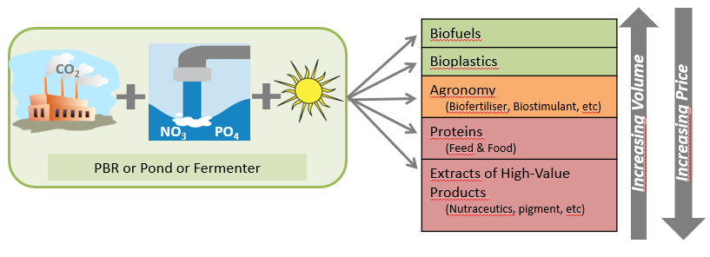

**Quality of wastes streams**

Each waste stream candidate for bioremediation by the use of microalgae growth has its own specification and should comply with its own regulation (regional, national, european) on quality criteria and contaminant limits. Therefore a good practice to assess the feasibility of microalgae bioremediation should follow the steps represented here below.

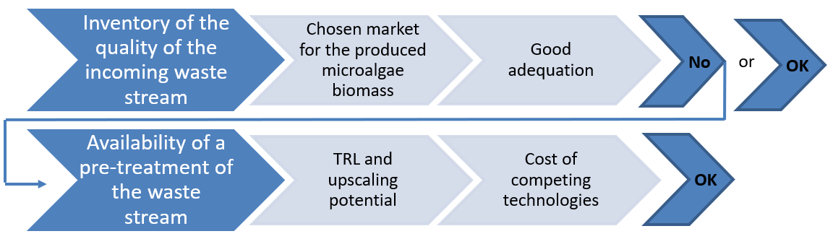

**SUBTASK 7 – PRODUCTION SYSTEMS**

|  |  |  |  |
| --- | --- | --- | --- |
| **Outcome O6 and O7** | Communication – Production systems | **Starting Date** | 12/03/2023 |
| **Registered contributors** | **Need experts on production systems** | **1st draft expected for** | 1st week of May |

|  |
| --- |
| **OBJECTIVE** |
| Provide a better view of the different production systems  A knowledge based document describing the different types of production systems from pilot to large scale |

|  |
| --- |
| **CONTENT** |
| List all types of production systems found in the EU (along a TRL / scale for example)  For each add illustrations : photos of productions systems / indicate countries, names of companies / link to website  Identify levers to reduce production costs  What is missing in terms of automisation ? |