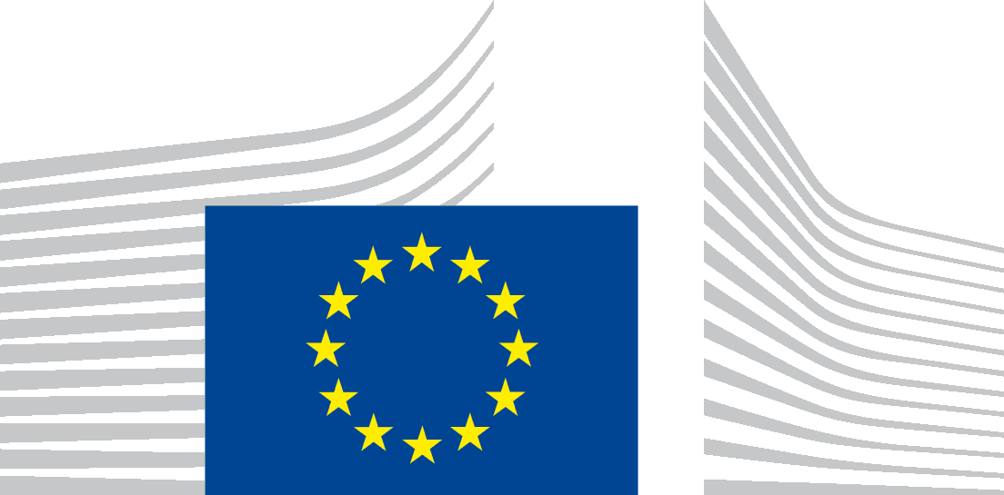 | EUROPEAN COMMISSION  DIRECTORATE-GENERAL FOR MARITIME AFFAIRS AND FISHERIES  Maritime Policy and Blue Economy  Maritime innovation, Marine Knowledge and Investment
Brussels,
MARE.A.1/CH
Note for the attention of
The Marine Knowledge Expert Group
Subject: Towards a blueprint
At the first marine knowledge expert group on 19th January 2018 the members of the group emphasised that EMODnet needed to engage actively with private sector stakeholders (e.g. via business associations) in order to identify how the European Blue Data Network (EMODnet and COPERNICUS ) could increase its usefulness to industry.
As a follow up to this recommendation, we have intensified our efforts to connect with business associations. The EMODnet for Business Brochure is now available online. As well as a preliminary data catalogue. This has to be considered a living document providing a snap shot of what EMODnet has to offer to potential users. The query tool (i.e. search on key words) is currently being upgraded to make it more users friendly as well. The EMODnet Secretariat is preparing a dedicated EMODnet for business campaign to take place in autumn 2018.
The “tour of business associations” resulted in a series of suggestions and identification of direct applications of EMODnet data as listed below.
We kindly invite the Marine Knowledge Expert Group to identify common needs and shared interest; to (dis)agree or add other priorities; indicate the usefulness as well as to inform us if any of the issues has already been solved by going somewhere else?
- Salinity data for use in scrubber;
- Data to identify "same risk areas" (invasive species), preferably in the format of a decision support tool which dictates where water can be discharged according the ballast water directive;
- Legal disclaimer on the use of data (e.g. to exclude liability of companies for the use of data submitted by them);
- Ship density maps (in preparation by EMODnet Human Activities Portal. The map will show quarterly maps on a 1km² grid for each vessel type – tankers, fishing boats etc.);
- Accurate map of all oil and gas installations;
- Weather forecast data (wave highs, storm surges, etc.) to apply safety measures for offshore activities;
- Showcase how EMODnet portals (chemistry, physics and human activities) can be of benefit for MSFD implementation and regional sea conventions obligations;
- Cumulative impact assessment – an application which allow users to select the necessary layers to estimate the cumulative impacts of their activities;
- EMODnet data to assess the environmental impacts of decommissioning of oil rags and other offshore installations (before, during and after);
- Underwater noise (in preparation by EMODnet Physics. The map will show the underwater noise levels, not on the impact because the latter is an interpretation);
- Adequate port reception facility for waste (e.g. visualisation of (Pdf formatted) data on port reception facilities per sea basin);
- Creation of map to locate algae biomass producers’ facilities can be useful especially for small producers to facilitate collaboration – e.g. spirulina producers.
Finally, we invite the marine knowledge expert group to draft a set of recommendation towards a Blue Print on EMODnet for Business. The marine knowledge expert group is invited to comment and provide input on the draft text as annexed in Annex I.
Charlotte HERMAN
c.c.: Magdalena Andreea Strachinescu Olteanu, Iain Shepherd, Marco Weydert, Fabienne Jacq
Annex draft blueprint

annex Draft Blue Print EMODnet for Business
We, the maritime industry representatives, believe that access to reliable marine data will improvc the competiveness of Europe’s blue economy. European programmes such as the European Marine Observation and Data Network (EMODnet) and the COPERNICUS Marine Service already contribute to that aim.
We need these programmes to continue with emphasis on:
- a 24/7 service;
- legal certainty on the use of data;
- user-friendliness;
- a helpdesk;
- etc

We, the maritime industry representatives’, believe that access to reliable marine data is crucial. European programmes such as the European Marine Observation and Data Network (EMODnet) and the Copernicus Marine Service are already making a good contribution.
To continue to improve the usefulness of these programmes, the following issues should have priority:
- a 24/7 service;
- legal certainty on use;
- ease of access;
- a helpdesk.

