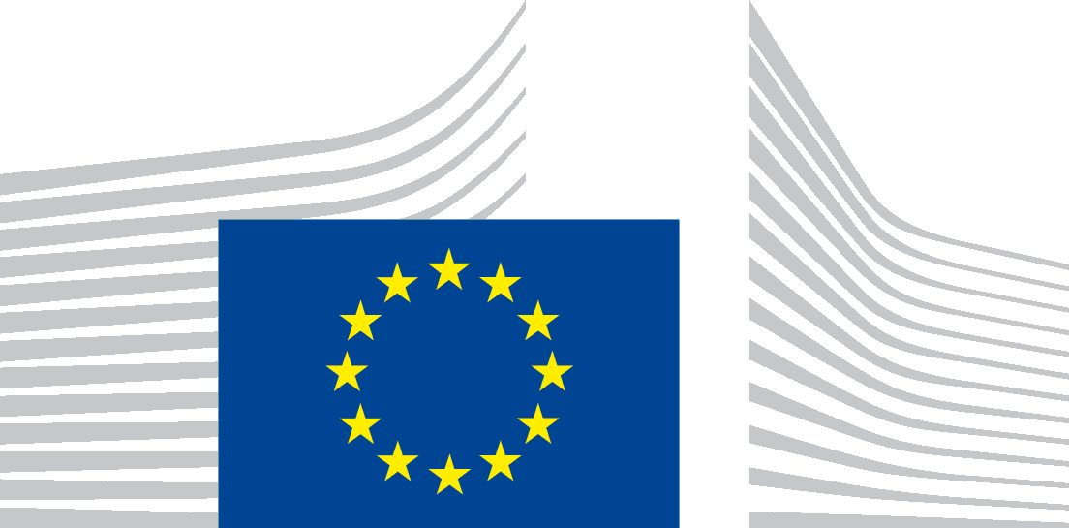 | EUROPEAN COMMISSION  DIRECTORATE-GENERAL FOR MARITIME AFFAIRS AND FISHERIES  General Affairs and Resources
Brussels, 8 June 2017
MARE A/MS
Kick-off meeting of the expert group on skills and career development in the blue economy
Crowne Plaza hotel, Brussels, 01/06/2017 14.00-17.00
Summary report

Welcome and introduction to outline the overall process
Purpose of the meeting was to kick-off the work of the newly established expert group on skills and career development in the blue economy, to get to know each other and to have a first brainstorming session on the key topics to be dealt in the coming years and to identify interest of experts in specific topics.
COM explained the rationale behind the creation of this expert group and what are the expectations. COM presented as well the work done with the experts in the last months in preparation of the kick-off meeting.
COM explained that from next time the experts will meet in sub-groups to work on specific topics.

Warming up
During the ''warming up'' exercises, participants were asked to quickly introduce themselves and place themselves in the room according to their area of expertise (education, business, cluster or other), economic sector and geographical region.

Story telling: an overview of the experts input as basis for the future work
COM thanked the experts for their valuable input submitted before the meeting. The experts were asked to suggest topics of interest to deal with in the coming years: all replies were processed and the topics proposed by the experts were clustered into 3 main groups: Industry-education cooperation; Ocean literacy and awareness raising of blue careers; Lifelong learning, mobility and training programs. The experts were also asked to share best practices in these areas, which will form an excellent input to the future work of the group. The experts input shaped the agenda of the meeting, by focusing on the 3 identified subjects.
For each of the 3 subjects, COM representative presented the current state of play, initiatives and EU added value. This was supplemented by 2 best practices reported by experts.
- Industry-education cooperation
Alessia Clocchiatti (MARE) emphasized the need to close the gap between the education offer and industry needs. So far DG MARE has funded 7 Blue careers projects launched under the EMFF 2016, has contributed to the EU new skills agenda through the Blueprint on sectorial skills cooperation and has created this expert group. Many best practices were communicated by experts, but only 2 examples (due to time constraints) were presented. Mr Jenkinson (John Moores University, UK) mentioned the Maritime Skills project to develop sector wide apprenticeships using SMEs in the Liverpool and Hull Clusters as well as the Mersey Maritime Liverpool Maritime Knowledge Hub initiative. Mr Gebraad (Stichting STC-Group, NL) explained the idea of hybrid lecturers for secondary vocational education and training, e.g. hybrid lecturers working 2 days a week for a company and 3 days for a secondary vocational education and training institute.
- Ocean literacy and awareness raising of blue careers
Ivan Conesa Alcolea (RTD) presented the EU ocean literacy initiatives, in particular H2020 projects aiming to raise the awareness on ocean literacy in the EU at all level. Mr Erwes (BioMarine International Clusters Association), presented the initiative to connect universities with industry in order to discuss how to fill the gaps between education offer and industry needs. Mr Erwes briefly presented the concept of MyBlueCity as a tool to raise awareness about the importance of blue economy. Ms Casagrande (ECSA) shared her experience in organising cross-countries actions to promote maritime careers.
- Lifelong learning, mobility and training programs
Carlo Scatoli (EMPL) gave a brief overview of the initiatives and projects done by DG EMPL as regards lifelong learning, mobility and training programs. Mr Boyesen (Maritime Development Center, DK) shared his experience establishing in one year 178 new vocational internships among maritime companies. The programme will continue for 2 years. Mr Monbet (Pol Mer Bretagne, FR) presented the specialised master in Marine Renewables set-up through the collaboration between academics and relevant industry representatives, in order to avoid mismatches.

World café –discussions in groups
The experts were asked to propose specific initiatives/actions for each of the three topics to identify, where possible, the next steps.

Lifelong learning, mobility and training programs
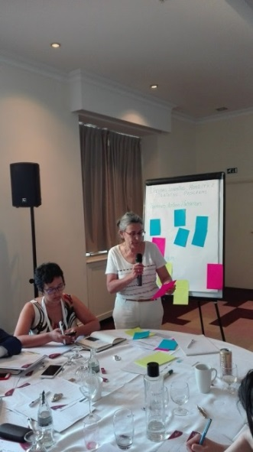
- Develop and promote flexible pathways for learning and careers and to define common parameters and standards between sub sectors (skills and competences)
- Need for trainings for Trainers and Career advisers
- Promote vocational education as a valuable career path
- Need for recognition and validation of skills
- Promote skills passport to facilitate mobility
- Pan-European certification that allows mobility (the Expert group may have limited input here as recognition of certification is within national competence)
- There is a need for common qualifications across countries and sectors to regulate jobs/careers (for instance, in the cruise boating sector - 7 Mio boats - no common qualifications exist)
- Look into the possibilities of labour mobility between sectors and among Member States
- Format of trainings available should take into account specific needs of SMEs, such as less time and money available
- Support the acquisition of foreign language (basic language and specific sector vocabulary)
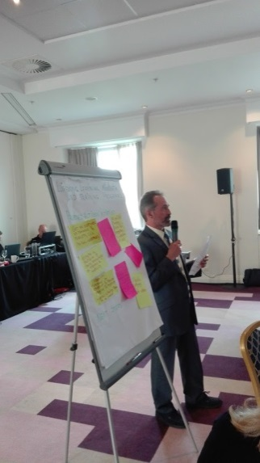
- Create an environment/context involving different types of actors to teach new skills
- Promote peer education (experienced workers to train young people)
- Create international marine camps (for 14-16 and 10-12 years old) (to clarify the purpose)
- Organise a road show through MS for parents/kids/teachers (to stimulate kids and families to choose a maritime learning pathway?)
- Mix national and European mobility (To clarify)
- Review existing funding opportunities in order to develop and provide training and learning mobility (in blue economy areas where there is a need)
- Get an overview of existing training and mobility knowledge sharing platforms (consequently agree on using an existing or creating a new platform)

Industry-education cooperation

Improving industry-education cooperation
- Support more social dialogue with industry, workers and education to cooperate in VET training
- Promote at national/regional level the establishment of cross-sectoral local institutions that will facilitate and engage in industry-academia cooperation on education/training/research/ innovation

Education-training initiatives:
- Consider the combination of skills for some areas (cruise: maritime vs hospitality skills)
- Promote co-operative private secondary schools (shipping, local maritime communities, maritime institutes)- all curriculum adopted to marine/maritime subject areas
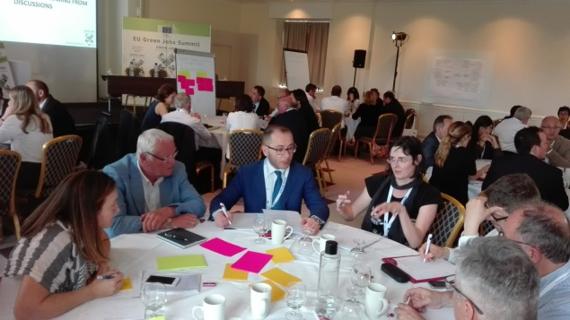
- Train the trainers (to be up to date on recent developments. The option when old seafarers teach what they have done in past 20 years is not valid)
- Tutors from (good) companies for students and in the schools – funding is needed, otherwise industry will lack incentives
- Industry invites students to companies
- Traineeships in companies – going to companies and back for education and training (partnership agreements?). 6 months traineeships are good but not enough
- Industry PHDs – ½ time in industry and ½ time studying
- Coordinated platform/service for internships. Industry clusters may facilitate the exchanges
- Applied masters – SMEs quite active already – at the end, companies should offer a job (possibly via paid apprenticeships or internships)
- Need for proper career guidance to avoid wrong choices by students and to be aware on the mobility options at different stages of career. Maritime training platform?
- Promote innovation in the industry to raise attractiveness and competitiveness

Identification of needs and challenges
- Identify industry needs for the next 5-10 years
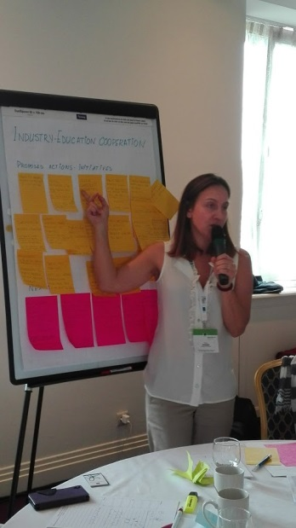
- Create a long-term regional strategy for education and training according to needs, with focus on SMEs;
- Digitalisation is key area, but also robotisation, big data. To address both technical and non-technical skills
- Pool companies together- identify needs- train and retrain staff (including unemployed people)
- Define which levels of education and training (incl. vocational) to address, based on agreed definitions of sectors (shipping, ocean energy…)
- Involve competent authorities on how to address the challenge of complying to current regulations while training for future
- Find win-win collaboration ways between industry and education
- How to support and facilitate labour mobility between sectors of the Blue economy and member states?
- Gather more sectorial data on employment trends to match CVs and to align educational systems

Qualifications and certification (Member States competence)
- Common qualifications framework for the Blue economy – identify common ground and cross-cutting aspects
- Common certification (e.g. leisure boat industry is growing, but no certification)
- Lack of recognition of qualifications in the pleasure boating sector – to develop European Common Core qualifications for professional skippers

Next steps in industry education cooperation
- Liaise with members of the expert group (industry/academia/society) to pitch for the blue career call
- Collect evidence to define problems
- Check and evaluate available best practices, tools …
- Identify key stakeholders and right levels (industry, companies, associations, platforms, networks etc.)
- Regroup the initiatives for business-education cooperation as a key for lifelong learning and mobility

Ocean literacy and awareness raising of Blue Careers

Education
- Start ocean-related education in primary schools (long term approach)
- Introduce ocean literacy and awareness rising on Blue economy jobs into the school curriculum
- Incorporate Ocean literacy into the formal education programs, e.g. of engineers
- Make blue economy jobs more attractive by linking them to new technologies, robotics, ICT, autonomy systems
- Organise school trips to seaside (Classe de mer), engage school in cleaning, environmental projects
- But also: bring marine environment/topics to schools and hinterland….
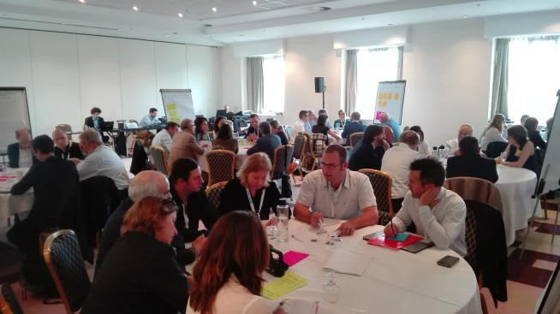
- Blue skills ambassadors in schools (UK, Canada)
- Develop virtual augmented reality tools (attractive to public/kids)
- Board games on shipping (DK)
- Adopt-a-ship initiative (classrooms on ships)
- Training vessels – to use Navy/Coast Guard vessels
- Educational trailer (to tour schools for hands on experience of kids)
- Guidance systems for career (changes)
- Use digital learning and open source resources
- Marine parks and aquariums – easily accessible to public/kids
- "Dive into science": Workshops on beaches e.g. on ocean acidification, impacts of climate change
- "Maths on the beach": Link educational objectives (e.g. statistics) to marine environment (e.g. beach cleaning activities generating data that are processed with statistical methods)
- "green flag schools", label for schools that itegrate ocean literacy in to curriculum and school life (see Norway, or for climate action Germany)
- International master programmes

Partnerships
- Get industry involved (convince them that it is in their interests)
- Encourage industry invest in outreach (sending staff to fairs etc.)
- Get tourism industry involved; target tour guides as knowledge hubs
- Organise partnerships among schools, museum and other organisations
- Cross-generational partnerships linking up primary to tertiary education systems as well as labour market.
- Partnerships with Arts sector

Communication
- Develop database for existing projects, to map ongoing activities and facilitate exchange among experts
- Re-define key concepts of ocean literacy
- Use media and technology to reach more people, e.g. Viral YouTube videos, blogs, live broadcasting from boats, TV adds to reach many people (e.g. interviews of young people)
- Use big events to reach out public, to share, spread information
- European maritime day
- Job days
- Open days in maritime businesses e.g. ports, windfarms, shipping days
- EU blue economy week, including EU ambassadors for blue economy sectors
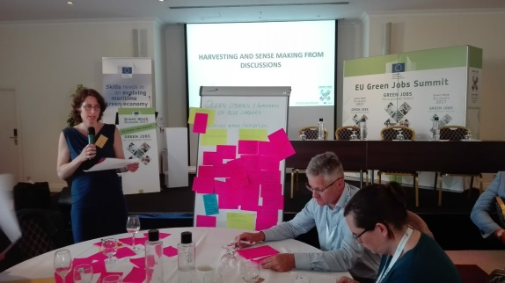
- Exhibitions such as "seaXXL"
- Marine Fairs
- Summer Marine Campus
- Develop maritime culture
- Ink the initiatives to the environment
- Do the inventory of maritime organisations (public, private) and advertise them
- Promote maritime heritage
- Involve NGOs in awareness raising (they are good)
- Reach all consumers – work with retailers
- Consider marine charities

EU added value
- Define common language vocabulary (e.g. definition of ocean literacy)
- Inform about relevant EU projects
- Map existing national initiatives
- Map available EU funding for ocean literacy and awareness rising initiatives

At the end of the exercise all experts were asked to identify their preferred topics to deal with in the next years.

Harvesting and Sense making from discussions
The facilitators from each group discussion shortly reported on the actions and initiatives proposed by experts during the group discussions. COM suggested clustering all the post-its from group discussions into the summary report of the expert group meeting

What’s next?
COM outlined that the further work of the expert group will be divided into the sub-groups. Experts were given the opportunity to choose which group(s) they are interested in (see the Annex to this report). COM to circulate the minutes by end of June.

Annex: Expert group on Blue skills 1 June 2017, Brussels
№ | Name Surname | Organisation/ Individual | Subgroups
 |  |  | Industry – education cooperation | Ocean literacy and awareness raising of blue careers | Lifelong learning, mobility and training programs
1 | Paul Gérard | Flanders' Maritime Cluster | x
2 | Tim Deprez | Ghent University (applied as individual) | x |  | x
3 | Blagovest Belev | Marine Cluster Bulgaria | x |  | x
4 | Boyko Doychinov | Regional Cluster "North-East" |  | x | x
5 | Zacharias Siokouros | Maritime Institute of Eastern Mediterranean | x
6 | Jan Boyesen | Maritime Development Center of Europe (applied as individual) |  | x | x
7 | Michael John | European Boating Industry |  |  | x
8 | David Appleton | European Transport Workers Federation (ETF) | x | x
9 | Damien Perisse | Conference of Peripheral Maritime Regions of Europe | x |  | x
10 | Sarai Blanc | SEA Europe |  | x | x
11 | Claudia Vella-Casagrande | European Community Shipowners' Association (ECSA) | x | x | x
12 | Athanasios Pallis  Aimilia Papachristou | MedCruise | x |  | x
13 | Phil Monbet | Pole Mer Bretagne Atlantique | x | x
14 | Claire Caralp | Aquimer | x |  | x
15 | Vincent Lequenne | Lycée Professionnel Maritime et Aquacole Daniel Rigolet |  | x | x
16 | François Arbellot-Repair | applied as individual |  | x | x
17 | Angela Schultz-Zehden | Submariner Network for Blue Growth EEIG | x | x
18 | Thomas Pawlik  Willi Wittig (Substitute) | Centre of Maritime Studies, Hochschule Bremen City University of Applied Sciences |  | x | x
19 | Avan Antia | KDM German Marine Research Consortium |  | x
20 | Thomas Rasmussen | University of Applied Sciences Stralsund (applied as individual) |  | x
21 | Christina Kontaxi | Mediterranean SOS Network (MedSOS) | x | x
22 | Margaret Eleftheriou | Hellenic Centre for Marine Research (applied as individual) |  | x | x
23 | Pierre Erwes | BioMarine International Clusters Association | x | x
24 | Manuel Michael Ekow | World Maritime University
25 | Pauhla McGrane | Strategic Marine Alliance for Research |  | x | x
26 | Paola Gualeni | Maritime Technology Cluster FVG | x |  | x
27 | Stefano Spennati | Conftrasporto-Confcommercio Imprese per l'Italia | x |  | x
28 | Mascha Stroobant | Distretto Ligure delle Tecnologie Marine (DLTM) | x |  | x
29 | Jaap Gebraad | Stichting STC-Group | x |  | x
30 | Westerberg Tine Viveka | University College of Southeast Norway (applied as individual) | x | x
31 | Halvor Mortensen | Val Videregående Skole AS | x |  | x
32 | Pawel Szymanski | Gdansk University of Technology, Faculty of Ocean Engineering and Ship Technology | x |  | x
33 | Rui Azevedo | Fórum Oceano - Associação da Economia do Mar |  |  | x
34 | Angelandrov Alma Elena | Manager of Alma Tours travel agency (applied as individual) | x |  | x
35 | Lucía Fraga Lago | Centro Tecnológico del Mar (applied as individual) | x | x
36 | Francisco Caparros Alcaraz | Servei d'Ocupació de les Illes Balears SOIB |  |  | x
36 | Fidel Echevarria | University of Cadiz Department of Biology |  | x | x
38 | Jenkinson Ian | John Moores University + Mersey Maritime | x | x
39 | Iain Shepherd | Marine South East |  | x | x
40 | John Bostock | European Aquaculture Technology and Innovation Platform (EATIP) | x |  | x
Total (Nr of experts) |  |  | 24 | 21 | 26

