Content
- Create Event
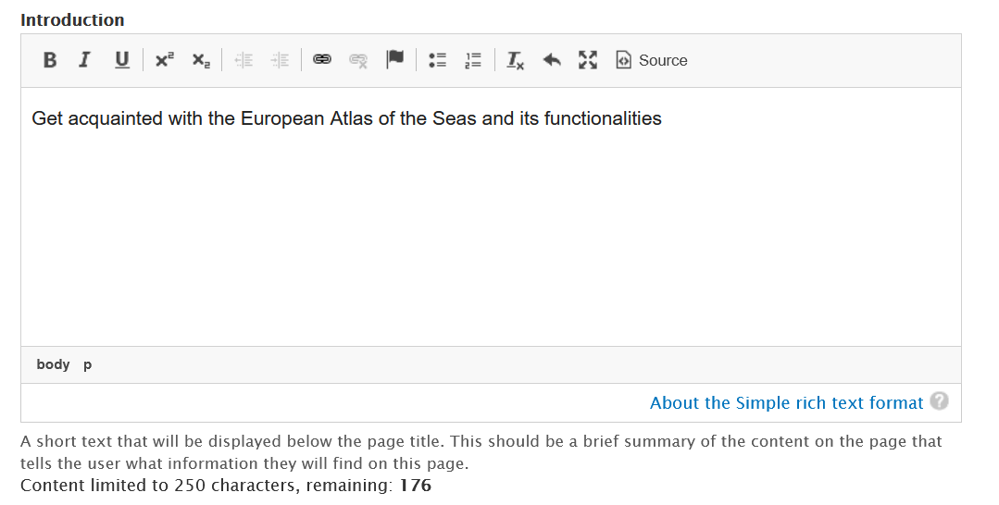
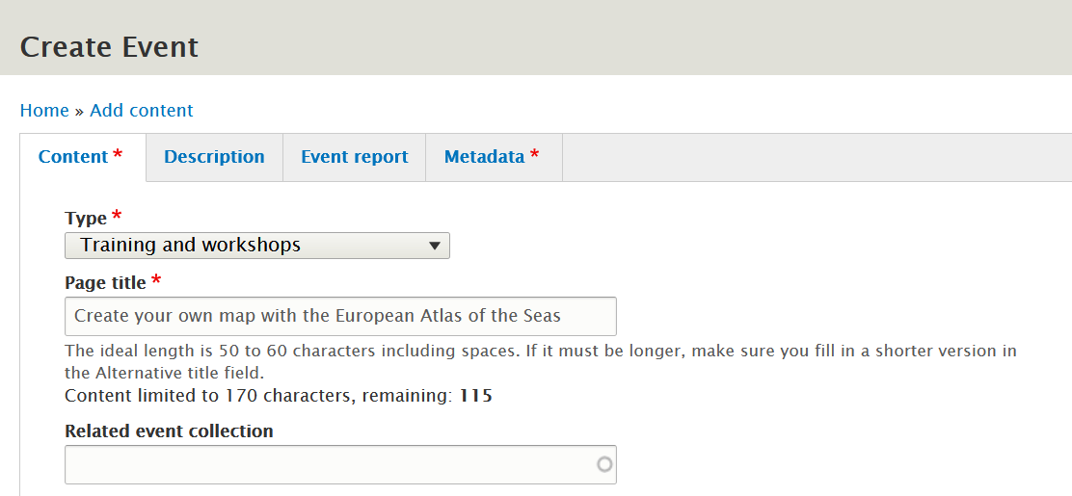

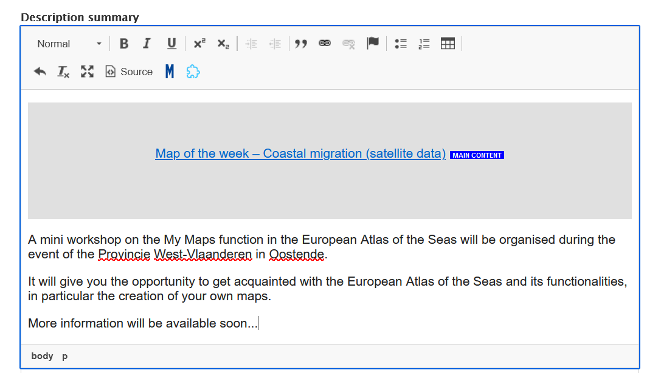
Insert Integrated Maritime Policy in the subject field
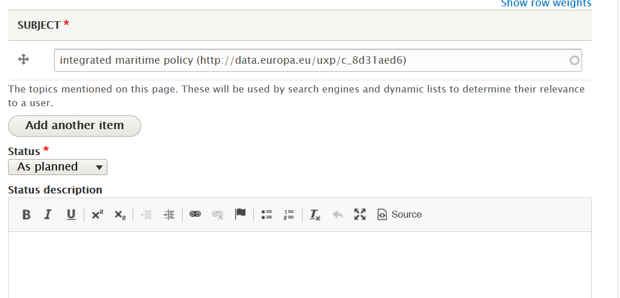
Complete event start and end date
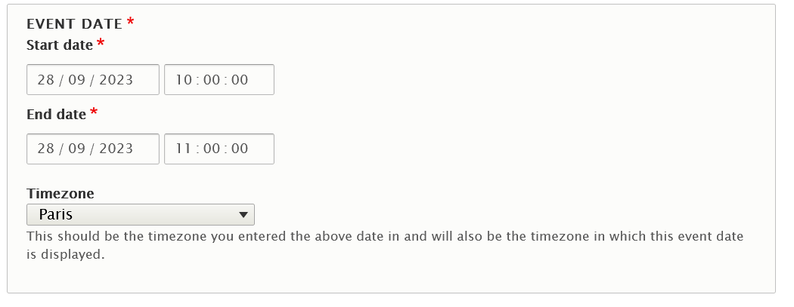
You can use other fields to enter e.g. the organiser’s website link
Complete alternative title and teasers
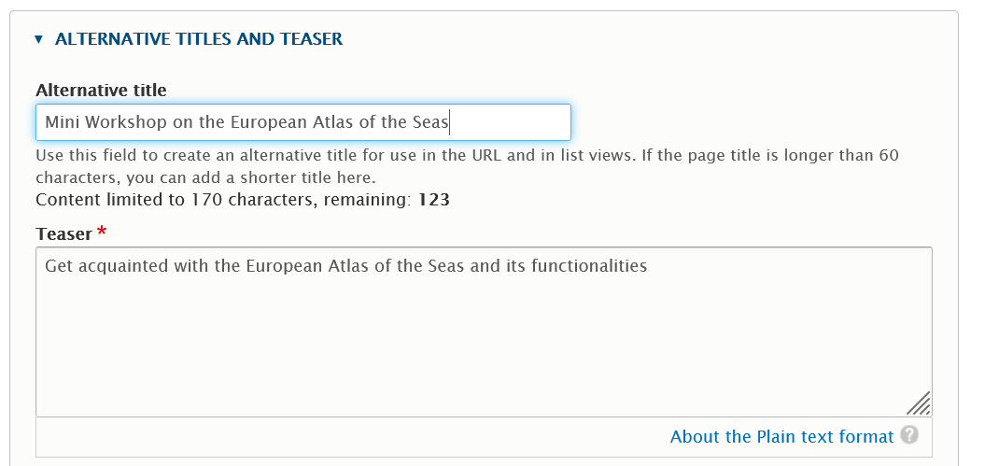

In the Metadata tab, you still have to add your community as theme and complete the responsible department
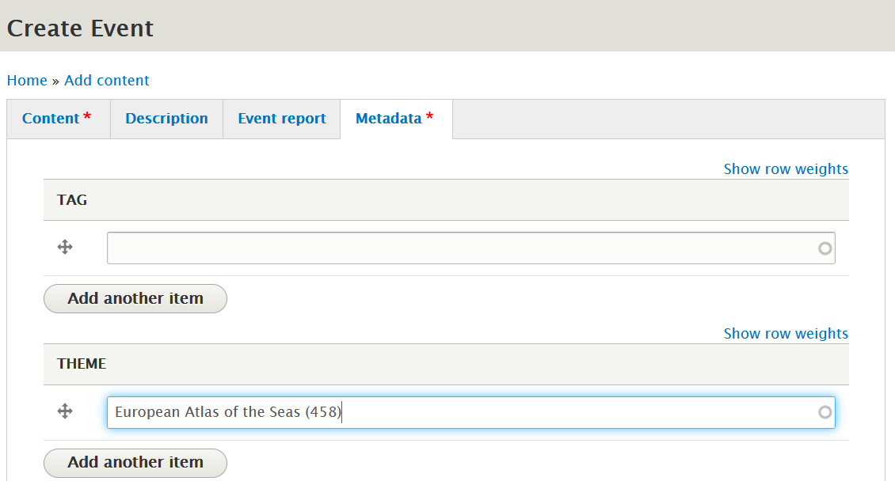
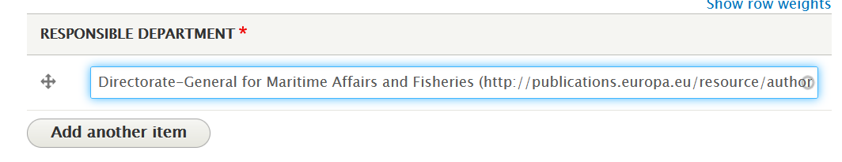
Click on Save.
Change the moderation state to publish your event and click on Apply.
