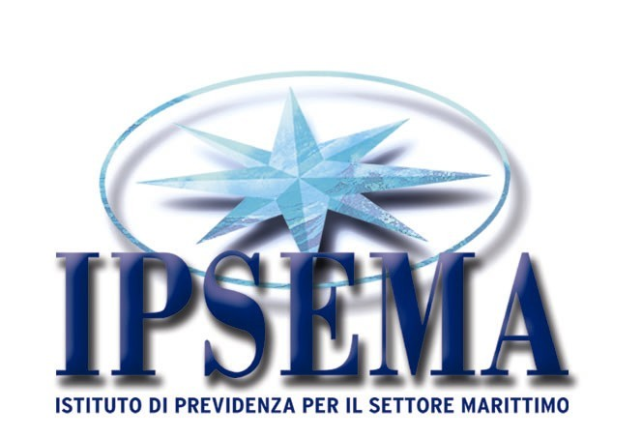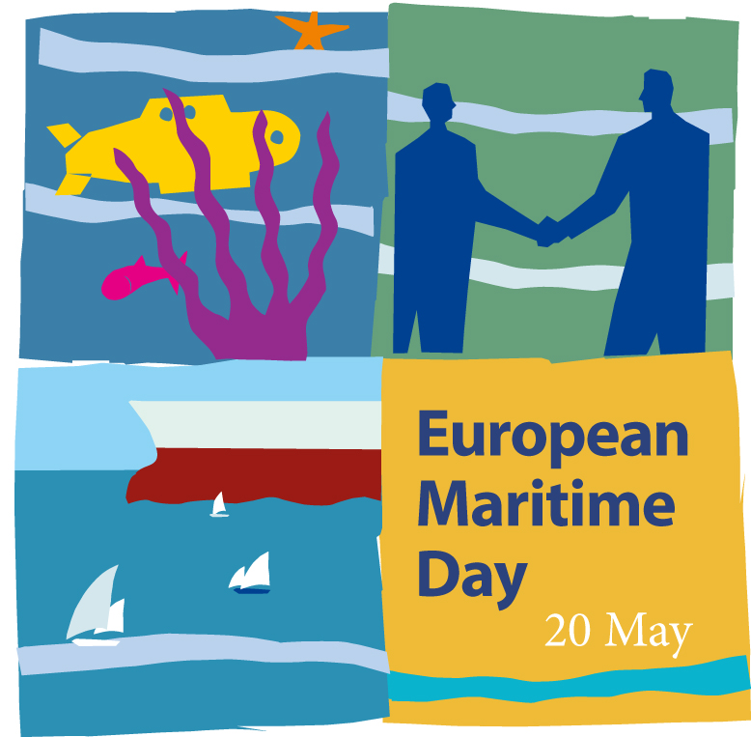

EUROPEAN MARITIME DAY 2010
MARITIME EVENTS ACROSS EUROPE

“The values of the sea”
Exhibition to spread the sea culture

Rome, 20-26 May 2010
Via San Nicola da Tolentino, 5
IPSEMA - Istituto di Previdenza per il Settore Marittimo

Naples 30 September – 5 October 2010
Via San Nicola alla Dogana, 9
IPSEMA - Istituto di Previdenza per il Settore Marittimo

Programme

This exhibition aims at increasing students’ knowledge on maritime jobs, in order to increase their interest in the maritime sector. Beyond presenting employment and career opportunities in the maritime sector, the exhibition will be an opportunity to discover all aspects of the culture related to the sea. It will display images, photographs related to the sea. Books from our sea library will also be available for reading. There will be a section will present the symbols of the sea (the rudder, the compass, the rope, the anchor, the model of a ship). There will be video shows, slides, multimedia, interactive games for kids (navigation simulator, guess the winds game, how to follow a route). There will be space devoted to illustrate curiosities from the sea: discoveries of seabed treasuries and archaeological sites.
The tour lasts an hour and fifteen minutes. There will be 4 entries per day, from 9.00 to 13.30. Each round will have a maximum capacity of 25 people. Admission free. Reservations required.

Rome, 20/21/24/25/26 May 2010

Naples, 30 September 1/4/5 October 2010
Available Times :

9.00 - 10.15
10.30 - 11.45
12.00 - 13.15
13.30 - 14.45

For further informations:

Dott.ssa Claudia Iosca
Tel. +39/0647877341 ciosca@ipsema.gov.it
Dott.ssa Fausta Savone
Tel. +39/06/47877238 fsavone@ipsema.gov.it

Ipsema – Direzione Generale
Via San Nicola da Tolentino, n. 5
00187 Rome Italy
www.ipsema.gov.it

------------------------------------------------

Edited by 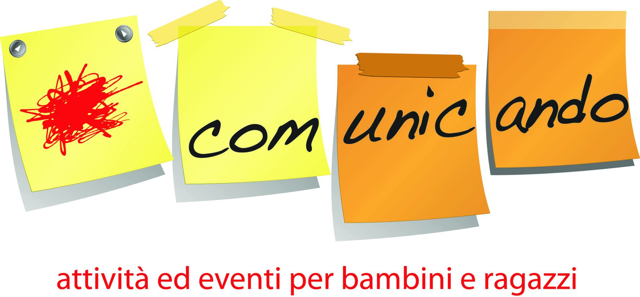

Comunicando, Associazione Culturale
Ufficio Scuola: Silvana Piscitelli
Tel e Fax: 0812405006 –3404602727 e-mail: comunicando@comunicanetwork.it

