EU4Algae PROJECT
European algae stakeholder’s forum and bringing more algae species to the EU market

MINUTES OF MEETING
Working Group 6

Date: 26 March 2023
Host Partner: EABA – WG6
Venue: Online

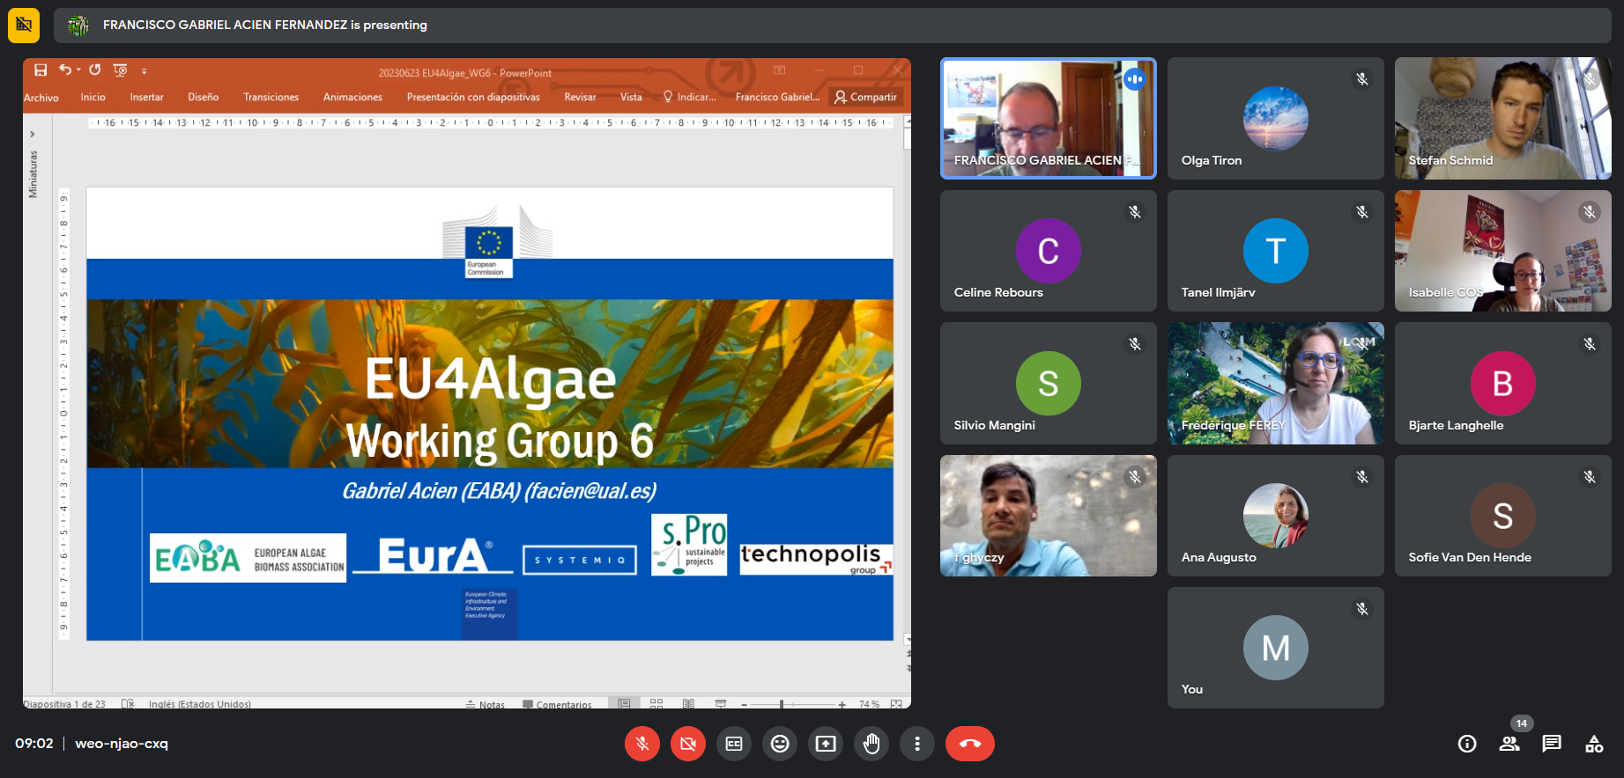

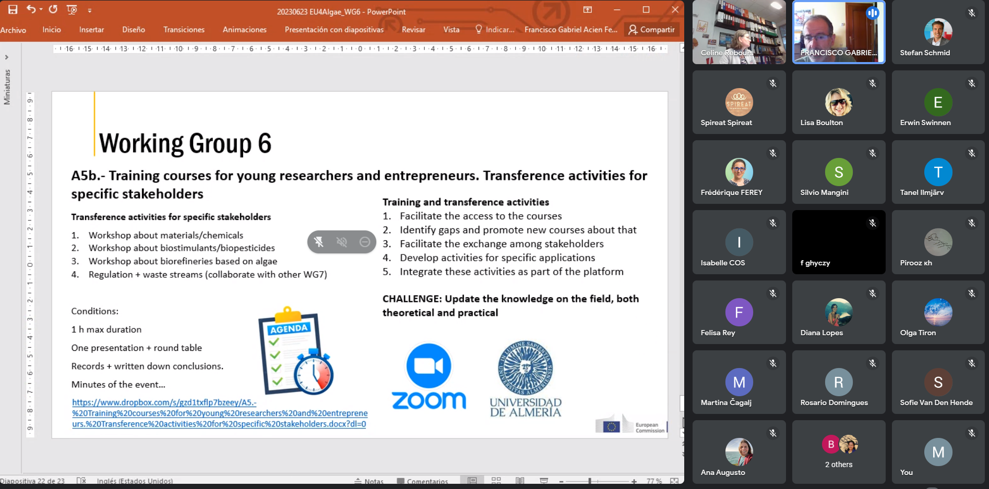
Minutes of Meeting
Meeting Title: | WG-6 meeting | Meeting Date/Time: | 23-06-23 / 9 PM CET
Meeting Type: | Progress meeting | Meeting Location: | ONLINE
Coordinator | Gabriel ACIEN (EABA) | Number of attendees | 23

Meeting Agenda
Review planning activities
Updates on activities
Take decision planned activities

Meeting Summary
4 Major constraints => lack of communication + necessity to obtain eductaion…=> 6 Major actions
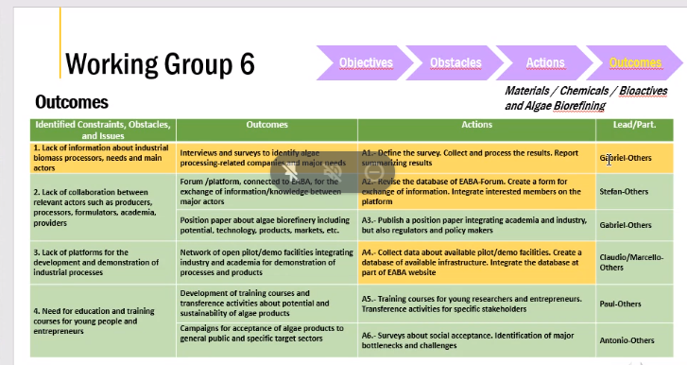
1/ Prepare dossier for amendment of current regulation avoiding the use of cyanobacteria in agriculture => collect documents and proof on a survey platform + meta-analysis of publications => publish a position paper on this then apply the amendment. Ewin Swinnen can share project outcomes => government project in Flanders called VIGOROUS. It is registred at the FRIS web portal, a website from the Flemish government in Belgium listing all research projects: https://researchportal.be/nl/project/vitale-gewasgroei-door-gebruik-van-biostimulanten-op-basis-van-microalgen-0 . The description is in Dutch however. You can find the link to our university page, giving a short English description: https://radius.thomasmore.be/sbo-vigorous.html
2/ Preparation of a toolkit for simulation of algae production. Application mapping based on modeling => connection with WG2. Only outside production / on-land (Light and temperature parameters) => available to all in 2-3 weeks on EABA website
3/ A.1. Define survey…link to complet
4/ A.2 -Data base on companies working on non-food-feed applications => platform directly connected to Maritime forum. What is needed is help to increase more fields (production capacity…etc), no economic data…etc. Can members send a proposal on list of realistic fields. Stefan Schmid can help to draft a first version. We need fixed fields (number and type) to harmonize between companies but leave an open space for free text. => tool for connecting people (suppliers / buyers). Lisa Boulton provides a link to help builing the tool : https://phyconomy.net/database/ - highly recommend the range of fields and filtering functionality. It was created by Steven Hermans.
5/ A.3 -Position paper on Use of algae in the blue bioeconomy. Need 5-6 contributors / deadline December 2023. Draft available => close list of Authors. Celine Rebours shares her recent paper on Algae blue bioeconomy which can be useful https://www.sciencedirect.com/science/article/pii/S0167779923001580#ab0005
6/ A.4 -Collection of data about pilot / demo facilities (infrastructure level)=> reduce gap between research and market. Need to define the final fields to be included. Database will be part of the EABA website. Celine Rebours provides a similar work done in Norway => https://link.springer.com/article/10.1007/s10811-021-02525-w
7/ A.5 -Education. Provide courses for young research and entrepreneurs. You can include information on survey link. a/ Development of a MOOC => send interest (20 videos in total) to Gabriel. b/ Webinars = 1 speaker 15-20min on a specific topic and question. Need to define subject and dates. All webinars shall be recorded and open access from webpage. University of Almeria shall provide the infrastructure for implementing both actions.
8/ A.6 -Survey about acceptance. 2 Surveys to be implemented : 1 for non algae industrial sectors 1 for general public. Need to define the fields, a first draft exists (with Antonio) but needs to be improved. Care should be given to confidentiality (company info).

Conclusions / decisions
- No disapproval on ongoing actions
- Please bring feedback on all items to Gabriel and keep Felix and Monique in copy
Gabriel : facien@ual.es
Felix : felix@ghyczy.nl
Monique : monique.ras@eaba-association.org

