GMES Fast Track
Marine Core Service

Strategic Implementation Plan*
2010 update Version, 16/04/2010

Author:
Hans Dahlin, Chairman
of the Marine Core Service Implementation Group

* DISCLAIMER : this is a working paper of the Implementation Group on GMES “Land Monitoring”. It does NOT represent the opinion of the European Commission
Outlines
The objective of the Global Monitoring for Environment and Security (GMES) is to provide, on a sustained basis, reliable and timely services related to environmental and security issues in support of public policy makers’ needs. GMES is an EU-led initiative, in which ESA implements the space component and the Commission manages actions for identifying and developing services, relying on both in-situ and space-borne remote sensing data. GMES will use, to the maximum extent possible, existing capacities in Member States or at European level.
The implementation is starting with three “Fast Track” Services (FTS) addressing Land Monitoring, Marine Monitoring and Emergency Response.
As announced in the Commission Communication in November 2005, the choice of these FTS has been driven by (i) their technical maturity, (ii) their uptake by the user communities (relevance for policy making and policy implementation); and (iii) existing conditions for long-term sustainability of demand and supply.
After user consultation workshops organised in 2005, three Implementation Groups (IG), composed with representatives of the various user communities, were set up for these three FTS in 2006.
In accordance with its terms of reference, each IG analyzed the main issues related to FTS implementation, including the scope of the service and its potential evolution, its functionality and architecture, its main structure and governance principles, as well as its requirements regarding observation infrastructure and data needs, data integration and information management issues.
The IG capitalised on previous and ongoing research activities financed under EC (FP6) and ESA schemes (GMES Service Element (GSE)).
The main outcomes of the IG analysis have been gathered in the enclosed Implementation Reports, which provide recommendations regarding the main FTS implementation issues based on the initial scope of the service (or “fast-track”) as well as its evolution.
Special attention has been given to the functions and structuring of the FTS at European level. More specifically, the GMES services are structured around ‘Core’ and ‘Downstream’ service layers. ‘Core services’ are pan-European in scope and generic in nature. More specialised
‘downstream services’ to meet the needs of a range of different users (e.g. national, regional or local) can be derived from them by further value-adding and customisation.
As a user-driven initiative, GMES should ensure a continuous user uptake through constant consultation with users and integration of their changing needs in an iterative process.
In the short term, the analysis included in IG reports will be used as a basis for current R&D and demonstration activities, in particular those that will be funded within the Space Theme of FP7. In the long-term, these reports will be fine-tuned through further interaction with user communities and consultation process and could contribute to the design of the overall GMES structure and governance.
Revised version following the comments from the GAC Delegations 1
Contents
1.1 The plan 1
1.2 GMES 1
1.3 Core Services 1
1.4 Downstream Sector 1
1.5 Marine Core Service 2
2.1 Purpose 5
2.2 The nature of the MCS 6
2.3 The requirements for delivering a marine core service 8
The operational objective of the 8
2.3.1 Computer models 8
2.3.2 Computing facilities 8
2.3.3 Observations 9
2.4 Resolution of marine core service 9
2.5 Marine Core Service Functionality 11
2.6 Relationships with upstream providers, intermediate users and end users 12
2.6.1 Upstream providers 12
2.6.2 intermediate users 12
2.7 Simulations – how to respond to ‘What if?’ questions 13
3.1 The proposed strategy and its application 14
3.1.1 Domains and Scale 14
3.1.2 Prototype Architecture 16
3.1.3 Data collection, assembly and quality control 19
3.1.4 Ocean modelling and data assimilation 21
3.1.5 Raw data Erreur ! Signet non défini.
3.1.6 Service generation, access, delivery and support 22
3.1.7 Standards 25
3.2 Data Policy 26
3.3 Funding 27
3.3.1 Marine core service 27
3.3.2 Downstream Services 28
4.1 The space infrastructure 30
4.1.1 The required space infrastructure 30
4.1.2 Data products from Sentinel-3 sensors 32
4.1.3 Data products from Sentinel-1 SAR 33
4.2 The in situ infrastructure 34
4.3 The Meteorological Forcing 37
5.1 EU procurement 38
5.1.1 Procurement or Grant 38
5.1.2 Direct or devolved management 38
5.2 Consortium Structure 39
5.3 Interactions with downstream services 40
5.4 Criteria for selecting operators and modification of the partnership 40
5.5 Conflicts of interest 41
6.1 In support of (the assumed) implementation of the Marine Environmental Strategy Directive and other environmental protection policies. Erreur ! Signet non défini.
6.1.1 Service requirements Erreur ! Signet non défini.
6.1.2 Specific product requirements Erreur ! Signet non défini.
6.1.3 Observing system requirements Erreur ! Signet non défini.
6.1.4 Relevant current coordinating organisations Erreur ! Signet non défini.
6.1.5 End-to-end services Erreur ! Signet non défini.
6.2 Ice Services Erreur ! Signet non défini.
6.2.1 Context Erreur ! Signet non défini.
6.2.2 Service requirements Erreur ! Signet non défini.
6.2.3 Specific product requirements Erreur ! Signet non défini.
6.2.4 Observing system requirements Erreur ! Signet non défini.
6.2.5 Relevant current coordinating organisations – Erreur ! Signet non défini.
6.2.6 End-to-end services Erreur ! Signet non défini.
6.2.7 Benefits Erreur ! Signet non défini.
6.3 Oil spill monitoring Erreur ! Signet non défini.
6.3.1 Context Erreur ! Signet non défini.
6.3.2 Service Requirements Erreur ! Signet non défini.
6.3.3 Specific Product Requirements Erreur ! Signet non défini.
6.3.4 Observing System Requirements Erreur ! Signet non défini.
6.3.5 Relevant Current Coordinating Organisations Erreur ! Signet non défini.
6.3.6 End-to-end services Erreur ! Signet non défini.
6.3.7 Benefits Erreur ! Signet non défini.
Terms of Reference 43
Composition & working methods of the Marine Core Service Implementation Group 43
Executive Summary 45
General recommendations: 45
Specific recommendations: 45
Introduction and mandate of the WG 46
Main requirements from the MCS 46
A3.4. Review of Sentinel 3 47
Overview of ESA Sentinel 3 MRD 47
Altimetry 47
SST 48
Ocean Colour 50
Recommendations for the Jason and METOP, MSG/MTG series and for non- European missions complementary to Sentinel-3 53
Jason-3 53
Review of Sentinel 1 / SAR 54
Other European and non-European SAR missions 56
Ground Segment (to be developed later) 56
Summary of recommendations 56
References 57
Performance & deployment 63
Network design 63
Data collection & management 64
Timeliness 64
Sustainability 64
Data management 65
Quality control 66
Standardisation 66
Existing infrastructure 68
Relevant existing information services 69
Past and current R&D projects 69

Executive Summary

To be rewritten

Introduction

The plan
This plan was developed by the Marine Core Service Implementation Group during 2010. It was heavily based on the previous version of the plan which effectively defined the MyOcean pre-operational marine core service demonstration. The present plan does not differ significantly in terms of recommendations but is somewhat shorter. It can draw on operational experience from the pre-operational MyOcean project and benefit from a number of Communications from the Commission on GMES in general as well as other parallel developments in EU policy such as the Marine Strategy Framework Directive and the new marine knowledge initiative.

GMES
The marine core service is part of the Global Monitoring for Environment and Security initiative (GMES). The purpose of GMES, as defined in 2008, is to deliver services of public interest. A communication in 2009 confirmed that these services should be in the environment and security domain.
It consists of three components, space, in-situ and services. The space and in-situ components provide measurements of the planet. Planning for the space component was set out in 2009Error: Reference source not found. The services, according to the 2008 definition, are
the basis for Europe's autonomy in information provision world-wide. The scope and delivery schemes of GMES services should be designed to ensure an operational implementation based on user requirements and applicable legislation, but might have to be prioritised according to institutional and policy needs.

Core Services
Since 2008, four pre-operational GMES service demonstrations have been launched. These are:
- a land monitoring service;
- a marine service;
- an atmospheric composition monitoring service;
- an emergency response service;
Each of these "core" services should deliver a number of products that can either be observations derived directly from the space or in-situ components or analysis and forecast parameters derived from models that assimilate these observations. It is assumed that these services will be publicly funded (on national and European level) and subject to some decision-making at an EU level.

Downstream Sector
Other services, "the downstream sector", can use the products from the "core" service to create other products. These are market-driven or performed by national/regional authorities. Public entities are encouraged for any particular service – at a local, national or EU level – from the appropriate budget subject to normal cost-benefit analyses and public procurement rules to order their services from the private market. They are not subject to the centralised planning of the "core" services. However the satisfaction of those providing services in the downstream sector will be the principal factor in judging the success of the core services.
All services using products funded by a GMES programme are GMES downstream services. These inputs can be from the space, in-situ or service component. Those that process products from the marine core service are "marine core service downstream services" which are a subset of all the potential GMES downstream services.

The purpose of this document is to define the functionality and products of the marine core service, not the whole of GMES. We aim to define a core service that maximises the benefit to these downstream services. For clarity and simplicity, only services that use products generated by the marine core service will here be designated as downstream service in this document.
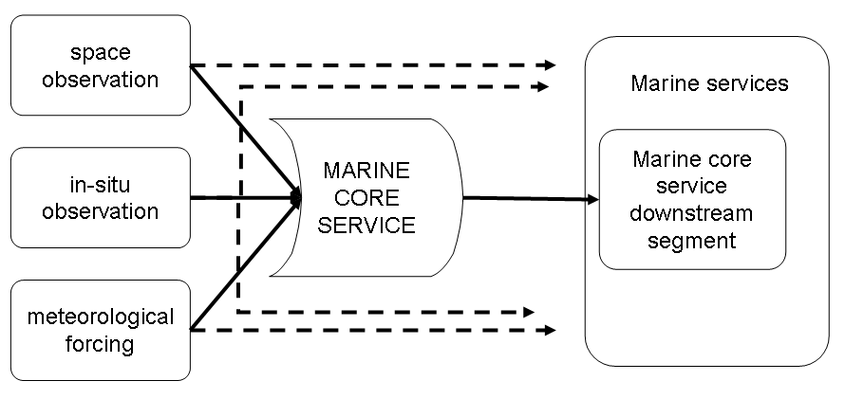
Figure 1 Marine Core Service with Downstream Segment

Marine Core Service
A Workshop which led to the acceptance of the Marine Core Service (MCS) as a GMES Fast Track was held in Brussels on October 27-28 2005.
Those present agreed that the MCS:
- will provide for existing & new downstream services;
- should deliver regular and systematic reference information (processed data, elaborated products) on the state of the oceans and regional seas:
    - at the resolution required by intermediate users & downstream service providers, of known quality and accuracy,
    - for the global and European regional seas, with downscaling capacity based on specific needs.
- products should comprise:
    - observational and model data,
    - real time data and predictions (from days to weeks) and re-analysis (longest time series of information about the ocean state in the past),
    - simulations (what-if scenarios).
In order to deliver its products, the MCS should contribute to:
- Organisation of sustainable development and operations (interoperable &coherent) of:
    - the observing systems
    - the modelling & forecasting facilities
    - the data harmonization and information for the global & regional scales, Strengthening of the connection with downstream services (e.g. marine safety,
- oil spill monitoring, harmful algae bloom monitoring, coastal management, marine resources…),
- Integration & upgrading of the capabilities of existing national services.
It was further agreed that there is a need to show that several components of the MCS are already working in Europe and to convey this message to the decision makers. In addition, it was noted that the MCS provides an effective means to utilize the significant investment of the GMES space component. In this context there was a complete understanding that the ESA-GMES Space programme is fundamental to the success of the MCS.
It was agreed that the MCS to concentrate on the global to the regional European scales (as opposed to the "non-European regional" or "European coastal"), so that the European concerted effort will be justified. MCS should then be configured as an initial European contribution to the marine segment for GEOSS.
Implementation Groups were appointed after the 2005 user workshops for each of the three GMES Fast Track Services. They largely consisted of Commission services, EU agencies, the European Space Agency, EUMETSAT, regional sea conventions and some other bodies that might provide services or products upstream or downstream of the core services. They were given the mandate of supervising and validating the implementation of these Services, in open cooperation with the relevant user communities.
The Terms of Reference, composition and working methods of the Marine Core Service Implementation Group (IG) are reproduced at Appendix 1.
The main output of the IG to date was a Strategic Implementation Plan and the supporting documents generated by working groups set up by the IG, subsequently approved, and either incorporated into or attached as appendices to the Plan. This plan was updated in 2010 as guidance for the 2012-2014 gap filling activities to move from R&D to real operational services.
The original plan was endorsed by the GMES Bureau and GMES Advisory Council. The new Plan will provide ratified guidelines and prioritisation for implementation. In the short term it is envisaged that it will guide current R&D and demonstration activities being pursued with EC and ESA funding, in particular those that will be funded within the Space Theme of FP7.
However, it is hoped that the Plan will also provide a roadmap for a long-term, sustainable Marine Core Service able to support a wide range of downstream services, some of which can be seen today but many of which will only emerge when the MCS is in place. With this in mind, an effort has been made to describe the rationale for the guidelines and priorities, not simply the proposals themselves. It is hoped that the Strategic Implementation Plan will give confidence to the EC and Member States that their expectations of GMES in the marine domain have a good chance of being fulfilled and that their continued support is warranted.
To fulfil its mandate and build upon the conclusions of the Workshop the IG has addressed a number of specific issues:
- The purpose, scope and functionality of the Marine Core Service, especially of its global and regional components
- The space infrastructure required by the Marine Core Service, including the requirement for and continuity of current European capacities (space and ground segments) operated by EUMETSAT, ESA and national agencies, and the possibilities for international cooperation (complementary or shared capacities)
- In situ infrastructure for the Marine Core Service, especially the requirement for and sustainability of European capacities and their contribution to international systems as well as the European coordination to manage these capacities
- Structure and governance of the Marine Core Service, including, for example, the sharing of activities and operational responsibilities between the service provision partners and the associated service level agreement process, defined between the GMES Management Authority, representing the MCS user communities, and, for example, a MCS Provider Consortium, including the impacts of this service level agreement on the consortium partner status and on service information policy,
- Links and interfaces between the Marine Core Service and downstream services, including the requirements of downstream services for MCS products, their dependencies in terms of product delivery (timeliness, quality control, …) and the associated contractual issues.

Add a sentence on IG meetings and their findings…

The purpose, scope and functionality of the MCS
Based on the adopted Working Group reports, other papers and discussions at the meetings of the IG, the following clarification of this issue has been obtained:

Purpose
The policy drivers have been identified as:
- Regional Conventions between Member States & the EC – OSPAR / HELCOM / Barcelona;
- 6th Environmental Action Plan; in particular its Climate Change and Marine Environmental Strategy2 components;
- The Sustainable Development imperative which is written into the Rome Treaty and is now being developed through the Green Paper on Maritime Policy3
- Relevant existing EU Directives, such as the Marine Strategy Framework Directive (MSFD) and the Water Framework Directive (WFD) in its application to coastal waters, and their monitoring and data needs.
- Specifically the Integrated Maritime Policy of the EU has defined many information needs, which the MCS is most suited to help to provide
- The EU's new initiative on marine knowledgeError: Reference source not found which proposes an overall architecture for marine data. The marine core service plays a principal role in this.
- Concerns over civil security which manifest themselves in particular for safety of life and property in the marine environment, and the recognition that whilst there are risks to be managed through well designed warning systems, defences and other preventive measures, major natural hazards and man made accidents will occur that also need to be managed. The Prestige accident in 2003 and flooding in Holland and England in 1953 and in New Orleans in 2005 are examples.
- There is also a growing requirement to prevent and police illegal activity, much of which centres on drug and human trafficking via the marine domain.
All of these require long running data sets to define the mean state of the marine environment, fluctuations about that, past trends and future predictions of change (particularly in areas of uncertainty about climate change) to establish baselines for environmental management including remedial measures and design criteria for structures operating in the environment. In addition short range predictions (out to several days ahead in general and with a few hours lead time with greater accuracy) are required particularly of hazardous conditions, but also for the efficient conduct of every day operations.
The marine core service must be designed and implemented to meet these needs in a reliable, easy to use, operational manner, with information of useful precision and stability.
GMES is also intended to contribute to the Lisbon Agenda. The programme was included in the Quick Start Programme and expected to foster the creation of new, innovative information based services and knowledge. As such it contributes to the goals of EU 2020

The nature of the MCS
The information services required to fulfil this purpose need to have global and pan- European scope. However the range and variability of these variables will be strongly domain- specific; i.e. likely to vary between the regional seas and global oceans & between high and mid latitudes.
The MCS is conceived as one part of a processing chain which operates on observational and other forms of data to help create tailored information services to meet a wide range of end user needs. Almost all such end user services relating to the marine environment require access to information about the state and dynamics of the oceans and seas. The MCS provides that information to intermediate users who combine this with other forms of information and data to provide customised downstream services for end users. The concept is illustrated in Figure 2and further elaborated in section 2.6 below.
Figure 2 Service delivery chain
Figure 2 illustrates the position of the MCS in the overall chain of service delivery from GMES input data to the provision of multiple information services to end users.
The implementation of the overall chain needs to have some flexibility. As components of downstream services are developed to serve multiple uses, it may be more efficient for them to be provided as part of the MCS.
The envisaged MCS variables & products are described in Appendix 2. A sample of applications /areas of benefit that these are capable of serving are indicated in Table 1.

Table 1 Examples of areas of benefit, product lines, intermediate and final users
Area of benefit | Products | Requirement for recent information | To intermediate users | Final application and user
Emergency management | High resolution ice/sea state & ocean current forecasts | Hours | national meteorological services, national Oceanographic Agencies, National Maritime safety agencies, coastguards, maritime transport industry | Search and rescue, drifting object management; extreme wave forecast preparation; marine transportation
Shipping & offshore operations | High resolution ice/sea- state & current forecasts for operations: reanalyses for design | Hours | Value adding service companies | Operation support, ship routing, structure design criteria, risk assessment; EMSA
Oil Spill management- | Temperature, drift forecasting and backtracking | Hours | Responsible National marine agencies & European Marine Safety Agency (EMSA) | Affected coastal public authorities &  businesses
Coastal protection | Boundary and initial conditions, data products | Hours | National Coastal monitoring and forecasting system | National environmental or marine agencies; National WFD reporting; Coastal management.
Civil Security | Temperature, sea state | Hours | Customs & Excise, Coast Guards | Immigration and drug control agencies, police forces
Extended range & seasonal weather forecasts | Initial ocean conditions; reanalysis | Days | ECMWF, National Meteorological Services (NMS) | Agriculture, insurance, energy, transport; public safety preparedness; research
Marine Management | Environmental state data for production of indicators | Months | EEA, OSPAR, HELCOM, Barcelona, National environmental agencies; | DG ENV, Policy makers at all levels, EPAs, NGOs, general public
fisheries management | Physical conditions; re- analysis of past conditions | Year | National marine and fisheries institutes | ICES, National fisheries agencies, research
Climate research | Comprehensive and inferred observational data sets reanalysed in state of the art models | Year | Climate research centres | Ocean and climate research; validation of scenarios.  Policy making on climate change
Table 1: A generic summary of areas of benefit, product lines, intermediate and final users

The requirements for delivering a marine core service
The operational objective of the marine core service is to describe
- properties of the surface layer of the ocean for those parameters that can be measured directly or indirectly eg surface temperature, ice cover etc (refer to table on p. 44, spelling out geophysical, biophysical and biogeochemical variables to be included)
- the physical state and dynamics of the oceans and seas from the surface to the sea floor or a depth for which necessary observation information is available.
This requires computer models, computing facilities and observations.

Computer models
Time-dependent circulation models of the oceans and seas are crucial for maximising the value of intermittent sparse data to deliver the best possible descriptions of their past, current and future state. Physical models are well developed and available with increasing resolution for the global oceans and regional seas. Methods for nesting limited area, higher resolution models within global and regional models are available too.
Models of biological and chemical processes in the seas that are capable of providing useful analyses and predictions of at least the lower trophic levels of ecosystems remain currently in the research domain, but must be further developed to meet the existing need to clarify environmental status of the seas. The GMES Marine Core Service has an important contribution to make in this regard which is currently insufficiently realised. Further research efforts should be undertaken to demonstrate feasilbility.

Computing facilities
Substantial powerful computing facilities, housed and operated to achieve 24- hour/7-day-a-week/every day of the year availability are essential to deliver truly operational services and such facilities are required to conduct development of ecosystem models for future operational use. These exist in the National Meteorological Services, National Oceanographic Agencies or major research facilities that have a mandate to provide operational services. Computing power is decreasing in cost, but equally the need to resolve phenomena in finer resolution is demanding steadily more.
Currently computer power is limiting performance of the models – particularly the global ones. Decreasing the grid spacing in the horizontal by a factor of two in both directions would also require halving the timestep. So that means a factor of 8 more computing. Vertical grid spacing might then be reduced by the same factor. So the cost goes up by factor between 8 and 16 on halving the grid spacing. Faster computing could therefore lead to finer discretisation although it is not clear if this would led to higher accuracy.

Observations

Physical parameters
Ocean circulation models require representative data to describe:
- the main dynamical and physical characteristics frequently enough to span the period of useful predictability of current numerical models (a few weeks);
- the forcing from the atmosphere;
- (for some purposes and locations) the extent and nature of ice cover and the flux of fresh water from the major rivers;
The nature of the bottom topography is clearly important but that is sufficiently well known, for the global and regional scales considered within the scope of the marine core service.

Chemical and biological parameters
Satellite observations generally have the spatial and temporal coverage required but, of course, only monitor the surface layers of the sea. Some limited properties, e.g. primary productivity and sediment levels, can be inferred from ocean colour measurements. The presence of some pollutants, in particular oil spills and excessive nutrients, leading to extensive algal blooms at the ocean surface, can be inferred from EO data too. But there is no doubt that additional in situ data are needed to define the biological and chemical state more comprehensively especially to estimate information in deeper layers.
Some in situ measurements are available from research vessels to characterize the biological and chemical state of the seas but these are often sparse in time and space and tend to be concentrated in coastal waters. They are rarely available in near real time but they do allow identification of long period trends at (hopefully) representative locations.

Adequacy of monitoring network
Initial experience from projects such as MERSEA and MyOcean indicates that the monitoring network does allow the preparation of products. It has not yet been established whether the accuracy or precision of these products would improve with a denser observation network.
To some extent results from the ongoing MyOcean project should answer this question. Furthermore certain current projects under the European Marine Observation and Data Network are also aiming to assess the adequacy of the current monitoring network. The marine knowledge communicationError: Reference source not found indicates that the Commission will make an assessment in 2012-2013 as to the needs for further observations in the marine domain.

Resolution of marine core service
With these caveats, and the hope that continuity of EO data can be maintained and in situ monitoring improved, it is clear that an MCS that can fulfil its purpose, given the availability of the necessary computing, data collection and processing facilities and skilled staff to operate them.
The descriptions above provide necessary but insufficient criteria to define the scope of a practical, deliverable MCS. It is also necessary to place some limits on the area extent and resolution of common services to be provided as part of the MCS and those which will be more properly and efficiently provided as downstream services – see below.
There are strong arguments for recognizing the particular characteristics and needs for marine core service products on a global scale, for the oceans which border Europe and their shelf and regional seas.
But are the needs for descriptions of the physical, biological and chemical state of every estuary or coastal zone to be met by the MCS? Are high resolution models of every EEZ to be maintained and operated when needed to predict the evolution of major accidental releases of pollutants as part of the MCS? It is currently not technically or financially feasible to provide this for the whole of the European shelf and it remains a national responsibility.
In certain coastal areas, a local risk assessment will indicate that this is cost-effective. In others it will not. It is also important to link these models to the land interface and river networks, which make local case-by-case modelling a more realistic approach. Such efforts should take into account the needs of WFD and MSFD.
The decision as to whether to implement local solutions are national concerns which should be met by downstream services funded from local budgets, coordinated where necessary at a regional or EU level. Such services will be supported by the marine core service through the provision of broader scale state descriptions; in particular in the form the boundary and initial conditions for high resolution models of coastal or otherwise defined domains of interest.

This respects the principle of subsidiairity that "nothing should be done by a larger and more complex organization which can be done as well by a smaller and simpler organization". The architecture that is proposed in section 4, a system of systems, from global to regional, follows that tenet. The coastal domain, where the greatest diversity of end users arises, is not considered part of the MCS, since it can be served most effectively at a national and local level by downstream services.
The boundary condition provided by the marine core service will release public and private downstream service providers from the need to duplicate the services provided by the MCS and enable them to focus on the many localised, tailored services that are required by end users.
A marine core service with the same geographical scope as the MyOcean prototype is approximately the correct dimension. Any follow-ups should not aim to increase the coverage towards the coast but rather focus on measuring and improving the quality of the existing service.

Marine Core Service Functionality
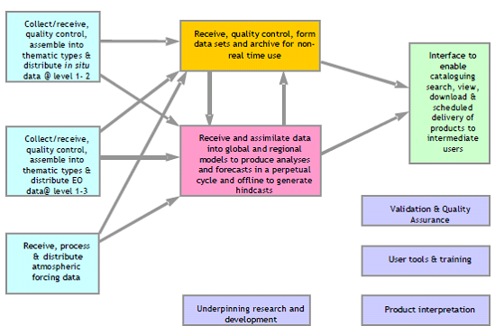
Figure 3 essential functions of an MCS

Recognizing that the MCS must collect, quality control and process data, using numerical models and standard analytical tools, to produce and deliver, hindcasts, analyses and forecasts the required operational functions of an MCS are as illustrated in Figure 2.
Briefly the functions are to:
- Acquire data from the ground segment of the space based observing systems and in situ networks. Typically these will be at level 1 or 2 (See Appendix 4).
- Acquire atmospheric forcing data (atmospheric winds, temperatures, fluxes) from NMSs and ECMWF
- Assemble these into QC thematic datasets (i.e. specific data types such as sea surface temperature, salinity profiles…) suitable for the generation of more extensive data sets for subsequent use, analytical products and assimilation by ocean models. Much of this has to be carried out in near real time
- Run numerical ocean models in near real time to assimilate the thematic data and generate analyses and forecasts from them to an agreed and generally perpetually repeating cycle, which uses information from earlier forecast cycles as well as the most recent thematic data. The centres also need to operate offline to produce reanalysis / hindcasts.
- Prepare products suitable for external service provision at the ‘Interface’ shown in Figures 1 & 2. Products include QC thematic datasets (from stage c) and results of numerical models (from stage d).
- That interface must have a discovery and viewing capabilities and the ability to download specific products in response to requests. It must also be able to deliver, probably quite large volumes of data, routinely to an agreed schedule to meet the needs of specific intermediate users.
The required support functions are elaborated further in 4.3.4; they are essentially to monitor and validate the performance of the MCS to assure the quality of its products, provide customer support in the form of interpretive tools and training, and prioritize and oversee the research and development needed to sustain the MCS.

Relationships with upstream providers, intermediate users and end users
The division into upstream and downstream components of the service chain is based on the imperative “to produce information once but use it many times” for specific public or commercial end user applications. Not all environmental information services are suitable for delivery in this way, but wherever there is a need for information about the current or predicted future state of the environment, widely defined, it makes sense to try to meet this once rather than many times. This is particularly true when, as here, substantial resources (computers and skilled people) are needed to assemble basic state data, assimilate them and use high resolution, complex models to predict future states. This lesson has been learned and applied extensively in operational meteorology and recent research has demonstrated that it is equally applicable to operational oceanography. Figure 2 exemplifies the chosen architecture of the chain.

Upstream providers
Upstream providers supply the input that the marine core service uses to create crosscutting/core products that are the basis for intermediate users/downstream services as described above. Certain intermediate users may use information directly from the upstream providers without going through the marine core service but this is not the concern of this paper.
The upstream providers can be divided into a satellite earth observation (sometimes called "space" component, an atmospheric forcing component and an "in-situ" component. These components are described in chapter 4 and in the associated appendices. However in simple terms it is expected that these upstream providers will:
- develop, construct and operate the space and ground based facilities necessary to deliver the required data; in fulfilling the delivery function, they will calibrate instrument measurements and convert them to geo-located estimates of geophysical, chemical or biological variables (i.e. generate level 2 data sets)
- in some areas produce coherent, quality controlled data sets, possibly from multiple sources (i.e. generate level 3 products).

Intermediate users and end users
Intermediate users are recipients of the data and products generated by the marine core servivce from the combined use of atmospheric forcing information and basic in situ and satellite earth observation data, models and data assimilation. Typically they will generate information services to real end users that
- downscale the larger scale marine core service products to the local scale and increase the number of analysed, predicted state variables at the local level
- integrate marine core service products with other information Typically such additional data might be high resolution meteorological forcing in delivering storm surge predictions, socio-economic in a policy development context, human activity (e.g. catch and fisheries effort data or turism)
to provide useful downstream services that fit with the general GMES philosophy (see section 1.4 "Downstream Sector".
Ultimately the public will validate, or not, the benefit of GMES. But, as characterised in Table 1 above, in general end users can be categorised as:
- governmental departments/agencies, at EU or Member State level, that require marine products and information for developing and validating policies respectively (e.g European Commission Directorates General, National Departments of Environment, EPAs.);
- “public downstream services” that actually implement public policies, and are frequently part of the mandate of European or national agencies (e.g. flood risk managers, environmental protection agencies, immigration and drug control agencies, police forces);
- providers of maritime services of various kinds, (e.g. shipping, port operations, coast guards,.. )
- commercial and industrial end users (e.g. offshore oil, gas and aggregate extraction companies, fishing companies, …).
- research institutes investigating the functioning of the ocean

Simulations – how to respond to ‘What if?’ questions
Much policy-making raises questions of the kind ‘What if we were to do x or y?’ as a precursor to formulating a response to an unwelcome impact of a pressure. This requirement was identified at the October 2005 workshop and the marine core service needs to respond to it.
The requirement can be met in a number of ways, but in essence, the capability is needed to run experiments in which all of the important processes affecting the outcome are mimicked and the consequences of the hypothesised action are tested. Scaled physical models can be used for this purpose to test the consequences of changing the morphology of an estuary for example, but on the scale of the oceans and seas recourse has to be made to numerical earth system models of sufficient scope to internalise all the important processes and feedbacks between them.
The models developed to assimilate data and model oceanographic processes for the marine core service are certainly capable of mimicking internal processes sufficiently well and therefore test the consequences of possible changes to inputs, e.g. of the consequences of large scale changes to nutrients from land based sources, but they are not designed for this purpose.
It would be misleading to suggest that these "what if" scenarios" can be pushed too far in the future for climate change assessments. According to Nature "there is a long way to go in the science before regional-impact studies provide a suitable basis for detailed planning". The more structured approach to satellite deployment through the space component of GMES and the insights into the in-situ monitoring network will certainly contribute towards a better understanding of regional climate change. The measurements required for climate studies of ocean circulation are almost identical to those needed for operational oceanography. And it is foreseeable becoming a primary function of the marine core service to also feed climate studies.
It will be important to develop the interface between the marine service and other GMES service, notably atmosphere and land, with regard to a GMES climate change contribution.

The Strategic Implementation Plan

The proposed strategy and its application
The requirement is to be responsive to intermediate users and, through them, to end users, who will respectively deliver and use the information generated as outlined below to inform policy making, validation and implementation in the areas outlined in paragraph 2.1. The chosen strategy to accomplish this is to build on the foundations described above by making maximum use of existing systems and past investment in knowledge and tools. The existing systems are distributed so the design of the MCS must be distributed. In effect a system of largely existing systems and those under development will be the goal.
The strategy must then be to analyse the required functionality of the component systems to establish whether and if so where they exist or might easily be upgraded to perform as required. The reports of the WGs on the space based and in situ infrastructures are used for this. Remaining gaps are identified, at least in functional terms and hopefully with some candidates to fill them. Where possible a road map for that process is suggested and priorities are established and recommendations made.
The suitability of the strategy is tested in section 6 through a small number of end to end case studies of its envisaged application.

Domains and Scale
The key step is to recognise that modelling of the marine environment can and needs to be carried out at different scales in different domains and that biological and chemical processes take place within the context of the prevailing physical environment. Ideally there are two way exchanges of properties at the boundaries, but one way exchange from the large to the small is practiced nesting finer models of limited area in global models. Models of biological and chemical processes require specification of the physical domain in which they take place hence are nested, too. These are imported from a physical model.
The actual choice of domains is determined by the combination of physical geography and user need. Thus:
- The Mediterranean, Baltic and Black Seas have their own particular physical and ecosystem characteristics largely defined by their bathymetry, fluvial inputs and limited but important exchanges with their adjoining seas.
- The Arctic Ocean is predicted to be the location of the most rapid and dramatic climate changes during the 21st century, with the potential of major ramifications for mid-latitude climate. It also plays a major role in the freshwater balance of the North Atlantic and is a very hostile environment.
- The North West shelf is one of the most challenging in the world in terms of the intensity of marine exploitation, multiplicity of industries, services and social amenities, complexity and detail of regulation, adjoining population density and industrial development. It is also subject to input from large European rivers, agricultural run off and sensitivity to climate change.
- The North Atlantic plays a major role in the global circulation and has significant effects on European weather and climate. It provides the boundary conditions directly for the North West shelf and interacts strongly with the Arctic Ocean.
- Seasonal and climate prediction are impossible without knowledge of the three dimensional state and dynamics of the global ocean. Europe has global interests requiring access to global information and needs the boundaries for the other domains
It is envisaged that the MCS will comprise at least one operational modelling and data assimilation activity for each of these domains, with an exchange of boundary conditions as necessary: e.g. between the global and ocean basins and their shelf seas, and between the enclosed regional seas and their adjoining ocean or shelf sea. The resolution of the models is not prescribed but should aim to be state-of-the-art for provision of the common denominator data that are required from the MCS.
Many examples of the adoption of this architecture can be cited; it is almost ubiquitous in its application in the research domain. Figure 4 is taken from a presentation by J.I. Allen of the Plymouth Marine Laboratory at the MERSEA Annual Science meeting held in London during March 2006.
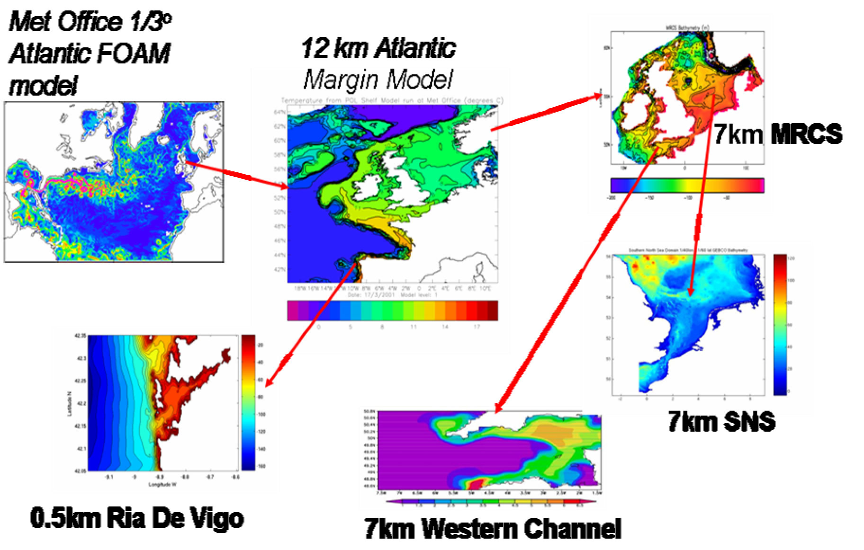
Figure 4 nesting of ocean circulation models

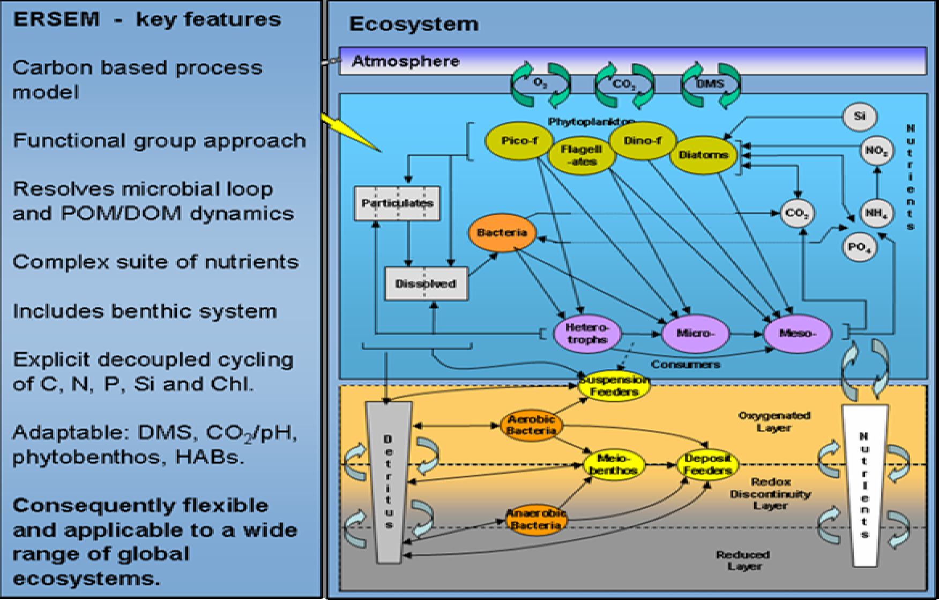
Figure 5 complex ERSEM model nested in the physical POLYCOMS in this example aims to characterize benthic and water column processes

The complex ERSEM model, which is nested in the physical POLCOMS in this example, aims to characterise benthic and water column processes and is illustrated in Figure 5.
In this example, in an operational context, the North Atlantic and Atlantic Margin Models might contribute to the MCS, whilst the higher resolution models would take boundary conditions and be employed in the provision of down stream services that could justify the higher resolutions.
In addition, as outlined in section 2.4, the modelling centres need to be supported by data assembly centres and service delivery capabilities to carry out the operational and support functions described there.
Before outlining how these might be implemented, it is noteworthy but not a coincidence that this architecture and rationale for segmentation into the global ocean and regional seas is reflected into the current organisation of operational oceanographic services by public bodies within intergovernmental programmes the GOOS Global Ocean Observation System.

Prototype Architecture
Figure 1 illustrates the functional architecture of the MCS in the context of data supply and downstream services. The functions which need to be carried out within an operational MCS are described briefly in section 2.2 and their connectivity is illustrated in figure 2.

How the parts fit together
The MyOcean consortium is building a prototype service that includes five thematic Assembly Centres ansd seven Monitoring and Forecasting Centres engaged in modelling and assimilation for hindcasts, nowcasts and forecast in the global ocean and six European seas (see Figure 6). The process chain is shown in Figure 7.
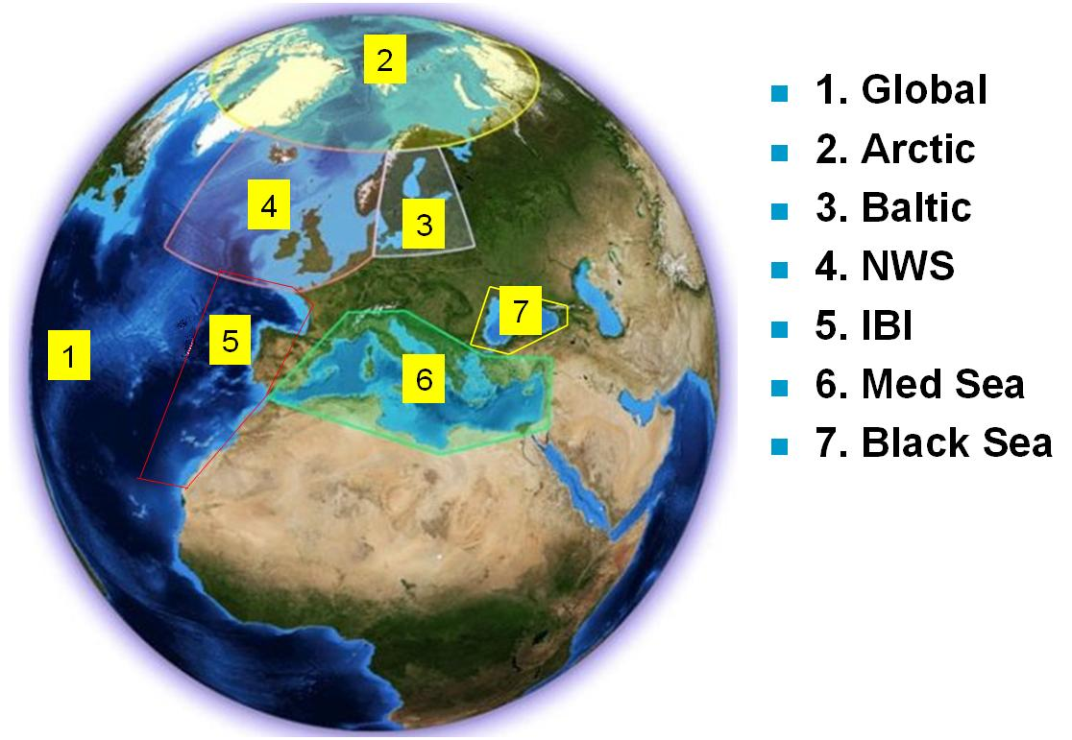

Figure 6 Area covered by monitoring and forecasting centres
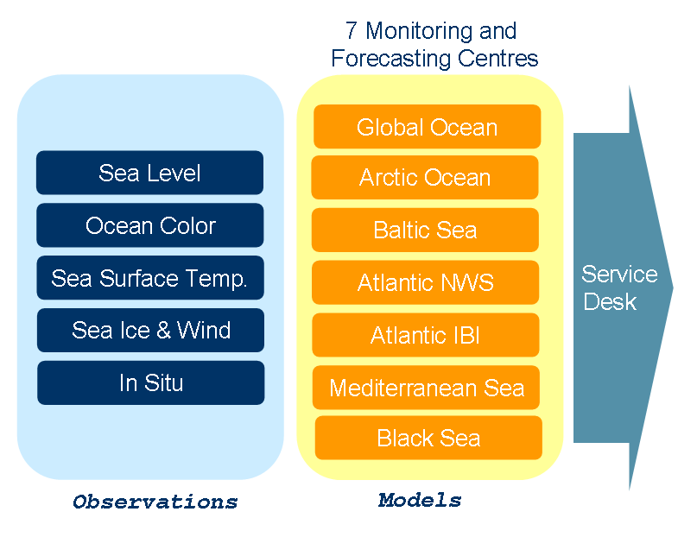
Figure 7 Thematic Assembly Centres, Modelling/Data Assimilation Centres and the prototype MCS delivery interface as developed in MyOcean.

Figure 7 illustrates the connectivity of the TACs to the modelling / assimilation centres and delivery interface, which in a simplified way mirrors the required functionality, described in figures 2 and 3 and section 2.4. In this manifestation, the TACs are in charge of processing the required in situ and satellite data to meet the needs of the centres so that they can meet the needs of end users through the delivery interface. In addition, the forcing fields for the predictive models need to be secured from Numerical Weather prediction centres operated by the National Meteorological Services and European Centre for Medium Range Weather Forecasting.

User Interface
The MyOcean products are available through a common interface with common standards for metadata, common procedures for downloading. The web interface for querying the products is illustrated in Figure 8.
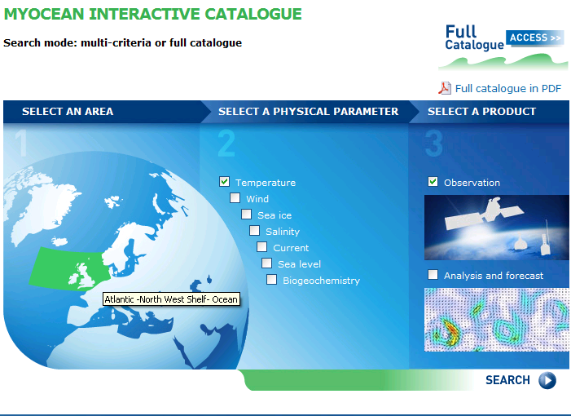
Figure 8 User interface for MyOcean allowing all measured and modeled parameters to be accessed through a common portal using common searching criteria.

Compatibility with overall marine knowledge architecture
The European Commission has set out a visionError: Reference source not found for an overall marine knowledge architecture including data from bathymetry, geology, physics, chemistry, biology and fisheries from surveys and near-real-time monitoring. It incorporates initiatives such as GMES and the Data Collection Framework for fisheries.
A European Marine Observation and Data Network (EMODnet) is being constructed to contribute to this architecture. In-situ measurements from EMODnet will contribute towards the Marine Core Service. EMODnet incorporates the concept of thematic assembly centres although these can distribute data directly rather than through a sea-basin monitoring and forecasting centre. It is also intended to set up sea-basin checkpoints that will analyse the quality and quantity of data for each sea basin and provide advice on the priorities for future investments in collecting and monitoring data.

Recommendations
Whilst care will be needed to ensure robustness and avoid single points of failure, implementation based on the MyOcean design, using the capabilities, tools, techniques, procedures and standards developed, adopted and being tested by the consortium, is an attractive way ahead and the IG recommends their adoption for the marime core service.
A key feature of the design is its commitment to interoperability and distributed functionality. This should allow potential contributors to the marine core service, who are not members of MyOcean, to augment its capabilities by contributing needed services, provided that they operate according to the rules which ensure that interoperability and ease of use by intermediate users.

Data collection, assembly and quality control
Appendix 4 also discusses the requirements for the data processing & management system needed to sustain the marine core service. Figure 2 outlines the functions. The design proposed by MyOcean to fulfil the functions listed in paragraph 2.4 (a)-(c), based on the use of Thematic Assembly Centres (TAC), is similar to WMO’s Data Collection and Processing Centres (DCPC), and also to the European Marine Observation and Data Network EMODnet.
All are required to generate and make available the appropriate QC dataset at levels 1b or 2 for analysis and assimilation by ocean models.
Figure 7 illustrates how the TACs are conceived within MyOcean as the gateways through which observational data reach the rest of the MCS activities. Because of the diversity of different sources from which observational data are acquired, including different sensor types that sample the same ocean product in different ways, the TACs are needed to harmonise the data in such a way as to facilitate their ingestion and assimilation into ocean forecasting models, and to blend the data into analysis products for application by downstream users.
The TACs will perform the following generic functions
- Real-time additional processing of level 2 data products received from European sensors, if necessary, to generate a common data format and product standard, facilitating an interoperable, harmonised data distribution system within the MCS.
- Provide access to the metadata, and where possible the data, of the raw data on which the measurements are based.
- Near-real-time level 3/4 processing activities, generating analysis products that correspond to the best estimate of an ocean property, blending data from various sources.
- Providing ready access to all data products using a spectrum of delivery methods to users using common standards, including real-time high volume data flow to the M/A centres and other operational users, solutions tailored to individual downstream services and web access for general public users.
- Provide confidence levels to the raw data and data products, including precision and accuracy where appropriate.
- Delayed mode level 3/4 processing activities, including the updating of ancillary data as they become available within a few days of acquisition, as well as later reanalyses to produce higher quality products for climate monitoring.
- Quality control, validation and error characterization, applying to the products and forecasts produced within the TAC. This activity needs to be underpinned by in situ observations. This does not remove the requirement for the space agencies to validate their basic level 2 products.
- Interfacing with international activities for the same type of data, and with TACs for other data types including in situ data for validation.
- Providing effective feedback on data products between users and the observing systems.

In general the TACs assemble data that is collected regularly rather than on request such as:
- Surface temperature
- Sea-level
- Sea-ice and wind
- Ocean colour (chlorophyll)
- In-situ
The data provided by MyOcean up to April 2010 is summarised in Table 2
Table 2 MyOCean products April 2010
 | Global | Arctic | Atlantic Iberian Biscay Irish | Atlantic European North West Shelf | Baltic | Black Sea | European | Mediterranean
Sea level along track | Yes |  |  |  |  | yes |  | Yes
Sea-level topography | Yes |  |  |  |  |  |  | yes
Ocean colour Global NLW, CHL, CDM443, BBP443, KD490 in near real time multi-satellite | ACRI L3 L4  JRC L3 SEAWIFS |  |  | PML L3 |  | CNR L3 | ACRI L3 L4  JRC L3 | CNR L3
Chlorophyl |  |  | Ifremer L3 L4
Sea surface temperature | OSTIA daily L4  GMPE daily | Met.no L4daily |  |  | DMI daily | CNR daily | L3 | CNR L4 daily
Sea-ice | Concentration, edge, type Arctic and Antarctic | Svalbard weekdays L4  Greenland |  |  | 1 km grid L4
wind | Ifremer CERSAT
in-situ temperature and salinity | Daily and weekly coriolis temperature and salinity
In-situ currents | Global ocean from Coriolis

It is evident that each of these data types has its own distinct user requirements and its processing system has achieved a different level of maturity. Thus although the TACs will serve the same generic functions (see the left hand side of Figure 3), it is important to treat each ocean data product type individually.
It has been suggested that a TAC be developed for the processing of synthetic aperture radar (SAR) in which all SAR data over European waters would be analysed to extract their information content concerning surface winds, wave spectra, oil pollution, ship detection, sea ice and other ocean phenomena. However this is still premature. It would be rather a labour-intensive and therefore expensive operation. Technology is not yet ripe for automatic image processing to extract these features
All the TACs deal with earth observation with the obvious exception of the in-situ TAC which will assemble data from various sources. In the period 2011-2013 some of these data will be provided by the ur-EMODnet project for physical data for which a call for tender was issued in the first half of 2010. These data include:
- wave height and period;
- temperature of the water column;
- wind speed and direction;
- salinity of the water column;
- horizontal velocity of the water column;
- light attenuation;
- sea level.
The EuroArgo research infrastructure, national meteorological services and others will also feed information through this TAC.
Regarding services tailored to the Arctic (see section 6.2) several new regular sea ice products need to be produced from wide swath SAR data such as: 1) sea ice deformation including drift, convergence, divergence and shear zones; 2) presence of leads and polynyas; 3) identification of fast ice zones; 4) deformed versus undeformed ice and ice- ocean discrimination using polarization ratio. Algorithms to produce these products already exist, and are being further developed by ESA’s GlobICE project. In due course, they could be implemented for operational use as part of the TAC function for sea ice.
Depending on the success of the ESA SMOS mission in measuring ocean salinity, there may be an opportunity to develop a TAC for Sea Surface Salinity from 2010.
The TAC functions to meet regional requirements remain to be determined but the tasks are being carried out to some extent by the OOS/N (NOOS, BOOS, MOON …) and exchange of the resulting data sets has been demonstrated in the SEPRISE project.

For atmospheric forcing data:
ECMWF and several national meteorological services are capable of carrying out this function and do provide the required information routinely within MyOcean. Where coupled ocean– atmosphere models are being run operationally, two way coupling is possible. A Council decision requires ECMWF to provide this data free of charge to GMES core services for the demonstration task until 2014 .

Ocean modelling and data assimilation
There are a relatively small number of global and regional ocean models capable of assimilating data and being run operationally in Europe and which could contribute to the Marine Core Service.
They are summarised here:
Table 3 Models capable of meeting needs of marine core service
Domain | model | Operated by | Horizontal Resolution | MyOcean
Global ocean | PSY3V1 | Mercator | 15' (5' in Atlantic) | yes
 | FOAM | UK Met Office
Arctic | TOPAZ | NERSC/Met Norway | 7½' | yes
Atlantic- European North West Shelf | POLCOMS | UK Met Office | 6' | Yes
 | FOAM | UK Met Office
 | PSY2V2 | Mercator
Atlantic-Iberian-Biscay Irish-Ocean | POLCOMS |  | 5' | yes
Baltic | DMI-BSHCmod | DMI | ½-3 nautical miles | yes
 | BALECO | FIMR
 | HIROMB | SMHI
Black Sea |  |  | 3⅔' (longitude) 2⅔' (longitude) | yes
Mediterranean | OPA9.0, NEMO v2 | INGV | 3¾' | yes
The main models available for the core service are summarised in Table 3.
In addition, there are many examples of smaller domain models being operated for local, national purposes taking boundary conditions from the above and delivering specialised products, e.g. surges, ice, oil and S&R drift, eutrophication, etc.
Within the MyOcean predecessor, MERSEA, there was considerable modelling effort to
- develop a new modelling framework – the NEMO code
- improve multivariate data assimilation methods
- increase model resolution
- incorporate ecosystem modules
Research continues to improve these models.
In the future marine core service, there are considerable advantages in having different models available for the same region. Because all core service products should be delivered in the same format, there should be no overhead for users in switching from one model to another.
Any supplier will need to commit to the supporting services outlined in section 2.5 "Marine Core Service Functionality" and described in more detail below.

Service generation, access, delivery and support
State of the art capabilities are being developed by MyOcean. These aim to provide one portal for users to access the services, which comprises:
- A discovery service
- A viewing service
- A download service, which will need to include or be supported by the facility for sustained, scheduled delivery of high volume datasets for intermediate users, who are themselves running continuous operations that need such a service.
Product descriptions are to be standardised and available in a homogenous catalogue.
The MyOcean consortium is committed to a number of supporting activities that guarantee a level of quality in service provision and that follow standards to be spelled out in Service Level Agreements. They are all crucial to the success of the MCS and are broadly compatible with the desired functional analysis of section 2.4. Others who might aspire to contribute to the MCS should expect to provide equivalent services and commit to the same Service Level Agreements.
SL1: production of marine core information and data
SL2: dissemination of marine core products
SL3: assessment and expertise on marine products
SL4: ocean analysis tools development and maintenance
SL5: training and research coordination

SL1 Production
Operators will need to develop and produce quality controlled fields (analyses & forecasts) describing the global ocean & European seas, based on space and in situ observations data and their assimilation into appropriate ocean models. This activity includes different product lines:
Observation and model products for the state variables listed in Table A2. 1 for example in several modes: nowcasting, forecasting (several days), and re-analysis (up to some decades)
The latter requires both real-time operational lines and delayed mode data lines.

SL2 Dissemination
All operators must provide to users the advertised information on the ocean state, either through their own production (SL1) or by being a reference access point to other production from centres that are not part of the MCSMO (MCS Management Organisation) – see section 5.1. This will include the appropriate tools for search and discovery, viewing and downloading of products. The download service will need to include or be supported by the facility for sustained, scheduled delivery of high volume datasets for intermediate users, who are themselves running continuous operations that need such a service.
- Catalogues and inventories of products must be homogenous, readily accessible, searchable, and updated regularly.
- The dissemination will be subject to the data policy to be agreed upon, but hopefully as set out in section 4.4.

Information products accessible through each portal should relate to the domain in question, meet the standards described in section 3.1.6 "Standards" and other service qualities set out below, including guidance in their use. The aim will be to give the easiest possible access to information and, where it exists, choice to the user.

SL3 Assessment and expertise
All production of the MCS must be fully validated, with known accuracy and error estimates. MCS must provide expertise on the marine core products, to support efficient use of its output or bring directly information to interested users. Human expertise is added to the production and dissemination functions, to proceed from data to information for the benefit of users.
Access to information from forecasts produced by different Centres is a powerful tool for assessment of their reliability and accuracy; it is desirable that the MFC should enable such multi-model interpretation and presentation.
For instance, regular bulletins and assessment reports can be published to explain the main features of some of the products; expert analysis can give a thematic interpretation of the marine core products; specific post-processing, on demand, to extract subsets of products; or to elaborate summary indicators based on MCS data (selection and transformation).
The expertise service could include the elaboration of calculated fields derived from the state variables (e.g. mixed layer depth, upwelling indices, transports, heat content), anomalies, climatologies or statistics.
In cooperation with expert topic centres a contribution to reference reports on the ocean state (Regional Conventions, EEA, ICES, etc) or simple and systematic studies of observing networks (Argo, altimetry, etc) or for operational user agencies is needed.

SL4 Ocean analysis tools, development and maintenance
The MCS should develop and maintain, for the benefit of the European community of intermediate users and other operators, a suite of reference codes and frequently-needed tools required to use MCS products and to develop downstream activities and services. It is mandatory that the codes be maintained at the forefront of the state of the art and be fully validated; with error estimates. This requires expertise in the transfer of research results into the operational suites.
The capabilities required to sustain and improve the MCS also need to be developed, validated, upgraded, maintained and disseminated at European level. These include tools such as the NEMO Ocean modelling code; data assimilation tools; toolboxes for nesting, downscaling, and interfacing models; validation algorithms (metrics, observations /model, …); data handling codes, visualisation, diagnostics routines.

SL5 Training, research, and outreach coordination
The MCS will actively develop and promote scientific and educational programs for the benefit of operational oceanography as a contribution to the development of European capacity in the subject.
An active research community must be entrained in disciplines and fields of research of relevance to operational oceanography. MCS can play a leading role in research networking and connection with research teams in Europe, and beyond; it can promote coordination of research initiatives linked to operational oceanography, and it must contribute to capacity building and outreach.
Training can be provided through summer schools, conferences, or students courses on operational oceanography; traineeships, PhD and post-docs program can be associated with the MCS Centres. Benchmarking against in-situ measurements and between different models can help to identify areas for improvement.
These research programmes will be of two types:
- One must be closely coupled to the MCS to ensure that projects are driven, in part at least by the specific needs of the operators, and remain aware of emerging research results. There is no doubt that progress in ocean modelling, monitoring and prediction will be achieved only if such programmes are effectively pursued, coordinated and funded. Experience from other successful providers of services of the kind to be offered by the MCS suggests that a fraction of the turnover of the endeavour (of the order of 5-10%) should be set aside for such closely coupled research; such examples include the major NMSs and ECMWF.
- The other will be driven by the need to resolve priority issues in the relevant sciences (as identified by the ESF Marine Board for example) and to explore new technologies for monitoring the marine environment, using EO and in situ methods. These are likely to be funded within national research programmes, the Framework Programmes, by ESA through their Explorer missions and industry.
GMES and Group on Earth Observation System of Systems (GEOSS) share a range of strategic and technical issues and offer opportunities for interactions (e.g. space and non-space observation platforms, data exchanges and network connections, tasking and integration of observations, ad-hoc campaigns). At the European level, the two initiatives are closely related in that:
- As it develops itself, GMES will become, with the data it can generate, a main European contribution to the GEOSS.
- GMES will benefit from the observations collected and exchanged in the frame of the international GEOSS activities.
European GEO consultation meetings are regularly organised and chaired by the Research DG to coordinate the position of all European GEO members supported by the Framework Programme in order to ensure a strong European voice and influence on decision making at the GEO plenary meetings. This includes ensuring appropriate European representation in the GEO Executive committee and providing the European share of funding of the GEO secretariat out of the EU Framework Programme.
It will be important that the MCS plays its part in ensuring that this ‘European voice’ is well informed by the benefits which the marine sector can gain from and contribute to the GEOSS.

Standards
One of the objectives of the MCS is to provide consistent quality and standard of service. This puts strong requirements in terms of robustness of the products and delivery channels; timeliness of production and delivery; fitness for purpose against specific requirements; stability and homogeneity of re-analyses; traceability and quality performance. Users of MCS serviced must not need bespoke interfaces to access and use its products. GMES as a whole has to deliver interoperability between its components, so conformity to the expected INSPIRE Directive will be mandatory.
In order to achieve this goal, the MCS delivery of data and data products should conform to International Open standards as will be established the INSPIRE program. In particular the viewing services should conform to Open GIS standards, providing Web Feature Services (WFS) for in situ data and Web Map Services (WMS) to allow viewing of geospatial gridded data. These can be live services working directly upon the data repositories. These viewing services should be available (with appropriate security) at all MCS service centres to allow the overlaying within a web portal of MCS geospatial view products with each other and with third party GIS based products without the exchange of the data themselves. For data exchange the MCS should eventually conform to the Web Coverage Service (WCS) standards although interim methods such as secure ftp or OpenDAP are envisaged.
The MCS should provide sufficient underpinning support for the development of appropriate viewing services to allow MCS information to be viewed within any downstream GIS based services conforming to the Open Standards. This could include commissioning of specific viewing services appropriate to the marine domain. As a Fast Track Service the MCS should be resourced to take the lead in this area which will (1) greatly increase the visibility and availability of MCS products in a highly professional way, (2) provide easy to use calibration/validation services for use within the consortium, e.g. by overlaying MCS products with satellite images, (3) provide a lead for future European geospatial services. The MCS should also seek to develop partnerships with other geospatial information services around Europe. A directory of all Geospatial information services in OGC format should be available with a portal to combine and overlay them. This would go a long way towards providing an integrated view of the European Environment as outlined in the INSPIRE initiative.
Standards to be applied will be specified or referenced in Service Level Agreements (SLA), and / or Service Charter for overall MCS consistency, which must cover the points above, as well as requirements to maintain the system at state of the art; to use all available information; to perform multi-model estimation and forecasts; to engage in research and development (see SL4 and SL5 above); specification of the areas of service provision; the rules for access to infrastructure; consideration of the operational status, security, system monitoring, etc
The data standards applied in MyOcean are specified in Table 4…
Table 4 data standards
Data format | NetCDF structure + CF convention
+ specificity | Grids based on GHRSST & GODAE, In situ based on Ocean Sites, Along swath based on Jason2
Inventory | THREDDS/CSML
Information System infrastructure | INSPIRE
Metadata | ISO TC211 (ISO-19115, ISO-19119, ISO-19139)
Metadata profile | INSPIRE at a minimum + MyOcean specificity
Vocabularies | OWL, SKOS, GEMET, SeaDataNet
Time | Network Time Protocol
Access Web Services or Protocol (OGC) | FTP for all, Opendap/Thredds/WCS/WMS and REST advanced subsetter web service for gridded products
Ordering & Subscription | WPS via Degree
Discovery | CSW via Constellation SDI
Search | service web RESTful
Archival (long term preservation) | OAIS
Authentication and authorisation | CAS + LDAP
Production monitoring | no standard
Transaction accounting | no standard

Data Policy
Commission Communications on GMESError: Reference source not found indicate that the services are of public interest but do not explicitly refer to them being a public good. In economics a public good is a good that is non-rivalrous and non-excludable. Non-rivalry means that consumption of the good by one individual does not reduce availability of the good for consumption by others; and non-excludability that no one can be effectively excluded from using the good. If GMES services are to be a public-good then it almost certainly implies that they should be free at point of consumption; otherwise some operators would be excluded from them.
The marine core service implementation group strongly believe that the marine core service should indeed become a public good. If they are not then the objectives set out in the GMES impact assessments, particularly creation of a sustainable information infrastructure tailored to the needs of users and the stimulation of a downstream service, will not happen. It is the downstream products, not the core service itself, that support environmental and security policies. Experience suggests that if the core service products are not free there will be no downstream services.
It has been suggested by some that core service products should be only available for GMES purposes. However the only benefit of such a restriction would be to the lawyers who would be kept busy in defining what GMES purposes are. Core service products should be available without restriction.
However we also need to consider the data that are used to create the core service products. These are usually termed the background data as opposed to the marine core service products themselves which are the foreground products. Many users will want access to these data partly to understand better the core service products and partly because they may wish to create services that derive directly from the raw data and do not use the core service products; possibly even to provide alternative or complementary core service products. Then GMES is in a position to define the data policy these situations are foreseeable. We can distinguish several cases:
Table 5 Proposed data policy for background data for GMES marine core service
Data provided through the GMES budget – from the space or in-situ component. | These data should be free of charge and free of restriction of use
Data owned by one of the consortium partners. | Free access to these data should be a condition for the partner to join the consortium
Data provided by a publicly-owned Member State body that is not a consortium partner | It is an ambition of the EU that publicly produced data should be free of charge. However this is a recommendation rather than a binding commitment. We live in the real world. If not using these data would result in an inferior product and there is no other way to obtain these data then some restrictions can be accepted.
Data provided from a privately-owned body | Where possible these should be acquired on terms that allow maximum possible access and re-use

Funding

Marine core service
If we accept that the data products provided by the marine core service should be free of charge then it follows that the marine core service should be publicly funded. A private organisation dedicated to the pursuit of profits is not going to fund an activity that brings in no revenue stream.
At present there are abstract estimates of the full costs of a reliable, efficient marine core service or of the upstream and downstream capabilities that are required to deliver value from it. Such estimates need to be detailed during the next year or so as experience grows during the FP7 funded demonstration phase; not least to ensure that the case for long term funding is robust. The level of national funding compared to European needs to be settled.
For the core service there is a question as to how much can be covered by national funding and how much should be covered from the EU budget.
There are various reasons why the EU needs to provide some of the funding; chief among them being that the architecture described above is impossible to set-up without a collaboration between the countries whose waters are being observed and for whose waters the service is intended to cover. Again it is clear that without a EU financial contribution there will be no marine core service. This is not a recommendation from the implementation group. Neither is it a hypothesis. It is a fact.
It is also clear that the EU is not going to pay for the total cost of the service. However the question as to what should be paid by national governments and what should be paid by the EU is a general GMES question and beyond the scope of the marine core service implementation group.

Downstream Services
These arguments do not apply for downstream services which will be market-driven and financed through user charges in effect for the value that they add to the information and services that they obtain from the marine core services and other upstream service providers. Some of these user-charges may be paid through the EU. For instance should the oil-spill monitoring service provided by the European Maritime Safety Agency, EMSA, become a downstream service and then it will benefit from EU financing. However this will not be financed from a general GMES pot but rather a budget dedicated to environmental protection where earth-observation based services will be used if the benefits justify the cost.
There is no doubt that some EU level support will be desirable for intermediate service providers during the marine core service demonstration phase at least. Some thought needs to be given to how this should be organised. In the past many of the projects from both the Framework Programme and the European Space Agency started from the hypothesis that the only barrier to a successful and sustainable downstream service was lack of knowledge amongst the user community of the great benefits that earth observation could bring them. All what was needed was a project to demonstrate these services to users. However there are several flaws to this hypothesis.
- In some cases the product provided by the downstream services was not of sufficient quality to satisfy the needs of the user either because of inherent limitations in earth observation or because further research was needed to improve the product. With an emphasis on demonstration and capacity building, there was no effort left for improving the product.
- In some cases products were provided that competed with existing commercial services. Because these products were provided free to users, there was an expectation that these services would always be free. This lowered the probability that profitable added-value services would be developed.
- Images still make up a substantial part of the cost of the services. In some cases the product could be useful to the end-user provided it was free but not if the images used to develop the product were provided at commercial rates. Back of envelope calculations could show that these services could never become sustainable without subsidised images. Where these images come from European public organisations the policy of providing images at reduced rates to research projects but not to commercial services needs rethinking. An example is vessel detection from SAR imagery.
- In other cases the market segment is not large enough to support the large number of providers that were encouraged to enter projects for the demonstration services. Oil-spill monitoring in European waters is an example. The total market for Europe may be about €2-3 million per year. There is probably room for about three or four providers to run profitable operations.
- Funding has largely been granted to projects aiming at civilian public authorities. The market is relatively limited. The defence sector is clearly out of scope for Framework Programme projects but thought needs to be given to expansion to services aimed at the research community or the private sector. This might require confirmation that this is still within the scope of the overall GMES initiative which, up to now, has focused almost exclusively on civilian public authorities.

Observation Infrastructure

The space infrastructure

The required space infrastructure
Appendix 3 provides the recommendations of the Space Infrastructure WG endorsed by the Implementation Group. These are primarily addressed to ESA to secure the EO data required by the MCS.
The main recommendations are:
- General recommendations:
    - Continuity of observation is crucial. This is particularly critical around 2010 when data gaps could occur for several of the most critical observations. Building the first of the GMES satellites must be taken most urgently.
    - It is more critical to establish satellite series for sustainable service availability than to try optimizing the specifications and designing for any one satellite and its instruments, if the latter leads to expensive, non renewable satellites. Establishing satellite series should lead to significantly lower production costs.
    - GMES should allow for research and technological developments. In particular, the possibility of embarking new instruments with the potential to meet GMES needs should be considered. Wide Swath altimetry and geostationary ocean colour are the two most important new technology developments that will benefit the GMES MCS in the long run. A workshop on space and the Arctic organised under the Swedish presidency in 2009 concluded that ice thickness measurements were a priority for the expected increased human activit in the far north
- Specific recommendations:
    - The Jason series (high accuracy altimeter system for climate applications and as a reference for other missions) is an essential and critical component of the GMES satellite programme for MCS. Including this type of mission into the Sentinel fleet must be a priority for GMES.
    - The MCS requires a high resolution altimeter system with at least three altimeters in addition to the Jason series. Sentinel-3 should include a constellation of two satellites, flying simultaneously, providing adequate coverage and operational robustness. Instrumentation costs for S3 should be reduced as much as possible to allow for a two-satellite system.
    - Compared to the present design of S3 instrumentation, the priority for Sea Surface Temperature is for high accuracy dual view measurements. The large swath requirement has a much lower priority, in particular (but not only), if S3 is a two satellite system. As far as Ocean Colour is concerned, a sensor having a similar spectral resolution to MERIS is essential to meet the important shelf and coastal ocean water quality measurement requirements. The use of a SeaWiFS type of instrument (reduced number of channels) would serve only the minimum operational requirements for the open ocean.
    - SAR data (Sentinel 1) are required for oil spill detection and sea ice monitoring. These are European core data in the sense that they have multiple uses and are required for downstream services in the marine domain. The requirement is for at least one and preferably two SAR missions in addition to the other non-European missions (e.g. Radarsat).
    - Access to other European and non-European (e.g. NPOESS, RADARSAT) satellite data in real time is fundamental for the MCS. The GMES ambition is autonomy in information services but measurements are a global responsibility.
    - Detailed ground segment requirements remain to be addressed. But the main recommendation is likely to be that the GMES ground segment should develop robust interfaces with EUMETSAT Ocean & Sea Ice SAF and with the MCS satellite Thematic Assembly Centres. The current offer from ESA and EUMETSAT is described in section 4.3.3.

The Working Group Report relating to the MCS requirements of space segment has been adopted by the IG and is attached as Appendix 3; the recommendations are summarised in section 3.1. These have been acted upon by ESA in the design of Sentinels 1 and 3. The way forward on the follow-on to Jason 2 remains to be determined.
ESA/PB-EO(2006)23, rev.2 of 7 November 2006 describes the GMES Space Component Implementation Plan from which the following is adapted:
Both Sentinel 1 and 3 will have a design life of 7 years. Sentinel 1 will carry a SAR in a well-controlled dawn-dusk sun synchronous orbit at approx. 700 km altitude with an exact repeat of 12 days in support of multi-pass interferometry (for land use). With the SAR swath of approx. 240 km, a 12-day quasi-global coverage is ensured. The ground resolution exceeds that of ERS and Envisat in imaging mode. Sentinel 3 will carry a Cryosat-derived microwave altimeter (incl. a microwave radiometer and precise orbit determination device) and two imagers, for ocean/land colour observations (MERIS-like) and for sea/land- surface temperature observations (AATSR-like) into an Envisat-like orbit.
It is accepted that 2 spacecrafts in orbit are needed to meet the coverage and observation frequency requirements for the Sentinel-1, -2 and -3 missions. However, an incremental deployment of capabilities is assumed. Therefore the implementation within Segment 1 includes only the first of a series of satellites per mission.
The target launch date (2011-2012) is driven by the expected end-of-life of ENVISAT and other missions.
A sentence about the status of Jason Follow-on could be useful.

ESA has a mandate, as part of the GMES programme approved by the ESA Member States, to:
- manage and coordinate the overall GMES space infrastructure including the access to all satellite data required by GMES, starting in 2008;
- develop GMES specific space infrastructure;
The funding of the space component will come from both the ESA GMES programme and the FP7 Space Theme work programme, in agreement with the EC. Part of the EC’s FP7 funding (130 M€ total for 2007-2013) is planned to be made available to ESA in order to organise the coordinated and harmonised access to EO data for GMES services. In this framework, ESA is setting up agreements with EO mission data providers in Europe and worldwide. In doing so, ESA will assure that existing data providers will be fully involved. EUMETSAT has already signalled its interest in acting as a data provider for the MCS through the provision of a consolidated real time satellite data stream (including EUMETSAT, NOAA and other 3rd party data), with the exception of the SAR data.
Therefore, it is necessary to harmonise the positions of the two organisations, and in this process, ESA will take due account of the position of EUMETSAT Member States and will make use of EUMETSAT assets/capabilities in the most efficient way for the delivery of EO data to the Marine Core Fast Track Service. The GMES Framework Agreement between EUMETSAT and ESA signed in Summer 2009 sets out the roles and responsibilities of EUMETSAT and ESA in their cooperation on the GMES Space Component (GSC). It is addressing the specific coordination with EUMETSAT that is necessary for the access to and provision of the data handled by EUMETSAT, as well as regarding the delivery of Sentinel-3 (S-3) data to the MCS. It is agreed that EUMETSAT will operate the marine part of S-3.
For this purpose, the EUMETSAT central ground segment will provide a (probably consolidated) level 1 satellite data stream as a direct input to the MCS. To further this some working assumptions have been reached between ESA and EUMETSAT, although these have yet to be approved by their governing bodies and the related financial provisions must be clarified. Provision is made as follows:
- EUMETSAT will serve the Marine User Community both with routine and off-line products, whereas ESA will serve the Land Services community with all land products.
- Starting from the launch of the first S-3 spacecraft, the scope of EUMETSAT operational role should be:
    - product generation and dissemination of all S-3 products routinely required by the MCS and the related downstream services;
    - serving the offline requests of the Marine User Community for S-3 products (using a distributed network of centres of expertise)
    - monitoring and control of spacecraft and flight operations segment;
    - payload data acquisition, consistent with the overall GMES ground segment design under ESA’s responsibility.
The ESA-EUMETSAT working assumptions further suggests that the “backbone” of the S-3 ground segment will consist of a polar ground station configuration that provides full orbit coverage together with a collocated centre based at EUMETSAT for serving the marine user community, i.e.:
- ground and spacecraft monitoring & control;
- routine S-3 product generation and dissemination;
This backbone will be augmented by distributed centres for product archiving, retrieval and re-processing to fulfil “ad hoc” data requests.
In addition, it is possible that additional centres could be available to supplement the payload data acquisition function (as a back-up).
The Ground Segment of the Space Infrastructure required for the MCS consists of two stages: (i) the basic processing that generates ocean data products from each individual sensor; and (ii) the additional processing that prepares data from multiple sources for operational tasks such as assimilation into ocean forecasting models. The first stage is a space agency task, following well established EO practices. Previously responsibility for the second stage, if it takes place at all, has been shared in an ad hoc way between the space agencies, major data users and the EO science community. It is recommended that for the MCS this stage of additional processing should be performed by Thematic Assembly Centres (TACs) as an integral part of the MCS, tailored to the special requirements of operational users of particular data products. Implementation of these latter functions is described in section 4.3.5.

Data products from Sentinel-3 sensors
The ground segment tasks for commissioning new sensors and performing data processing to deliver level 2 products (atmospherically corrected measures of a remotely sense ocean property, sampled on a grid oriented along and across the satellite track) are well established. Noting the plans of the space agencies noted above, in the case of the Sentinel missions required to support the MCS, it is assumed that ESA will calibrate and commission the new sensors and that, in the case of Sentinel 3, Eumetsat will manage the data processing to deliver Level 2 products for the ocean. Table 2 identifies the outline time-of-delivery required from the ground segment for the Sentinel-3 ocean data products.
To ensure the highest quality of data, current best practices for the ground segment should be followed but with two notable differences; it is essential to maintain an adequate data product validation programme throughout the sensor lifetime, and periodic reprocessing of data must be anticipated.
Table Outline delivery requirements for Sentinel-3 ocean data products
Sensor | Product delivery requirement
Altimeter | “precise” IGDR within one day
SST | Level 2 data in L2P format in real time (within 3 hours).
Ocean Colour | Level 1 and 2 products within one day
Hitherto, because ESA Explorer missions have been launched in association with a strong science user sector, any validation activity beyond the commissioning phase has often been omitted from the ground segment budget and in practice left to the science community. This approach is unacceptable for the Sentinel-3 mission whose goal is to deliver satellite observations to meet operational needs. In order to be fit for purpose, an essential component of Sentinel-3 level 2 data products is pixel-by-pixel error estimates. This implies a well planned programme to acquire independent validation observations, including in situ measurements, on which the error statistics can be based. It must continue as long as operational products are being delivered. It is essential that such validation programmes are planned and budgeted from the outset as an integral component of the ground segment task to deliver each level 2 data product needed by the MCS.
The MCS is concerned not only with supplying near-real time data for operational use but also with establishing an accurate long-term record of the ocean for climate purposes. It is the experience of all recent ocean satellite missions that the accuracy of data products can be improved by refining the processing algorithms following months or years of experience and careful analysis of the sensor calibration and product validation characteristics. In order to ensure a consistent climate record from a sensor throughout its lifetime, it is essential to re-process the entire historic dataset whenever major improvements are made to the processing algorithms. A programme of reprocessing should therefore be planned and budgeted from the outset as an integral part of the ground segment task for Sentinel-3 sensors.

Data products from Sentinel-1 SAR
For Sentinel-1, the primary ground segment tasks relevant to the MCS can be defined according to the following application areas:
- oil pollution monitoring
- ship detection
- monitoring sea ice and iceberg monitoring
- open ocean (sea state) surveillance
Near real time, wide swath operating mode is required for the first three services, whereas the latter need access to near real time image mode or wave mode data. As the duty cycle for the data intensive SAR is restricted the ground segment will need to carefully combine baseline acquisitions to properly service the above application areas.
The ground segment will need to provide operational, long-term services, short ordering times for ad hoc needs (one or two days), short latency between data capture and availability on the ground (under 2 hours) and rapid data processing (20-30 minutes).
In the context of the MCS for the Arctic, it is necessary to produce wide-swath SAR image strips calibrated as normalised radar backscatter cross-section (Level 1b), in near real- time. For instance, for the monitoring of the Arctic circumpolar region, 3-day coverage is necessary for reliable ice deformation estimates (this amounts to about 6500 wide swath images per year.) More frequent acquisitions for limited regions will be needed on a case- by-case basis for specific operational services. The ESA rolling archive for ASAR has already demonstrated the capability to deliver near real time SAR strips to support both routine Arctic sea ice monitoring and specific operational applications but in future clear guarantees will need to be provided for data delivery, as is the case for RADARSAT now.

Data products from the Ocean and Sea Ice SAF
The Sea Surface Temperature TAC and the Sea Ice TAC are using other higher level satellite based data like the EUMETSAT Satellite Application Facility for Ocean and Sea Ice. Both are a complementary contribution to the Marine Core Service.

The in situ infrastructure
Appendix 4 contains the report of the in situ infrastructure WG. As in the case of the space infrastructure, it identifies the candidate technologies that are available for a composite operational in situ observing system capable of meeting the needs of an MCS serving the purposes identified in section 2.1; essentially they are those that are sufficiently tried and tested in such applications. Potentially useful technologies are identified for possible future use too.
Candidate observing systems comprise:
- Drifting Argo Floats for the measurement of temperature and salinity profiles to ~2000m and, by tracking them, mean subsurface currents.
- Research vessels which deliver complete suites of multidisciplinary parameters from the surface to the ocean floor. The information collected is of high accuracy, quite necessary for various validation tasks, but very sparse, with intermittent spatial coverage, at very high cost of operations and with very limited real-time transmission. Such vessels should be encouraged to collect and report routine surface observations whenever they are underway.
- XBTs launched by research vessels and ships of opportunity underway for the measurement of temperature and salinity profiles to ~450-750m depth.
- Surface Moorings capable of measuring subsurface temperature and salinity profiles in particular continuously over long periods of time. Currents are often monitored and meteorological measurements are usually made too. Bio fouling restricts the range of measurements that can be made from long deployments in the photic zone but surface salinity and biogeochemical measurements are attempted.
- Ferry-Box and other regional ship of opportunity measurement programmes for surface transects which may include temperature, salinity, turbidity, chlorophyll, nutrient, oxygen, pH and algal types.
- The Continuous Plankton Recorder (CPR) operated by the Sir Alister Hardy Foundation for Ocean Science which is towed from merchant ships on their normal sailings in order to monitor the near-surface plankton of the North Atlantic and North Sea on a monthly basis.
- The network of tide gauges which provides long term reference and validation sea level data.
- Priorities for implementing these technologies in a coordinated manner to provide continuity and expand their utilisation, particularly to achieve near real time data collection, are discussed further in section 4.
The European Marine Observation and Data Network, as part of the marine knowledge 2020Error: Reference source not found process, aims to assemble in-situ measurements for use by public and private operators. Preparatory actions already underway are assembling biological, chemical and physical parameters in selected sea-basins. It is a contractual obligation for these parameters to be prepared in a form that can be used by prototype or operational marine core services. These actions should also clarify whether there is a need to strengthen these monitoring networks.
The Implementation Group Report relating to the required in situ infrastructure is attached at Appendix 4. This reviews the key observing system technologies and the modalities of a data collection and management system that must deal with its multi- scalar, multi – ownership and highly distributed characteristics. These considerations have been addressed in and used to recommend priorities and essential coordination activities.
Presently this infrastructure is fragmented. Much is deployed for research purposes or as national contributions to ongoing environmental assessment programmes committed under the Regional Conventions. There are national efforts to coordinate measurements such as MEDIN in the UK or Coriolis in France and various initiatives coordinate specific types of measurements of physical parameters– measurement buoys (SEPRISE project now closed), FerryBox Community.EuroArgo.
Preparatory Actions under the European Marine Observation and Data Network (EMODnet) framework are aiming to deliver harmonised data on a sea-basin scale. Most of these parameters – bathymetry, geology, chemistry and biology – will not be delivered in real-time - for the preparatory phase at least. But the physical parameters will be from 2012 onwards and it is planned that these will feed into the GMES marine core service.
It is believed that the present network is not sufficiently fine-grained but there are no studies indicating what further measurements are needed or where they are needed. There is some consensus that the present Argo float network is sufficient for the global monitoring and forecasting centre but that more measurements may be needed for the finer-detail models used in regional sea-basin. Most tend to be concentrated in coastal waters and few deliver real time data. The ODON project, listed in section "Past and current R&D projects" developed techniques for the effective design of spatial-temporal sampling strategies for water temperature and salinity observing system in North Sea and Baltic Sea but nobody is known to have used these techniques in earnest.
Indeed despite some attempts during the process for the impact assessment of marine knowledge there is still no overall view of the adequacy of the present network. Two efforts underway should help to clarify this matter. Firstly the MyOcean partners should indicate where there is a need for better in-situ data for calibrating or validating models and secondly the ur-EMODnet preparatory actions will identify the spatial coverage of the present network and identify whether the requirements of the marine core service could be met through better access to existing measurements or whether more measurements are needed.
In order to make progress two specific actions are needed. Firstly, where the impact of the data is either global or pan-European it might be appropriate for an investment to be made by the EC on behalf of Member States or by the Member States acting together. A case of this kind has been put for investment in the Argo technology within the European Roadmap for Research Infrastructures. It should be taken up. The impact of the Continuous Plankton Recorder (measured by the maturity of the technology, the length and extent of the existing record and uniqueness and importance of the data which result) is a further candidate for such coordinated investment.
Secondly, there is a need and opportunity within the context of GMES, supported jointly by the Commission, ESA and Member States, for integration and better coordination of in situ monitoring efforts.
We need to have some words on the EEA`s GISC project here, which after all intends to take a closer look at what i/s is needed in each thematic, how much it should cost, and how the needed data flow should best be sustained

The sea-basin checkpoints, proposed within the Marine Knowledge 2020 CommunicationError: Reference source not found and due to be tested in the 2011-2013 period, will provide platforms at a sea-basin level for examining monitoring networks and advising where the priorities are for strengthening. The EuroGOOS Regional Task Teams or Operational Oceanographic Systems/Networks (where they have been formed) would be expected to contribute to this effort as would the European Environment Agency (EEA). According to the 2008 GMES CommunicationError: Reference source not found
The EEA is expected to play an important role, in coordination with the Commission, in relation to the supervision of some services and coordination with user communities under the SEIS umbrella. Some specific coordination activities could be delegated to other existing relevant coordination bodies.
On the global scale the Joint WMO-IOC Technical Commission for Oceanography and Marine Meteorology (JCOMM) provides an appropriate mechanism at an intergovernmental level for planning and coordinating the acquisition, exchange and management of marine observations, although it would be helpful if a mechanism for developing a common EU position on this could be agreed, particularly if EU funding is provided for specific components of the global observing network, such as the Argo float technology.
In the meantime, whilst waiting for the more comprehensive overview of the current needs that is expected in 2012 or 2013, the following priorities are suggested:
- sustain the Argo network ~ 800 new floats to be deployed each year to replace the ones that fail. The European ‘fair share’ of this is about 250 units;
- encourage the deployment of and collection of near real time data from automated observing systems such as XBTs, Ferry-box & CPR on research vessels and Ships of Opportunity;
- encourage Member States to continue to make marine observations that are useful for national purposes and, if shared in near real-time, would help sustain the MCS and downstream services. Specific examples include data from the tide gauge network and moorings;
- promote investment in carefully chosen well equipped observatories at locations where data would provide valuable constraints on models;

The Meteorological Forcing
Oceanographic modelling is depending at the sea surface boundary on input from numerical weather prediction model output. This has a strong requirement to be done operationally. It is therefore essential to secure the delivery of this meteorological data to the marine core service. The main source of this information is the European Center for Medium-ranged Weather Forecasting. Its council has agreed to make the data available free of charge to all GMES core services.

Governance and related issues

EU procurement
There are a number of issues to be resolved that transcend the strictly scientific and technical matters which guide the infrastructure design and implementation. Some considerations, particularly those of top-down governance, will be settled at a political level, for all of the GMES Core Services and follow-on initiatives jointly, presumably in the GMES Bureau and GMES Partnership. However it is reasonable to suppose that the structure and day to day governance of the MCS can and will be designed according to some general principles.

Procurement or Grant
If the EU is to partially fund the marine core service, and we have indicated that there will be no marine core service if it does not, then it must do so within the EU’s financial regulations. It can do this in two ways through:
- procurement – essentially the EU issues a set of specifications and buys the service on behalf of the users. Payment is against deliverables;
- a grant – the EU provides financial support to an ongoing concern. Payment is of costs incurred;
In either case the funding must follow a competitive process through calls for tender or calls for proposals. Only if there is a monopoly provider is an exception allowed. This might be the case for part of the space segment of GMES but is not for the marine core service. In theory there are several providers that could contribute.
Up to now, it has been assumed that the core service would be funded through a grant procedure but this needs to be carefully considered. Procurements are a more natural procedure for services requiring user-defined deliverables and probably result in less administrative expenses; both for the authority providing the services and the provider.
The choice depends on the capabilities that the managing body has in making specifications defining the services. This can be a rather technical issue, which is not among core knowhow of the European Commission. So the level at which service specifications are defined will impact this choice.
Delegating procurement to Intergovernmental organisations which represent a joint operation of GMES member states knowledgeable in procuring earth system modelling services could be considered. ECMWF has such a status and excellent knowhow in modelling services, while not directly seeking to provide marine core services and rather being a user of marine core service itself. In this option service specifications could be sufficiently detailed to ensure a successful procurement compared to procuring with overly broad specs and not being able to control service content.

Direct or devolved management
It is envisaged that the marine core service will be distributed. It will consist of a number (of order 12 as discussed in section 2.3) of monitoring and forecasting centres and thematic assembly centres that will produce and offer products and services, as characterized in appendix 2 and section 4, to intermediate users. Some such operators are likely to be consortia.
Beneath this layer will be data providers such as ESA and EUMETSAT for Earth Observation and agencies in Member States for in situ data, acting singly or as the consortia which comprise the Operational Ocean Systems/Networks of EuroGOOS. If the EEA assumes greater responsibility for oversight of in situ data collection for GMES generally, it may act in loco parentis for such agencies and consortia. These upstream data providers are not the concern of this section which is purely concerned with the marine core service.
Two broad classes of solution can be envisaged to manage the interfaces between these providers and the expected GMES Management Authority described in GAC(2006)6 or whatever body is in charge of GMES.
Direct management option | The GMES Management Authority itself could manage all of the interfaces with the monitoring and forecasting centres and with the thematic assembly centres Logically it would need to do so for all the Fast Tracks and their follow-ups. If we assume that each fast-track or core service has a similar number of “nodes” to the marine core service and if, in addition, the management authority would manage the space component, this would require a large amount of effort.
Devolved management option | Alternatively the Management Authority could issue one contract or grant agreement for the whole of the core service. In this case the Management Authority would have less control of how the contractor managed its internal affairs but would limit its complexity by giving it fewer interfaces to deal with.
The contractor or grant recipient in the devolved management option could be a consortium of organisations as at present. Administratively the organisations might find it more convenient to create a new “management organisation” with a legal personality. In this case the forecasting and thematic assembly centres would be subcontractors. It is not clear whether this would result in any benefits for the management authority. In the case of procurement it would make little difference because the financial and technical capacity of “significant subcontractors” would still need to be checked. In the case of a grant, probably the amount spent on subcontractors would need to be audited but not a breakdown of the subcontractors’ spending. So there could be a saving.
In any case it is clear that the complex, time-consuming procedure followed in negotiating an agreement with the MyOcean consortium to deliver a service that was almost identical to one provided by the predecessor MERSEA should not be repeated.

Consortium Structure
The MyOcean consortium is essentially the same as the predecessor MERSEA consortium and it is assumed that they would see themselves as prime contenders for the next version of the marine core service. However it cannot be excluded that another consortium could bid.
It is not really the business of the Implementation Group to determine what internal arrangement the consortium uses. However a European Economic Interest Group (EEIG) has some characteristics which would make it an attractive company structure
The EEIG, i.e. European Economic Interest Grouping is a company structure which can be registered in all European Union Member States according to EC Law (Regulation (EEC) 2137/85). The EEIG offers the possibility of cross-border co- operation and collaboration within Europe especially to small and middle-sized enterprises of every legal category including associations and local authorities. A precondition is however that at least two of the enterprises or other bodies of the grouping are located in at least two different EU Member States; enterprises from Member States of the European Economic Area can also take part. To date approximately 1200 EEIG have been registered in the EU with altogether about ten thousand members.
As a result of the growing demands on companies within the field of cross-border transactions, the EEIG is an attractive alternative for co-operation in various economical fields; examples are the establishment of a purchasing and marketing association, joint research and development or co-operation in fields of personnel and training. In addition an EEIG may have significant tax advantages (an EEIG is not submitted to corporate taxation etc.).
These include the following:
- it is a legal framework which aims to develop and facilitate the collaboration between entrepreneurs and can represent a profit centre for its members of its own;
- it is a very flexible and non-bureaucratic legal instrument, whose rules can be decided by the members in observance of a few guidelines fixed in the European regulation;
- a grouping can be founded with or without assets, investment or know-how transfer;
- a grouping can be established by subjects with a different legal status: self- employed persons, private limited company, chambers of commerce etc.;
- the members of a grouping go on carrying out their own activities autonomously. They maintain the activities they ran before and besides obtain new business opportunities;
- a grouping can guarantee a high-level liability: members have unlimited and several liability for its debts;
- profits and losses resulting from its activities are taxable only in the hands of the members; profits must be divided up among the members, if not reinvested;
- a grouping pays neither company taxes nor taxes on earnings;
- a grouping can run its own business and can have a trade mark;
- the official address of a grouping can be easily transferred within the Community. Other legal instruments require a previous winding up of the enterprise, which involves costs, activities and loss of corporate image;
- due to the European regulation no. 2137/85 constituting the legal basis of EEIG and, being drafted in each European official language, there is no discrimination because of the use of a foreign language.

Interactions with downstream services
Day to day interactions between product and service providers and their users should be conducted directly. Proposals for cataloguing and searching for data, products and services are made in the Strategic Implementation Plan.
However the GMES Management Authority needs to understand how well the core service meets the needs of downstream users so that they can adjust the requirements of the grant or procurement procedure for subsequent years.
The Marine Knowledge Communication proposes setting up sea-basin checkpoints that allow stakeholders to comment on the effectiveness of thematic assembly centres – not only for GMES but also for the data collection regulation in fisheries and the European Marine Observation and Data Network. These will gather stakeholders – both downstream providers and end-users - who should provide feedback on what has been provided and proposals for future priorities.
Conclusions from these checkpoints should feed into the overall GMES process. The previous version of this implementation report suggests a marine core service Commissioning Forum; meeting at least annually could fulfil these requirements.
We should make a strong link to the USER FORUM/Board that will most probably be part of the GIO and follow-up proposals…

Criteria for selecting operators and modification of the partnership
The services will be provided by operators (i.e. institutes, agencies, companies, or consortia) that manage and operate functional centres. They should be selected on the basis of their ability to fulfil the requirements of a legally binding contract, their access to the required resources, their expertise (scientific and technical), their operational status, track record and previous performance, commitment to work with the interfaces, and cost-effectiveness. Regional knowledge and ownership will clearly be important.
For the devolved management option the composition of the partnership, including subcontractors, is largely a matter for the consortium itself. Should the service be obtained through a procurement procedure then the technical capacity will be judged as part of the selection process. According to the financial regulation this is a yes/no process, i.e. all potential bidders meeting the criteria will go forward to the award criteria. In a grant procedure the quality of the partnership could be an award criterion.
In any case the main parameter to be considered will be the ability of the consortium to provide operational and sustainable services.
There have been in the past some suggestions that there should be a sound repartition of work between Member States. Whilst some local knowledge will surely be useful for the monitoring and forecast centres, any formal repartition between Member States would break internal market public procurement rules and cannot be considered. Furthermore repartition of work along any other grounds than value for money would mean that the service would be even less user-driven than it already is.
There have also been some suggestions to take into account national resources committed to the system. Again this would break public procurement rules. However those Member States that have invested in operational oceanography in the past and continue to do so in the future will naturally be in a better bargaining position when joining consortia.

Conflicts of interest
Potential marine core service operators have their own downstream service activities and will wish to use the marine core service data and products in them. This includes both public and private entities. This possibility raises issues of equity, particularly when they are in competition with other intermediate users/service providers who are not part of the marine core service.
This problem will be solved if foreground and background data were made freely available as indicated in section 3.2 "Data Policy".

Appendices
Appendix 1 GMES Fast Track Service Implementation Groups: Terms of Reference and composition and working methods of the Marine Core Service Implementation Group
Terms of Reference
To supervise and validate the implementation of the ”fast track” services, in particular by organising regular progress reviews during the developmental period, and to report on its progress to the GMES management structure. This will involve:
Interacting with major relevant user organisations at EU and national levels, representing their interests and advising on invested resources to exploit the added value of GMES.
Proposing specific activities to be included under the “fast track” service agenda, both related to “core” services and to possible downstream elements, and discussing possible collective paths for all related activities.
Acting as an “advisory board” to all the main projects (funded by the EC, ESA or other national or European international organisations) linked to the “fast track” service agenda. This would include, for example:
  - Giving advice to all such projects with regard to cost-efficiency, long-term sustainability and user requirement compliance
  - Helping define, distinguish and prioritise operational and R&D tasks.
More generally, giving advice about the work plan and the funding issues related to the implementation and operation of the “fast track” services, including the internal organisation and functions.
Gathering information about relevant complementary activities in the EU and Member States, having regard to interoperability and efficient integration into an ongoing update of the service definition with a vision beyond 2008, including the context of FP7 support.
Advising the EC on reference documents related to other essential components of the “fast track” services, notably the development of related space infrastructure (by ESA and other national or European organisations).
Advising the EC on a coordinated policy for access to data (“data procurement”) in the context of FP7, as well as on other important related issues (e.g. on data and service information policies).
Reporting to GAC meetings on the above issues.
To help organise topical workshops and conferences where appropriate during the implementation period, in order to improve user awareness of the “fast track” services and consolidate and enlarge their user base, with a specific emphasis on regional issues. This will include:
Reporting on “fast track” service developments at major relevant workshops. Helping promote GMES and establish brand values.
Composition & working methods of the Marine Core Service Implementation Group
The Marine Core Service Implementation Group (IG) is comprised of representatives of EuroGOOS (chairman), the EEA, the EMSA, the EC Maritime Policy Task Force, the ESF Marine Board and EUMETNET. ESA and EUMETSAT are observers at its meetings and OSPAR, HELCOM and Barcelona have been invited to act in a similar capacity. Meeting papers and reports have been provided to them and a representative of OSPAR has recently joined the IG. The IG has met four times in 2006 and has fulfilled its obligations in this first year by:
- building upon the conclusions of the Workshop on the MCS held in Brussels on October 27-28 2005;
- receiving advice from the user community represented on the IG;
- identifying and clarifying, a number of specific issues through small Working Groups;
- providing specific advice to ESA and EUMETSAT on the space infrastructure required by the MCS and receiving feedback and further advice from them;
- drawing upon the findings of relevant research and development funded by the EC Framework Programmes, the ESA GSEs and national programmes
- taking note of guidance from GOOS and GCOS and their advisory groups and research projects/initiatives;
- making presentations and providing reports on emerging ideas to the GAC and, by invitation, appropriate meetings of EuroGOOS & a European Marine Monitoring and Assessment (EMMA) workshop on operational oceanography hosted by the EEA;
- receiving input from interested parties in Member States;
- preparing this Strategic Implementation Plan.
Specific advice has also been received from the GMES Bureau and members of the MERSEA consortium, who have contributed extensively to the Working Groups.

We can add here the latest letter from PW, which spelled out the tasks of the IG regarding FP7 my Ocean and GIO

Appendix 3 Adopted Report from the Working Group on Space Infrastructure for the GMES Marine Core Service
P.Y. Le Traon, J. Johannessen, I. Robinson, O. Trieschmann
September 12, 2006
Executive Summary
The working group was asked to provide recommendations for the space infrastructure required by the GMES Marine Core Services. The work relied on existing ESA reports (Roadmap study, Sentinel MRDs) and background knowledge of the WG members. An analysis of Sentinel-3 specifications was carried out and main issues for the three main sensors/systems (altimetry, sea surface temperature and ocean colour) have been identified. Requirements for Sentinel-1 (SAR) are also given as SAR data are needed to establish a European service for oil spill and sea ice monitoring. Requirements for Jason, METOP, MSG/MTG and for non- European missions are also analysed. Main recommendations are summarized hereafter:
General recommendations:
Continuity of observation is crucial. This is particularly critical around 2010 when data gaps could occur for several of the most critical observations. Decisions for developing the first of the GMES satellites must then be taken most urgently.
It is more critical to establish satellite series for sustainable service availability than to try optimizing the specifications and designing for any one satellite and its instruments, if the latter leads to expensive, non renewable satellites. Establishing satellite series should lead to significantly lower production costs.
GMES should allow for research and technological developments. In particular, the possibility of embarking new instruments with the potential to meet GMES needs should be considered. Wide Swath altimetry and geostationary ocean colour are the two most important new technology developments that will benefit the GMES MCS in the long run.
Specific recommendations:
The Jason series (high accuracy altimeter system for climate applications and as a reference for other missions) is an essential and critical component of the GMES satellite programme for MCS. Planning of Jason-3 must be a priority for GMES.
The MCS requires a high resolution altimeter system with at least three altimeters in addition to the Jason series. Sentinel-3 should include a constellation of two satellites, flying simultaneously, providing adequate coverage and operational robustness. Instrumentation costs for S3 should be reduced as much as possible to allow for a two- satellite system.
Compared to the present design of S3 instrumentation, the priority for Sea Surface Temperature is for high accuracy dual view measurements. The large swath requirement has a much lower priority, in particular (but not only), if S3 is a two satellite system. As far as Ocean Colour is concerned, a sensor having a similar spectral resolution to MERIS is essential to meet the important shelf and coastal ocean water quality measurement requirements. The use of a SeaWiFS type of instrument (reduced number of channels) would serve only the minimum operational requirements for the open ocean.
SAR data (Sentinel 1) are required for oil spill detection and sea ice monitoring. This is clearly a European core service that should be considered as part of the MCS. The requirement is for at least one and preferably two SAR missions in addition to the other non-European missions (e.g. Radarsat).
Access to other European and non-European (e.g. NPOESS, RADARSAT) satellite data in real time is fundamental for the MCS.
Ground segment requirements will be addressed in a specific report/note. The main recommendation is likely to be that the GMES ground segment should develop stronginterfaces with Eumetsat Ocean&Sea Ice SAF and with the MCS satellite Thematic Assembly Centres (TACs).
Introduction and mandate of the WG
The working group was asked to provide to the implementation group:
A description of the best case specification for those parameters required by the
Marine Core Service that can be estimated from space.
A description of possible degradations of these specifications and their likely impact upon the Marine Core Service.
A description of the satellite systems and instrument specifications required to fulfil these various options.
An analysis of the foreseeable satellite systems worldwide which would contribute to fulfil these various options.
An analysis of the specifications to request to ESA and European national space agencies for their foreseeable projects to meet the requirements as best as possible for the lowest cost. In this analysis, the Sentinel 3, Jason series, MSG and Metop missions should be considered in particular.
An analysis of the major gaps in terms of continuity, parameters, precision, space time coverage and their impact on the Marine Core Service.
The work relied on existing ESA reports (Roadmap study, Sentinel MRDs) and background knowledge of the WG members.
The report is organized as follows. The next section summarizes the main requirements from the MCS as stated during the MCS workshop (October 2005). We then proceed to the analysis of Sentinel-3 specifications and identify the main issues for the three main sensors/systems: altimetry, sea surface temperature and ocean colour. Requirements for Jason, METOP, MSG/MTG and for non- European missions are also analysed. The same analyses are performed to define the requirements for Sentinel-1 (SAR data for a European core Service for oil spill and sea ice monitoring). A summary of main recommendations is given in the conclusion.
Main requirements from the MCS
The main requirement from the MCS is to have a long-term, continuous access to the core operational satellite observations required for the global and regional ocean monitoring and forecasting systems. Sea level, SST, Ocean Colour, sea ice and winds are the backbone prognostic parameters in operational oceanography. Such data are needed to constrain ocean models. Sea Surface Salinity will be needed on the longer run but feasibility must be first demonstrated (SMOS and Aquarius). In addition, radar backscatter signals are the basic source for operational oil spill and sea ice monitoring.
From these requirements and taking into account existing and planned missions, the GMES Marine core services main requirements for space infrastructure (Oct MCS workshop, Oct.,2005) were derived as:
AATSR-class SST needed as part of combined satellite/in situ SST measurement system to give the highest absolute accuracy.
3-4 altimeters required: as the only plausible way to initialise ocean mesoscale models. Need long term series of Jason satellites (climate reference).
Ocean colour increasingly important.
SAR for sea-ice characteristics and for ocean pollution monitoring.
Access to other European and non-European satellite data.
The main mandate of the WG was to revisit these requirements and analyze trade- offs (costs/performances) options.
A3.4. Review of Sentinel 3
Overview of ESA Sentinel 3 MRD
As stated in the ESA MRD, Sentinel 3 should embark three main sensors:
- Altimetry. Main instrumentation is a SRAL (heritage of Poseidon and Cryosat) altimeter. Objective is to provide a high inclination mission complementary to the Jason series. SRAL will also allow the monitoring of sea ice.
- Sea Surface Temperature. Instrumentation is similar to AATSR, i.e. dual view for precise SST retrieval. In addition, single view measurements over a wider swath are foreseen. This should allow a revisit time of 1 to 2 days.
- Ocean Colour. The instrument should have 15 channels (MERIS and VGT heritage) and a 1500 km swath. Ocean colour capabilities are similar to MERIS but with improvements in terms of swath and sun glint effect. The instrument is also designed to fulfil land requirements (as VGT on board Spot4). It has 8 cameras with 2 for land requirements.
S3 thus covers not only ocean but land requirements. This has an impact on the design and cost of the OC sensor.
Orbit is sun synchronous with a 35 day repeat as ENVISAT (but with a different ground track pattern). The ascending time should be 10 a.m. Life time of the satellite is 7 years with the first mission scheduled in 2011 and the second in 2014 (to increase the sampling). The full mission duration is 20 years but this cannot be achieved with three satellites only.
Altimetry
Satellite altimetry is the most essential observing system required for global operational oceanography. It provides global, real time, all-weather sea level measurements (SSH) with high space/time resolution. Sea level is a strong constraint to infer the 4D ocean circulation through data assimilation. Altimeters also measure significant wave height, which is essential for operational wave forecasting. High resolution from multiple altimeters is required to adequately represent ocean eddies and associated currents (the “ocean weather”) in models. Most MCS applications (e.g. marine security, pollution
monitoring) require high resolution surface currents that cannot be adequately reproduced without a high resolution altimeter system. Use of altimeter data and ocean models to improve hurricane intensification forecasting also requires resolution of warm eddies and their thermal structure. The Gamble project (Cotton et al., 2004) as well as recent studies (Pascual et al. 2005; 2006) show that, at least three, but preferably four, altimeter missions are needed for monitoring the mesoscale circulation.
This is particularly needed for real time nowcasting and forecasting. For example, significant degradation of the performance of MERSEA global and regional ocean forecasting systems and downstream services (e.g. Ocean Numerics service for offshore industry in the Gulf of Mexico) was recently observed when the number of available altimeters was reduced from three to two due to the unavailability of ENVISAT data (Dombrowsky et al., personal communication).

 | Application area | Accuracy* | Spatial resolution | Revisit  Time | Priority
1 | Climate applications | 1 cm* | 300-500 km | 10-20 days | High
 | and reference
 | mission
2 | Ocean nowcasting/ | 3 cm* | 50-100 km | 7-15 days | High
 | forecasting for
 | mesoscale
 | applications
3 | Coastal/local | 3 cm* | 10 km | 1 day | Low**

Table 1: User requirements for different applications of altimetry
*for the given resolution;**limited by feasibility
Class | Orbit | Mission characteristics | Revisit interval | Track separation at the Equator
A | Non-sun synchronous | High accuracy for climate applications and to reference other missions | 10-20 days | 150-300 km
B | Polar | Medium-class accuracy | 20 - 35 days | 80 - 150 km

Table 2: Altimeter mission characteristics
Tables 1 and 2 give the requirements for different applications of altimetry and characteristics of altimeter missions. The main MCS requirements for satellite altimetry can be summarized as follows:
Priority 1 is to ensure the continuity of the Jason (reference mission and climate applications) and ENVISAT time series. This requires inclusion of the Jason series as a major and critical component of the GMES MCS altimeter system. It requires one class A and one class B altimeter mission.
Priority 2 is to augment the sampling. The main requirement for medium to high resolution altimetry would be to fly three class B altimeters in addition to the Jason series (class A). This would yield a track separation of about 80 km at the Equator and an effective repeat period of about 10 days (e.g. the same ground track as ENVISAT with a pseudo repeat period of 35 days/3). The recommendation for S3 mission would be to fly as soon as possible the second satellite (e.g. one year after the first launch). The recent descoping of the NPOESS altimeter (which was assumed to provide the third altimeter) makes the recommendation even more important. Such a scenario would also provide an improved operational reliability (e.g. in case of a satellite failure, continuity of service -albeit in a degraded mode- would be guaranteed). Moreover, it would enhance the spatial and temporal sampling for monitoring and forecasting significant wave height.
MCS performances require the compliance with regard to priority 1 and priority 2 requirements, i.e. three class B altimeters in addition to the Jason series (class A).
In parallel, there is a need to develop/test innovative instrumentation (wide swath) to better answer existing and future MCS requirements for high resolution.
SST
Table 3 summarises the requirements for sea surface temperature (SST). The slightly tighter resolutions than specified in Table 7 of the Sentinel 3 MRD reflect recent trends inthe models that assimilate SST. Requirements 1, 2 and 3 correspond to the well defined needs of the key operational users, whereas 4 expresses a general aspiration to detect thermally strong small scale features in coastal waters Because there are no strong operational drivers, requirement 4 should be assigned a lower priority than the other three applications for which there is an established user base. Clearly defined operational benefits will accrue from satisfying needs 1, 2 and 3.

 | Application area | Temperature accuracy [K] | Spatial resolution [km] | Revisit  Time | Priority
1 | Weather prediction | 0.2 – 0.5 | 10 – 50 | 6 – 12 hrs | High
2 | Climate monitoring | 0.1 | 20 – 50 | 8 d | High
3 | Ocean forecasting | 0.2 | 1 – 10 | 6 – 12 hrs | High
4 | Coastal/local | 0.5 | < 0.3 | 1 d | Low

Table 3: User requirements for SST provision
In order to meet the key requirements of the MCS for SST (1-3 in table 3) no single sensor is adequate. To remedy this, the GODAE High Resolution SST Pilot Project (GHRSST-PP) has established an internationally accepted approach to blending SST data from different sources that complement each other. For this to work effectively, there must be an assemblage of four distinct types of satellite SST missions in place at any time, as defined in Table 4.
 | SST mission type | Radiometer wavebands | Nadir resolution | Swath width | Coverage/revisit
A | Two polar orbiting meteorological satellites with infra-red radiometers. Generates the basic global coverage | 3 thermal IR (3.7, 11, 12 •m) 1 near-IR, 1 Vis | ~1 km | ~2500 km Day and night global coverage by each satellite
B | Polar orbiting dual-view radiometer. SST accuracy approaching 0.1K, used as reference standard for other types. | 3 thermal IR (3.7, 11,12 •m) 1 near-IR, 1 vis, each with dual view | ~ 1 km | ~ 500 km | Earth coverage in ~4 days
C | Polar orbiting microwave radiometer optimised for SST retrieval. Coarse resolution coverage of cloudy regions | Requires channels at ~ 7 and ~ 11 GHz | ~ 50 km (25 km pixels) | ~ 1500 km | Earth coverage in 2 days
D | Infra-red radiometers on geostationary platforms. Spaced around the Earth | 3 thermal IR (3.7, 11,12 •m) 1 near-IR, 1 Vis | 2 - 4 km | Earth disk from 36000 km altitude | Sample interval < 30 min

Table 4: Minimum assemblage of missions required to meet the need for operational SST.
The SST sensor on Sentinel 3 should not be treated as a stand-alone mission, but as one of the essential components in the global assemblage of SST sensors (Table 4). The priority
expressed by the international SST community, through GHRSST, is for GMES to continue to provide a type B (ATSR class) sensor. Its on-board calibration system and especially its
dual-view methodology allow AATSR to deliver the highest achievable absolute accuracy of
SST, robustly independent of factors such as stratospheric aerosols from major volcanic eruptions or tropospheric dust, which cause significant biases in other infra-red sensors.
Because its absolute calibration (for dual view) is better than 0.2 K it is used for bias correction of the other data sources before assimilation into models or analyses.
When Sentinel 3 operates, two type A sensors will undoubtedly be in place for the meteorological community, probably a combination of METOP carrying AVHRR and NPOESS carrying VIIRS. The type D sensor appropriate for Europe will be SEVIRI on MSG, and something similar on GOES-E and other geostationary satellites for a global coverage.
What will be lacking beyond the lifetime of AATSR is a type B sensor. By meeting this need on Sentinel-3, ESA will allow all the other SST products of lower quality to be upgraded and become fit for the operational models which underpin the MCS. There remains some uncertainty about type C provision beyond AMSR-E on Aqua. It had been expected that
CMIS on NPOESS could fulfil this role but it has been removed. If JAXA can not provide continuity of AMSR, Europe may need to look again at providing a microwave radiometer carrying ~7 GHz and ~11 GHz channels. However, the AATSR replacement remains the priority.
In recommending that Sentinel 3 should carry an infra-red sensor of type B, based on the AATSR heritage, we specify that its key design driver should be the absolute accuracy of retrieved SST that is achieved. This requires three infra-red channels, each with a dual view in order that the atmospheric correction process is robust to changes in atmospheric aerosols as well as water vapour. It will also require near-IR and visible channels to facilitate cloud detection. Since global 4-times daily coverage will be provided by the meteorological (type A) sensors, there is no need for Sentinel-3 to offer wide-swath SST coverage. Wide swath coincidence between SST and ocean colour is a low priority for MCS compared with providing the reference standard for the global SST assemblage of sensors, and should not be allowed to compromise that role. In order to secure the maximum integrity of the long term climate record, mission overlap of the Sentinel Type B sensor with Envisat AATSR is highly desirable.
The preferred orbit to meet the primary SST objective is for a morning overpass before diurnal warming has developed significantly. A 10.00-10.30 equator crossing is not optimal but is an acceptable compromise.
Ocean Colour
The requirements for ocean parameters derived from satellite colour sensors as stated in Table 5 of the Sentinel 3 MRD fairly represent the needs of European operational oceanography. Within MCS, the data products needed to support forecasting models of open ocean biogeochemical processes are the concentration of chlorophyll-a (Chlo), total suspended material (TSM), the optical diffuse attenuation coefficient (K) and the photosynthetically available radiation (PAR). The latter two are not explicitly mentioned in the Sentinel 3 MRD but are needed to define the in-water light field that drives photosynthesis in ocean ecosystem models. Progress towards assimilation of ocean colour data is less mature than for SST or SSH, but by 2010 there will be a demand for assimilation of near-real time Chlo, K and PAR, in the open ocean, which could be met by a spectrally simple SeaWiFS-like colour sensor. In the shelf seas, where MCS must monitor water quality, marine ecosystem models will require input of K and PAR. but it is less likely that satellite data products such as Chlor and TSM will be assimilated by 2010. Rather they will be applied directly by users as an essential component of marine environment management (e.g. reporting HAB, eutrophication, sediment transport etc).
 | Category of use | Optical class of water | Minimum set of satellite-derived variables needed | Accuracy  [%] | Spatial resolution [km] | Revisit  Time
1 | Assimilation into | Case 1 | Chlor | 30% | 2 - 4 | 1 – 3 days
 | operational open |  | K | 5%
 | ocean models |  | PAR | 5%
 |  |  | Lw(•) | 5%
2 | Ingestion in | Case 2 | K | 5% | 0.5 - 2 | 1 day
 | operational shelf |  | PAR | 5% |  | desired, but
 | sea & local models |  | Lw(•) | 5% |  | 3-5 days
 |  |  | Chlor | 30% |  | useful
 |  |  | TSM | 30%
 |  |  | CDOM | 30%
3 | Data products used | Case 2 | K | 5% | 0.25 - 1 | 1 day
 | directly by marine |  | PAR | 5% |  | desired, but
 | managers in shelf |  | Lw(•) | 5% |  | 3-5 days
 | seas |  | Chlor | 30% |  | useful
 |  |  | TSM | 30%
 |  |  | CDOM | 30%
4 | Global ocean | Case 1 | Chlor | 10 – 30% | 5 - 10 | 8 d average
 | climate monitoring |  | K | 5%
 |  |  | PAR | 5%
5 | Coastal ocean climate monitoring | Case 2 | Chlor TSM CDOM K | 10 – 30%  10 – 30%  10 – 30% | 5 | 8 day average
 |  |  | PAR | 5%
 |  |  | K | 5%
6 | Coastal and estuarine water | Case 2 | Lw(•) | 5% | 0.1 - 0.5 | 0.5 – 2 hrs
 | quality monitoring

Table 5: User requirements for ocean colour data products
The needs of the MCS may therefore be summarised as in Table 5, which distinguishes categories of use between the needs of the open ocean forecasting models, the finer scale shelf sea and local models, and those operational end users who analyse the data directly rather than through assimilation into a model system. There is a variety of additional products desired in coastal waters depending on the local water character. These include the coloured dissolved organic material (CDOM) and the discrimination of different functional groups of phytoplankton. Unlike SST and altimetry, there is ongoing scientific debate about the best way to confront models with ocean colour satellite data, and the product definitions are not completely stable. In this situation, some operational users prefer to use directly the atmospherically corrected water leaving radiance, Lw(•) (defined over the spectrum of given wavebands), applying their own approach for deriving water quality information or for confronting a model. Climate applications (categories 4 and 5) are envisaged to be derived from the operational categories 1 and 2 respectively, trading spatial and temporal resolution for improved accuracy. Category 6 is included in Table 5 to represent those users needing to monitor estuarine processes in fine spatial detail and to resolve the variations within the tidal cycle. This is a much more demanding category than the others, and although desirable it does not have such a high priority as categories 2 and 3 which are central to the MCS requirements.
Table 6 summarises the broad classes of colour sensor which could be made available. Class A is a simple SeaWiFS-like instrument with a resolution of 1 km and a set of 5 or 6 wavebands. This would be adequate for user categories 1 and 4, to monitor global chlorophyll for assimilation into open ocean ecosystem models and for monitoring global primary production, but would fail to meet the main MCS requirement to monitor water quality in coastal and shelf seas represented by user categories 2 and 3.
These require a Class B imaging spectrometer sensor, satisfying the measurement requirements stated in the Sentinel 3 MRD. Table 7 summarises these, and broadly indicates the purpose of the various spectral bands. The set of spectral bands should include those used for MERIS, enabling new product retrieval algorithms based on MERIS data to be used. Additional bands in the red and near-infrared may be indicated by recent research using MERIS and MODIS data to observe turbid Case 2 waters. The fine spatial resolution of 0.2 – 0.5 km is desirable for coastal and shelf seas applications if the sensor is to resolve the short-scale patchiness characteristic of phytoplankton blooms. 1 km would be acceptable but misses fine structure in European Seas, demonstrated by comparisons between MODIS 250 m and 1 km images.
The Class C sensor corresponds to an imaging spectrometer on a geostationary platform. As well as uniquely serving the user category 6 by resolving variability within the tidal cycle, it also serves other user categories in cloudy conditions by exploiting any available cloud windows that occur during the day. Such a sensor does not presently exist and it remains to be determined whether it would be possible to achieve fine spatial and/or spectral resolution at such a high altitude, and also to develop/adapt methodologies (inversion algorithms, calibration/validation methods) for this type of mission.
Class | Orbit | Sensor type | Revisit Time | Spatial resolution | Priority
A | Polar | SeaWiFS type multispectral scanner, 5-8 Vis-NIR wavebands | 3 days | 1 km | High
B | Polar | Imaging spectrometer as in Table 5 (MERIS/MODIS type.) | 3 days | 0.25 – 1 km | High
C | Geostationary | Radiometer or spectrometer - feasibility to be determined | 30 min | 100 m – 2 km | Medium
Table 6: Classes of ocean colour sensor
Spectral Bands | Minimum of 15 bands from 400-900nm. The role of the various bands is:  413 nm: Discrimination of CDOM in open sea blue water  443, 490, 510, 560 nm: Chlorophyll retrieval from blue-green ratio algorithms  560, 620, 665 nm +? Potential to retrieve water content in turbid Case  2 waters using new red-green algorithms  665, 681, 709 nm +? Use of fluorescence peak for chlorophyll retrieval  779, 870, nm for atmospheric correction plus another above 1000 nm to improve correction over turbid water.
Spatioal Resolution | 2-4 km (global monitoring) 0.2-0.5 km (coastal)
Revisit time | 1 day (coastal) – 2-3 days (global). Note that a 20º tilt capability to avoid sun glint considerably improves low latitude coverage and revisit time.
Observation time | Optimised to minimise sun-glint and cloud cover.

Table 7: Measurement requirements for Class B sensor
In order to satisfy the ocean colour measurement requirements of the MCS, the minimum requirement is for one Class B sensor and at least one other sensor (Class A, B or C). Thus, for example, it would be possible (just) to support the MCS with the ocean colour sensors presently operating (SeaWiFS, MODIS and MERIS), although some improvements to the spectral bandset is desired.
Since neither MERIS nor MODIS can be expected to operate beyond about 2010, it is clear that a Class B sensor must be the priority for Sentinel 3. This should have a sun- synchronous orbit, and provision for tilting to avoid sun glitter at low latitudes. While the data processing should exploit the synergy from having colour and SST sensors on the same platform viewing the same scene, there is no requirement for them to have the same optical path.
The VIIRS instrument on NPOESS is expected to have spatial resolution of about 1 km, with
8 bands in the visible and NIR, comparable to SeaWiFS. With a wide swath it should complement Sentinel-3 sensor for meeting the global chlorophyll mapping requirement, but its spectral band set is seriously inadequate for coastal (Case 2) waters, and will not
sustain the present capabilities of MODIS.
While a single class B sensor on Sentinel-3 is a sine qua non for the MCS, a second class B sensor is also important. If this is not provided by another agency, it will be necessary for the Sentinel-3 mission to provide a second sensor in an afternoon orbit. Meanwhile, it would also be worth exploring the feasibility of a Class C sensor to sit over longitude 0º.
Recommendations for the Jason and METOP, MSG/MTG series and for non- European missions complementary to Sentinel-3
Jason-3
As noted in section 3.2, Jason-3 is an essential altimeter component for GMES MCS. The contribution of Jason-3 (or more exactly of a Jason series) is critical for the MCS for three main reasons:
- to provide high accuracy sea level measurements over long time periods that are necessary to monitor ocean climate variations (e.g. mean sea level rise, El Nino/La Nina, North Atlantic Oscillation, etc). Those large scale signals are often small and difficult to observe but they potentially have a large impact on applications (e.g. triggering of an El Nino event).
- to provide a reference for the other missions. Before merging or assimilating data from different altimeters, it is necessary to remove all the inconsistencies between the different missions. Without a Jason reference, inconsistencies between different altimeters can create spurious signals that can be misinterpreted as eddies or fronts/currents (thus impacting most of the MCS applications).
- to improve the space/time sampling in addition to the other altimeters.
Requirements for Jason-3 are as follows:
It should have the same accuracy as T/P, Jason-1 and Jason-2. Orbit error should be, in particular, of the order of 1 cm rms. The Jason-3 altimeter system should also allow the estimation of mean sea level drift with accuracy better than 1 mm/year.
One should allow an overlap of at least 6 months with Jason-2.
Orbit must be optimised non-synchronous to avoid aliasing of major tidal signals onto low frequency signals. This is mandatory to monitor climate signals but also coastal regions (where tidal models have still large errors). Ideally, the orbit should be the same as T/P, Jason-1 and Jason-2. However, to reduce costs and to optimize mission duration, otherorbits could be analyzed. A new Jason-3 orbit should be optimized, in particular, with respect to S3 orbit(s).
Other European and non-European missions
In addition to the Sentinel series, the MCS will rely through its R/S TACs (remote sensing
Thematic Assembly Centres) on other European and non European satellites.
Requirements are as follows:
Access to MSG, MTG, and METOP SST data in real time is required following standards defined by the GHRSST-PP and MCS SST TAC.
Access to METOP ASCAT data for specific MCS wind products (MCS wind TACs). Access to non-European satellite data in real time. In particular, access to NPOESS
L1B and Level 2 data in real time (SST, OC)
Access to other altimeter missions (e.g. Alti-Ka) in real time through the
SSALTO/DUACS altimeter TAC.
Review of Sentinel 1 / SAR
Sentinel-1 SAR is an imaging radar mission in C-band, aimed at providing continuity of data for user services, in particular those initiated within GMES Service Elements program (http://earth.esa.int/gmes/). The SAR observation requirements for the space component of GMES are summarized in Table 8 (from ESA MRD Sentinel-1) and are of relevance for both Marine Core Services and for Marine Downstream Services
Application area | SAR mode | Spatial resolution [m] | Revisit Time | Priority
1 | Oil pollution monitoring | ScanSAR | 50-100 | daily | High
2 | Ship detection and fishery monitoring | Strip map ScanSar | 20 – 50 | 12 hours | Medium
 | Ship detection and fishery monitoring |  | 50
3 | Sea ice and iceberg monitoring | ScanSAR Strip map | 50-100 | daily | high
 | Sea ice and iceberg monitoring |  | 20-50
4 | Open ocean surveillance | Wave mode | 10-50 | Daily to 12 hours | medium
Table 8: Key applications and their specification requirements
Requirements 1 and 2 (that are slightly connected) have high and medium priority respectively. They are related to the expressed needs specified by Euro pean legislations (i.e. OSPAR, HELCOM) as well as by the recent establishment of the European Maritime Safety Agency (EMSA). Requirements 3 and 4 have also respectively high and medium priority. They are contrasted by the fact that 3 is regional to local specific and has a clear seasonal demand, while 4 is global and annual.
The user service requirements for SAR are connected to monitoring of the European Marine Environment, the Arctic Environment and Sea Ice Zones, and the open ocean sea state monitoring. These requirements might be tailored to both core and downstream services. Global climate monitoring and forecasting undertaken by MCS relies on contribution from SAR to provide information products and indices on sea ice motion, thickness, lead area, and sea ice volume fluxes out of the Arctic through, for instance, the Fram Strait. On the other hand, oil spill and detailed sea ice monitoring where the contribution from SAR is of critical importance, are considered more relevant for downstream services (i.e. more details can be found in the EU funded OCEANIDES and ESA funded Marcoast and PolarView GMES Service Element project reports).
Oil Spill: The European Member States have declared the goal of achieving zero pollution of the European waters by 2020. This encompasses an effective response and combating mechanism in case of both deliberate and accidental spills, but preferably through prevention of spills by applying a strong deterrence on the ship operators. Both response and deterrence require an efficient, pan-European monitoring system. Therefore space borne SAR data are a highly needed source of information for detection of oil spills both from illicit vessel discharges and major accidents (e.g. Prestige case). The continuing use of multiple platforms (minimum of 2) and wide swath sensors is necessary to maintain sufficient temporal and spatial coverage. Daily coverage is the aim for a pan-European oil spill monitoring. Although limitations of SAR exist, such as accurate spill identification and estimate of spill thickness, they can be overcome by supplementary aerial surveillance means.
In particular the contribution from SAR observations and related information are needed for:
identifying illicit oil spills on a pan-European or even larger scale
better support for combating and response in terms of drift forecasting and local sea state information
more effective collection of evidence of potential polluters by combining vessel tracking systems with hindcasting and SAR imagery
To achieve the best monitoring results C-band SAR with a resolution of 50 m is appropriate. Studies have demonstrated that C-band SAR performs better than L- and X-band SAR for oil slick detection. The SAR imagery must be available to the institutions in charge of response in near-real-time (30min. after satellite overpass) to begin verification and response within a reasonable time. Whereas the imagery and feature extraction is a European core service, the tailoring and merging with other information (e.g. sea state and algae information) and models (also MCS services) are typically downstream activities. The wide area coverage of spaceborne-SAR imagery is unique and can not be obtained by classical aerial surveillance, which remains necessary for verification and combating support. The sum of these complementary systems will contribute to a much improved surveillance capability.
Sea Ice: Sea ice plays a crucial role in air-sea interaction in polar regions and is of significant importance with regard to changes of both the climate and the environment. Satellite observations are the only source of continuous information about sea ice extent, concentration, type and drift. The sparseness of non-space observing systems and the high cost of operating such systems in polar regions (i.e. aircraft, icebreakers, helicopters, buoy systems, etc.) enhance the importance of satellite observing systems in these regions.
In particular the contribution from SAR observations is highly needed for:
better understanding of sea ice deformation processes and their impact on climate change
better management of environment, conservation of polar ecosystems and prevention/control of marine pollution
facilitate fisheries and exploitation of oil and gas resources in polar regions safer sea transportation and offshore operations at high latitudes
Increased human activities in polar regions (i.e. fisheries, oil and gas exploitation, sea transportation in the Northern Sea Route) with risks of accidents and damage to a very vulnerable environment require improved monitoring and forecasting systems. Operational downstream services for offshore industry, shipping and safety in polar regions rely on regular iceberg detection and sea ice type, extent and deformation monitoring at a spatial resolution (~50 - 100 m) that is only feasible with spaceborne SAR. Building on these observations detailed information products such as ice types, concentration, thickness, roughness, ridges, leads, polynyas, fast ice, ice motion, presence of iceberg are delivered in near-real time. Within the downstream services these and other value-added products can be tailored to any specific regions and user requirements having special request for spatial and temporal coverage as well as information product accuracies such as for ice motion, thickness and probability density function of ridges.
Sea state: The global measurement of sea state parameters is important for assimilation into wave models that, in turn, provide wave prediction for ship routing and for recreational use. SAR data lack information on shorter waves propagating in the sensor flight direction (azimuth), and depending on the sea surface motion waves shorter than150 m can usually not be resolved by SAR.
The strict data requirements for these services regarding temporal coverage, revisit time and near real time availability have immediate impact on the system specification (see Table 9). Whereas, the selections of frequency and polarisation have relevance for the continuity aspect, the swath width is directly related to the global coverage, repeat cycle, spatial resolution and revisit time. For a 200 - 300 km wide swath imaging mode with 50-100 m resolution, the average revisit time shows a significant improvement when going from 1 to 2 SAR satellites; i.e. from about 6 to 3 days at equator, from slightly more than 4 to 2 days at mid-latitude and from 2 to 1 day at 70 N. Hence, in order to satisfy coverage requirements as well as programmatic considerations, the ESA GMES Programme proposal assumes a constellation with 2 satellites (Sentinel-1A and Sentinel-1B) operating with reliable and sufficient duty cycles to avoid unwanted data gaps.
Single Satellite | First Priority
Frequency | C-band (5.25 – 5.57 GHz)
Polarization | VV, HH, cross-polarization, full polarimetric considered best
Spatial Resolution | 5 – 150 m
Swath width | 20*20 km wave mode, 200-300 km wide swath
# sub-swaths | 3
Revisit time | 48 hours (Arctic), biweekly (mid-latitude), weekly (equator)
Orbit, repeat cycle | polar (sun-synchronous), 12-day repeat-cycle
Constellation | First Priority
Frequency | C-band (Sentinel-1A) and L-band (Sentinel-1B)
Polarization | VV, HH, cross-polarization, full polarimetric considered best
Spatial Resolution | 5 – 150 m
Swath width | 20*20 km imagette, 200-300 km wide swath
# sub-swaths | 3
Revisit time | 12-24 (Arctic), biweekly 48 hours (mid-latitude), biweekly days (equator)
Orbit, repeat cycle | polar (sun-synchronous), 12-day repeat cycle
Table 9: Measurement specification for SAR
Other European and non-European SAR missions
Sustainability and a sufficient coverage (wide swath width) of C-Band SAR satellites are the key issues for a successful operational service on oil spill and sea ice monitoring. Complementing this planned Sentinel-1 SAR spaceborne system there are the following additional approved and planned SAR missions:
Complementary to Sentinel-1 SAR:
(C-band, approved) – Continuity Radarsat-2 SAR with tentative launch in 2007.
Higher resolution, but smaller swath width:
(X-band, approved) – Experimental TerraSAR SAR with launch in June/July 2006.
(X-band, approved) – Experimental COSMO-Skymed SAR with tentative launch in
2007 for the first element of the constellation.
(C-band, planned) – Continuity Radarsat-3 with tentative launch in 2012.
The important value of Radarsat 2 for the services and user requirements are ensuring the continuity aspects from Radarsat 1. The design of RADARSAT 3 is not yet defined. It might be a multi satellite constellation with a higher resolution but also with a lower swath width. Furthermore, the duty cycles and data acquisitions in polar regions regarding the experimental SAR missions are not known, and it is therefore unclear how much they can contribute to and be compliant with the requirements specified in Table 4.
Ground Segment (to be developed later)
Ground segment requirements will be detailed in a separate report. Main recommendation is that GMES ground segments should develop strong interfaces with the MCS satellite Thematic Assembly Centres (TACs). TACs will gather data from European (through GMES ground segment and through Eumetsat and its Ocean&Sea Ice SAF) and non-European missions (e.g. NPOESS, RADARSAT) to prepare the satellite data sets and products required by the MCS modelling and data assimilation systems.
Summary of recommendations
Main recommendations are summarized below:
The Jason series (high accuracy altimeter system) is an essential and critical component of GMES satellite program for MCS. Planning of Jason-3 must be a priority of GMES. Ideally Jason-3 orbit should be the same as T/P, Jason-1 and Jason-2. If a new orbit is
considered, it must remain non-synchronous to avoid aliasing of the main tidal constituents. A specific study on Jason-3 specification and optimization versus Sentinel-3 should be carried out.
MCS requires a high resolution altimeter system with at least three altimeters in addition to the Jason series. Sentinel-3 should include a constellation of two satellites providing improved coverage and operational redundancy.
Instrumentation costs for S3 should be reduced as much as possible to allow a two-satellite system. Compared to the present design of S3 instrumentation, the priority for Sea Surface Temperature is for high accuracy dual view measurements. Large swath requirement has a much lower priority, in particular (but not only), if S3 is a two satellite system.
As far as Ocean Colour is concerned, the minimum requirement is to fly a SeaWiFS type of instrumentation (reduced number of channels) that covers operational requirements for the open ocean. For addressing coastal ocean water quality issues a similar spectral resolution to MERIS is, however, essential.
In parallel with the development of the GMES space segment, technology infusion is needed. Wide Swath altimetry and geostationary ocean colour are the two most important new technology developments that will benefit the GMES MCS in the long run.
SAR data (Sentinel 1) are required for oil spill detection and sea ice monitoring. This is clearly a European core service that should be considered as part of the MCS. The requirement is for at least one and preferably two SAR missions in addition to the other non-European missions (e.g. Radarsat). S1 has important applications for MCS and downstream services. Its benefit will be strongly improved, however, with a high resolution altimeter system (e.g. detecting oil pollution without the capability to forecast its drift).
The sustainability of the C-band SAR sensors and the large coverage of European waters (which requires wide swath images) are the key requirement for oil spill and sea ice monitoring.
Access to other European and non-European (e.g. NPOESS, RADARSAT) satellite data in real time (through the MCS TACs) is fundamental for the MCS.
Ground segment requirements were marginally addressed in the report. Main recommendation is that GMES ground segments should develop strong interfaces with MCS satellite Thematic Assembly Centers (TACs). Ground segment requirements will be addressed in a specific report.
References
Pascual A., M.I. Pujol, G. Larnicol, P.Y. Le Traon and M.H. Rio, 2005. Mesoscale Mapping Capabilities of Multisatellite Altimeter Missions: First Results with Real Data in the Mediterranean Sea. J. Mar. Systems (in press).
Pascual, A., Faugere, Y., G. Larnicol, P.Y. Le Traon, 2006. Improved description of the ocean mesoscale variability by combining four satellite altimeters. Geophys. Res. Letters,
27, 2006.
Cotton, D., et al., 2004. Global Altimeter Measurements By Leading Europeans (GAMBLE). Requirements for Future Satellite Altimetry: Recommendations for Missions and Research Programmes. Final report. “Thematic Network”, funded by the EC under Framework 5 – EVR1-CT-2001-20009.
Hühnerfuss, H, W. Alpers, F. Witte, 1989. Layers of different thickness in mineral oil spills detected by grey level textures of real aperture radar images. Int. J. Remote Sensing, Vol.
10, No. 6, 1989
OCEANIDES EU-PP5-project
Sentinel 1 MRD, ESA.
Sentinel 3 MRD, ESA.
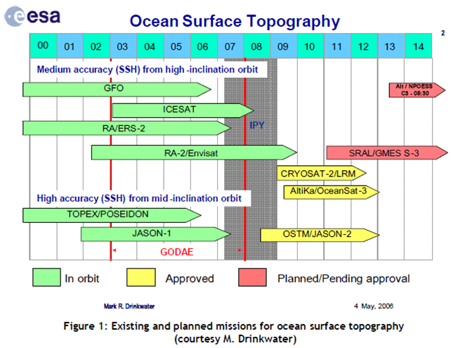
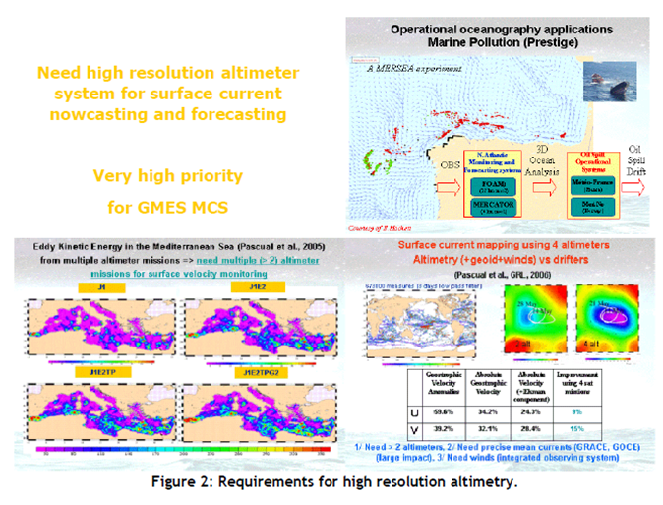
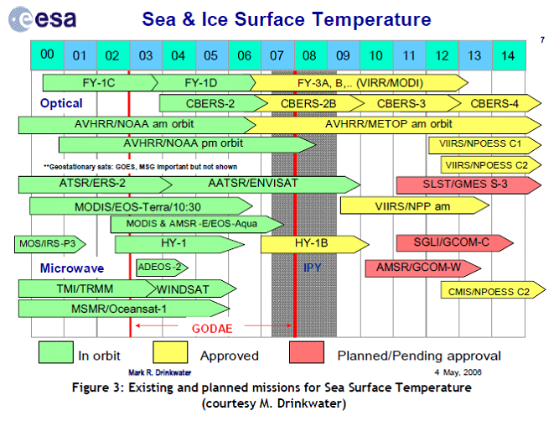
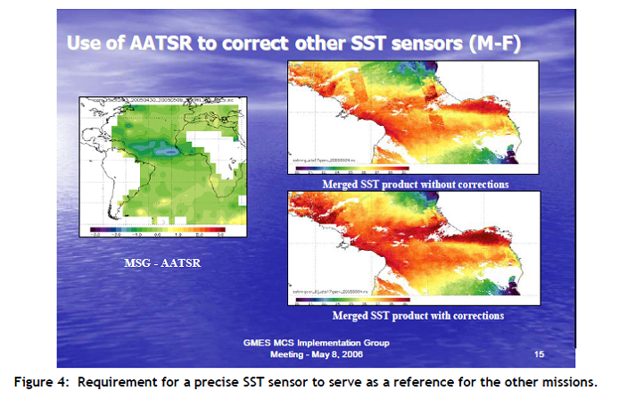
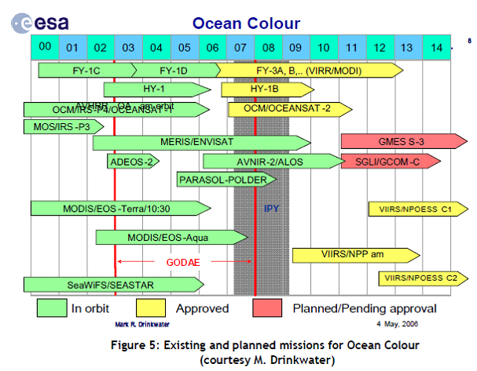
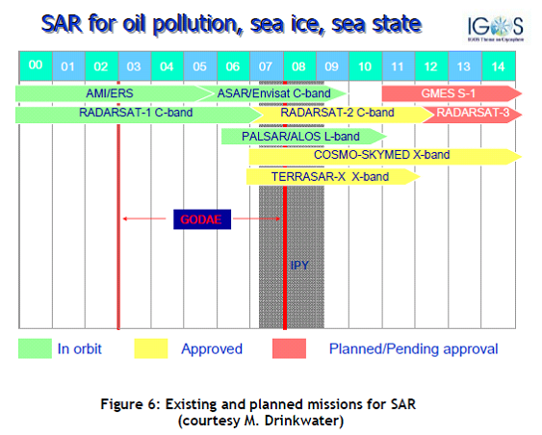
Appendix 4 Adopted Report of the In situ Infrastructure Working Group
While satellites provide a global view of the surface of the oceans, in situ systems provide complementary data, primarily by monitoring their interiors, although valuable surface measurements are made too. In the context of the MCS, global to regional scale observations are required to constrain the models at depth & provide surface calibration and verification data. The primary MCS requirement for in situ measurements at present is for the physical state variables of temperature, salinity & currents and for verification of the forcing wind and wave properties at the surface. However the cost of deployment is generally high, so where possible, it makes sense to make biological and chemical measurements at the same time, provided this does not create a disproportionate cost for the observing system itself.
The candidate observing system technologies for in situ measurements required by the MCS comprise:
- Drifting Argo Floats for the measurement of temperature and salinity profiles to ~2000 m and, by tracking them, mean subsurface currents.
- Research vessels which deliver complete suites of multidisciplinary parameters from the surface to the ocean floor, but with very sparse and intermittent spatial coverage and at very high cost of operations.
- XBTs launched by research vessels and ships of opportunity underway for the measurement of temperature and salinity profiles to ~450-750 m depth.
- Surface Moorings capable of measuring subsurface temperature profiles in particular continuously over long periods of time. Currents are often monitored and meteorological measurements are usually made too. Biofouling restricts the range of measurements that can be made from long deployments in the photic zone but surface salinity and biogeochemical measurements are attempted.
- Ferry-Box and other regional ship of opportunity measurement programmes for surface transects which may include temperature, salinity, turbidity, chlorophyll, nutrient, oxygen, pH and algal types.
- The Continuous Plankton Recorder (CPR) operated by the Sir Alister Hardy Foundation for Ocean Science which is towed from merchant ships on their normal sailings in order to monitor the near-surface plankton of the North Atlantic and North Sea on a monthly basis.
- The network of tide gauges provides long term reference and validation sea level data.
- Gliders which complement floats and moorings and are able to perform transects of physical and biogeochemical parameters from the surface to 1000m at a lower cost than ships.
- Surface drifters that are cheap and light-weight platforms which passively follow the horizontal near surface flow via a drogue/sail. They complement satellites for sea surface temperature and surface current measurements.
- Long-range (up to 200 km) HF-radar monitoring systems in specific regions of national/international interest and importance, typically as part of an observatory
At present it is not realistic to define the full range of in situ measurements and the infrastructure required for down stream services; they are too diverse and in many cases too immature. Progress here will be made by the efforts such as those of the Working Group on European Marine Monitoring and Assessment (EMMA), set up by DG Environment and of the European Environment Agency, which are actively working to define needs and methods of data gathering for assessments foreseen in the (draft) European Marine Strategy Directive. The role to be played here by the MCS can be discerned however, and this has been taken into account in this Report.
There are two key considerations in designing and implementing the in situ infrastructure for the MCS: the performance and deployment of the observing systems themselves and the approach to the collection and processing of the data, at least to level 2.
Performance & deployment
Because of the costs and general difficulty of deployment, it is never sensible to use sensors of marginal sensitivity, robustness and stability over as long a period as possible. Problems are caused by biofouling in the photic zone and attention has to be paid to this in the system maintenance programme at least.
A key issue for the design of networks is the small scale of many important features in the oceans and seas (~100skm in the open ocean; ~10skm in strong flows). It is almost impossible to resolve such features using in situ methods alone; this has to be the role of remote sensing (e.g. EO) methods. The unique role of in situ networks is to augment such broad coverage of a limited set of variables by providing measurements which cannot be obtained in any other way, whilst paying attention to possible aliasing.
Network design
Observing systems differ depending on the area and the phenomena to be sampled. They are usually sorted into 3 categories:
Global: The overall system (remotely sensed and in situ) is designed to provide data from all the oceans and be capable of resolving or at least avoiding excessive aliasing of important dynamical features. Realistically this demands observation on at least the order of 100km. Typically such a system delivers surface and upper ocean observations of a limited number of parameters (Temperature, salinity, SSH, SST, currents) on a time scale from 1 day to 1 month. Such a system can only be built at the international level.
Regional: The overall system is designed to provide data in a specific area, such as a regional sea, to monitor specific dynamical phenomena and state features primarily to sustain one or more specific services (e.g. the TAO/TRITON/PIRATA buoy array for the in situ component of El Nino detection, the Arctic buoy network as a contribution to ice monitoring, etc).Again the goal is to resolve the important dynamical features which are of the order of a few tens of km in the regional seas. Collaboration between several countries (usually less than 10) is needed and the number of parameters is larger (between 10 and 20), including ocean (both physical and bio-chemical) and meteorological measurements. The temporal sampling is often at a higher rate: from hours to days.
Coastal: These observing systems are usually set up at the national level to answer very specific questions such as coastal monitoring of the water quality or wind/wave/tide monitoring in harbour areas, HF radar image acquisition, etc. There is limited collaboration among countries and these data are often used exclusively by the coastal models that have led to setting up the system. These coastal observations that do not form part of multipurpose networks are not in the scope of MCS, but assist in the delivery of downstream services

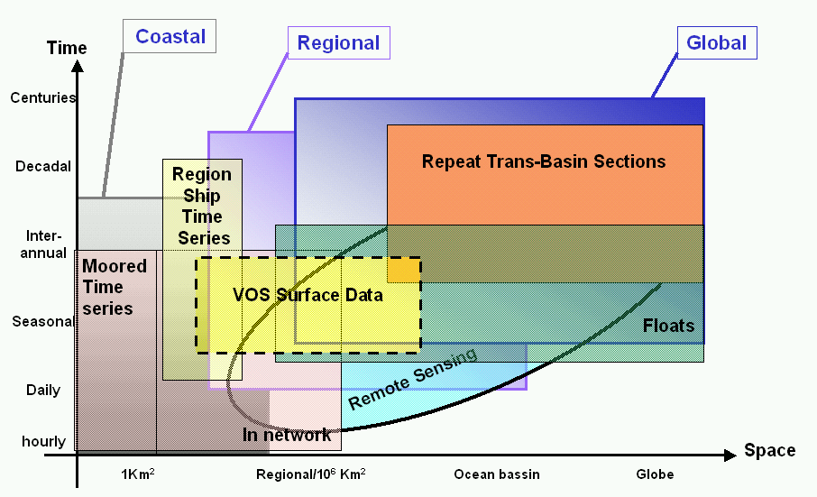

Data collection & management
There are a number of characteristics that define the fitness for purpose of any data collection scheme. These are considered in turn:
Timeliness
MCS needs two types of data. Firstly there are those data delivered in near real time that are required for daily/weekly forecasting activities that provide the common denominator data for downstream services. Secondly there are data that are subject to greater quality control and delivered in delayed mode. These are particularly valuable data for reanalysis work, & to assist seasonal forecasting and climate monitoring/prediction where long term stability is essential and signals are small.
In operational oceanography near real time has a specific meaning. The main criterion is the maximum delay between measurements and assimilation beyond which the measurement adds nothing to the performance of the model. There is no unique answer: this depends on the type of model, the variables that are assimilated, the forecast product and the application for which it is produced. For instance, assimilated information of deep ocean temperature and salinity will persist within an ocean global circulation model for weeks or months and so a delay of several days in supplying data can be acceptable. On the other hand, ocean mixed layers vary on more rapid timescales in response to the diurnal heating and to storms. The impact of such data will probably not persist more than 3-5 days after assimilation, so measurements are needed within a day. As a compromise, real time for operational oceanography generally means availability within 1 or 2 days from acquisition, to allow data centres to allow first-line quality-control of the data.
Sustainability
The observations have to be sustained because when an emergency event happens (tanker pollution, storm events, …) only very few additional useful measurements can be taken. Numerical models that are assimilating data run according to a regular repetitive pattern and require data accordingly. Datasets required to describe climatologies need to be filled on a regular reliable basis. Although it is important for a sustainable operational system to be funded in an ongoing stable manner - in particular other than through research funding - the culture and success criteria of the organisation have to be appropriate too. Services and essential support activities have to be available at all times - 24-hour/7-day-a-week. Attention must be paid to product creation and delivery chains. Services should be fit for purpose and provided efficiently; appropriate performance measures need to be in place to verify this.
All operational activities do need closely coupled R&D activities dedicated to exploiting new science, new sources of data & improved, more capable technology (particularly computer systems), in order to sustain existing services more efficiently and help deliver new and improved services.
Although not always recognised as such these are key features of sustainability.
Availability
As indicated above, data from the domain of interest need to be available in a timely manner to sustain operational services. Because of chronic under- or non optimal sampling there is always value in sharing global and regional data particularly of the state and dynamical variables that are fundamental to the MCS. A data exchange policy that facilitates this is absolutely crucial to success therefore.

Data management
In 1998 EuroGOOS issued a publication called "The science base of EuroGOOS" where some limitations related to data exchange were highlighted. The situation has improved but some statements are still relevant and targeted actions are necessary within Europe to solve them fully:
- Lack of international infrastructure for operational oceanographic data gathering, transmission, and products, (e.g. as adopted in World Weather Watch by the WMO), and consequently a lack of common standards. Although still substantially true in general, some experience on the global scale, within GODAE such as the Argo program have shown that it is possible to reach consensus on common standards (formats, real-time and delayed mode quality control, data distribution…)
- Lack of a clear right or duty to collect and transmit real-time data. In the past five years we have seen the concept of “portals” emerging with the duty to serve their user in real time: Salto/DUACS for altimetry, Medspiration/GHRSST for SST, Argo and GOSUD Global Data centres, and JCOMMOps are examples that exist nowadays.
- Lack of proper design of a service infrastructure, using, for example, multiple data inputs such as wind, waves, and currents, to generate predictions of oil spill movements. Such infrastructures are operational within the Baltic and on parts of the NW Shelf. They are being demonstrated and consolidated more generally within projects such as MERSEA, MARCOAST and Polarview.
- Imbalance between monitoring (measurement) technology and capacity for post- processing data and subsequent real time use by numerical models. In part this has required the development of data assimilation methods in ocean modelling and as that has been shown to be possible and valuable the need has begun to be met through initiatives such as the Coriolis project in France. This effort should be sustained and expanded in the future.
A data management system for operational oceanography must provide quality controlled data, in a timely way, on a regular basis, according to procedures that are clearly documented and evolve upon common agreed decisions between user and provider. There are three fundamental characteristics that define such a system

A4.4. Data access
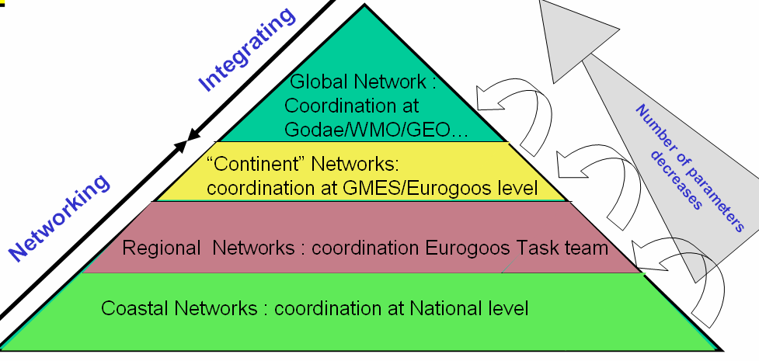

It has been demonstrated that professional users of data need portals that build the connection to all the relevant datasets and provide access to these data as if they were all in a single place. Data are acquired at coastal, regional, pan-continent, global levels and together they enable the overall operational system needed by users. More parameters are usually monitored and needed at the coast than on the global scale. In Europe, EuroGOOS Task Teams and then regional Operational Oceanographic Systems or Networks such as NOOS, BOOS and MOON are coordinating data exchange to sustain coastal and regional services. In principle the regional operational systems could organise data exchange between themselves and contribute to data exchange at the global level. Such coordination would complement initiatives like ESEAS for sea level, SeaDataNet for data infrastructure, DMAC in USA, Argo or GHRSST for GODAE, etc.

Quality control
Quality control of data exchanged in near real-time must be automated leading to the rejection of outliers. In delayed mode, more scientific expertise is applied to the data and error estimations can be provided with the data.
Data quality control is a fundamental component of any ocean data assimilation system because accepting erroneous data can cause incorrect forecasts, but rejecting extreme data can also lead to erroneous forecasts by missing important events or anomalous real features. The challenge of quality control is to check the input data against prior information and either reject or accept them. That prior information may include the historical error characteristics of such measurements and earlier forecasts for the data time, knowing the error characteristics of such forecasts. As most of the data are processed by different actors, but used all together by operational models, clear documentation of the quality control procedures, a homogenisation of the quality flags, and the reliability of different actors in applying these rules are required.
Standardisation
Data must be preserved in such a manner that their usefulness will be retained, essentially for all time. They must also be distributed so that a user can easily merge them with other relevant datasets. They must be catalogued in a way which will facilitate their use. This is the purpose of correctly defining data formats as well as maintaining metadata (data on the data) that need to be preserved for future processing.
Data formats have always been a nightmare both for users and data managers and they all search for the "Esperanto" of data formats. Computer technology has improved the situation in the past decade and we are slowly moving from ASCII formats (easy to use by human eyes but not for software), to binary format (easy for software but not shareable among platforms (Windows, Unix, etc), to self-descriptive, multiplatform formats (Netcdf, Hdf, etc) that allow more flexibility in sharing data among a network and are read by all software that are in common use.
A common vocabulary to record metadata is required. This should be easy to achieve for a specific community such as physical operational oceanography as the number of parameters is small, but it starts to be a bit more difficult when multidisciplinary datasets are addressed. To help in this area some metadata standards are emerging for the marine community with Marine XML in Europe, CF/COARDS convention in USA, and ISO19115 norm.
Appendix 5 Existing Components
Existing infrastructure
was identified in the form of:
- In situ observing systems funded by Member States to meet national needs, e.g. for defence, safety & environmental protection, to fulfil national obligations under Regional Conventions and Directives, sustain research programmes and participate in international programmes partially funded by non-EU states. Generally these have not been designed for multiple uses and the research programmes are rarely funded on other than a short term basis. They do tend to use the technologies listed in Appendix 4, to a variable extent. Any coordination that takes place seems to be on an ad hoc, best endeavours basis, based on the premise that the sum of the parts will probably represent a satisfactory outcome.
- Space based Earth Observation systems funded by Member States via their respective ESA and EUMETSAT membership, or through national programmes. The investments are used to sustain research programmes, meet operational needs, e.g. in defence and meteorology, develop & demonstrate technology, improve industrial capacity and build markets. Access is also gained on various terms to EO systems funded and operated by non-European Space Agencies. The resulting data are used for utilitarian purposes.
- For the marine domain, the technologies that are used and the data requirements and priorities are shaped by the requirement to monitor state, as described above, and what it is feasible to measure to useful accuracy from space based instruments. Appendix 3 characterises current needs, on the basis of the demonstrated capabilities of the current infrastructure. The key issue is that, with the exception of the (EU and non-EU) meteorological (and inaccessible defence) systems, none of the current systems capable of meeting these needs are truly operational. As a result continuity of data supply cannot be guaranteed. This apart, Europe has access to all the necessary capabilities and technologies to meet those needs, in particular through ESA and its Member States and their commitment to GMES.
- Ocean Modelling funded by Member States to meet national needs, e.g. for defence, safety & environmental protection and to sustain research programmes. There are huge numbers of the latter, built firstly for research purposes, impossible to describe in a plan such as this, and arguably with an uneasy connexion to the needs described in section 2.1, other than through the results of those research programmes. Those that are relevant to implementation of the plan, i.e. capable of being operated operationally are identified with their attend data management infrastructure in section 4.3.6. It is important to recall again that models that have the necessary, demonstrated performance capabilities require major investment in very powerful computing facilities that are sufficiently robust (e.g. with appropriate attention being paid to backed-up power supplies and telecommunication links and to staffing). There are rather few of these and most are linked in some way to the meteorological services.
- Operational information dissemination of the real time component and high volume satellite and model output at least is always going to be an issue. Fortunately this is not a problem which is unique to the MCS and so the presumption has to be that it will be solved through the use of existing commercially or otherwise available solutions – not through bespoke methods. The EUMETCAST facility is an operational facility currently available for distribution of the SAF data referred to below. The internet provides a suitable vehicle for the exchange of small amounts of data in the form of ftp files and for the discovery/view functions see section 4.3.7
Relevant existing information services
include those provided in non-real time and real-time
- as public goods by Member State agencies for international Conventions such as HELCOM, OSPAR, Barcelona and ICES and for/via the EEA: e.g. as environmental / climate assessments;
- as public goods by Member State agencies in the form of national environmental assessments and to help secure safety of life and property. Typically the core information services for the latter are provided by the National Meteorological Services for elaboration in downstream services by national agencies according to their particular mandates (e.g. flood risk management, pollution control, etc).
- as public and private goods provided by EuroGOOS (http://www.eurogoos.org/) agencies, some of whom provide prototype MCS type and downstream services: e.g. as analyses and model based forecasts of sea level, temperature and currents for the regional seas, oil slick and algal bloom forecasts;
- as thematic data services by European agencies for their Members: e.g. the EUMETSAT Ocean & Ice SAF (http://www.osi-saf.org/), ocean forcing information by ECMWF, marine observations by EUMETNET and the ESA rolling archive providing access to products obtained from the ERS and ENVISAT missions.
- as service demonstration projects delivering relevant geo-information on an operational basis (e.g. ESA GSEs: Polar View (http://www.polarview.org/) for ice services & MarCoast (http://marcoast.info/) for oil spill and water quality services).
- as operational services for oil-spill detection and attribution run by the European Maritime Safety Agency on behalf of Member State Authorities
- as private goods by public and private organisations offered to their customers to confer commercial advantage e.g. for enabling increased efficiency and/or effectiveness (offshore industries, transport).
All of these have some lessons to offer and provide points of departure for the MCS design. In particular: the high and known quality of the data required to meet the legal requirements of the Conventions; the tested architecture of the Meteorological Services provision as a useful model for that of the MCS and its downstream services; the value of the critical mass and the resulting world class performance that can be achieved by carrying out some functions at a European level, and the possibility of creating and satisfying markets by tailoring and fusing data within specialist services, particularly where these can be served, in part at least, by core information generated once and used many times. There are difficulties too. As far as the Conventions are concerned, the time between “sampling events” and publication of assessed results is presently about three years. The involvement of an operational MCS, as described in section 6.1, may be able to reduce this delay.
Past and current R&D projects
Some of these were funded within the 5th, 6th and 7th Framework Programmes, others through ESA or by national investment. It is neither necessary nor possible in this plan to describe them all but there are examples which have contributed substantially to the building blocks of an effective, efficient MCS. For example:
from the Framework Programmes, in the form of:
- Observing systems foundations – EDIOS, ODON, SeaDataNet
- In situ observing systems – GYROSCOPE, ANIMATE, BRIMOM, FerryBox
- EO based observing systems – SOFT, GAMBLE
- Capacity Building – MAMA, PAPA, ARENA, GRAND
- Sea-level monitoring – GAVDOS, ESEAS-RI
- Safety of Shipping – MaxWave, IRIS
- Ice Services – DAMOCLES
- Pre-operational pilots – TOPAZ, IOMASA, MFSTEP
- GMES preparations – MerSea Strand 1, OCEANIDES
- Integrated Projects – MERSEA, ECOOP, MyOcean
The MyOcean IP is currently developing and demonstrating the capabilities required of an MCS as discussed further in sections 4.3.2 and 4.3.5 -7.
From ESA projects:
- Medspiration – developing a European service for near real time precise sea surface temperature
- Globcolour – developing a European service for ocean colour.
- The GODAE Sea Surface Temperature Pilot Project (GHRSST-PP) is a good example of an international project that has spun up a global service, with European contributions from the Medspiration project and EUMETSAT Ocean & Sea Ice SAF, and which now provides an excellent basis for a truly operational, comprehensive European SST service within the MCS, to mirror the US Global Data Analysis Center (GADC).
In addition there have been innumerable national R&D projects which have developed relevant specific capabilities, many of which are now contribute to operational services. These include:
- MERCATOR (France) – global & regional models
- FOAM (UK) – global and regional models
- Coriolis (France) – a data management system
- MONCOZE (Norway) – for coastal environment management
- SmartBuoy (UK) – in situ physical, biological and chemical monitoring
- Alg@line (Finland, Estonia) - automated ship borne monitoring
- Seatrack Web (Sweden/Denmark) – an oil drift forecasting system
- POL (UK) – a coastal observatory
- POSEIDON (Greece) – an in situ monitoring and forecasting system
- ADRICOSM (Italy) – an in situ monitoring and forecasting system for the Adriatic Sea
All of these have brought or are bringing some new insights and tools of relevance to operational oceanography and hence to the MCS. Unsurprisingly the recent MERSEA IP was of particular importance in developing and demonstrating capabilities that are fundamental importance to an operational MCS. Much of the ensuing design is based on the exploitation of those capabilities and lessons learned. There is more to do to develop observing systems, other data collection mechanisms & forms (e.g. surveys) and models to provide the information for soundly based ecosystem management and the ECOOP IP is needed to help push these capabilities further towards the coast. Particular lessons were learnt It is very important that the MCS,as an operational system, has a closely coupled R&D programme – another important lesson learned in operational meteorology, and elsewhere.
Finally the lessons learned in the MyOcean project are described in a separate section.

Appendix 6 Organisation of operational oceanographic services by public bodies and intergovernmental bodies
The Global Ocean Observing System (GOOS) http://www.ioc-goos.org/ has now organised its work into a global component, largely targeted upon understanding and describing the role of the oceans in climate research and prediction, and regional observing systems developed by Regional Alliances. These regional observing systems aim to deliver information relevant to climate on these scales but also to the full range of policy issues described in paragraph 2.1 for the European area.
EuroGOOS is the GOOS Regional Alliance for Europe. It liaises, at an institutional level, with MedGOOS in the Mediterranean to work with non-European States there and with Black Sea GOOS, to aid capacity building.
From this liaison and through its 33 member institutes, a number of Regional Task Teams have been set up based on the rationale above. Several of these have made formal agreements to form Operational Oceanographic Systems /Networks (collectively known as ROOSs) to implement best practice and achieve effective day to day collaboration. At present these comprise:
- Arctic TT • Arctic GOOS, with a pending MOU designed to deliver operational oceanography in the Arctic.
- Baltic TT • BOOS, with an MoU between 19 institutes to do likewise in the Baltic
- North West Shelf TT • NOOS, with a MoU between 19 institutes with an interest and relevant capabilities on the North West shelf, including the North Sea.
- Biscay / Iberian TT • IBI-ROOS (MOU pending), with similar interest and capabilities in those shelf areas
- Mediterranean collaboration • MOON, secured by a MoU between 26 institutes in the riparian states.
- Black Sea – to be created.
This is helpful because it provides a body of organisations, agencies and individuals that have learned to work together to provide operational oceanographic services and the associated infrastructure in the form of in situ observing systems, models, data assembly centres and communication/distribution systems to meet the needs of their end users.
The available evidence suggests that the implementation of standard technologies and the development and deployment of new in situ sensors are organised effectively at the regional level. A detailed knowledge of the physical, biological and chemical characteristics of the domain and appropriate logistic and technical expertise are generally available. Relatively rapid decisions can be taken and data exchange within a ROOS is normally very effective. It is less clear that deployments are made other than to meet national priorities, i.e. regional coordination of network design is weak.
A global coordination is needed for homogenisation of sampling criteria at regional level, for exchange of experience and information, for homogenisation of quality assurance/control. Global coordination is required to define common protocols and guidelines (quality assurance of field work, calibration – intercalibration of sensors, quality control procedures, standards, etc). ESA, EUMETSAT, their Member States and national space agencies have been very effective in building up these capabilities for the exploitation of EO data.
It is expected that thee Members of EuroGOOS will contribute towards the implementation and monitoring of the marine core service.

Communication from the Commission to the European Parliament, the Council, the European Economic and Social Committee and the Committee of the Regions Global Monitoring for Environment and Security (GMES): we care for a safer planet Brussels, 12.11.2008 COM(2008) 748 final
Communication from the Commission to the European Parliament, the Council, the European Economic and Social Committee and the Committee of the Regions Global Monitoring for Environment and Security (GMES): Challenges and Next Steps for the Space Component Brussels, 28.10.2009 COM(2009) 589 final
GAC(2005)12 - Workshop on GMES Marine Core Service, Brussels – October 27-28, 2005: a report by P. Ryder, J.-F. Minster, N. Pinardi, K. Resfnes, M. Bell and J. Johannessen
See section 6.1
The Maritime Policy Green Paper has emphasised that commercial sectors such as shipping, fishing, oil exploration, offshore construction, aquaculture, and tourism, and public sectors such as coastal protection, defence, search and rescue, R&D and government policy making all need dataon past, present and future meteorological, oceanographic, hydrographic and ecological state of the seas and the oceans. Global-scale monitoring is required to meet this need and the EU is being encouraged to set up a European Marine Observation & Data Network to provide sustainable, improving access to information.
An Integrated Maritime Policy for the European Union Brussels, 10.10.2007 COM(2007) 575 final
Here we mean the physical, biological and chemical state of the environment, in general. The need for the biological component is likely to be expressed in terms of the state of ecosystems, and habitats; the chemical component in terms of pollutants and nutrients. Legally, the MSFD speaks of good environmental status.
Europe 2020, A European Strategy for smart, sustainable and inclusive growth, 03.03.2010 COM(2010) 2020
timing indicates fastest speed that information is required. In most cases archived data is required as well in order to analyze past trends, predict future events and calibrate models.
In practice, the actual intermediate users may be contactors appointed by the listed agencies or institutes
Most of these applications require vessel detection in synthetic aperture radar. Better knowledge of sea-state can improve confidence in results.
The marine core service is a necessary but not a sufficient condition for better seasonal weather forecasts. More research is needed to show whether these are viable.
There is a relationship between sea conditions and recruitment but it is not yet well known. It is expected that, as knowledge accumulates, better data on physical and chemical composition of the water might reduce uncertainties in fisheries management
Some moorings and the Ferry Box technology are capable of near real time biogeochemical reporting. New technologies such as gliders and ARGO floats can also collect biogeochemical data and are very promising for the provision of near real time data
Marine Knowledge 2020 – should be adopted as a Communication in June 2010
In general such models need to embrace the important, relevant processes on/in the land, sea, cryosphere and atmosphere, and interactions between them.
"validation required" Editorial Nature 463, 849 (18 February 2010)
The Global Ocean Observing System (GOOS) http://www.ioc-goos.org/
Commission Staff Working Document accompanying the Proposal for a Regulation Of The European Parliament And Of The Council on the European Earth observation programme (GMES) and its initial operations (2011 – 2013) Impact Assessment And Ex Ante Evaluation SEC(2009) 639
Need to reference presentation by Bahurel at implementation group meeting
It is not at the moment because it does not use any products from the marine core service
Workshop Conclusions, Space and the Arctic Workshop, Stockholm 20 ‐21 October, 2009, Under the auspices of the Swedish presidency of the European Union
http://www.ferrybox.org/
http://www.euro-argo.eu/
According to its Mandate (especially Art 3, Council Regulation (EEC) No 1210/90 of 7 May 1990) EEA plays a key role in the European in-situ monitoring community. In July 2004 EEA outlined its view of the objectives and role of in-situ monitoring within GMES (GAC (2004)6), followed by a first progress report on the development of the GMES in-situ monitoring component in November 2004 (GAC(2004)21
For instance, EUMETNET (the European network of meteorological services) for meteorological insitu observation systems and services; EUROGOOS (the European Association for the Global Observing System); EUROGEOGRAPHICS (the European association of National Mapping and Cadastral Agencies) and Eurogeosurveys (the European Association of Geological Surveys) for cartography, geology, mapping and reference data; and EMODNET (the European Marine Observation and Data Network) for marine data or other bodies under the umbrella of the EU Integrated Maritime Policy.
CEOS has defined a number of data/product levels for use in Earth Observation. It is helpful to use a common nomenclature in discussing data processing. Level 0 Data: Raw data after restoration of the chronological data sequence for each instrument, i.e. after demultiplexing of the data by instrument, removal of any data overlap due to the data dump procedure and relevant quality checks. Raw instrument data information (telemetry packets) is maintained during this process. Level 1a Data: Instrument data in full resolution with radiometric and geometric (i.e. Earth location) calibration computed and appended but not applied. Level 1b Data: Calibrated, earth located and quality controlled data, expressed as radiance or brightness temperature, in the original pixel location, and packaged with needed ancillary, engineering and auxiliary data. Level 1c Data: In case of the IASI spectra, level 1b data after application of the apodisation function. Level 2 Product: Earth located pixel values converted to geophysical parameters, at the same spatial and temporal sampling as the level 1b data. Level 3 Product: Gridded point geophysical products on a multi-pass basis. Level 4 includes the use of other data sources, e.g. model results etc.

