ALGAE SPECIES CONSUMED AS TRADITIONAL FOOD
EU4Algae – Working Group 3
EABA - Vitor Verdelho

What are novel and traditional foods?
Novel food refers to food that European citizens have not consumed to a significant degree prior to May 1997. It includes food from new sources (e.g. oil rich in omega-3 fatty acids from krill), food obtained through the application of new technologies (e.g. nanotechnology) or by using new substances (e.g. phytosterols or plant sterols).
Traditional food is a subset of novel food. The term relates to food traditionally consumed in countries outside the EU. It includes foods made from plants, microorganisms, fungi, algae and animals (e.g. chia seeds, baobab fruit, insects, water chestnuts).
https://www.efsa.europa.eu/en/press/news/161110

Image | Specices | Traditional consumption
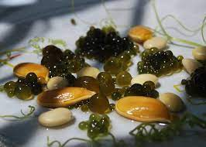 | Nostoc
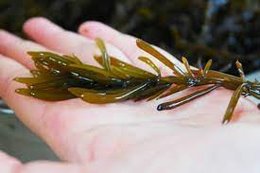 | Hizikia fusiformis | Hijiki is a dark, wiry seaweed that is often used in Japanese, Korean, and Chinese cuisine.
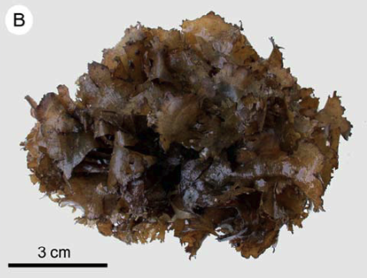 | Cladosiphon okamuranus | Mozuku is a brown algae native to Okinawa, Japan, and is often served in salads and cold dishes.
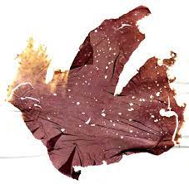 | Porphyra spp. | Laver is a type of red algae used in Korean cuisine, particularly in the preparation of kim and other side dishes.
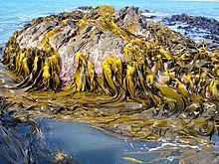 | Durvillaea spp. | Cochayuyo : Cochayuyo is a large brown seaweed that grows along the coast of Chile.
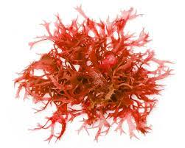 | Lithothamnium calcareum | This red coralline algae is consumed in parts of Chile and Peru and is used as a seasoning in dishes like ceviche and salads.
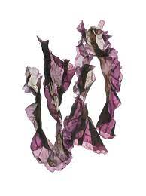 | Pyropia spp. | Nori: In parts of South America, similar red algae species to Asian nori are consumed by indigenous peoples and used in traditional recipes.
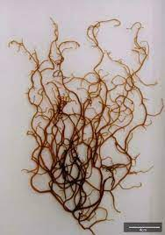 | Cladosiphon okamuranus | Mozuku is a type of brown seaweed that has been traditionally consumed in parts of South America, particularly in Peru and Chile.
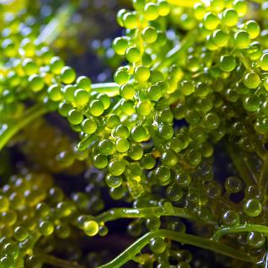 | Caulerpa lentillifera | Also known as "green caviar" or "sea grapes," this green algae is used in Chinese cuisine, especially in the southern coastal regions.
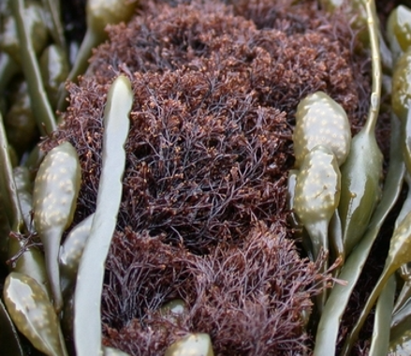 | Polysiphonia lanosa | Polysiphonia lanosa is a widespread growing epiphytically on Ascophyllum nodosum wherever it is found and occasionally on other species of Fucus.
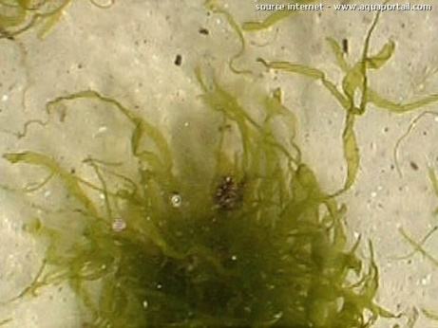 | Enteromorpha flexuosa | A green algae named “imu vai, imu tapaa or imu ketaha depending on the location of the algae. This is the main consumed algae in French polynesia (Ua Huka and Ua Pou).
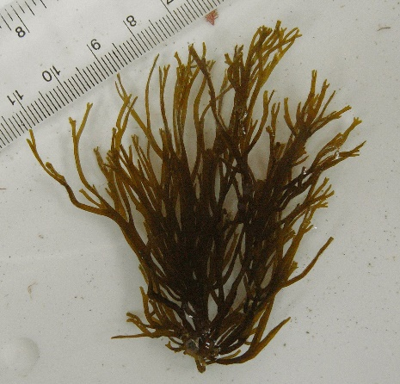 | Chnoospora minima | A brown algae named imu keikei aoa is consumed in French polynesia (Ua Huka).
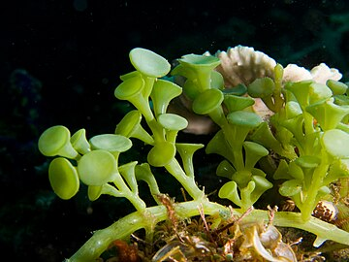 | Caulerpa racemosa | A green algae named imu topua (or flower algae) is consumed in French polynesia (Ua Huka and Ua Pou).
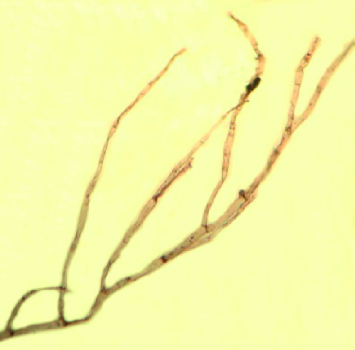 | Cladophora patentiramea | A green algae named imu ouoho (or hair algae) is consumed in French polynesia (Ua Huka).
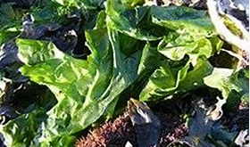 | Ulva lactuca | A green algae named imu kokuu is consumed in French polynesia (Ua Huka).
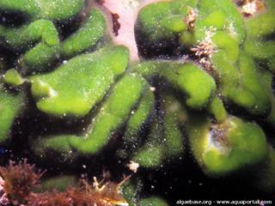 | Codium arabicum | A green algae named imu totae kioe (rat poo algae) is consumed in French polynesia (Ua Huka and Ua Pou).
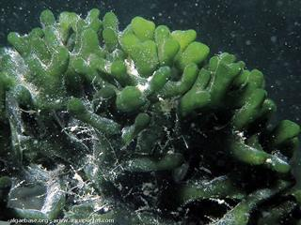 | Codium geppiorum | Consumed in Hawaii and several islands in the Pacific, either raw ou cooked with fish in coconut milk.
 | Palmaria palmata | Egil Saga

The new guidance documents explain in detail the kind of information applicants need to provide for risk assessment. They also clarify how to present this information before EFSA can assess the safety of the novel or traditional food.
Applicants submitting novel food applications need to present data describing the product. Dossiers should include data on the compositional, nutritional, toxicological and allergenic properties of the novel food as well as information relating to the production process, and the proposed uses and use levels.
EFSA addresses traditional food from third countries (non-EU countries) in a separate guidance document. Applicants need to present evidence of safe use of the traditional food in at least one country outside of the EU for a period of at least 25 years. EFSA and Member States will assess the evidence in parallel procedures.

Guidance on the preparation and presentation of the notification and application for authorisation of traditional foods from third countries in the context of Regulation (EU) 2015/2283
Published:
10 November 2016
Adopted:
22 September 2016

https://www.efsa.europa.eu/en/efsajournal/pub/4590

REFERENCES

- La consommation des algues en Polynésie française : premiers résultats d’une enquête. Journal de la Société des océanistes · May 2002. Conte et Payri, 2002.

