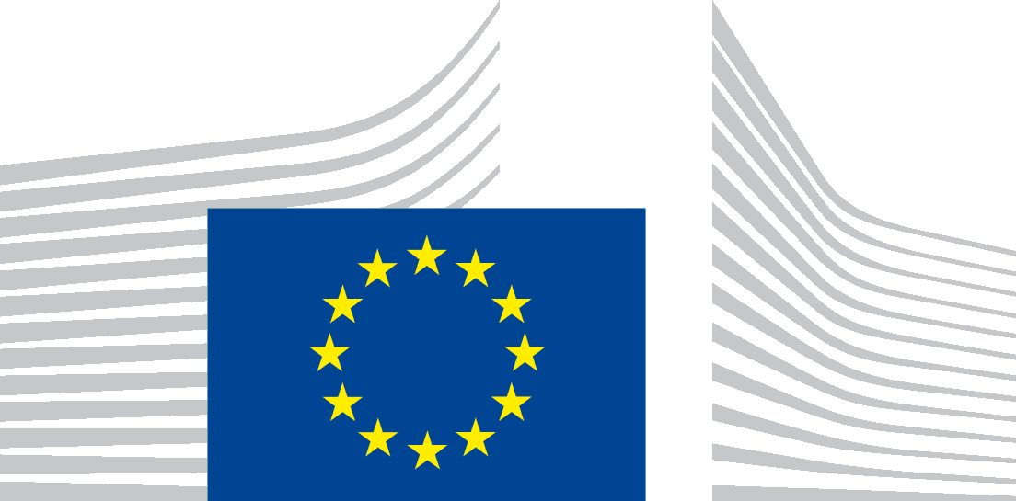 | EUROPEAN COMMISSION  DIRECTORATE-GENERAL FOR RESEARCH & INNOVATION  Directorate F - Bioeconomy  F.4 - Marine Resources
DRAFT AGENDA
3rd meeting for developing a Blue Growth Initiative for Research and Innovation in the Black Sea
Monday, 11 December 2017
Time: 11.00 – 17.00
Venue: European Commission - DG MARE
Rue Joseph II 99 1000 - Brussels
Meeting Room: J99 00/53

- Welcome and Tour de table
- The matrix of marine research projects:
  - Presentation of the updated matrix followed by discussion (Institute of Marine Sciences, METU, Turkey)
  - next steps
- Short updates from
  - DG RTD - Sigi Gruber (Head of Unit, DG RTD) and
  - DG MARE - Christos Economou (Head of Unit, DG MARE)
- R&I International cooperation in the Black Sea basin (Andrea Carignani Di Novoli, Head of Unit, DG RTD)
- Presentation from EuroGOOS, Glenn Nolan, Secretary General, EuroGOOS - European Global Ocean Observing System
- German research cooperation in the Black Sea basin - presentation from KDM German Marine Research Consortium, Jan-Stefan Fritz, Head of Brussels Office
- Update on the Facility for blue economy development (DG MARE)
- Vision paper for the Strategic Research and Innovation Agenda, next steps towards the EMD in Burgas
- AOB

