Setting up a redirect

Information shared with us by Raul Jimenez van Hoorn

I managed to set up a redirect from an unwanted page with duplicate content to an appropriate page:  
<https://maritime-forum.ec.europa.eu/contents/eu4ocean-coalition-ocean-literacy-connecting-diverse-organisations-projects-and-people_en>  
… now redirects automatically to … <https://maritime-forum.ec.europa.eu/theme/ocean-literacy-and-blue-skills/ocean-literacy_en>

The way to do this was quite straightforward:  
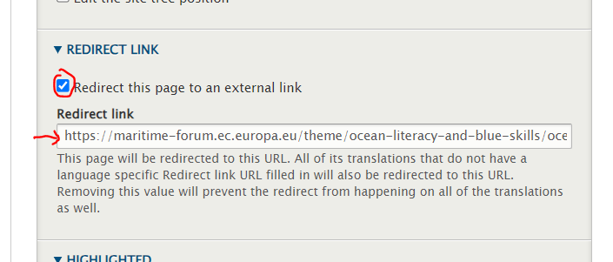

In other words, on a published page you want to redirect elsewhere:

1. Click New Draft
2. In the bottom-right of the edit screen, check the “Redirect this page to an external link” check box
3. Fill in the URL you want to page to redirect to
4. Save the draft
5. Then Publish the draft

Setting up this redirection means that Google may transfer some ‘SEO score’ from the old page to the new page and makes sure people who Google us don’t arrive to a “404 Page not found” or “Access Denied” page which would otherwise interrupt their exploration of EU4Ocean.