GMES Fast Track
Marine Core Service

Strategic Implementation Plan*
2010 update Version, 16/04/2010

Author:
Hans Dahlin, Chairman
of the Marine Core Service Implementation Group

* DISCLAIMER : this is a working paper of the Implementation Group on GMES “Land Monitoring”. It does NOT represent the opinion of the European Commission
Outlines
The objective of the Global Monitoring for Environment and Security (GMES) is to provide, on a sustained basis, reliable and timely services related to environmental and security issues in support of public policy makers’ needs. GMES is an EU-led initiative, in which ESA implements the space component and the Commission manages actions for identifying and developing services, relying on both in-situ and space-borne remote sensing data. GMES will use, to the maximum extent possible, existing capacities in Member States or at European level.
The implementation is starting with three “Fast Track” Services (FTS) addressing Land Monitoring, Marine Monitoring and Emergency Response.
As announced in the Commission Communication in November 2005, the choice of these FTS has been driven by (i) their technical maturity, (ii) their uptake by the user communities (relevance for policy making and policy implementation); and (iii) existing conditions for long-term sustainability of demand and supply.
After user consultation workshops organised in 2005, three Implementation Groups (IG), composed with representatives of the various user communities, were set up for these three FTS in 2006.
In accordance with its terms of reference, each IG analyzed the main issues related to FTS implementation, including the scope of the service and its potential evolution, its functionality and architecture, its main structure and governance principles, as well as its requirements regarding observation infrastructure and data needs, data integration and information management issues.
The IG capitalised on previous and ongoing research activities financed under EC (FP6) and ESA schemes (GMES Service Element (GSE)).
The main outcomes of the IG analysis have been gathered in the enclosed Implementation Reports, which provide recommendations regarding the main FTS implementation issues based on the initial scope of the service (or “fast-track”) as well as its evolution.
Special attention has been given to the functions and structuring of the FTS at European level. More specifically, the GMES services are structured around ‘Core’ and ‘Downstream’ service layers. ‘Core services’ are pan-European in scope and generic in nature. More specialised
‘downstream services’ to meet the needs of a range of different users (e.g. national, regional or local) can be derived from them by further value-adding and customisation.
As a user-driven initiative, GMES should ensure a continuous user uptake through constant consultation with users and integration of their changing needs in an iterative process.
In the short term, the analysis included in IG reports will be used as a basis for current R&D and demonstration activities, in particular those that will be funded within the Space Theme of FP7. In the long-term, these reports will be fine-tuned through further interaction with user communities and consultation process and could contribute to the design of the overall GMES structure and governance.
Revised version following the comments from the GAC Delegations 1
Contents
Executive Summary 7
Introduction 7
Purpose, scope & functionality of the MCS 7
Observational components of the MCS 9
Implementation plan 10
Main guidelines 10
Proposed strategy and application 10
Architecture implementation 11
Demonstration 12
MCS governance and related issues 12
Selection of operators 13
Funding & Data Policy 13
Conclusion 14
1 Introduction 16
2 The purpose, scope and functionality of the MCS 18
2.1 Purpose 18
2.2 The nature of the MCS 19
2.3 The scope of the MCS and its rationale 20
2.4 Marine Core Service Functionality 23
2.5 The concepts of upstream providers, intermediate users & end users 24
2.6 Simulations – how to respond to ‘What if?’ questions 25
3 The required observational components 26
3.1 The required space infrastructure 26
3.2 The required in situ infrastructure 27
4 The Strategic Implementation Plan 28
4.1 Principles and sources of guidance used 28
4.2 Foundations of the Marine Core Service 28
4.2.1 Existing infrastructure 29
4.2.2 Relevant existing information services 30
4.2.3 Past and current R&D projects 30
4.3 The proposed strategy and its application 32
4.3.1 Architecture 32
4.3.2 Implementing the architecture 36
4.3.3 The space infrastructure 37
4.3.4 The in situ infrastructure 40
4.3.5 Data collection, assembly and quality control 41
4.3.6 Ocean modelling and data assimilation 43
4.3.7 Service generation, access, delivery and support 44
4.3.8 Standards 48
4.4 Funding & Data Policy 48
5 Governance and related issues 50
5.1 Accountability & Management structures 50
5.2 Interactions with intermediate users 51
5.3 Criteria for selecting operators and modification of the partnership 52
5.4 Conflicts of interest 52
6 Examples which test the suitability of the strategy in delivering specific end-to-end services in and beyond 2008 53
6.1 In support of (the assumed) implementation of the Marine Environmental Strategy Directive and other environmental protection policies. 53
6.1.1 Service requirements 53
6.1.2 Specific product requirements 54
6.1.3 Observing system requirements 54
6.1.4 Relevant current coordinating organisations 55
6.1.5 End-to-end services 55
6.2 Ice Services 55
6.2.1 Context 55
6.2.2 Service requirements 57
6.2.3 Specific product requirements 57
6.2.4 Observing system requirements 57
6.2.5 Relevant current coordinating organisations – 57
6.2.6 End-to-end services 57
6.2.7 Benefits 58
6.3 Oil spill monitoring 58
6.3.1 Context 58
6.3.2 Service Requirements 59
6.3.3 Specific Product Requirements 59
6.3.4 Observing System Requirements 59
6.3.5 Relevant Current Coordinating Organisations 60
6.3.6 End-to-end services 60
6.3.7 Benefits 60
GMES Fast Track Service Implementation Groups: Terms of Reference and composition and working methods of the Marine Core Service Implementation Group 62
Terms of Reference 62
Composition & working methods of the Marine Core Service Implementation Group 62
Characterisation of MCS variables & products 64
Adopted Report from the Working Group on Space Infrastructure for the GMES Marine Core Service 66
Executive Summary 66
General recommendations: 66
Specific recommendations: 66
Introduction and mandate of the WG 67
Main requirements from the MCS 67
A3.4. Review of Sentinel 3 68
Overview of ESA Sentinel 3 MRD 68
Altimetry 68
SST 69
Ocean Colour 71
Recommendations for the Jason and METOP, MSG/MTG series and for non- European missions complementary to Sentinel-3 74
Jason-3 74
Review of Sentinel 1 / SAR 74
Other European and non-European SAR missions 77
Ground Segment (to be developed later) 77
Summary of recommendations 77
References 78
Adopted Report of the In situ Infrastructure Working Group 80
Performance & deployment 81
Network design 81
Data collection & management 82
Timeliness 82
Sustainability 82
Data management 83
Quality control 84
Standardisation 84

Executive Summary
Introduction
The formative Workshop which led to the acceptance of the Marine Core Service (MCS) as a GMES Fast Track was held in Brussels on October 27-28 2005. Subsequently a small Implementation Group (IP) was set up to supervise and validate the implementation of the Service, in open cooperation with the relevant user communities. The Terms of Reference, composition and working methods of the IG are reproduced at Appendix 1 to the report.
The main output of the IG to date is this Strategic Implementation Plan and the supporting documents generated by working groups set up by the IG, subsequently approved, and either incorporated into or attached as appendices to the Plan.
If endorsed by the GMES Bureau and GMES Advisory Council, the Plan will provide ratified guidelines and prioritisation for implementation. In the short term it is envisaged that it will guide current R&D and demonstration activities being pursued with EC and ESA funding, in particular those that will be funded within the Space Theme of FP7. However, it is hoped that the Plan will also provide a roadmap for a long-term, sustainable Marine Core Service able to support a wide range of downstream services, some of which can be seen today but many of which will only emerge when the MCS is in place. With this in mind, an effort has been made to describe the rationale for the guidelines and priorities, not simply the proposals themselves. It is hoped that the Strategic Implementation Plan will give confidence to the EC and Member States that their expectations of GMES in the marine domain have a good chance of being fulfilled and that their continued support is warranted.
Purpose, scope & functionality of the MCS
The Implementation Group in representing the requirements of users has confirmed that the purpose of the Marine Core Service is to make available & deliver a set of basic, generic services based upon common-denominator ocean state variables that are required to help meet the
needs for information of those responsible for environmental and civil security policy making, assessment and implementation.
The relevant policy drivers have been identified as the Regional Conventions, the 6th Environmental Action Plan (in particular its Climate Change and Marine Environmental Strategy components), the Sustainable Development imperative now being developed through the Green Paper on Maritime Policy, relevant existing EU Directives, and ongoing concerns over civil security.
All of these require long running data sets to define the mean, fluctuations, and past trends in the state of the marine environment to record its evolution and the success or otherwise of policy responses and, with predictions of future change, to establish baselines for effective environmental management. Data reanalyses, obtained through assimilation by state of the art models, will be particularly helpful in an era of climate change. Such information will also provide design criteria for structures and operations in the marine environment that are fit for purpose. In addition short range predictions (out to several days ahead in general and with a few hours lead time with greater accuracy) are required particularly of hazardous conditions, but also for the efficient conduct of every day operations.
The information services required to fulfil these purposes need to have global and pan-European scope. The variables about which information is provided will be domain-specific; i.e. likely to vary between the regional seas and global oceans & between high and mid latitudes. They are described in appendix 2.
The MCS is conceived as one part of a processing chain which operates on observational and other forms of data to help create tailored information services to meet a wide range of end user needs. Almost all such end user services relating to the marine environment require access to information about the state and dynamics of the oceans and seas. The MCS provides that information to intermediate users who combine it with other forms of information and data (e.g. socio-economic data) to provide customised downstream services for the end users.
The implementation of the overall chain needs to have some flexibility; as components of downstream services are developed to serve multiple uses, it may be more efficient fo r them to be provided as part of the MCS.

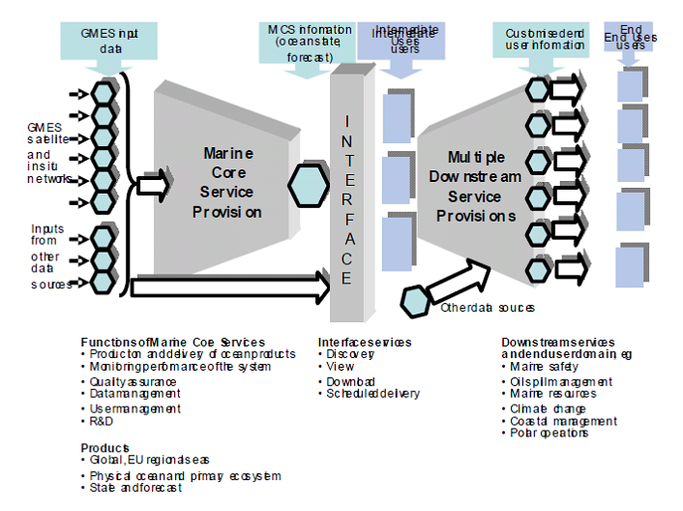
The processing chain within the MCS must:
Acquire data from the ground segment of the space based observing systems and in situ networks.
Acquire atmospheric forcing data (atmospheric winds, temperatures, fluxes) from National Meteorological Services and ECMWF
Assemble these into quality controlled thematic datasets (i.e. specific data types such as sea surface temperature, salinity profiles…) suitable for the generation of more extensive data sets for subsequent use, analytical products and assimilation by ocean models. Much of this has to be carried out in near real time
Run numerical ocean models in near real time to assimilate the thematic data and generate analyses and forecasts from them to an agreed and generally perpetually repeating cycle, which uses information from earlier forecast cycles as well as the most recent thematic data. The centres also need to operate offline to produce reanalyses / hindcasts.
Prepare products suitable for external service provision at the ‘Interface’ shown above. That interface must have a discovery and viewing capabilities and the ability to download specific products in response to requests. It must also be able to deliver, probably quite large volumes of data, routinely to an agreed schedule to meet the needs of specific intermediate users.
Observational components of the MCS
The main requirements of the space-based observation infrastructure are:
Continuity of tried and tested observational methods is crucial. This is particularly critical around 2010 when data gaps could occur for several of the most critical observations.
It is more critical to establish satellite series for sustainable service availability than to try optimizing the specifications and designing for any one satellite and its instruments, if the latter leads to expensive, non renewable satellites. Establishing satellite series should lead to significantly lower production costs.
The Jason series (high accuracy altimeter system for climate applications and as a reference for other missions) is an essential and critical component of the GMES satellite programme for MCS. Planning of Jason-3 must be a priority for GMES.
The MCS requires a high resolution altimeter system with at least three altimeters in addition to the Jason series. Sentinel-3 should include a constellation of two satellites, flying simultaneously, providing adequate coverage and operational robustness. Instrumentation costs for S3 should be reduced as much as possible to allow for a two- satellite system.
Compared to the present design of S3 instrumentation, the priority for Sea Surface Temperature is for high accuracy dual view measurements. The large swath requirement has a much lower priority, in particular (but not only), if S3 is a two satellite system.
For Ocean Colour a sensor having a similar spectral resolution to MERIS is essential to meet the important shelf and coastal ocean water quality measurement requirements.
SAR data (Sentinel 1) are required for oil spill detection and sea ice monitoring. This is clearly a European core service that should be considered as part of the MCS. The requirement is for at least one and preferably two SAR missions in addition to the other non-European missions (e.g. RADARSAT).
Access to other European and non-European (e.g. NPOESS) satellite data in real time is fundamental for the MCS.
GMES should allow for research and technological developments. In particular, the possibility of embarking new instruments with the potential to meet GMES needs should be considered. Wide Swath altimetry and geostationary ocean colour are the two most important new technology developments that will benefit the GMES MCS in the long run.
Detailed ground segment requirements and offerings by ESA and EUMETSAT remain to be agreed. But the main recommendation is likely to be that the GMES ground segment should develop robust interfaces with EUMETSAT Ocean & Sea Ice SAF and with the MCS satellite data assembly centres – see below.
The main requirements of the in situ observation infrastructure are:
Again the focus must be on observing methods and technologies that have been sufficiently tried and tested in research and operational services. Candidate observing systems comprise:
Drifting Argo Floats for the measurement of temperature and salinity profiles to ~2000m and, by tracking them, mean subsurface currents.
Research vessels which deliver complete suites of multidisciplinary parameters from the surface to the ocean floor. Such vessels should be encouraged to collect and report routine surface observations whenever they are underway.
XBTs launched by research vessels and ships of opportunity underway for the measurement of temperature and salinity profiles to ~450-750m depth.
Surface Moorings capable of measuring subsurface temperature profiles in particular continuously over long periods of time. Currents are often monitored and meteorological measurements are usually made too. Biofouling restricts the range of measurements that can be made from long deployments in the photic zone but surface salinity and biogeochemical measurements are feasible.
Ferry-Box and other regional ship of opportunity measurement programmes for surface transects which may include temperature, salinity, turbidity, chlorophyll, nutrient, oxygen, pH and algal types.
The Continuous Plankton Recorder (CPR) operated by the Sir Alister Hardy Foundation for Ocean Science which is towed from merchant ships on their normal sailings in order to monitor the near-surface plankton of the North Atlantic and North Sea on a monthly basis.
The network of tide gauges which provides long term reference and validation sea level data.
Priorities for implementing these technologies in a coordinated manner to provide continuity and expand their utilisation, particularly to achieve near real time data collection, are proposed and the need for global and regional data assembly centres is discussed.
Implementation plan
Main guidelines
The IG has adopted a number of principles:
GMES is a joint initiative of the EC, ESA & Member States so it is assumed that all have a vested interest in its success, judged by the value of the information services that it delivers, and will be willing to commit commensurate resources and adapt working practices to achieve that success.
To be judged successful in these terms, the MCS must be genuinely driven to support intermediate users on behalf of their end users, all of whom will appreciate the value of its services and be able to determine its output & influence its evolution.
The MCS must be designed and implemented to meet identified needs in a reliable, easy to use manner, having guaranteed 24-hour/7-day-a-week availability, and providing information of useful precision and stability.
There is considerable scope for integration and coordination of existing efforts. The MCS must:
make maximum use of past investment and existing facilities;
be sustainable on an operational basis, with appropriate governance and funding built into the system.
Proposed strategy and application
In keeping with the imperative to ensure that the needs of end users are understood and acted upon, and to make maximum use of past investment and existing facilities these have been reviewed to establish sound foundations upon which to build the MCS.
The identified needs are summarised in section 2.1 and appendix 2. The MCS foundations can be characterised as:
the existing infrastructure in the form of in situ observing systems, EO systems and data collection and modelling systems that are in place to provide environmental information services;
those information services themselves, and
previous and current R&D projects that have or are delivering relevant understanding, tools and capabilities.
The chosen strategy is to build on these foundations by making maximum use of existing systems and past investment in knowledge and tools. The existing systems are distributed so the design of the MCS must be distributed. In effect a system of largely existing systems and those under development is the goal.
The strategy is then implemented by analysing the required functionality of the component systems to establish whether and if so where they exist already or might easily be upgraded to meet requirements. The reports of the WGs on the space based and in situ infrastructures are used for this, together with other knowledge and insights obtained from published literature, the members of the IG and their contacts. Remaining gaps are identified, at least in functional terms and with some candidates to fill them. Sustainability demands that unnecessary duplication is not carried into the implementation of the MCS. Where possible a road map for the process has been suggested and priorities established and recommendations made.
Architecture implementation
The key step is to recognise that modelling of the marine environment can and needs to be carried out at different scales in different domains and that biological and chemical processes take place within the context of the prevailing physical environment. This recognition leads to the adoption of two categories of nesting of models; (i) physically from the global, to the regional, to the national, to the local and (ii) nesting of ecosystem process modelling within an appropriate physical model.
For (i), the actual choice of domains is determined by the combination of physical geography and user need. Thus:
The Mediterranean, Baltic and Black Seas have their own particular physical and ecosystem characteristics largely defined by their bathymetry, fluvial inputs and limited but important exchanges with their adjoining seas.
The Arctic Ocean is predicted to be the location of the most rapid and dramatic climate changes during the 21st century, with the potential of major ramifications for mid- latitude climate. It also plays a major role in the freshwater balance of the North Atlantic and is a very hostile environment.
The North West shelf is one of the most complex in the world in terms of the intensity of marine exploitation, multiplicity of industries, services and social amenities, complexity and detail of regulation, adjoining population density and industrial development. It is also subject to input from large European rivers, agricultural run off and sensitivity to climate change.
The North Atlantic plays a major role in the global circulation and has significant effects on European weather and climate. It provides the boundary conditions directly for the North West shelf and interacts strongly with the Arctic Ocean.
Seasonal and climate prediction are impossible without knowledge of the three dimensional state and dynamics of the global ocean. Europe has global interests requiring access to global information.
It is envisaged that the MCS will comprise at least one operational modelling and data assimilation activity for each of these domains, with an exchange of boundary conditions as necessary: e.g. between the global and ocean basins and their shelf seas, and between the enclosed regional seas and their adjoining ocean or shelf sea. The resolution of the models is not prescribed but should aim to be start-of-the art for provision of the common denominator data that are required from the MCS.
The MERSEA IP Consortium has adopted a functional architecture for a demonstration of its perception of the MCS based on three Thematic Assembly Centres (TAC) and five Monitoring and Forecasting Centres (MFC), which it jointly describes as Thematic Portals (TEPs). The five MFC cover the main ocean domains: Global, Arctic, North West Shelves and NE Atlantic, Baltic, and Mediterranean (the, Black sea remains to be integrated). Jointly the TEPs comprise a processing chain which carries out the functions listed in section 2 above through a collection of services distributed among providers’ physical systems. Responsibility for the necessary services resides with the appropriate TEP.
Whilst care will be needed to ensure robustness and avoid single points of failure, implementation based on the MERSEA design, using the capabilities, tools, techniques, procedures and standards developed, adopted and being tested by the consortium, is an attractive way ahead and the IG recommends their adoption for the MCS. A key feature of the design is its commitment to interoperability and distributed functionality. This should allow potential contributors to the MCS, who are not members of the IP, to augment its capabilities by contributing needed services, provided that they operate according to the rules which ensure that interoperability and ease of use by intermediate users.
A number of candidate providers of the TACs required for processing space based and in situ observations are identified, as are centres operating ocean models which should be able to carry out the required data assimilation and modelling functions by 2008.
It is further concluded that there should be one service delivery centre for each of the global and regional sea domains identified above providing information discovery, viewing and download/delivery functions based on open standards. These should provide access to the required and available MCS products and defined support services.
Demonstration
The suitability of the strategy is tested in section 6 through a small number of end-to-end case studies of its envisaged application. These are based on:
Support for existing environmental protection Conventions and the (assumed)
implementation of the Marine Environmental Strategy Directive.
The provision of ice services.
Support for oil spill detection and management.
In each case the required data, the contribution of the MCS and of intermediate users providing required down stream services are reviewed.
MCS governance and related issues
It is envisaged that the MCS will be distributed and comprise a number (of order 10 as discussed in section 2.3) of operators that will produce and offer products and services, as characterized in appendix 2 and section 4, to intermediate users. Some such operators are likely to be consortia. Other operators will be responsible for the Thematic Assembly Centres. Other actors will exist in the form of external data providers, such as ESA and EUMETSAT for Earth Observations and agencies in Member States for in situ data, acting singly or as the consortia which comprise the Operational Ocean Systems/Networks of EuroGOOS.
Although other options exist, in order to provide the necessary degree of integration and coordination of policies and decisions made in common by the MCS operators, it is suggested that a MCS Management Organisation (MCSMO) be formed. This would need to have a legal
personality. Looking inwards, it would be responsible for ensuring that the operators as outlined above delivered their offered services according to agreed Service Level Agreements (SLAs). The external data providers would probably have SLAs with the GMES Management Authority, but the alternative of making them with the MCSMO is for consideration. Looking outwards, such an Authority would represent the MCS in its interaction with the GMES Management Authority with respect to the ‘General Management’ Function described in GAC(2006)6. An MCSMO would be better able to exercise the Technical Management function described in that document than would a GMES-wide Authority, simply because the user demand, technical solutions, actual performance, research needs and qualification processes are likely to be specific to the marine domain at least.
In the very short term, i.e. in responding to opportunities to demonstrate and develop the MCS within FP7, such a Management Organisation might be created and operated by a lead partner and comprise an executive composed of representatives of a consortium of operators. However, in the longer term, there would be some merit in creating a separate entity with its own legal identity. The European Economic Interest Group (EEIG) has some characteristics which would make it an attractive company structure.
Day to day interactions between product and service providers and their users should be conducted directly. Proposals for cataloguing and searching for data, products and services are made in this Strategic Implementation Plan. However there will be a need for intermediate users to interact with the operators and MCSMO to determine, on a long term basis, the scope and characteristics of services to be offered, any changes to them and agree priorities and an associated R&D programme. Some form of MCS Commissioning Forum, meeting at least annually, could provide a suitable body for this.
Selection of operators
The services will be provided by operators (i.e. institutes, agencies, companies, or consortia) that manage and operate functional centres. They should be selected on the basis of their ability to fulfil the requirements of a legally binding contract, their access to the required resources, their expertise (scientific and technical), their operational status, track record and previous performance, commitment to work with the interfaces, and cost-effectiveness. Regional knowledge and ownership will clearly be important, as well as sound repartition of the work between Member States
The composition of the MCS should be reviewed periodically to allow for modifications of the partnership. Several elements could be considered in such reviews, e.g. the (duly weighted) national resources committed to the system, the relative performance and strengths of potential operators, national policies, needs for new services, and their ability to provide fully operational and sustainable services.
A level of competition in some aspects of the process chain will be appropriate to create incentives to innovate and improve performance. For this purpose there will be a need to encourage a measure of functional duplication. However, this will need to be balanced against the imperative to create critical mass in a relatively few centres and the difficulty of duplicating major investments.
Funding & Data Policy
At present there are no reliable estimates of the full costs of an effective, efficient MCS or of the upstream and downstream capabilities that are required to deliver value from it. Such estimates are required during the next year or so as experience grows during the FP7 funded demonstration phase; not least to ensure that the case for long term funding is robust.
In the interim, it is assumed that, because the services being delivered by the MCS are public goods they will be co-funded by the EU and Member States, not at the point of delivery by charges levied on intermediate users.
On this basis, it is further assumed that upstream data and MCS data, products and services made available to intermediate users will be free of charge, except for the cost of delivery, if they are used exclusively for GMES purposes.
It is expected that intermediate users will be financed through user charges in effect for the value that they add to the information and services that they obtain from the MCS and other upstream service providers. Some ancillary data may fall within the scope of the INSPIRE Directive others will be available on terms specified by their suppliers.
There is no doubt that some EU level support will be desirable for intermediate service providers during the MCS demonstration phase at least. It is understood that this is planned within FP7. At present such support is being provided by the ESA GSEs, in particular MarCoast and Polar View.
In future the data purchase activities of EMSA and the ESA managed - EC funded data-buy planned within FP7 will be important in this regard, if they are sustained.
Conclusion
The Marine Core Service was chosen as a GMES Fast Track initiative because a clear need was identified for its output and the necessary foundations for its creation and successful demonstration by 2008, and successful operational implementation thereafter, were in place. That remains the case.
The task now is to build on those foundations by mobilising the undoubted intellectual and material resources that exist within European organisations such as ESA and EUMETSAT and within agencies, institutes and industry within EU Member States and focus them on activities throughout the processing chain that:
Are well researched (and tested where possible) and therefore known to be scientifically and technically robust, and state of the art.
Will deliver what is required by intermediate and end users in order to ensure that polices designed to deliver environmental protection and sustainable development are developed, tested and implemented.
The critical success factors are judged to be:
Implementation of the priorities/actions requested in this Plan to secure space based and
in situ observing capabilities, noting in particular the need for continuity of data supply;
Successful mobilisation of the resources needed to implement the MCS, in a fair, transparent, efficient and effective manner. That involves building on past investment, which has inevitably created strong centres with capabilities in specific areas, whilst keeping open the door to innovation and valuable contributions from elsewhere – no
‘closed shop’;
Avoiding unnecessary duplication that does not add to robustness and can be wasteful of resources;
Achieving interoperability throughout what is likely to be a complex processing chain and thereby making services readily accessible to intermediate users, only some of whom are identifiable today;
Adding needed improvements to existing services; Adoption of the requested data policy.
The strategy of building upon the capabilities being developed in the successful Integrated Project (MERSEA), relevant ESA GSEs (MarCoast and Polar View) and past national R&D and Framework Programmes is designed to ensure state of the art. The use of service delivery portals focussed on the global and specific regional seas should it make it easy for users to locate data & products to meet their requirements. By making these portals available to all potential suppliers willing and able to provide effective services, users will have choice and no such supplier will be at a disadvantage. The insistence upon the use of open standards should ensure interoperability.
The substantial funding by the EU and ESA Member States of the first Sentinel 3 and 1 is vital of course, but continuity beyond this first segment of the mission and of the Jason series is not yet secure. The funding of a pre operational MCS demonstration project, designed on the principles set out above, within the FP7 Space Programme will facilitate implementation of the strategy. The allocation of FP7 funds to the purchase of space data is welcome. The commitment of a relatively small amount of money for coordination of and investment in selected in situ networks should help to maximise the value of Member States’ current investment in such data sources, and could have a disproportionate impact because such coordination is ad hoc at present.

Introduction
The formative Workshop which led to the acceptance of the Marine Core Service (MCS) as a GMES Fast Track was held in Brussels on October 27-28 2005.
There it was agreed that the MCS:
- will provide the common denominator data for all users in the marine sector, in other words the information (sometimes mandatory) for existing & new downstream services;
- should deliver regular and systematic reference information (processed data, elaborated products) on the state of the oceans and regional seas:
    - at the resolution required by intermediate users & downstream service providers, of known quality and accuracy,
    - for the global and European regional seas, with downscaling capacity based on specific needs.
- products should comprise:
    - observational and model data,
    - real time data and predictions (from days to weeks) and re-analysis (longest time series of information about the ocean state in the past),
    - simulations (what-if scenarios).
In order to deliver its products, the MCS should contribute to:
- Organisation of sustainable development and operations (interoperable &coherent) of:
    - the observing systems
    - the modelling & forecasting facilities
    - the data harmonization and information for the global & regional scales, Strengthening of the connection with downstream services (e.g. marine safety,
- oil spill monitoring, harmful algae bloom monitoring, coastal management, marine resources…),
- Integration & upgrading of the capabilities of existing national services.
It was further agreed that there is a need to show that several components of the MCS are already working in Europe and to convey this message to the decision makers. In addition, it was noted that the MCS provides an effective means to utilize the significant investment of the GMES space component. In this context there was a complete understanding that the ESA-GMES Space programme is fundamental to the success of the MCS.
The MCS was enjoined to concentrate on the global to the regional European scales, so that the European concerted effort will be justified. MCS should then be configured as an initial European contribution to the marine segment for GEOSS.
Small Implementation Groups were set up after the 2005 user workshops for each of the three GMES Fast Track Services. They were given the mandate of supervising and validating the implementation of these Services, in open cooperation with the relevant user communities.
The Terms of Reference, composition and working methods of the Marine Core Service
Implementation Group (IG) are reproduced at Appendix 1.
The main output of the IG to date is this Strategic Implementation Plan and the supporting documents generated by working groups set up by the IG, subsequently approved, and either incorporated into or attached as appendices to the Plan. This plan has been updated in 2010 as guidance for the 2012-2014 gap filling activities to move from R&D to real operational services.
If endorsed by the GMES Bureau and GMES Advisory Council, the Plan will provide ratified guidelines and prioritisation for implementation. In the short term it is envisaged that it will guide current R&D and demonstration activities being pursued with EC and ESA funding, in particular those that will be funded within the Space Theme of FP7. However, it is hoped that the Plan will also provide a roadmap for a long-term, sustainable Marine Core Service able to support a wide range of downstream services, some of which can be seen today but many of which will only emerge when the MCS is in place. With this in mind, an effort has been made to describe the rationale for the guidelines and priorities, not simply the proposals themselves. It is hoped that the Strategic Implementation Plan will give confidence to the EC and Member States that their expectations of GMES in the marine domain have a good chance of being fulfilled and that their continued support is warranted.
To fulfil its mandate and build upon the conclusions of the Workshop the IG has addressed a number of specific issues:
- The purpose, scope and functionality of the Marine Core Service, especially of its global and regional components
- The space infrastructure required by the Marine Core Service, including the requirement for and continuity of current European capacities (space and ground segments) operated by EUMETSAT, ESA and national agencies, and the possibilities for international cooperation (complementary or shared capacities)
- In situ infrastructure for the Marine Core Service, especially the requirement for and sustainability of European capacities and their contribution to international systems as well as the European coordination to manage these capacities
- Structure and governance of the Marine Core Service, including, for example, the sharing of activities and operational responsibilities between the service provision partners and the associated service level agreement process, defined between the GMES Management Authority, representing the MCS user communities, and, for example, a MCS Provider Consortium, including the impacts of this service level agreement on the consortium partner status and on service information policy,
- Links and interfaces between the Marine Core Service and downstream services, including the requirements of downstream services for MCS products, their dependencies in terms of product delivery (timeliness, quality control, …) and the associated contractual issues.
These are now reviewed before the implementation roadmap is developed and described.

The purpose, scope and functionality of the MCS
Based on the adopted Working Group reports, other papers and discussions at the meetings of the IG, the following clarification of this issue has been obtained:

Purpose
The policy drivers have been identified as:
- Regional Conventions between Member States & the EC – OSPAR / HELCOM / Barcelona;
- 6th Environmental Action Plan; in particular its Climate Change and Marine Environmental Strategy2 components;
- The Sustainable Development imperative which is written into the Rome Treaty and is now being developed through the Green Paper on Maritime Policy3
- Relevant existing EU Directives, such as the Marine Strategy Framework Directive and the Water Framework Directive in its application to coastal waters.
- Specifically the Integrated Maritime Policy of the EU has defined many information needs, which the MCS is most suited to help to provide
- EMODNET is a new initiative to gather and share better Marine Knowledge and the MCS has a specific role to provide parts of it.
- Concerns over civil security which manifest themselves in particular for safety of life and property in the marine environment, and the recognition that whilst there are risks to be managed through well designed warning systems, defences and other preventive measures, major natural hazards and man made accidents will occur that also need to be managed. The Prestige accident in 2003 and flooding in Holland and England in 1953 and in New Orleans in 2005 are examples.
- There is also a growing requirement to prevent and police illegal activity, much of which centres on drug and human trafficking via the marine domain.
All of these require long running data sets to define the mean state of the marine environment, fluctuations about that, past trends and future predictions of change (particularly in era of uncertainty about climate) to establish baselines for environmental management and design criteria for structures operating in the environment. In addition short range predictions (out to several days ahead in general and with a few hours lead time with greater accuracy) are required particularly of hazardous conditions, but also for the efficient conduct of every day operations.
The MCS must be designed and implemented to meet these needs in a reliable, easy to use, operational5 manner, with information of useful precision and stability.
The Lisbon agenda is also an important policy initiative for GMES as a whole, noting that the programme is included in the Quick Start Programme and expected to foster the creation of new, innovative information based services and knowledge.

The nature of the MCS
The information services required to fulfil this purpose need to have global and pan- European scope. The variables about which information is provided will be domain- specific; i.e. likely to vary between the regional seas and global oceans & between high and mid latitudes.
The MCS is conceived as one part of a processing chain which operates on observational and other forms of data to help create tailored information services to meet a wide range of end user needs. Almost all such end user services relating to the marine environment require access to information about the state and dynamics of the oceans and seas. The MCS provides that information to intermediate users who combine this with other forms of information and data to provide customised downstream services for end users. The concept is illustrated in figure 1 and further elaborated in section 2.5 below.
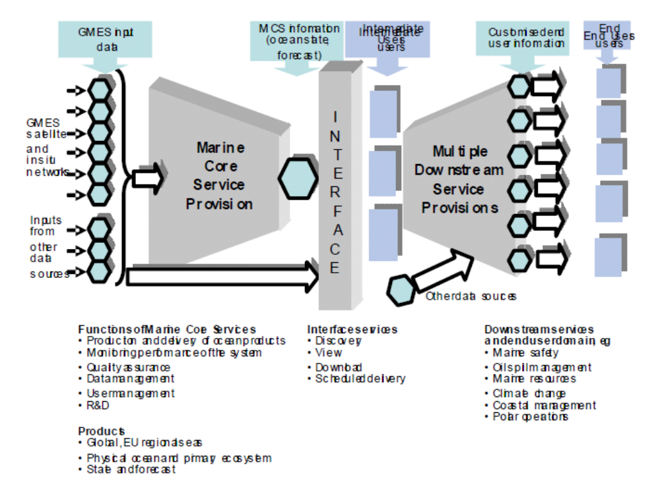
Figure 1service delivery chain
Figure 1 illustrates the position of the MCS in the overall chain of service delivery from GMES input data to the provision of multiple information services to end users.
The implementation of the overall chain needs to have some flexibility. As components of downstream services are developed to serve multiple uses, it may be more efficient for them to be provided as part of the MCS.
The envisaged MCS variables & products are described in Appendix 2. The applications /areas of benefit that these are capable of serving are indicated in table 1.

Area of benefit | Products | To intermediate users6 | Final user
Climate research | Comprehensive and inferred observational data sets reanalysed in state of the art models | Climate research centres | Ocean and climate research; validation of scenarios.  Policy making on climate change
Marine Environmental Protection | state and impact data &  associated indicators | EEA, OSPAR, HELCOM, Barcelona, National environmental agencies; | DG ENV, Policy makers, general public
Extended range & seasonal weather forecasts | Initial ocean conditions;  reanalysis | ECMWF, National Meteorological Services (NMS) | Agriculture, insurance, energy, transport;  public safety preparedness; research
Marine safety | High resolution ice/sea state & ocean current forecasts | NMSs, National Oceanographic Agencies, National Marine safety agencies, maritime transport industry | Search and rescue, drifting object management; extreme wave forecast preparation; marine transportation
Fisheries, ecosystems | Physical conditions; re- analysis of past conditions | National marine and fisheries institutes | ICES, DG FISH, National fisheries;  research
Shipping & offshore industries | High resolution ice/sea- state & current forecasts for operations: reanalyses for design | Value adding service companies | Operation support, ship routing, structure design criteria, risk assessment; EMSA
Oil Spill management- | Temperature, wind, wave & current data | Responsible National marine agencies & European Marine Safety Agency (EMSA) | Affected coastal public authorities &  businesses
Civil Security | Temperature, wind, wave & current data | Customs & Excise, Coast Guards | DG TREN, Immigration and drug control agencies, police forces
Marine Environment, Ecosystems | Boundary and initial conditions, data products | National Coastal monitoring and forecasting system | National environmental or marine  agencies; National WFD reporting; Coastal  management.

Table 1: A generic summary of areas of benefit, product lines, intermediate and final users

The scope of the MCS and its rationale
At the present time it is entirely feasible, with useful accuracy, to describe the physical state of the oceans and seas, including the relevant dynamics, from the surface to the sea floor, provided that representative data are available to (a) resolve the main dynamical and physical characteristics sufficiently often to span the period of useful predictability of current numerical models (a few weeks) and (b) describe the forcing from the atmosphere. It is valuable, and for some purposes and locations essential, to know the extent and nature of ice cover and the flux of fresh water from the major rivers. The nature of the bottom topography is clearly important but that is sufficiently well known, on the broad scale at least.
Some in situ measurements are available from research vessels to characterize the biological and chemical state of the seas but these are often sparse in time and space and tend to be concentrated in coastal waters. They are rarely available in near real time. They do allow identification of long period trends at (hopefully) representative locations. Some limited properties can be inferred more frequently and extensively from EO data, e.g. primary productivity and sediment levels from ocean colour measurements. The presence of some pollutants, in particular oil spills and excessive nutrients, leading to extensive algal blooms at the ocean surface, can be inferred from EO data too. But there is no doubt that additional in situ data are needed to define the biological and chemical state more comprehensively.
Time dependent models of the oceans and seas are crucial for maximising the value of intermittent sparse data to deliver the best possible descriptions of their past, current and future state. Physical models are well developed and available with increasing resolution for the global oceans and regional seas. Methods for nesting limited area, higher resolution models within global and regional models are available too. Models of biological and chemical processes in the seas that are capable of providing useful analyses and predictions of at least the lower trophic levels of ecosystems remain in the research domain. Substantial powerful computing facilities, housed and operated to achieve 24- hour/7-day-a-week availability are essential to deliver truly operational services and such facilities are required to conduct development of ecosystem models for future operational use. These exist in the National Meteorological Services, National Oceanographic Agencies or major research facilities that have a mandate to provide operational services, but are few in number.
With these caveats, and the hope that continuity of EO data can be maintained and in situ monitoring improved, it is clear that an MCS that can fulfil its purpose, given the availability of the necessary computing, data collection and processing facilities and skilled staff to operate them.
The descriptions above provide necessary but insufficient criteria to define the scope of a practical, deliverable MCS. It is also necessary to place some limits on the areal extent and resolution of common services to be provided as part of the MCS and those which will be more properly and efficiently provided as downstream services – see below. There are strong arguments – see section 4.3.1 - for recognizing the particular characteristics and needs for MCS products on a global scale, for the oceans which border Europe and their shelf and regional seas. But are the needs for descriptions of the physical, biological and chemical state of every estuary or coastal zone to be met by the MCS? Are high resolution models of every EEZ to be maintained and operated when needed to predict the evolution of major accidental releases of pollutants as part of the MCS? Surely not. These are important specialised, normally national, needs which should be met by downstream services, coordinated where necessary at a regional or EU level. Such services will be supported by the MCS through the provision of broader scale state descriptions, in particular in the form the boundary and initial conditions for high resolution models of coastal or otherwise defined domains of interest.
The rationale for this conclusion is both political and economic.
Firstly, the principle of subsidiairity notes that: "nothing should be done by a larger and more complex organization which can be done as well by a smaller and simpler organization". The architecture that is proposed in section 4, a system of systems, from global to regional, follows that tenet. The coastal domain, where the greatest diversity of end users arises, is not considered part of the MCS, since it can be served most effectively at a national and local level by downstream services. If the MCS was to maintain the capability to provide diverse, high resolution services everywhere, for all possible purposes requiring information about the common denominator state variables, it would need to be a very large and complex organization. Furthermore, it would still be necessary for the MCS to interface with intermediate users to combine the state variables with all other local information, which is necessary to resolve real social, economic and environmental issues, so there would be few savings and the potential for complex, unmanageable interfaces. This is not to deny that some of the ‘front end’ functions of the MCS – see section 2.4 below – could and should not be carried out at regional centers, particularly where they can make use of existing capabilities as discussed in section 4.2.
Secondly, the substantial investment that will be needed to provide MCS services requires the number of computer intensive modeling/data assimilation centers at least to be kept to a minimum, consistent with the recognized large scale variation in the global and regional European oceans and seas and a desire for some technical competition at the margin. The envisaged consolidation and integration to relatively well equipped centres brings the potential for improved value for money and scientific quality, as well as robustness to the system. In the spirit of the European Research Area, the integration of the MCS can play a significant role in drawing the intellectual resources and tapping the expertise of a wide community. The Workshop which led to the decision to Fast Track MCS implementation, and much prior discussion, recognised this and concluded that the number of such centres should be of order 10. Provided that information from the MCS is freely and readily available for further elaboration in downstream services and there is a sharing of tools, that conclusion is upheld by the IG. This will release public and private downstream service providers from the need to duplicate the services provided by the MCS and enable them to focus on the many localised, tailored services that are required by end users.
The intention to provide significant EU funding through the FP7 Space Programme to support the further development and demonstration of the MCS, whilst investment in downstream service provision is likely to fall mainly to Member States and commercial organizations, provides a countervailing pressure to maximize the size and scope of the MCS. The IG believes this pressure to be unfortunate because it could deliver an unsustainable outcome in the long term unless managed carefully. It would be a huge mistake to support development and demonstration of a multiplicity of pre-operational systems (potentially with sub-optimal performance) through FP7 which could not be sustained. This again argues for an MCS which is as small as necessary to deliver its fundamental purpose at the European scale. This is not to deny the need to build up expertise in Member States to use the MCS information for their specific needs. The issue of funding is discussed further in section 7.

Marine Core Service Functionality
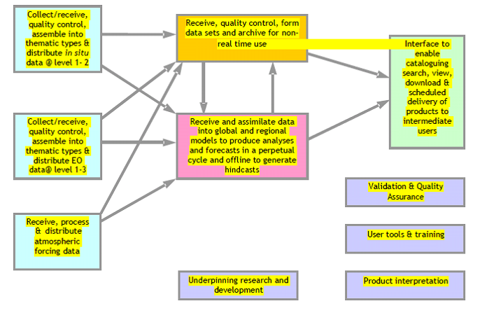
Figure 2 essential functions of an MCS
Recognizing that the MCS must collect, quality control and process data, using numerical models and standard analytical tools, to produce and deliver, hindcasts, analyses and forecasts the required operational functions of an MCS are as illustrated in Figure 2.
Briefly the functions are to:
- Acquire data from the ground segment of the space based observing systems and in situ
- networks. Typically these will be at level 1 or 2 (See Appendix 4).
- Acquire atmospheric forcing data (atmospheric winds, temperatures, fluxes) from NMSs and ECMWF
- Assemble these into QC thematic datasets (i.e. specific data types such as sea surface temperature, salinity profiles…) suitable for the generation of more extensive data sets for subsequent use, analytical products and assimilation by ocean models. Much of this has to be carried out in near real time
- Run numerical ocean models in near real time to assimilate the thematic data and generate analyses and forecasts from them to an agreed and generally perpetually repeating cycle, which uses information from earlier forecast cycles as well as the most recent thematic data. The centers also need to operate offline to produce reanalysis / hindcasts.
- Prepare products suitable for external service provision at the ‘Interface’ shown in Figures 1 & 2. That interface must have a discovery and viewing capabilities and the ability to download specific products in response to requests. It must also be able to deliver, probably quite large volumes of data, routinely to an agreed schedule to meet the needs of specific intermediate users.
The required support functions are elaborated further in 4.3.4; they are essentially to monitor and validate the performance of the MCS to assure the quality of its products, provide customer support in the form of interpretive tools and training, and prioritize and oversee the research and development needed to sustain the MCS.

The concepts of upstream providers, intermediate users & end users
The division into upstream and downstream components of the service chain is based on the imperative “to produce information once but use it many times” for specific public or commercial end user applications. Not all environmental information services are suitable for delivery in this way, but wherever there is a need for information about the current or predicted future state of the environment, widely defined, it makes sense to try to meet this once rather than many times. This is particularly true when, as here, substantial resources (computers and skilled people) are needed to assemble basic state data, assimilate them and use high resolution, complex models to predict future states. This lesson has been learned and applied extensively in operational meteorology and recent research has demonstrated that it is equally applicable to operational oceanography. Figure 1 exemplifies the chosen architecture of the chain.
Upstream providers collectively comprise the providers of (i) relevant EO and in situ data and atmospheric forcing information and (ii) the Marine Core Service (MCS). They provide crosscutting/core products and data services (upstream services), which are the basis for intermediate users/downstream services as described above.
The expected functionality of the MCS is described in paragraph 2.4. The equivalent functionality of the EO and in situ data providers is described in sections 3 and 4 respectively, and in the associated appendices. However in simple terms it is expected that these upstream providers will:
- develop, construct and operate the space and ground based facilities necessary to deliver the required data; in fulfilling the delivery function, they will calibrate instrument measurements and convert them to geo-located estimates of geophysical, chemical or biological variables (i.e. generate level 2 data sets)
- in some areas produce coherent, quality controlled data sets, possibly from multiple sources (i.e. generate level 3 products).
Note that intermediate users are recipients of the data and products generated by the MCS from the combined use of atmospheric forcing information and basic in situ and EO data, models and data assimilation. Typically they will generate information services that downscale the larger scale MCS products to the local scale and increase the number of analysed, predicted state variables at the local level to meet end user needs. Therefore, such services will generally require the capture of additional forms of data to deliver economic or societal benefit. Typically such additional data might be high resolution meteorological forcing in delivering storm surge predictions, socio-economic in a policy development context, pressures (e.g. catch and fisheries effort data) to set alongside state variables from the MCS to understand observed environmental impacts, assets at risk in managing a hazardous event, vessel identification and tracking information for maritime surveillance etc. The resulting information services are downstream services. It is recognised that downstream services today might become core services in future, as multiple uses are found for particular data sets and types of information. Therefore the definition of these two service streams has been couched in general terms to provide flexibility in future.
Ultimately the public will validate, or not, the benefit of GMES. But, as characterised in
Table 1 above, in general end users can be categorised as:
- governmental departments/agencies, at EU or Member State level, that require marine products and information for developing and validating policies respectively (e.g. DG Environment, DG Fish, DG TREN, National Departments of Environment,.) ;
- “public downstream services” that actually implement public policies, and are frequently part of the mandate of national agencies (e.g. flood risk managers, environmental protection agencies, immigration and drug control agencies, police forces);
- providers of maritime services of various kinds, (e.g. shipping, port operations, coast guards,.. )
- commercial and industrial end users (e.g. offshore oil, gas and aggregate extraction companies, fishing companies, …).

Simulations – how to respond to ‘What if?’ questions
Much policy-making raises questions of the kind ‘What if we were to do x or y?’ as a precursor to formulating a response to an unwelcome impact of a pressure. This requirement was identified at the October 2005 workshop and the MCS needs to respond to it.
The requirement can be met in a number of ways, but in essence, the capability is needed to run experiments in which all of the important processes affecting the outcome are mimicked and the consequences of the hypothesised action are tested. Scaled physical models can be used for this purpose to test the consequences of changing the morphology of an estuary for example, but on the scale of the oceans and seas recourse has to be made to numerical earth system models of sufficient scope to internalise all the important
processes and feedbacks between them. The models developed to assimilate data and model oceanographic processes for the MCS are certainly capable of mimicking internal processes sufficiently well and therefore test the consequences of possible changes to inputs, e.g. of the consequences of large scale changes to nutrients from land based sources, but they are not designed for this purpose. Fortunately suitable world class earth system models have been developed and do exist within Europe - to assess the consequences for climate of increased greenhouse gas emissions and deforestation for example. The obvious strategy is not to attempt to replicate such (major) capabilities but for the intermediate and downstream users to contract out for them when required.

The required observational components

The required space infrastructure
Appendix 3 provides the recommendations of the Space Infrastructure WG endorsed by the Implementation Group. These are primarily addressed to ESA to secure the EO data required by the MCS.
The main recommendations are:
- General recommendations:
    - Continuity of observation is crucial. This is particularly critical around 2010 when data gaps could occur for several of the most critical observations. Building the first of the GMES satellites must be taken most urgently.
    - It is more critical to establish satellite series for sustainable service availability than to try optimizing the specifications and designing for any one satellite and its instruments, if the latter leads to expensive, non renewable satellites. Establishing satellite series should lead to significantly lower production costs.
    - GMES should allow for research and technological developments. In particular, the possibility of embarking new instruments with the potential to meet GMES needs should be considered. Wide Swath altimetry and geostationary ocean colour are the two most important new technology developments that will benefit the GMES MCS in the long run.
- Specific recommendations:
    - The Jason series (high accuracy altimeter system for climate applications and as a reference for other missions) is an essential and critical component of the GMES satellite programme for MCS. Including this type of mission into the Sentinel fleet must be a priority for GMES.
    - The MCS requires a high resolution altimeter system with at least three altimeters in addition to the Jason series. Sentinel-3 should include a constellation of two satellites, flying simultaneously, providing adequate coverage and operational robustness. Instrumentation costs for S3 should be reduced as much as possible to allow for a two-satellite system.
    - Compared to the present design of S3 instrumentation, the priority for Sea Surface Temperature is for high accuracy dual view measurements. The large swath requirement has a much lower priority, in particular (but not only), if S3 is a two satellite system. As far as Ocean Colour is concerned, a sensor having a similar spectral resolution to MERIS is essential to meet the important shelf and coastal ocean water quality measurement requirements. The use of a SeaWiFS type of instrument (reduced number of channels) would serve only the minimum operational requirements for the open ocean.
    - SAR data (Sentinel 1) are required for oil spill detection and sea ice monitoring. These are European core data in the sense that they have multiple uses and are required for downstream services in the marine domain. The requirement is for at least one and preferably two SAR missions in addition to the other non-European missions (e.g. Radarsat).
    - Access to other European and non-European (e.g. NPOESS, RADARSAT) satellite data in real time is fundamental for the MCS.
    - Detailed ground segment requirements remain to be addressed. But the main recommendation is likely to be that the GMES ground segment should develop robust interfaces with EUMETSAT Ocean & Sea Ice SAF and with the MCS satellite Thematic Assembly Centres. The current offer from ESA and EUMETSAT is described in section 4.3.3.

The required in situ infrastructure
Appendix 4 contains the report of the in situ infrastructure WG. As in the case of the space infrastructure, it identifies the candidate technologies that are available for a composite operational in situ observing system capable of meeting the needs of an MCS serving the purposes identified in section 2.1; essentially they are those that are sufficiently tried and tested in such applications. Potentially useful technologies are identified for possible future use too.
Candidate observing systems comprise:
- Drifting Argo Floats for the measurement of temperature and salinity profiles to ~2000m and, by tracking them, mean subsurface currents.
- Research vessels which deliver complete suites of multidisciplinary parameters from the surface to the ocean floor. The information collected is of high accuracy, quite necessary for various validation tasks, but very sparse, with intermittent spatial coverage, at very high cost of operations and with very limited real-time transmission. Such vessels should be encouraged to collect and report routine surface observations whenever they are underway.
- XBTs launched by research vessels and ships of opportunity underway for the measurement of temperature and salinity profiles to ~450-750m depth.
- Surface Moorings capable of measuring subsurface temperature and salinity profiles in particular continuously over long periods of time. Currents are often monitored and meteorological measurements are usually made too. Biofouling restricts the range of measurements that can be made from long deployments in the photic zone but surface salinity and biogeochemical measurements are attempted.
- Ferry-Box and other regional ship of opportunity measurement programmes for surface transects which may include temperature, salinity, turbidity, chlorophyll, nutrient, oxygen, pH and algal types.
- The Continuous Plankton Recorder (CPR) operated by the Sir Alister Hardy Foundation for Ocean Science which is towed from merchant ships on their normal sailings in order to monitor the near-surface plankton of the North Atlantic and North Sea on a monthly basis.
- The network of tide gauges which provides long term reference and validation sea level data.
- Priorities for implementing these technologies in a coordinated manner to provide continuity and expand their utilisation, particularly to achieve near real time data collection, are discussed further in section 4.

The Strategic Implementation Plan

Principles and sources of guidance used
The IG has adopted a number of principles:
- GMES is a joint initiative of the EC, ESA & Member States so it is assumed that all have a vested interest in its success, judged by the value of the information services that it delivers, and will be willing to commit commensurate resources and adapt working practices to achieve that success.
- To be judged successful in these terms, the MCS must be genuinely driven to support intermediate users on behalf of their end users, all of whom will appreciate the value of its services and be able to determine its output & influence its evolution.
- Given the impossibility of operating an IG containing a large number of users, representatives from EEA, EMSA, EUMETNET and the Maritime Policy Task Force will federate intermediate and end user needs. They were able to draw on their own and colleagues experience of existing services in Member States and from relevant ESA GSEs.
- The MCS must be designed and implemented to meet identified needs in a reliable, easy to use, operational9 manner, with information of useful precision and stability.
- There is considerable scope for integration and coordination of existing efforts. The MCS must:
    - make maximum use of past investment and existing facilities;
    - be sustainable on an operational basis, with appropriate governance and funding built into the system.
Guidance has been obtained as follows:
- Advice on scientific/technical matters and priorities for R&D from the ESF.
- Current user needs and experience in meeting them from EuroGOOS members and their publications, the EEA and EMSA;
- Proffered national guidance and proposals.
- Published material on best practice from GOOS, GCOS, and Regional Conventions
- Findings and capabilities developed from FP5/6 projects: the MERSEA IP in particular.
- he experience of the ESA GSEs: MarCoast and Polar View in particular.
- Experience from EUMETNET in generating efficiencies through collaborative efforts: in particular in coordinating in situ observing systems.

Foundations of the Marine Core Service
In keeping with the imperative to ensure that the needs of end users are understood and acted upon, and to make maximum use of past investment and existing facilities these matters have been reviewed to establish sound foundations upon which to build the MCS.
The identified needs are summarised in section 2.1 and appendix 2.
The MCS foundations can be characterised as:
- the existing infrastructure in the form of in situ observing systems, EO systems and data collection and modelling systems that are in place to provide environmental information services;
- those information services themselves, and
- Previous and current R&D projects that have or are delivering relevant understanding, tools and capabilities.
This review has itself been greatly aided by the proceedings and papers of the four triennial EuroGOOS conferences, stretching back to 1996, past R&D projects such as MerSea Strand 1 and the ongoing SEPRISE project.

Existing infrastructure
was identified in the form of:
- In situ observing systems funded by Member States to meet national needs, e.g. for defence, safety & environmental protection, to fulfil national obligations under Regional Conventions and Directives, sustain research programmes and participate in international programmes partially funded by non-EU states. Generally these have not been designed for multiple uses and the research programmes are rarely funded on other than a short term basis. They do tend to use the technologies listed in Appendix 4, to a variable extent. Any coordination that takes place seems to be on an ad hoc, best endeavours basis, based on the premise that the sum of
- the parts will probably represent a satisfactory outcome.
- Space based Earth Observation systems funded by Member States via their respective ESA and EUMETSAT membership, or through national programmes. The investments are used to sustain research programmes, meet operational needs, e.g. in defence and meteorology, develop & demonstrate technology, improve industrial capacity and build markets. Access is also gained on various terms to EO systems funded and operated by non-European Space Agencies. The resulting data are used for utilitarian purposes.
- For the marine domain, the technologies that are used and the data requirements and priorities are shaped by the requirement to monitor state, as described above, and what it is feasible to measure to useful accuracy from space based instruments. Appendix 3 characterises current needs, on the basis of the demonstrated capabilities of the current infrastructure. The key issue is that, with the exception of the (EU and non-EU) meteorological (and inaccessible defence) systems, none of the current systems capable of meeting these needs are truly operational. As a result continuity of data supply cannot be guaranteed. This apart, Europe has access to all the necessary capabilities and technologies to meet those needs, in particular through ESA and its Member States and their commitment to GMES.
- Ocean Modelling funded by Member States to meet national needs, e.g. for Defence, safety & environmental protection and to sustain research programmes. There are huge numbers of the latter, built firstly for research purposes, impossible to describe in a plan such as this, and arguably with an uneasy connexion to the needs described in section 2.1, other than through the results of those research programmes. Those that are relevant to implementation of the plan, i.e. capable of being operated operationally are identified with their attend data management infrastructure in section 4.3.6. It is important to recall again that models that have the necessary, demonstrated performance capabilities require major investment in very powerful computing facilities that are sufficiently robust (e.g. with appropriate attention being paid to backed-up power supplies and telecommunication links and to staffing). There are rather few of these and most are linked in some way to the meteorological services.
- Operational information dissemination of the real time component and high volume satellite and model output at least is always going to be an issue. Fortunately this is not a problem which is unique to the MCS and so the presumption has to be that it will be solved through the use of existing commercially or otherwise available solutions – not through bespoke methods. The EUMETCAST facility is an operational facility currently available for distribution of the SAF data referred to below. The internet provides a suitable vehicle for the exchange of small amounts of data in the form of ftp files and for the discovery/view functions see section 4.3.7

Relevant existing information services
include those provided:
- as public goods by Member State agencies for international Conventions such as HELCOM, OSPAR, Barcelona and ICES and for/via the EEA: e.g. as environmental / climate assessments;
- as public goods by Member State agencies in the form of national environmental assessments and to help secure safety of life and property. Typically the core information services for the latter are provided by the National Meteorological Services for elaboration in downstream services by national agencies according to their particular mandates (e.g. flood risk management, pollution control, etc).
- as public and private goods provided by EuroGOOS (http://www.eurogoos.org/) agencies, some of whom provide prototype MCS type and downstream services: e.g. as analyses and model based forecasts of sea level, temperature and currents for the regional seas, oil slick and algal bloom forecasts;
- as thematic data services by European agencies for their Members: e.g. the EUMETSAT Ocean & Ice SAF (http://www.osi-saf.org/), ocean forcing information by ECMWF, marine observations by EUMETNET and the ESA rolling archive providing access to products obtained from the ERS and ENVISAT missions.
- as service demonstration projects delivering relevant geo-information on an operational basis (e.g. ESA GSEs: Polar View (http://www.polarview.org/) for ice services & MarCoast (http://marcoast.info/) for oil spill and water quality services).
- as private goods by public and private organisations offered to their customers to confer commercial advantage e.g. for enabling increased efficiency and/or effectiveness (offshore industries, transport).
All of these have some lessons to offer and provide points of departure for the MCS design. In particular: the high and known quality of the data required to meet the legal requirements of the Conventions; the tested architecture of the Meteorological Services provision as a useful model for that of the MCS and its downstream services; the value of the critical mass and the resulting world class performance that can be achieved by carrying out some functions at a European level, and the possibility of creating and satisfying markets by tailoring and fusing data within specialist services, particularly where these can be served, in part at least, by core information generated once and used many times. There are difficulties too. As far as the Conventions are concerned, the time between “sampling events” and publication of assessed results is presently about three years. The involvement of an operational MCS, as described in section 6.1, may be able to reduce this delay.

Past and current R&D projects
Some of these were funded within the 5th and 6th Framework Programmes, others through ESA or by national investment. It is neither necessary nor possible in this plan to describe them all but there are examples which have contributed substantially to the building blocks of an effective, efficient MCS.
For example:
from the Framework Programmes, in the form of:
- Observing systems foundations – EDIOS, ODON, SeaDataNet
- In situ observing systems – GYROSCOPE, ANIMATE, BRIMOM, FerryBox
- EO based observing systems – SOFT, GAMBLE
- Capacity Building – MAMA, PAPA, ARENA, GRAND
- Sea-level monitoring – GAVDOS, ESEAS-RI
- Safety of Shipping – MaxWave, IRIS
- Ice Services – DAMOCLES
- Pre-operational pilots – TOPAZ, IOMASA, MFSTEP
- GMES preparations – MerSea Strand 1, OCEANIDES
- Integrated Projects – MERSEA, ECOOP, MyOcean
The MyOcean IP is currently developing and demonstrating the capabilities required of an MCS as discussed further in sections 4.3.2 and 4.3.5 -7.
From ESA projects:
- Medspiration – developing a European service for near real time precise sea surface temperature
- Globcolour – developing a European service for ocean colour.
- The GODAE Sea Surface Temperature Pilot Project (GHRSST-PP) is a good example of an international project that has spun up a global service, with European contributions from the Medspiration project and EUMETSAT Ocean & Sea Ice SAF, and which now provides an excellent basis for a truly operational, comprehensive European SST service within the MCS, to mirror the US Global Data Analysis Center (GADC).
In addition there have been innumerable national R&D projects which have developed relevant specific capabilities, many of which are now contribute to operational services. These include:
- MERCATOR (France) – global & regional models
- FOAM (UK) – global and regional models
- Coriolis (France) – a data management system
- MONCOZE (Norway) – for coastal environment management
- SmartBuoy (UK) – in situ physical, biological and chemical monitoring
- Alg@line (Finland, Estonia) - automated ship borne monitoring
- Seatrack Web (Sweden/Denmark) – an oil drift forecasting system
- POL (UK) – a coastal observatory
- POSEIDON (Greece) – an in situ monitoring and forecasting system
- ADRICOSM (Italy) – an in situ monitoring and forecasting system for the Adriatic Sea
All of these have brought or are bringing some new insights and tools of relevance to operational oceanography and hence to the MCS. Unsurprisingly the recent MERSEA IP is of particular importance in developing and demonstrating capabilities that are fundamental importance to an operational MCS. Much of the ensuing design is based on the exploitation of those capabilities and lessons learned. There is more to do to develop observing systems, other data collection mechanisms & forms (e.g. surveys) and models to provide the information for soundly based ecosystem management and the ECOOP IP is needed to help push these capabilities further towards the coast. It is very important that the MCS,as an operational system, has a closely coupled R&D programme – another important lesson learned in operational meteorology, and elsewhere.

The proposed strategy and its application
The requirement is to be responsive to intermediate & and, through them, to end users, who will respectively deliver and use the information generated as outlined below to inform policy making, validation and implementation in the areas outlined in paragraph 2.1. The chosen strategy to accomplish this is to build on the foundations described above by making maximum use of existing systems and past investment in knowledge and tools. The existing systems are distributed so the design of the MCS must be distributed. In effect a system of largely existing systems and those under development will be the goal.
The strategy must then be to analyse the required functionality of the component systems to establish whether and if so where they exist or might easily be upgraded to perform as required. The reports of the WGs on the space based and in situ infrastructures are used for this, together with other knowledge and insights obtained as discussed in section 4.1. Remaining gaps are identified, at least in functional terms and hopefully with some candidates to fill them. Where possible a road map for that process is suggested and priorities are established and recommendations made.
The suitability of the strategy is tested in section 6 through a small number of end to end case studies of its envisaged application.

Architecture
The key step is to recognise that modelling of the marine environment can and needs to be carried out at different scales in different domains and that biological and chemical processes take place within the context of the prevailing physical environment. This recognition leads to the adoption of two categories of nesting10 In principle a variable scale model can achieve a similar economy of computing resource by concentrating high resolution where it is needed and relaxing to larger scales elsewhere. But the models that are readily available for actual and near operational use are largely based on the use of a fine scale model covering a small domain embedded within a model of larger scale and domain. Ideally there is two way exchange of properties at the boundaries, but one way exchange from the large to the small is also practiced. Models of biological and chemical processes require specification of the physical domain in which they take place. These are imported from a physical model. of models; (i) physically from the global, to the regional, to the national, to the local and (ii) nesting of ecosystem process modelling within an appropriate physical model.
For (i), the actual choice of domains is determined by the combination of physical geography and user need. Thus:
- The Mediterranean, Baltic and Black Seas have their own particular physical and ecosystem characteristics largely defined by their bathymetry, fluvial inputs and limited but important exchanges with their adjoining seas.
- The Arctic Ocean is predicted to be the location of the most rapid and dramatic climate changes during the 21st century, with the potential of major ramifications for mid-latitude climate. It also plays a major role in the freshwater balance of the North Atlantic and is a very hostile environment.
- The North West shelf is one of the most complex in the world in terms of the intensity of marine exploitation, multiplicity of industries, services and social amenities, complexity and detail of regulation, adjoining population density and industrial development. It is also subject to input from large European rivers, agricultural run off and sensitivity to climate change.
- The North Atlantic plays a major role in the global circulation and has significant effects on European weather and climate. It provides the boundary conditions directly for the North West shelf and interacts strongly with the Arctic Ocean.
Seasonal and climate prediction are impossible without knowledge of the three dimensional state and dynamics of the global ocean. Europe has global interests requiring access to global information.
It is envisaged that the MCS will comprise at least one operational modelling and data assimilation activity for each of these domains, with an exchange of boundary conditions as necessary: e.g. between the global and ocean basins and their shelf seas, and between the enclosed regional seas and their adjoining ocean or shelf sea. The resolution of the models is not prescribed but should aim to be state-of-the-art for provision of the common denominator data that are required from the MCS.
Many examples of the adoption of this architecture can be cited; it is almost ubiquitous in its application in the research domain. Figure 3 is taken from a presentation by J.I. Allen of the Plymouth Marine Laboratory at the MERSEA Annual Science meeting held in London during March 2006.
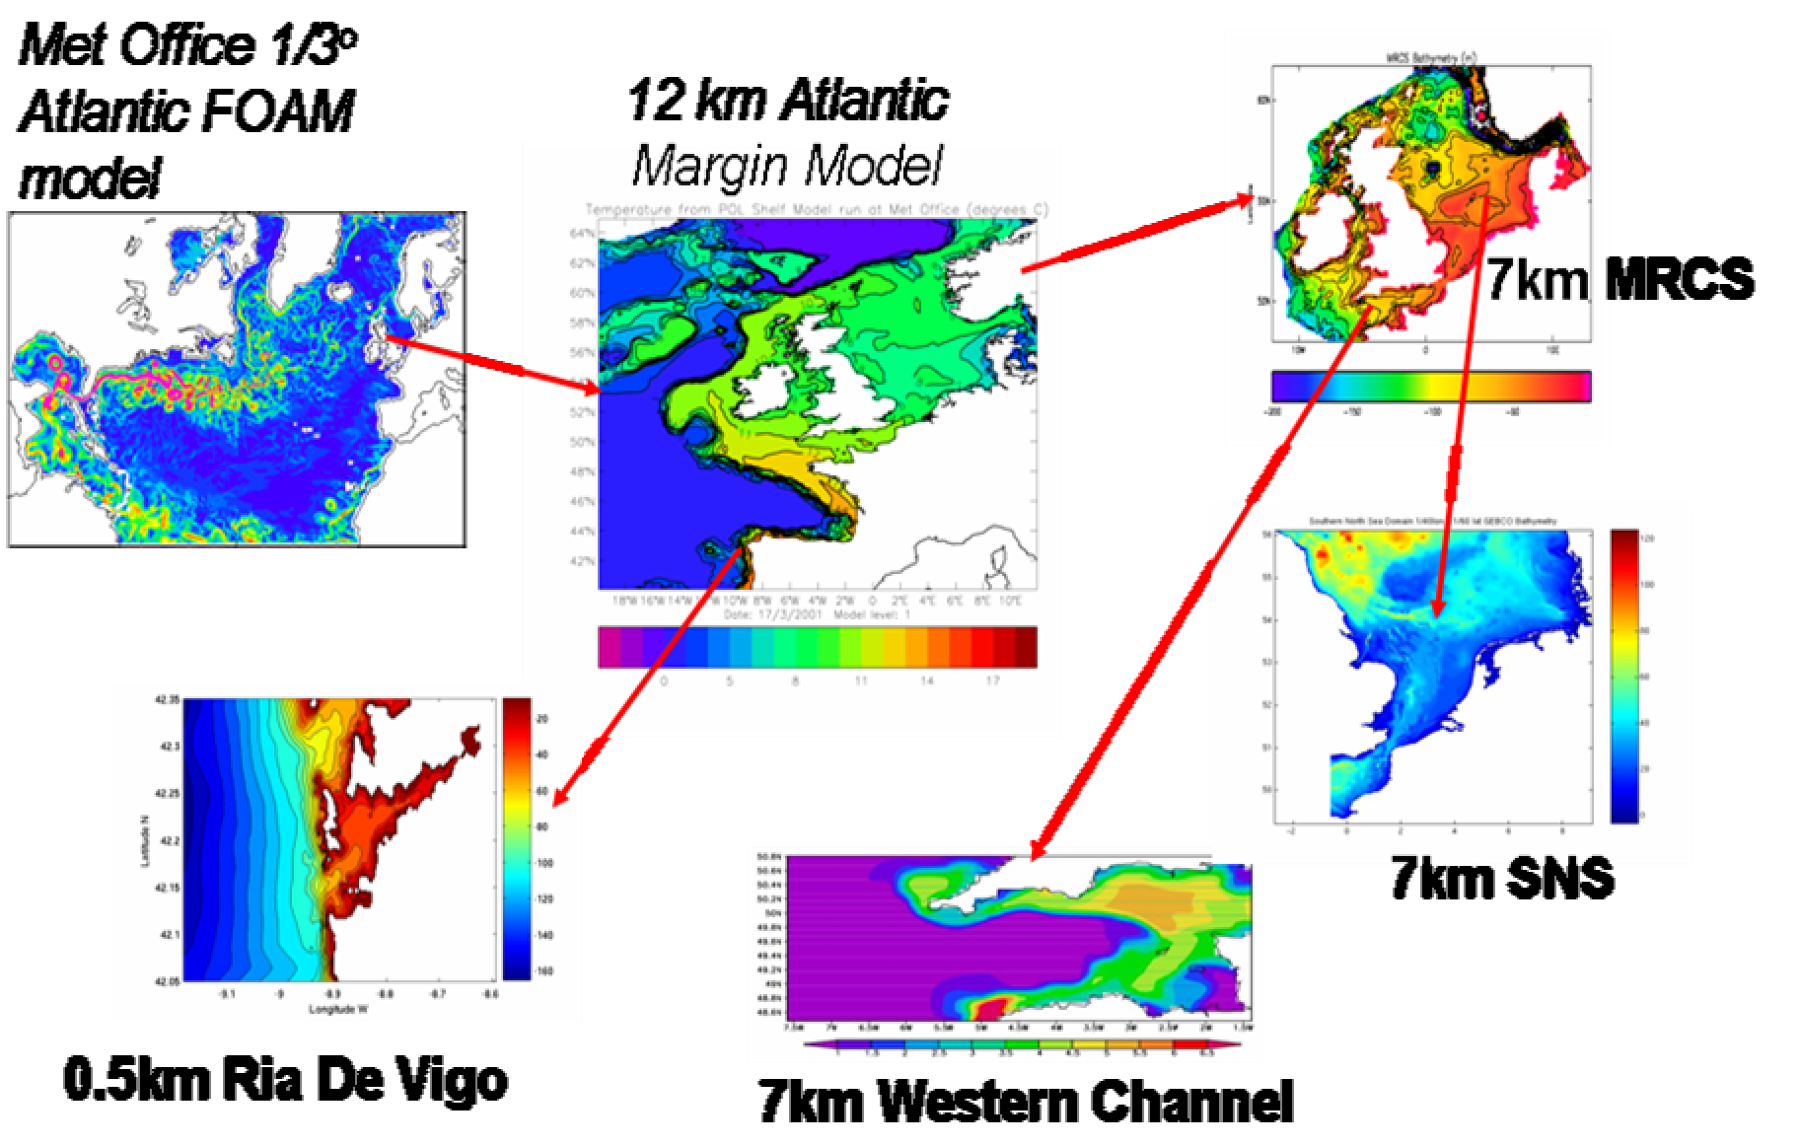
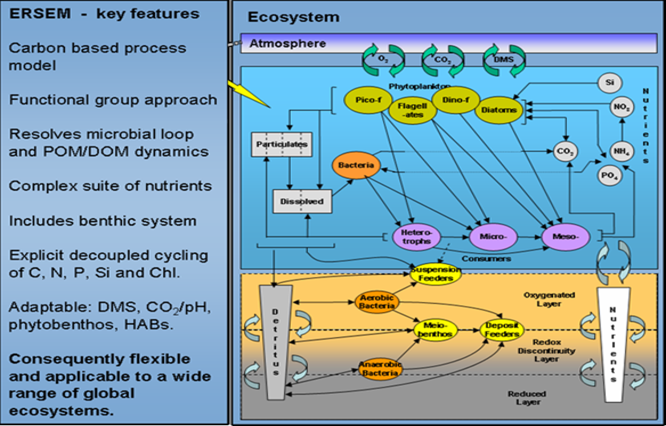
Figure 3 complex ERSEM model nested in the physical POLYCOMS in this example aims to characterize benthic and water column processes

Figure 3a illustrates the use of physical nesting. The complex ERSEM model, which is nested in the physical POLCOMS in this example, aims to characterise benthic and water column processes and is illustrated in figure 3b.
In this example, in an operational context, the North Atlantic and Atlantic Margin Models might contribute to the MCS, whilst the higher resolution models would take boundary conditions and be employed in the provision of down stream services that could justify the higher resolutions.
In addition, as outlined in section 2.4, the modelling centres need to be supported by data assembly centres and service delivery capabilities to carry out the operational and support functions described there. Before outlining how these might be implemented, it is noteworthy but not a coincidence that this architecture and rationale for segmentation into the global ocean and regional seas is reflected into the current organisation of operational oceanographic services by public bodies within intergovernmental programmes.
The Global Ocean Observing System (GOOS) http://www.ioc-goos.org/ has now organised its work into a global component, largely targeted upon understanding and describing the role of the oceans in climate research and prediction, and regional observing systems developed by Regional Alliances. These regional observing systems aim to deliver information relevant to climate on these scales but also to the full range of policy issues described in paragraph 2.1 for the European area.
EuroGOOS is the GOOS Regional Alliance for Europe. It liaises, at an institutional level, with MedGOOS in the Mediterranean to work with non-European States there and with Black Sea GOOS, to aid capacity building.
From this liaison and through its 33 member institutes, a number of Regional Task Teams have been set up based on the rationale above. Several of these have made formal agreements to form Operational Oceanographic Systems /Networks (collectively known as ROOSs) to implement best practice and achieve effective day to day collaboration. At present these comprise:
- Arctic TT • Arctic GOOS, with a pending MOU designed to deliver operational oceanography in the Arctic.
- Baltic TT • BOOS, with an MoU between 19 institutes to do likewise in the Baltic
- North West Shelf TT • NOOS, with a MoU between 19 institutes with an interest and relevant capabilities on the North West shelf, including the North Sea.
- Biscay / Iberian TT • IBI-ROOS (MOU pending), with similar interest and capabilities in those shelf areas
- Mediterranean collaboration • MOON, secured by a MoU between 26 institutes in the riparian states.
- Black Sea – to be created.
This is helpful because it provides a body of organisations, agencies and individuals that have learned to work together to provide operational oceanographic services and the associated infrastructure in the form of in situ observing systems, models, data assembly centres and communication/distribution systems to meet the needs of their end users.
The available evidence suggests that the implementation of standard technologies and the development and deployment of new in situ sensors are organised effectively at the regional level. A detailed knowledge of the physical, biological and chemical
characteristics of the domain and appropriate logistic and technical expertise are generally available. Relatively rapid decisions can be taken and data exchange within a ROOS is normally very effective. It is less clear that deployments are made other than to meet national priorities, i.e. regional coordination of network design is weak.
A global coordination is needed for homogenisation of sampling criteria at regional level, for exchange of experience and information, for homogenisation of ualityassurance/control. Global coordination is required to define common protocols and guidelines (quality assurance of field work, calibration – intercalibration of sensors, quality control procedures, standards, etc). ESA, EUMETSAT, their Member States and national space agencies have been very effective in building up these capabilities for the exploitation of EO data.

Implementing the architecture
Figure 1 illustrates the functional architecture of the MCS in the context of data supply and downstream services. The functions which need to be carried out within an operational MCS are described briefly in section 2.2 and their connectivity is illustrated in figure 2.
The MERSEA IP Consortium, which comprises 38 partners/contractors, has adopted a functional architecture for a demonstration of its perception of the MCS based on three Thematic Assembly Centres (TAC) and five Monitoring and Forecasting Centres (MFC), which it jointly describes as Thematic Portals (TEPs). The five MFC cover the main ocean domains: Global, Arctic, North West Shelves and NE Atlantic, Baltic, and Mediterranean (the Black sea remains to be integrated). Figure 4 provides a schematic of the interconnections between the TEPs, which generally has physical implementation but in practice consists of a collection of services distributed among providers’ physical systems. Nevertheless, responsibility for the necessary services resides with the appropriate TEP. This is an attractive concept which, carried to a logical conclusion, should enable flexibility in service definition and provision with new players able to contribute, provided that they conform to ‘the rules of the game’.
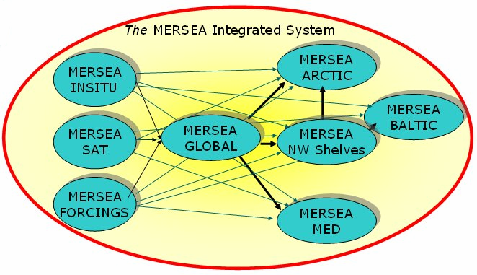
Figure 4 Schematics of the System’s architecture, as it is being developed by the MERSEA Project, including Thematic Assembly Centres and Monitoring and Forecasting Centres.

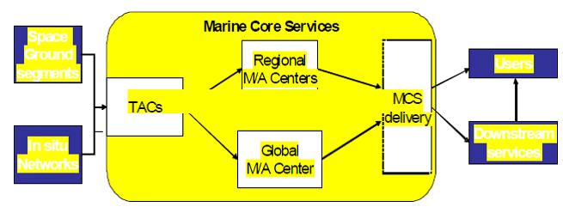
Figure 5 Connectivity of the Thematic Assembly Centres, Modelling/Data Assimilation Centres and prototype MCS delivery interfaces being developed by MERSEA.

Figure 5 illustrates the connectivity of the TACs to the modelling / assimilation centres and delivery interface, which in a simplified way mirrors the required functionality, described in figures 2 and 3 and section 2.4. In this manifestation, the TACs are in charge of processing the required in situ and satellite data to meet the needs of the centres so that they can meet the needs of end users through the delivery interface. In addition, the forcing fields for the predictive models need to be secured from Numerical Weather prediction centres operated by the National Meteorological Services and ECMWF.
The MERSEA consortium asserts that in their manifestation of the MCS: “The components of this system of systems are linked by an information system that allows efficient transfer and exchange of data within the system, as well as easy access to the products by the users: timely delivery of high volume data and products; discovery, access, retrieval of products; monitoring of the MCS system efficiency, user desk; implementation of common procedures, formats, metadata as agreed by international standards (WMO, JCOMM).The Information Management system will rely on a partnership of few partners that will dedicate real manpower to it. This partnership will perform coordination activities to ensure the link with international standardization bodies, ensure the MCS catalogue maintenance, the user desk and the monitoring of the system as well as the maintenance and evolution of the MCS Information Management System.
The architecture conforms to the specifications of the WMO Information System (WIS), which is designed and implemented to serve the information exchange needs of NMS and other national centres, such as relevant non-NMHS agencies /users, national disaster management platforms, research, and international programmes. A major upgrade of the GTS, the WIS is being implemented from 2006; it is articulated around Data Collection and Production Centres (DCPC), whose mission is to fulfil an international responsibility for the generation and provision for international distribution of data, forecast products, processed or value-added information, and/or for providing archiving services; and to provide basic WIS functions such as metadata catalogues, internet portals and data access management.”
Whilst care will be needed to ensure robustness and avoid single points of failure, implementation based on the MERSEA design, using the capabilities, tools, techniques, procedures and standards developed, adopted and being tested by the consortium, is an attractive way ahead and the IG recommends their adoption for the MCS. A key feature of the design is its commitment to interoperability and distributed functionality. This should allow potential contributors to the MCS, who are not members of the IP, to augment its capabilities by contributing needed services, provided that they operate according to the rules which ensure that interoperability and ease of use by intermediate users.
Before amplifying this proposal, by identifying the opportunities for such augmentation, the proposed implementation of the space based and in situ is developed.

The space infrastructure
The Working Group Report relating to the MCS requirements of space segment has been adopted by the IG and is attached as Appendix 3; the recommendations are summarised in section 3.1. These have been acted upon by ESA in the design of Sentinels 1 and 3. The way forward on the follow-on to Jason 2 remains to be determined.
ESA/PB-EO(2006)23, rev.2 of 7 November 2006 describes the GMES Space Component Implementation Plan from which the following is adapted:
Both Sentinel 1 and 3 will have a design life of 7 years. Sentinel 1 will carry a SAR in a well-controlled dawn-dusk sun synchronous orbit at approx. 700 km altitude with an exact repeat of 12 days in support of multi-pass interferometry (for land use). With the SAR swath of approx. 240 km, a 12-day quasi-global coverage is ensured. The ground resolution exceeds that of ERS and Envisat in imaging mode. Sentinel 3 will carry a Cryosat-derived microwave altimeter (incl. a microwave radiometer and precise orbit determination device) and two imagers, for ocean/land colour observations (MERIS-like) and for sea/land- surface temperature observations (AATSR-like) into an Envisat-like orbit.
It is accepted that 2 spacecrafts in orbit are needed to meet the coverage and observation frequency requirements for the Sentinel-1, -2 and -3 missions. However, an incremental deployment of capabilities is assumed. Therefore the implementation within Segment 1 includes only the first of a series of satellites per mission.
The target launch date (2011-2012) is driven by the expected end-of-life of ENVISAT and other missions.
ESA has a mandate, as part of the GMES programme approved by the ESA Member States, to:
- manage and coordinate the overall GMES space infrastructure including the access to all satellite data required by GMES, starting in 2008;
- develop GMES specific space infrastructure.
The funding of the space component will come from both the ESA GMES programme and the FP7 Space Theme work programme, in agreement with the EC. Part of the EC’s FP7 funding (130 M€ total for 2007-2013) is planned to be made available to ESA in order to organise the coordinated and harmonised access to EO data for GMES services. In this framework, ESA is setting up agreements with EO mission data providers in Europe and worldwide. In doing so, ESA will assure that existing data providers will be fully involved. EUMETSAT has already signalled its interest in acting as a data provider for the MCS through the provision of a consolidated real time satellite data stream (including EUMETSAT, NOAA and other 3rd party data), with the exception of the SAR data.
Therefore, it is necessary to harmonise the positions of the two organisations, and in this process, ESA will take due account of the position of EUMETSAT Member States and will make use of EUMETSAT assets/capabilities in the most efficient way for the delivery of EO data to the Marine Core Fast Track Service.
A consolidated ESA/EUMETSAT approach regarding the provision of EO data to the MCS is expected to be available during 2007.
As noted previously, specific coordination with EUMETSAT is necessary for the access to and provision of the data handled by EUMETSAT, as well as regarding the delivery of Sentinel-3 (S-3) data to the MCS. It is understood that EUMETSAT will operate the marine part of S-3.
For this purpose, the EUMETSAT central ground segment will provide a (probably consolidated) level 1 satellite data stream as a direct input to the MCS. To further this some working assumptions have been reached between ESA and EUMETSAT, although these have yet to be approved by their governing bodies and the related financial provisions must be clarified. Provision is made as follows:
- EUMETSAT will serve the Marine User Community both with routine and off-line products, whereas ESA will serve the Land Services community with all land products.
- Starting from the launch of the first S-3 spacecraft, the scope of EUMETSAT’s operational role should be:
    - product generation and dissemination of all S-3 products routinely required by the MCS and the related downstream services;
    - serving the offline requests of the Marine User Community for S-3 products (using a distributed network of centres of expertise)
    - monitoring and control of spacecraft and flight operations segment;
    - payload data acquisition, consistent with the overall GMES ground segment design under ESA’s responsibility.
The ESA-EUMETSAT working assumptions further suggests that the “backbone” of the S-3 ground segment will consist of a polar ground station configuration that provides full orbit coverage together with a collocated centre based at EUMETSAT for serving the marine user community, i.e.:
- ground and spacecraft monitoring & control;
- routine S-3 product generation and dissemination.
This backbone will be augmented by distributed centres for product archiving, retrieval and re-processing to fulfil “ad hoc” data requests.
In addition, it is possible that additional centres could be available to supplement the payload data acquisition function (as a back-up).
The Ground Segment of the Space Infrastructure required for the MCS consists of two stages: (i) the basic processing that generates ocean data products from each individual sensor; and (ii) the additional processing that prepares data from multiple sources for operational tasks such as assimilation into ocean forecasting models. The first stage is a space agency task, following well established EO practices. Previously responsibility for the second stage, if it takes place at all, has been shared in an ad hoc way between the space agencies, major data users and the EO science community. It is recommended that for the MCS this stage of additional processing should be performed by Thematic Assembly Centres (TACs) as an integral part of the MCS, tailored to the special requirements of operational users of particular data products. Implementation of these latter functions is described in section 4.3.5.

Data products from Sentinel-3 sensors
The ground segment tasks for commissioning new sensors and performing data processing to deliver level 2 products (atmospherically corrected measures of a remotely senseocean property, sampled on a grid oriented along and across the satellite track) are well established. Noting the plans of the space agencies noted above, in the case of the Sentinel missions required to support the MCS, it is assumed that ESA will calibrate and commission the new sensors and that, in the case of Sentinel 3, Eumetsat will manage the data processing to deliver Level 2 products for the ocean. Table 2 identifies the outline time-of-delivery required from the ground segment for the Sentinel-3 ocean data products.
To ensure the highest quality of data, current best practices for the ground segment should be followed but with two notable differences; it is essential to maintain an adequate data product validation programme throughout the sensor lifetime, and periodic reprocessing of data must be anticipated.
Table 1 Outline delivery requirements for Sentinel-3 ocean data products
Sensor | Product delivery requirement
Altimeter | “precise” IGDR within one day
SST | Level 2 data in L2P format in real time (within 3 hours).
Ocean Colour | Level 1 and 2 products within one day
Hitherto, because ESA Explorer missions have been launched in association with a strong science user sector, any validation activity beyond the commissioning phase has often been omitted from the ground segment budget and in practice left to the science community. This approach is unacceptable for the Sentinel-3 mission whose goal is to deliver satellite observations to meet operational needs. In order to be fit for purpose, an essential component of Sentinel-3 level 2 data products is pixel-by-pixel error estimates. This implies a well planned programme to acquire independent validation observations, including in situ measurements, on which the error statistics can be based. It must continue as long as operational products are being delivered. It is essential that such validation programmes are planned and budgeted from the outset as an integral component of the ground segment task to deliver each level 2 data product needed by the MCS.
The MCS is concerned not only with supplying near-real time data for operational use but also with establishing an accurate long-term record of the ocean for climate purposes. It is the experience of all recent ocean satellite missions that the accuracy of data products can be improved by refining the processing algorithms following months or years of experience and careful analysis of the sensor calibration and product validation characteristics. In order to ensure a consistent climate record from a sensor throughout its lifetime, it is essential to re-process the entire historic dataset whenever major improvements are made to the processing algorithms. A programme of reprocessing should therefore be planned and budgeted from the outset as an integral part of the ground segment task for Sentinel-3 sensors.

Data products from Sentinel-1 SAR
For Sentinel-1, the primary ground segment tasks relevant to the MCS can be defined according to the following application areas:
- oil pollution monitoring
- ship detection and fishery
- monitoring sea ice and iceberg monitoring
- open ocean (sea state) surveillance
Near real time, wide swath operating mode is required for the first three services, whereas the latter need access to near real time image mode or wave mode data. As the duty cycle for the data intensive SAR is restricted the ground segment will need to carefully combine baseline acquisitions to properly service the above application areas.
The ground segment will need to provide operational, long-term services, short ordering times for ad hoc needs (one or two days), short latency between data capture and availability on the ground (under 2 hours) and rapid data processing (20-30 minutes).
In the context of the MCS for the Arctic, it is necessary to produce wide-swath SAR image strips calibrated as normalised radar backscatter cross-section (Level 1b), in near real- time. For instance, for the monitoring of the Arctic circumpolar region, 3-day coverage is necessary for reliable ice deformation estimates (this amounts to about 6500 wide swath images per year.) More frequent acquisitions for limited regions will be needed on a case- by-case basis for specific operational services. The ESA rolling archive for ASAR has already demonstrated the capability to deliver near real time SAR strips to support both routine Arctic sea ice monitoring and specific operational applications but in future clear guarantees will need to be provided for data delivery, as is the case for RADARSAT now.

The in situ infrastructure
The Implementation Group Report relating to the required in situ infrastructure is attached at Appendix 4. This reviews the key observing system technologies and the modalities of a data collection and management system that must deal with its multi- scalar, multi – ownership and highly distributed characteristics. These considerations have been addressed in and used to recommend priorities and essential coordination activities.
There are several difficulties associated with the deployment of systems based on these technologies. Almost all are deployed for research purposes or as national contributions to ongoing environmental assessment programmes committed under the Regional Conventions. These latter tend to be concentrated in coastal waters and none delivers real
time data. Although some attempt has been made to coordinate deployments for individual research programmes, there is no mechanism at present to coordinate efforts to produce what might be described as a designed, composite network. The ODON project, listed in section 4(d), developed techniques for this but they are not known to have been used since the end of the project.
In order to make progress it does seem that two specific actions are needed. Firstly, where the impact of the data is either global or pan-European it would be appropriate for an investment to be made by the EC on behalf of Member States or by the Member States acting together. A case of this kind has been put for investment in the Argo technology within the European Roadmap for Research Infrastructures. It should be taken up. The impact of the CPR (measured by the maturity of the technology, the length and extent of the existing record and uniqueness and importance of the data which result) is a further candidate for such coordinated investment.
Secondly, there is a need and opportunity within the context of GMES, supported jointly by the Commission, ESA and Member States, for integration and coordination of in situ monitoring efforts. On the regional scale, the EuroGOOS Regional Task Teams or Operational Oceanographic Systems/Networks (where they have been formed) would be ideally placed to take this on, perhaps coordinated overall by the EEA11. In due course a EUMETNET like arrangement might be put in place for this purpose. There is a need for a relatively small investment in efforts to identify where such actions would bear most fruit, and it is hoped that can be found within the GMES Space Component of FP7. On the global scale the Joint WMO-IOC Technical Commission for Oceanography and Marine Meteorology (JCOMM) provides an appropriate mechanism at an intergovernmental level for planning and coordinating the acquisition, exchange and management of marine observations, although it would be helpful if a mechanism for developing a common EU position on this could be agreed, particularly if EU funding is provided for specific components of the global observing network, such as the Argo float technology.
At this stage the following priorities are suggested to guide these two actions:
- sustain the Argo network ~ 800 new floats to be deployed each year to replace the ones that fail. The European ‘fair share’ of this is about 250 units.
- encourage the deployment of and collection of near real time data from automated observing systems such as XBTs, Ferry-box & CPR on research vessels and Ships of Opportunity.
- encourage Member States to continue to make marine observations that are useful for national purposes and, if shared in near real-time, would help sustain the MCS and downstream services. Specific examples include data from the tide gauge network and moorings.
- investment is needed in carefully chosen well equipped observatories at locations where data would provide valuable constraints on models.

Data collection, assembly and quality control
Appendix 4 also discusses the requirements for the data processing & management system needed to sustain the MCS. Figure 2 outlines the functions which are needed by the MCS. The design proposed by MERSEA to fulfil the functions listed in paragraph 2.4 (a)-(c), based on the use of Thematic Assembly Centres (TAC), is similar to WMO’s Data Collection and Processing Centres (DCPC), and is recommended for operational use for the reasons set out in paragraph 4.3.2. The responsible Centres must have or might reasonably achieve operational status. Except for the oil spill detection and characterisation Centre, all are required to generate and make available the appropriate QC dataset at levels 1b or 2 for analysis and assimilation by ocean models.
Figure 5 illustrates how the TACs are conceived within MERSEA as the gateways through which observational data reach the rest of the MCS activities. Because of the diversity of different sources from which observational data are acquired, including different sensor types that sample the same ocean product in different ways, the TACs are needed to harmonise the data in such a way as to facilitate their ingestion and assimilation into ocean forecasting models, and where appropriate to blend the data into analysis products for application by downstream users.
The TACs will perform the following generic functions
- Real-time additional processing of level 2 data products received from European sensors, if necessary, to generate a common data format and product standard, facilitating an interoperable, harmonised data distribution system within the MCS.
- Near-real-time level 3/4 processing activities, generating analysis products that correspond to the best estimate of an ocean property, blending data from various sources.
- Providing ready access to all data products using a spectrum of delivery methods to users, including real-time high volume data flow to the M/A centres and other operational users, solutions tailored to individual downstream services and web access for general public users.
- Delayed mode level 3/4 processing activities, including the updating of ancillary data as they become available within a few days of acquisition, as well as later reanalyses to produce higher quality products for climate monitoring.
- Quality control, validation and error characterization, applying to the products and forecasts produced within the TAC. This activity needs to be underpinned by in situ observations. This does not remove the requirement for the space agencies to validate their basic level 2 products.
- Interfacing with international activities for the same type of data, and with TACs for other data types including in situ data for validation.
- Providing effective feedback on data products between users and the observing systems.
A number of collaborative multi-mission processing and dissemination facilities are already in place within Europe which perform the whole or part of the TAC functions for Altimetry, Sea Surface Temperature, Ocean Colour, Sea Ice and Winds, and which are already interfaced with different satellite ground segments. These represent a point of departure at least for the implementation of the MCS. They include:
- The CNES/CLS SSALTO/DUACS processing activity for sea surface topography.
- The ESA DUE project Medspiration and MERSEA, serving as the European component of the international GHRSST Project, delivers a set of harmonised SST products that are now being used operationally by a steadily growing user base. It has an upstream interface with Eumetsat’s Ocean & Sea Ice SAF and downstream
- interfaces with operational users.
- Ocean Colour data have been provided for MERSEA by a consortium led by EC/JRC. Merged products are also being developed by the ESA DUE GlobCOLOUR project. Some consolidation will be appropriate.
- CERSAT delivers Sea Surface Winds and fluxes (interfaces with Ocean & Sea Ice SAF).
- Eumetsat’s Ocean & Sea Ice SAF provides Sea Ice data from passive radiometry on an operational basis.
It is evident that each of these data types has its own distinct user requirements and its processing system has achieved a different level of maturity. Thus although the TACs will serve the same generic functions (see the left hand side of figure 2), it is important to treat each ocean data product type individually. Further consideration is needed to define the comprehensive requirements for fulfilling the TAC functions for each type of ocean data product. It also remains to be decided whether Regional TACs are required or whether regional data can be provided satisfactorily by a global TAC.
In the future, it may be appropriate to consider developing a TAC for the processing of synthetic aperture radar (SAR) in which all SAR data over European waters are analysed to extract their information content concerning surface winds, wave spectra, oil pollution, ship detection, sea ice and other ocean phenomena. This could evolve from both geographically limited sea ice analysis, and the service currently being developed by EMSA for routine monitoring of European SAR data to detect oil spills at sea. Oil spill detection and characterisation based on SAR data is being carried out by a combination of KSAT (Norway), Boost Technologies (France) and Telespazio (Italy) within the MarCoast project.
Regarding services tailored to the Arctic (see section 6.2) several new regular sea ice products need to be produced from wide swath SAR data such as: 1) sea ice deformation including drift, convergence, divergence and shear zones; 2) presence of leads and polynyas; 3) identification of fast ice zones; 4) deformed versus undeforrmed ice and ice- ocean discrimination using polarization ratio. Algorithms to produce these products already exist, and are being further developed by ESA’s GlobICE project. In due course, they
should be implemented for operational use as part of the TAC function for sea ice.
Depending on the success of the ESA SMOS mission in measuring ocean salinity, there may be a need to develop a TAC for Sea Surface Salinity from 2010.

For processing in situ data:
The Coriolis centre in France is providing the necessary functionality for global and some regional data within MERSEA
The TAC functions to meet regional requirements remain to be determined but the tasks are being carried out to some extent by the OOS/N (NOOS, BOOS, MOON, …) and exchange of the resulting data sets has been demonstrated in the SEPRISE project.

For atmospheric forcing data:
ECMWF and several NMSs are capable of carrying out this function and do provide the required information routinely within MERSEA. Where coupled ocean– atmosphere models are being run operationally, two way coupling is possible.

Ocean modelling and data assimilation
There are a relatively small number of global and regional ocean models capable of assimilating data and being run operationally in Europe and which could contribute to the MCS. The MERSEA IP Modelling TEPs are highlighted. Candidates known to be available are:
- Global models, at various resolutions:
    - PSY3V1 operated by Mercator FOAM operated by UK Met Office
- For the Arctic / North Atlantic Oceans:
    - TOPAZ operated by NERSC/Met Norway
- For the Baltic:
    - BALECO operated by FIMR
    - HIROMB operated by SMHI
    - BSHCmod operated by DMI +
both of which require boundary conditions from the North West Shelf Area and therefore provide output in this domain too.
- For the North West Shelf / North East Atlantic:
    - POLCOMS & FOAM respectively operated by the UK Met Office
    - PSY2V2 operated by Mercator
- For the Mediterranean:
    - The Mediterranean Forecasting System operated by INGV
In addition, there are many examples of smaller domain models being operated for local, national purposes taking boundary conditions from the above and delivering specialised products, e.g. surges, ice, oil and S&R drift, eutrophication, etc.
There is substantial model development within MERSEA to:
- develop a new modelling framework – the NEMO code
- improve multivariate data assimilation methods
- increase model resolution
- incorporate ecosystem modules
It is to be expected that this will deliver new, more capable global and regional ocean models.
Given the substantial investment needed in computing resources and skilled staff necessary to operate, maintain and develop them, and the agreement reached between the partners over the global and regional responsibilities of the individual centres, it will be wise to base the initial MCS, at least on the MERSEA assignments. However, if there is a possibility of providing choice of model products to the downstream service providers that option should not be precluded, i.e. there should be no ‘closed shop’. However, the services provided by the MCS consist of much more than model products. Any supplier will need to commit to the supporting services outlined in section 2.4 and described in more detail below.

Service generation, access, delivery and support
State of the art capabilities are being developed by MERSEA for implementation in 2008. These aim to provide a portal for each domain, which comprises:
- A discovery service
- A viewing service
- A download service, which will need to include or be supported by the facility for sustained, scheduled delivery of high volume datasets for intermediate users, who are themselves running continuous operations that need such a service.
Product descriptions are to be standardised and available in a homogenous catalogue.
The MERSEA consortium is committed to a number of supporting activities that guarantee a level of quality in service provision and that follow standards to be spelled out in Service Level Agreements. They are all crucial to the success of the MCS and are broadly compatible with the desired functional analysis of section 2.4. Others who might aspire to contribute to the MCS should expect to provide equivalent services and commit to the same Service Level Agreements.
Five service lines are proposed:
SL1 : production of marine core information and data
SL2 : dissemination of marine core products
SL3 : assessment and expertise on marine products
SL4 : ocean analysis tools development and maintenance
SL5 : training and research coordination

SL1 Production
Operators will need to develop and produce quality controlled fields (analyses & forecasts) describing the global ocean & European seas, based on space and in situ observations data and their assimilation into appropriate ocean models. This activity includes different product lines:
Observation and model products for the state variables listed in Table A2. 1 for example
in several modes: nowcasting, forecasting (several days), and re-analysis (up to some decades)
The latter requires both real-time operational lines and delayed mode data lines.

SL2 Dissemination
All operators must provide to users the advertised information on the ocean state, either through their own production (SL1) or by being a reference access point to other production from centres that are not part of the MCSMO (MCS Management Organisation) – see section 5.1. This will include the appropriate tools for search and discovery, viewing, downloading of products. The download service will need to include or be supported by the facility for sustained, scheduled delivery of high volume datasets for intermediate users, who are themselves running continuous operations that need such a service.
Catalogues and inventories of products must be homogenous, readily accessible, searchable, and updated regularly.
The dissemination will be subject to the data policy to be agreed upon, but hopefully as set out in section 4.4.
The proposed assignment of responsibility for the portals that will carry these tools is that chosen by the MERSEA consortium and illustrated in figure 6.
Information products accessible through each portal should relate to the domain in question, meet the standards described in section 4.3.8 and other service qualities set out below, including guidance in their use. The aim will be to give the easiest possible access to information and, where it exists, choice to the user.
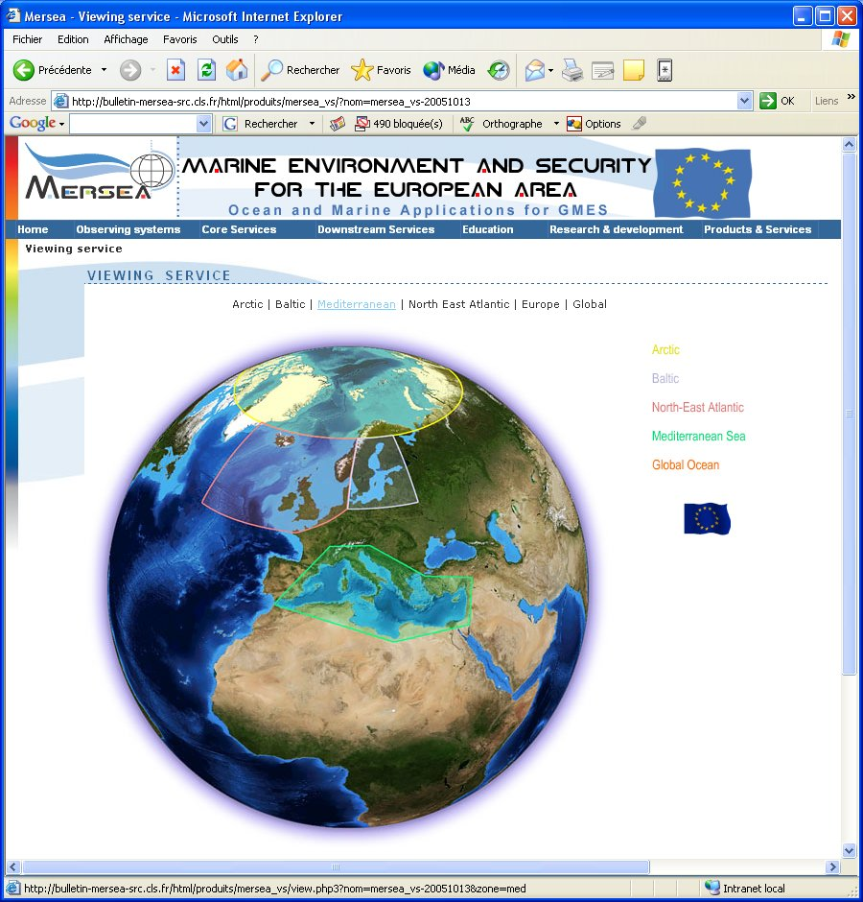
Figure 6

.SL3 Assessment and expertise
All production of the MCS must be fully validated, with known accuracy and error estimates. MCS must provide expertise on the marine core products, to support efficient use of its output or bring directly information to interested users. Human expertise is added to the production and dissemination functions, to proceed from data to information for the benefit of users.
Access to information from forecasts produced by different Centres is a powerful tool for assessment of their reliability and accuracy; it is desirable that the MFC should enable such multi-model interpretation and presentation.
For instance, regular bulletins and assessment reports can be published to explain the main features of some of the products; expert analysis can give a thematic interpretation of the marine core products; specific post-processing, on demand, to extract subsets of products; or to elaborate summary indicators based on MCS data (selection and transformation).
The expertise service could include the elaboration of calculated fields derived from the state variables (e.g. mixed layer depth, upwelling indices, transports, heat content), anomalies, climatologies or statistics.
In cooperation with expert topic centres, contribution to reference reports on the ocean state (Regional Conventions, EEA, ICES, etc); or simple and systematic studies of observing networks (Argo, altimetry, etc), or for operational user agencies.

SL4 Ocean analysis tools, development and maintenance
The MCS should develop and maintain, for the benefit of the European community of intermediate users and other operators, a suite of reference codes and frequently-needed tools required to use MCS products and to develop downstream activities and services. It is mandatory that the codes be maintained at the forefront of the state of the art and be fully validated; with error estimates. This requires expertise in the transfer of research results into the operational suites.
The capabilities required to sustain and improve the MCS also need to be developed, validated, upgraded, maintained and disseminated at European level. These include tools such as the NEMO Ocean modelling code; data assimilation tools; toolboxes for nesting, downscaling, and interfacing models; validation algorithms (metrics, observations /model, …); data handling codes, visualisation, diagnostics routines.

SL5 Training, research, and outreach coordination
The MCS will actively develop and promote scientific and educational programs for the benefit of operational oceanography as a contribution to the development of European capacity in the subject.
An active research community must be entrained in disciplines and fields of research of relevance to operational oceanography. MCS can play a leading role in research networking and connection with research teams in Europe, and beyond; it can promote coordination of research initiatives linked to operational oceanography, and it must contribute to capacity building and outreach.
Training can be provided through summer schools, conferences, or students courses on operational oceanography; traineeships, PhD and post-docs program can be associated with the MCS Centres.
These research programmes will be of two types:
One must be closely coupled to the MCS to ensure that projects are driven, in part at least by the specific needs of the operators, and remain aware of emerging research results. There is no doubt that progress in ocean modelling, monitoring and prediction will be achieved only if such programmes are effectively pursued, coordinated and funded. Experience from other successful providers of services of the kind to be offered by the MCS suggests that a fraction of the turnover of the endeavour (of the order of 5-10%) should be set aside for such closely coupled research; such examples include the major NMSs and ECMWF.
The other will be driven by the need to resolve priority issues in the relevant sciences (as identified by the ESF Marine Board for example) and to explore new technologies for monitoring the marine environment, using EO and in situ methods. These are likely to be funded within national research programmes, the Framework Programmes, by ESA through their Explorer missions and industry.
GMES and GEOSS share a range of strategic and technical issues and offer opportunities for interactions (e.g. space and non-space observation platforms, data exchanges and network connections, tasking and integration of observations, ad-hoc campaigns). At the European level, the two initiatives are closely related in that:
As it develops itself, GMES will become, with the data it can generate, a main European contribution to the GEOSS.
GMES will benefit from the observations collected and exchanged in the frame of the international GEOSS activities.
European GEO consultation meetings are regularly organised and chaired by the Research DG to coordinate the position of all European GEO members supported by the Framework Programme in order to ensure a strong European voice and influence on decision making at the GEO plenary meetings. This includes ensuring appropriate European representation in the GEO Executive committee and providing the European share of funding of the GEO secretariat out of the EU Framework Programme.
It will be important that the MCS plays its part in ensuring that this ‘European voice’ is well informed by the benefits which the marine sector can gain from and contribute to the GEOSS.

Standards
One of the objectives of the MCS is to provide consistent quality and standard of service. This puts strong requirements in terms of robustness of the products and delivery channels; timeliness of production and delivery; fitness for purpose against specific requirements; stability and homogeneity of re-analyses; traceability and quality performance. Users of MCS serviced must not need bespoke interfaces to access and use its products. GMES as a whole has to deliver interoperability between its components, so conformity to the expected INSPIRE Directive will be mandatory.
In order to achieve this goal, the MCS delivery of data and data products should conform to International Open standards as will be promoted within the INSPIRE program. In particular the viewing services should conform to Open GIS standards, providing Web Feature Services (WFS) for in situ data and Web Map Services (WMS) to allow viewing of geospatial gridded data. These can be live services working directly upon the data repositories. These viewing services should be available (with appropriate security) at all MCS service centres to allow the overlaying within a web portal of MCS geospatial view products with each other and with third party GIS based products without the exchange of the data themselves. For data exchange the MCS should eventually conform to the Web Coverage Service (WCS) standards although interim methods such as secure ftp or OPeNDAP are envisaged.
The MCS should provide sufficient underpinning support for the development of appropriate viewing services to allow MCS information to be viewed within any downstream GIS based services conforming to the Open Standards. This could include commissioning of specific viewing services appropriate to the marine domain. As a Fast Track Service the MCS should be resourced to take the lead in this area which will (1) greatly increase the visibility and availability of MCS products in a highly professional way, (2) provide easy to use calibration/validation services for use within the consortium, e.g. by overlaying MCS products with satellite images, (3) provide a lead for future European geospatial services. The MCS should also seek to develop partnerships with other geospatial information services around Europe. A directory of all Geospatial information services in OGC format should be available with a portal to combine and overlay them. This would go a long way towards providing an integrated view of the European Environment as outlined in the INSPIRE initiative.
Standards to be applied will be specified or referenced in Service Level Agreements (SLA), and / or Service Charter for overall MCS consistency, which must cover the points above, as well as requirements to maintain the system at state of the art; to use all available information; to perform multi-model estimation and forecasts; to engage in research and development (see SL4 and SL5 above); specification of the areas of service provision ; the
rules for access to infrastructure; consideration of the operational status, security, system monitoring, etc…

Funding & Data Policy
At present there are abstract estimates of the full costs of a reliable, efficient MCS or of the upstream and downstream capabilities that are required to deliver value from it. Such estimates need to be detailed during the next year or so as experience grows during the FP7 funded demonstration phase; not least to ensure that the case for long term funding is robust. The level of national funding compared to European needs to be settled.
In the interim, it is assumed that, because the services being delivered by the MCS are public goods they will be co-funded by the EU and Member States, not at the point of delivery by charges levied on intermediate users. This is the model adopted for the development and demonstration phase of the GMES Fast Track MCS funded through the FP7
Space Programme. Continued adoption of this model has to be verified, probably within the context of the proposed INSPIRE initiative. The scale of the expenditure required suggests that some form of cost sharing by Member States and the EU would be agreed to deliver the service defined ultimately in the SLA(s) between the GMES Management Authority and the MCSMO or operators. In effect this is the current funding model of the space infrastructure with ESA too. Presumably some Member States contributions would be in-kind, in the form of national support for the operators and data collection/provision (both EO and in situ).
On this basis, it is further assumed that upstream data and MCS data, products and services made available to intermediate users will be free of charge, except for the cost of delivery, if they are used exclusively for GMES purposes.
It is expected that intermediate users will be financed through user charges in effect for the value that they add to the information and services that they obtain from the MCS and other upstream service providers. Some ancillary data may fall within the scope of the INSPIRE Directive others will be available on terms specified by their suppliers.
There is no doubt that some EU level support will be desirable for intermediate service providers during the MCS demonstration phase at least. This has been done within FP7 Space Theme in two consequitive calls. Such support is still also being provided by the ESA GSEs, in particular MarCoast and Polar View, and through the data purchase activities of EMSA. The ESA managed, EC funded data-buy planned within FP7 will be crucial in this regard too.

Governance and related issues
There are a number of issues to be resolved that transcend the strictly scientific and technical matters which guide the infrastructure design and implementation. Some considerations, particularly those of top-down governance, will be settled at a political level, for all of the GMES Fast Tracks and follow-on initiatives jointly, presumably in the GMES Bureau and GMES Advisory Council. However it is reasonable to suppose that the structure and day to day governance of the MCS can and will be designed according to some general principles.

Accountability & Management structures
It is envisaged that the MCS will be distributed and comprise a number (of order 10 as discussed in section 2.3) of operators that will produce and offer products and services, as characterized in appendix 2 and section 4, to intermediate users. Some such operators are likely to be consortia. Other operators will be responsible for the Thematic Assembly Centres described above. Other actors will exist in the form of external data providers, such as ESA and EUMETSAT for Earth Observations and agencies in Member States for in situ data, acting singly or as the consortia which comprise the Operational Ocean Systems/Networks of EuroGOOS. If the EEA assumes greater responsibility for oversight of in situ data collection for GMES generally, it may act in loco parentis for such agencies and consortia.
Two broad classes of solution can be envisaged to manage the interfaces between these providers and the expected GMES Management Authority described in GAC(2006)6.
  - The GMES Management Authority itself could manage all of the interfaces with all of the actors. Logically it would need to do so for all the Fast Tracks and their follow-ons, which would be a complex business requiring a detailed knowledge of very diverse technical operations.
- Alternatively and more realistically, in order to provide the necessary degree of integration and coordination of policies and decisions made in common by the MCS operators, an MCS Management Organisation (MCSMO) could be formed. This would need to have a legal personality. Looking inwards, it would be responsible for ensuring that the operators as outline above delivered their offered services according to agreed Service Level Agreements (SLAs). The external data providers (ESA, EUMETSAT, in situ consortia, EEA etc.) would probably have SLAs with the GMES Management Authority, but the alternative of making them with the MCSMO is for consideration. Looking outwards, such an Authority would represent the MCS in its interaction with the GMES Management Authority with respect to the ‘General Management’ Function described in GAC(2006)6. An MCSMO would be better able to exercise the Technical Management function described in that document than would a GMES-wide Authority, simply because the user demand, technical solutions, actual performance, research needs and qualification processes are likely to be specific to the marine domain at least. Of course in this model the MCSMO would be accountable to the GMES Authority for all the functions for which it was responsible.
In the very short term, i.e. in responding to opportunities to demonstrate and develop the MCS within FP7, such a Management Organisation might be created and operated by a lead partner and comprise an executive composed of representatives of a consortium of operators. However, in the longer term, there would be some merit in creating a separate entity with its own legal identity. The European Economic Interest Group (EEIG) has some characteristics which would make it an attractive company structure.
The EEIG, i.e. European Economic Interest Grouping is a company structure which can be registered in all European Union Member States according to EC Law (Regulation (EEC) 2137/85). The EEIG offers the possibility of cross-border co- operation and collaboration within Europe especially to small and middle-sized enterprises of every legal category including associations and local authorities. A precondition is however that at least two of the enterprises or other bodies of the grouping are located in at least two different EU Member States; enterprises from Member States of the European Economic Area can also take part. To date approximately 1200 EEIG have been registered in the EU with altogether about ten thousand members.
As a result of the growing demands on companies within the field of cross-border transactions, the EEIG is an attractive alternative for co-operation in various economical fields; examples are the establishment of a purchasing and marketing association, joint research and development or co-operation in fields of personnel and training. In addition an EEIG may have significant tax advantages (an EEIG is not submitted to corporate taxation etc.).
These include the following:
- it is a legal framework which aims to develop and facilitate the collaboration between entrepreneurs and can represent a profit centre for its members of its own;
- it is a very flexible and unbureaucratic legal instrument, whose rules can be decided by the members in observance of a few guidelines fixed in the European regulation;
- a grouping can be founded with or without assets, investment or know-how transfer;
- a grouping can be established by subjects with a different legal status: self- employed persons, private limited company, chambers of commerce etc.;
- the members of a grouping go on carrying out their own activities autonomously. They maintain the activities they ran before and besides obtain new business opportunities;
- a grouping can guarantee a high-level liability: members have unlimited and several liability for its debts;
- profits and losses resulting from its activities are taxable only in the hands of the members; profits must be divided up among the members, if not reinvested;
- a grouping pays neither company taxes nor taxes on earnings;
- a grouping can run its own business and can have a trade mark;
- the official address of a grouping can be easily transferred within the Community. Other legal instruments require a previous winding up of the enterprise, which involves costs, activities and loss of corporate image;
- due to the European regulation no. 2137/85 constituting the legal basis of EEIG and, being drafted in each European official language, there is no discrimination because of the use of a foreign language.

Interactions with intermediate users
Day to day interactions between product and service providers and their users should be conducted directly. Proposals for cataloguing and searching for data, products and services are made in the Strategic Implementation Plan. However there will be a need for intermediate users to interact with the operators and MCSMO (or GMES Management Authority as appropriate, depending on the adopted management model) to determine, at a more strategic level, the scope and characteristics of services to be offered, any changes to them and agree priorities and an associated R&D programme. Some form of MCS Commissioning Forum, meeting at least annually, could provide a suitable body for this. It seems likely that there will be a wide range of intermediate users. Some means of brigading!! common interests will be helpful and probably necessary, perhaps through involvement of associations in the Forum, rather than individual organisations.

Criteria for selecting operators and modification of the partnership
The services will be provided by operators (i.e. institutes, agencies, companies, or consortia) that manage and operate functional centres. They should be selected on the basis of their ability to fulfil the requirements of a legally binding contract, their access to the required resources, their expertise (scientific and technical), their operational status, track record and previous performance, commitment to work with the interfaces, and cost-effectiveness. Regional knowledge and ownership will clearly be important. As well as sound repartition of the work between Member States
The composition of the MCS should be reviewed periodically to allow for modifications of the partnership (inclusion of new members or severance). Several elements could be considered in such reviews, e.g. the (duly weighted) national resources committed to the system, the relative performance and strengths of potential operators, national policies, needs for new services, and their ability to provide fully operational and sustainable services.
A level of competition in some aspects of the process chain will be appropriate to create incentives to innovate and improve performance. For this purpose there will be a need to encourage a measure of functional duplication. However, this will need to be balanced against the imperative to create critical mass in a relatively few centres and the difficulty of duplicating major investments.
Although the major modelling centres that are likely to form the MCS and most of the currently capable thematic data assembly centres are public organisations – because it is they who have made the necessary investments – there is every reason to suppose that the capabilities required by them and the other up and downstream services will be supplied by the private sector. Some are likely to be provided and operated under contract by the private sector, particularly outside the modelling and specialist data processing centres.

Conflicts of interest
Potential MCS operators have their own downstream service activities and will wish to use the MCS data and products in the latter. This includes both public and private entities. This possibility raises issues of equity, particularly when they are in competition with other intermediate users/service providers who are not part of the MCS.
A priori it seems possible to address this question in the frame of the SLAs and the MCS and GMES governance. The SLAs will clearly identify the tasks to be carried out in the MCS and the resources available for this purpose. The MCS and GMES governances will need to clarify the decision making mechanisms for the MCS activities. It might be specified, for example, that teams involved in a MCS operational activity, or in MCS development activities be clearly identified, and perhaps separated from teams involved in downstream and other services. Of course this problem would also be solved if MCS data and products were freely available to all engaged in serving GMES purposes, and MCS operators were fully funded.

Examples which test the suitability of the strategy in delivering specific end-to-end services in and beyond 2008
A significant effort is still required to elaborate and market downstream services. The data policy recommended in section should encourage this because the free access to basic data and MCS products will act as a considerable stimulus to the market. There is evidence for this in the subsidised provision of EO data and support for the ESA GSEs, which has encouraged and begun to satisfy downstream use. Furthermore, the well developed strong private meteorological service sector in the US is sustained by the same data policy and centralised provision of core (meteorological) services. There is every reason to expect similar strong innovation and growth in Europe in the marine sector.
Even without that stimulus there are a number of clear requirements for end-to-end services now, as follows:

In support of (the assumed) implementation of the Marine Environmental Strategy Directive and other environmental protection policies.
Europe’s marine environment is faced with increasing and severe threats. They include climate change; pollution (including contamination by dangerous substances; from land- based sources; litter, microbiological; oil spills as a result of accidents as well as pollution from shipping and offshore oil and gas exploration; pollution from ship dismantling; and noise pollution); the impacts of commercial fishing; the introduction of non-native (exotic) species principally through discharge of ships’ ballast water; nutrient enrichment (eutrophication) and associated algal blooms; and illegal discharges of radionuclides.
Against this background a new Marine Environmental Strategy and associated Directive is proposed. It aims to promote sustainable use of the seas and to conserve marine ecosystems, by giving priority to achieving good environmental status in the Community’s marine environment, to continuing the protection and preservation of that environment, and to ensuring that subsequent deterioration is prevented. For this purpose Member States will be required to prepare Marine Strategies which, while being specific to their own waters, reflects the overall perspective of the appropriate Marine Region14. For this purpose they will be required initially to carry out assessments of the current state of their marine waters. Subsequently they will need to establish environmental targets and monitoring programmes for ongoing assessment, enabling the state of the waters concerned to be evaluated on a regular basis. Then programmes of measures which are designed to achieve good environmental status will need to be established and implemented.

Service requirements
Assessments will be required to include physical and chemical features, habitat types, biological elements – at several trophic levels – the hydromorphology and any particular problems such as nutrient inputs and chemical hotspots. Analyses of pressures and social and economic issues are also required.
Indicators will need to be developed and determined in order to establish where intervention is required and whether resulting measures are proving successful in delivering the aims of the Strategy & Directive. Many pressures are episodic and some arise from crises that create substantial pollution events. Services capable of informing policing and emergency responses will also be required.
A recent EEA-led EMMA Workshop15 concluded that operational oceanography in general, and the MCS in particular, can contribute to marine monitoring and assessments by:
  - Providing input to indicator development (especially the State and Impact components of the DPSIR assessment framework)
- Identifying temporal variability
- Describing spatial variability & dynamics
- Contributing to crisis management & episodic events that affect the state of the marine environment
- Providing context for in-situ sampling & interpretation of their data.
As indicated in appendix 2, the primary contribution in the short term will be in the form of physical and a subset of the chemical and biological variables. Furthermore in the longer term it will be impossible to describe and understand biological and chemical characteristics unless the physical context is clear. In particular much effort could be wasted on measures if the major natural marine transport pathways and structures are not well described, and their role understood and accepted; allowing actions to be taken when and where they will be effective. Examples of this are to be found in the identification of regions where oxygen depletion is a natural consequence of a lack of mixing in shallow water (with associated productivity) rather than a signal of eutrophication. Similarly, phytoplankton growth is known to be concentrated along a thin boundary (the thermocline) at the base of warm summer waters in the northern North Sea where the favourable combination occurs of sunlight and a supply of nutrients from below. This has consequences for the development of Harmful Algal Blooms (HAB) and the formation of a reliable food source for organisms further up the food web. Dependencies of these kinds need to be understood and quantified if measures are to deliver what is expected of them.
Although direct monitoring is limited to the sea surface, EO data provide a valuable source of timely information about water quality. Inferences about the development and extent of algal blooms and sediment loads can be made from ocean colour observations. Additional in situ sampling is required to identify the potential for and existence of HAB, nutrient concentrations and the presence of other pollutants. Managers and communities need forecasting systems that address where a harmful algal bloom is today and where it will be in the near future. This places a particular emphasis on near real time collection of such in situ data. The use of SAR data in oil spill detection is described in section 6.3.

Specific product requirements
Reanalyses of EO and in situ observations over a number of years are required to establish mean physical and chemical states (including currents) in a GIS format, together with variations about the mean and for identification of trends.
Indicators and state data contributing to indicators. Analyses of meteorological and oceanographic conditions, to provide context to measurement campaigns and during environmental crises, such as those manifest as eutrophication, oil spills and algal blooms.
Forecasts of the evolution of such crises to enable coordinated responses.

Observing system requirements
EO: Continuity of ocean colour measurements as described in section 3.4 of appendix 3.
In situ: physical, chemical and phyto- and zooplankton variables to contribute to the above products using the technologies described in appendix 4.

Relevant current coordinating organisations
EEA and its partners in the European Environment Information and Observation Network. The Regional Conventions: HELCOM, OSPAR, Barcelona; UNEP-MAP.
IOC-SCOR Scientific Steering Committee for GEOHAB (Global Ecology and Oceanography of
Harmful Algal Blooms)

End-to-end services
EO data in the form of measurements of sea surface height and temperature and in situ measurements of salinity, temperature and current profiles are required for assimilation by MCS models. In situ measurements of the bio-geochemical and biophysical variables listed in appendix 2 provide important contributions for the assessments and to validate the specific products listed above, which will be created by the MCS.
The MCS will provide some indicators but intermediate users within the EEA’s Topic Centres are likely to use the MCS products to generate more. These products will also be used by intermediate users carrying out research to construct and validate the measures required to deliver good ecological status. Estimates of the transport across EEZ and territorial water boundaries will also be prepared to determine the extent to which pollutants are being exported and imported.

Ice Services

Context
The Arctic Climate Impact Assessment report, which has been developed under the Arctic Council, shows that the global warming in the Arctic is dramatic with many significant consequences. There are enormous oil and gas fields, minerals, fisheries and other resources in the Arctic regions that will be increasingly important for Europe. The exploration and exploitation of the resources in these regions are severely hampered by harsh climate and in particular by the presence of sea ice. Sea traffic in the Baltic Sea is growing (731 M tons in 2003 is expected to grow into 1,148 M tons by 2020), especially oil transport from Russia via the new oil terminals in the Gulf of Finland (according to conservative estimates, 200-250 M tons by 2015). Marine operations including transportation by ships in the Northern Sea Route between Russia and Western Europe is increasing with associated risk for accidents and damage to the environment.
Global climate change with many severe consequences is on the political agenda. The Arctic is of particular interest because the global warming is predicted to be the most pronounced in this region with many implications for sea transport, resource exploitation, construction, ecosystems, and the environment. The Arctic sea ice is predicted to be reduced by 80% during summer at the end of this century, while during winter the now seasonally ice-covered Barents Sea is expected to be ice-free. This will have a range of important potential bio-geophysical consequences and associated socio-economic impacts. The Arctic environment is very vulnerable and small disturbances can have very long- lasting impact. Environmental policies have defined a number of regulations with impact on all human activities in high latitudes.
National ice services have been providing sea ice information for almost a hundred years. Ice charts and ice forecasts are the most important outputs today. A list of national ice services and their products with examples can be found at WMO No 574: Sea Ice Services in the World (http://dmiweb.dmi.dk/pub/GDSIDB_mirror/wmo_574/content.html )
A joint North American Ice Service (NAIS) has been created between the National Ice Service (USA), Canadian Ice Service (Canada) and International Ice Patrol (USA), which in some years joins operations, budgets and manpower under a single system. Compared to Europe this new service cluster will have a powerful influence in all Arctic ice services.
The ESA GSE Polar View offers integrated monitoring and forecasting services in the Polar Regions using satellite earth observation data to support improved decision-making, planning and adaptation to climate change. The intent is to deliver those services that address both the operational and scientific needs of stakeholder groups who are interested in issues related to sustainable economic development, marine safety, and the environment. The GSE includes over 30 different user groups.
Current products include:
- global and regional daily maps at medium resolution (3-6km) of ice extent and composition based on the US Advanced Microwave Scanning Radiometer (AMSR-E) and Advanced Synthetic Aperture Radar Global Mode mosaics (~1km) from ENVISAT.
- ice drift estimates at low resolution (30-60km) based on the sources above and scatterometer data.
- an IPY portal designed and operated jointly by national ice services via the International Ice Charting Working Group (IICWG). The main purpose is to provide ice information in near real time to all research vessels engaged in the IPY
- The Finnish Institute of Marine Research provides forecasts of ice motion, concentration, thickness, ridges and deformations for the Baltic Sea.
- The Swedish Meteorological and Hydrological Institute provides operational ice forecasts based on HIROMB (High-Resolution Operational Model for the Baltic).
The International Polar Year (IPY) is scheduled from March 2007 to March 2009. It has a number of objectives (http://www.ipy.org/development/objectives.htm ), including to:
- Utilise the vantage point of the polar regions to carry out an intensive and internationally coordinated burst of high quality, important research activities and observations that would not otherwise occur
- Lay the foundation for major scientific advances in knowledge and understanding of the nature and behaviour of the polar regions and their role in the functioning of the planet
- Leave a legacy of observing sites, facilities and systems to support ongoing polar research and monitoring.
In particular an integrated Arctic Ocean Observing System (iAOOS) has been proposed17, which if implemented will provide a very substantial resource capable of observing the Arctic Ocean from space to the sea bed. It will use satellites, surface ships, manned ice camps, autonomous ice-tethered platforms (ITP) and IABP/ICEX buoys, floats, moorings, gliders and AUVs. The DAMOCLES IP is providing a network of floats and gliders. Measurements from observatories at key locations are also planned for the subarctic seas – an approach which is recommended more generally in appendix 4. The aspiration to leave a post-IPY legacy, informed by findings from the major research programme has obvious potential to aid information service provision well beyond the experimental phase.
The Antarctic is also an important region for European countries in terms of national importance, economic activity and global climate significance. Many European nations are signatories to the Antarctic Treaty, which has governed affairs on the continent since 1957, with European nations comprising approximately a third of the national signatories. This underlines the importance of the European regional presence in Antarctica and the responsibilities in leading internati onal affairs in the region. The economic importance of the Southern Ocean has also grown rapidly in recent years. In addition to the significant increase in tourist numbers to the continent, the Southern Ocean also includes important fisheries and shipping routes. With the Antarctic playing such an important role in the global climate system, the contribution of the scientific research activities into the Antarctic have international significance.

Service requirements
There is a requirement for both better, more harmonised, monitoring and forecasting of ice evolution and movement. In particular, services and products at higher spatial resolution are needed (approaching a ship’s scale if possible) for marine transportation in ice and the offshore industry. In an era of climate change long running data sets are required to understand the changes that are taking place and to provide adequate guidance for the design of structures and operations in the Polar Regions.

Specific product requirements
High quality, reliable descriptions and forecasts of sea ice extent, type, thickness & movement on a daily basis for day to day operations plus long term datasets.

Observing system requirements
EO: Continuity of visual/infrared, passive & active microwave & SAR data. –e.g. currently SSM/I, AMSR-E, SEAWINDS, RADARSAT and ENVISAT
In situ – for characterization of composition – field expeditions and buoys – but the IPY legacy may provide other options

Relevant current coordinating organisations –
Baltic Sea Ice Meeting, Expert Team on Sea Ice within JCOMM, EuroGOOS Arctic Task Team, International Ice Charting Working Group.

End-to-end services
On the assumption that the basic EO data streams to support ice monitoring will be guaranteed and Member States will provide access to relevant in situ data and atmospheric forcing data:
The MCS will comprise in part a subset of existing national ice services and regional oceanographic organisations and be able to provide
- suitable TACs for the required EO data (e.g. by developing and expanding the remit of existing centres);
- integrated state of the art modelling using regional ocean models of the Arctic, Baltic and a global ocean model for the Antarctic, with ice physics and dynamics, taking atmospheric forcing from ECMWF & National Meteorological Service NWP;
- the use of such models to create long period datasets for climate research and prediction;
- short period services in the form of analyses and forecasts of ice concentration, ice thickness, ridged ice density & height, ice motion (direction and velocity) and likely areas of ice compression, in standard formats;
- the evaluation of in situ observing systems and the case for their development, in particular for retaining in situ observing systems used during the IPY;
- validation data on the quality of forecasts;
- advice/training on their use;
- boundary conditions for higher resolution, national modelling
- coordinated R&D to develop the services.
Downstream services will be able to provide:
- the robust, operational, bespoke ship routing and other integrated, high resolution data and advisory services required by marine transport and offshore industries in the Arctic and Baltic
- iceberg monitoring services

Benefits
The above MCS services will enable intermediate users to offer specialised downstream services that will improve the safety, efficiency and effectiveness of marine transport and the offshore industry in polar waters, iceberg monitoring, datasets for climate change assessment, and decision support systems, etc.

Oil spill monitoring

Context
The Erika and Prestige disasters focused attention on the hazards associated with the transport of oil on which the successful functioning of the European economy depends. European oil imports total 27% of the world total trade in oil of which 90% is transported by sea. 70% of the EU oil imports are channelled along the Brittany coast while 30% of the global oil trade transits through the Mediterranean. This will increase as new terminals are brought on-stream for Caspian and Russian exports. As the economy expands, demand for oil increases generating higher levels of tanker traffic. This in turn creates an increased risk of oil tanker collision or grounding and well known consequences for the surrounding marine and coastal environment.
However, the impact of these accidents represents only a fraction of the oil released by shipping operators and this in turn represents only a small part of the total volume of oil discharged into the marine environment. For shipping operators, the main cause of pollution is operational discharges, either accidental or deliberate. As levels of maritime traffic increase, the impact of these discharges is expected to get worse. These discharges and accidents threaten fragile coastal ecosystems, impact on tourism and generate significant clean-up costs – as an indication, direct clean up costs following the Prestige are estimated to be in the region of €2.5 billion.
In Europe, several regional agreements have been set up to prevent operational discharges in the North Sea, the Baltic Sea and the Mediterranean Sea. These are actively supported by cooperation agreements for aircraft surveillance of shipping lanes to detect vessels making illicit discharges and the exchange of evidence between states to improve the prosecution of offenders.
The European policy goal is a complete elimination of discharges into the marine environment by 2020. New legislation has been put in place including the creation of the European Maritime Safety Agency, the introduction of double hulled tankers and the Ship Source Pollution Directive. This directive makes any discharge in European waters or adjacent areas of the High Seas a criminal offence. These packages represent a significant expansion of the legal apparatus available to deter operational discharges in European seas. However, without effective surveillance and enforcement these objectives will not be met.
Even with such policies in place, accidents can still occur and effective response tools are critical to protect Europe’s sensitive coastal areas. Timely deployment of clean up and containment assets is critical and this requires effective monitoring and forecasting of the evolution and drift of large spills in order to identify areas at risk and the most appropriate responses.

Service Requirements
Routine surveillance of sea lanes in Europe appears to be acting as a deterrent on illegal discharges but more needs to be done. Wide area SAR coverage of European waters on a regular (daily) basis can ensure oil slicks are detected within 20-30 minutes of the satellite overpass. Combining SAR images with AIS data streams can enable a match between an oil slick and a vessel track, supporting improved polluter identification.
Drift forecasting services are the first stage in cueing an emergency response to a major oil slick. These require high resolution models (approximately 1km) capable of forecasting the evolution of a large oil slick in time steps of 6-12 hours out to a forecast time of 72-96 hours in advance. Their operation, typically by a specialist intermediate user, is a downstream service (as provided by the ESA GSE MarCoast and the Sea Track web service
in the Baltic for example). These local models must have access to boundary conditions provided by regional seas models, operated by the MCS, to ensure accurate representation of oceanic conditions and effective characterisation of their effects on the oil slick ( e.g. weathering, evaporation, advection, beaching etc). Access to geographic information on sensitive ecosystems, beach types and local infrastructure is also essential.

Specific Product Requirements
For polluter identification:
High quality rapid (within 30 minutes of satellite overpass) identification of oil spills with better than 90% probability of detection for large spills and a false alarm rate lower than 10% of all high confidence spills
Co-registration of SAR detected oil spills with AIS data streams with a geometric accuracy no worse than a single pixel of the SAR data.
For drift & spill evolution forecasting:
Current, salinity, temperature analysis and forecast profiles with spatial samplings for regional seas
Wind and wave analysis and forecast profiles with performance levels equivalent to current European regional products

Observing System Requirements
To support these activities, SAR systems with a swath of 400km, a spatial resolution of 100m and a daily revisit over European waters are required. In addition, the ground segment must ensure that SAR imagery for all European waters are processed and analysed within 30 minutes of the satellite overpass.
Access to AIS data streams (and LRIS when available) is critical for polluter identification. This must be on timescales consistent with those of the SAR data processing.
Finally, to support the oil spill drift forecasting, ocean state observations are necessary. These are based on state of the art regional seas models for all European waters which require both satellite and in-situ measurements. Satellite measurements include sea surface temperature at 1km spatial resolution and sea level anomaly data with a precision and sampling at least equivalent to that obtainable currently from the combination of Jason and Envisat radar altimeter data.

Relevant Current Coordinating Organisations
European level organisations: EMSA, MCMP
Regional level agreements and networks - HELCOM, Bonn Agreement, REMPEC, Network of North Sea Prosecutors,
Expert groups - EGEMP

End-to-end services
GMES (in partnership with EMSA) will guarantee the basic EO data streams to support oil spill detection and polluter identification.
Under contract to EMSA, a data assembly centre will identify oil slicks and issue warnings as appropriate.
The MCS will support oil spill detection and drift forecasting through:
The provision of basic oceanographic data to enable operators to improve the quality of their oil spill identification working practices
The provision of state of the art modelling using regional seas models for the Arctic, Baltic, North Sea, North West Atlantic, Mediterranean and Black Seas. These will include the integration of appropriate atmospheric forcing terms. This will ensure:
- Integrated long range drift forecasting for tier 3 slicks (e.g. Prestige type events)
- accurate boundary, initial and forcing conditions on local models used for high resolution oil spill evolution forecasting
- Validation data on all oceanographic products provided and advice and training on the use of these products.
Based on the above and ancillary data (shown in italics) downstream service providers will: Provide advice to operators (Coast Guards) on actions to be taken based on the location, type of oil, volume released, forecast drift and evolution, assets at risk;
Assemble evidence necessary for prosecution;
…

Benefits
Sustained, regular access to SAR data and their expert interpretation (to achieve the required detection performance) coupled with the MCS services described above and access to local, high resolution models operated by intermediate users/downstream service providers on a sub regional scale, should allow an uniform service to be delivered everywhere it is required within European waters. The existence and widespread advertising of such a service will act as a strong deterrent to would-be offenders and contribute significantly to their detection and prosecution if they are not deterred.
Although a major accidental release is unlikely to be detected for the first time from SAR data, subsequent updates which characterise the extent and structure of the spill at the sea surface acts as validation (or otherwise) of drift and evolution predictions and provides a new source term for subsequent predictions. Forecasts of beaching and prospective contamination of other marine assets at risk enable prioritisation of efforts to collect oil at sea and the assembly of clean-up resources.

Appendices
GMES Fast Track Service Implementation Groups: Terms of Reference and composition and working methods of the Marine Core Service Implementation Group
Terms of Reference
To supervise and validate the implementation of the ”fast track” services, in particular by organising regular progress reviews during the developmental period, and to report on its progress to the GMES management structure. This will involve:
Interacting with major relevant user organisations at EU and national levels, representing their interests and advising on invested resources to exploit the added value of GMES.
Proposing specific activities to be included under the “fast track” service agenda, both related to “core” services and to possible downstream elements, and discussing possible collective paths for all related activities.
Acting as an “advisory board” to all the main projects (funded by the EC, ESA or other national or European international organisations) linked to the “fast track” service agenda. This would include, for example:
  - Giving advice to all such projects with regard to cost-efficiency, long-term sustainability and user requirement compliance
  - Helping define, distinguish and prioritise operational and R&D tasks.
More generally, giving advice about the work plan and the funding issues related to the implementation and operation of the “fast track” services, including the internal organisation and functions.
Gathering information about relevant complementary activities in the EU and Member States, having regard to interoperability and efficient integration into an ongoing update of the service definition with a vision beyond 2008, including the context of FP7 support.
Advising the EC on reference documents related to other essential components of the “fast track” services, notably the development of related space infrastructure (by ESA and other national or European organisations).
Advising the EC on a coordinated policy for access to data (“data procurement”) in the context of FP7, as well as on other important related issues (e.g. on data and service information policies).
Reporting to GAC meetings on the above issues.
To help organise topical workshops and conferences where appropriate during the implementation period, in order to improve user awareness of the “fast track” services and consolidate and enlarge their user base, with a specific emphasis on regional issues. This will include:
Reporting on “fast track” service developments at major relevant workshops. Helping promote GMES and establish brand values.
Composition & working methods of the Marine Core Service Implementation Group
The Marine Core Service Implementation Group (IG) is comprised of representatives of EuroGOOS (chairman), the EEA, the EMSA, the EC Maritime Policy Task Force, the ESF Marine Board and EUMETNET. ESA and EUMETSAT are observers at its meetings and OSPAR, HELCOM and Barcelona have been invited to act in a similar capacity. Meeting papers and reports have been provided to them and a representative of OSPAR has recently joined the IG. The IG has met four times in 2006 and has fulfilled its obligations in this first year by:
- building upon the conclusions of the Workshop on the MCS held in Brussels on October 27-28 2005;
- receiving advice from the user community represented on the IG;
- identifying and clarifying, a number of specific issues through small Working Groups;
- providing specific advice to ESA and EUMETSAT on the space infrastructure required by the MCS and receiving feedback and further advice from them;
- drawing upon the findings of relevant research and development funded by the EC Framework Programmes, the ESA GSEs and national programmes
- taking note of guidance from GOOS and GCOS and their advisory groups and research projects/initiatives;
- making presentations and providing reports on emerging ideas to the GAC and, by invitation, appropriate meetings of EuroGOOS & a European Marine Monitoring and Assessment (EMMA) workshop on operational oceanography hosted by the EEA;
- receiving input from interested parties in Member States;
- preparing this Strategic Implementation Plan.
Specific advice has also been received from the GMES Bureau and members of the MERSEA consortium, who have contributed extensively to the Working Groups.
Characterisation of MCS variables & products
The most basic service of the MCS is the transformation of raw data into quality controlled data sets and products. Marine core products include all real-time and archived observational data, and real-time and archived output from the numerical ocean
prediction systems which have undergone automated quality control and/or automated processing, e.g. data synthesis, gridded fields. All information that results from the transformation or processing of data, or from mathematical models, in the form of pictures, charts, text or data files is also a product.
The marine core products can be derived directly from observations (satellite and in situ; global and regional) or from numerical prediction models (Global, Arctic, Baltic, Mediterranean, N-W Shelf, Black Sea).
A preliminary list of marine state variables to be monitored is contained in the recommendations of GOOS, the Coastal Ocean Observing Panel (COOP), including the Essential Climate Variables of GCOS extended by considerations of environmental variables of specific European interest (oil slicks). The related marine core products are listed in Table A2.1 together with their expected delivery status by 2008.
It must be recognized that ecosystem variables present a scientific challenge at present and that uncertainties with them are much larger than for the physical variables. Care must be taken not to release products prematurely, before full confidence can be stated. Winds and wave core products will need to be carefully coordinated with Meteorological Offices. The bio-chemical, bathymetry and shoreline state variables are monitored by existing coastal observational networks and they should be coordinated through EEA actions; several of those variables are more in the near-shore domain and therefore a result of national monitoring.
Generally, the MCS will deliver products in real time, in the form of short term forecasts (10 days), and as archives of observational and optimal estimates of the relevant state variables and the 3-D state of the ocean. Regular re-analysis over extended periods (several years) will be produced, as more data are retrieved and quality controlled, and based on the latest modelling upgrades. Reports and bulletins for Institutional users will be produced on a periodic basis.
Services are distinguished by the delivery of products and, where necessary, guidance on their essential characteristics and optimum use. The availability of such guidance will be a hall-mark of the MCS.

Geophysical State Variable | Marine core products derived from observations | Marine core products derived from models | Products expected to be available by  2008
Sea level, sea surface height | ü | ü | ü
Temperature | ü | ü | ü
Salinity | ü | ü | ü
Currents | ü | ü | ü
Surface winds | ü | ü | ü
Surface waves | ü | ü | ü
Sea ice (extent, concentration, thickness, motion) | ü | ü | ü
Biophysical State Variable
Attenuation of solar radiation – Note 4 | ü |  | ü
Bio-geochemical State Variable
Chlorophyll-a | ü | ü | ü
Dissolved inorganic nutrients | ü | ü
Dissolved O² | ü | ü
pCO² | ü
Benthic biomass – Note 3 | ü
Sediment grain size & organic content | ü
Faecal indicators - Note 1
Oil slicks - Note 2

The first column is derived from the common state variables indicated by the COOP Implementation Plan (2005) and the essential climate variables of GCOS. The second and third column indicate the basic information source for the products and the third those that will be available by 2008 (most are already available).
Notes:
- This is not a common denominator variable, although it provides a useful indication of the presence of specific forms of pollution. It is also monitored close to shore rather than on a regional or global scale.
- This is not a common denominator variable, but is certainly of regional importance. The envisaged role of the MCS is to provide the products that enable predictions of the evolution and movement of oil slicks in dedicated downstream services – see Section 6.3
- This requires extensive, labour intensive observation and analysis. There is no prospect of obtaining such data in near real time.
- or assimilation by models, it may be more fruitful to deliver the Intrinsic Optical Properties of the ocean surface inferred from the EO Ocean Colour measurement.
Adopted Report from the Working Group on Space Infrastructure for the GMES Marine Core Service
P.Y. Le Traon, J. Johannessen, I. Robinson, O. Trieschmann
September 12, 2006
Executive Summary
The working group was asked to provide recommendations for the space infrastructure required by the GMES Marine Core Services. The work relied on existing ESA reports (Roadmap study, Sentinel MRDs) and background knowledge of the WG members. An analysis of Sentinel-3 specifications was carried out and main issues for the three main sensors/systems (altimetry, sea surface temperature and ocean colour) have been identified. Requirements for Sentinel-1 (SAR) are also given as SAR data are needed to establish a European service for oil spill and sea ice monitoring. Requirements for Jason, METOP, MSG/MTG and for non- European missions are also analysed. Main recommendations are summarized hereafter:
General recommendations:
Continuity of observation is crucial. This is particularly critical around 2010 when data gaps could occur for several of the most critical observations. Decisions for developing the first of the GMES satellites must then be taken most urgently.
It is more critical to establish satellite series for sustainable service availability than to try optimizing the specifications and designing for any one satellite and its instruments, if the latter leads to expensive, non renewable satellites. Establishing satellite series should lead to significantly lower production costs.
GMES should allow for research and technological developments. In particular, the possibility of embarking new instruments with the potential to meet GMES needs should be considered. Wide Swath altimetry and geostationary ocean colour are the two most important new technology developments that will benefit the GMES MCS in the long run.
Specific recommendations:
The Jason series (high accuracy altimeter system for climate applications and as a reference for other missions) is an essential and critical component of the GMES satellite programme for MCS. Planning of Jason-3 must be a priority for GMES.
The MCS requires a high resolution altimeter system with at least three altimeters in addition to the Jason series. Sentinel-3 should include a constellation of two satellites, flying simultaneously, providing adequate coverage and operational robustness. Instrumentation costs for S3 should be reduced as much as possible to allow for a two- satellite system.
Compared to the present design of S3 instrumentation, the priority for Sea Surface Temperature is for high accuracy dual view measurements. The large swath requirement has a much lower priority, in particular (but not only), if S3 is a two satellite system. As far as Ocean Colour is concerned, a sensor having a similar spectral resolution to MERIS is essential to meet the important shelf and coastal ocean water quality measurement requirements. The use of a SeaWiFS type of instrument (reduced number of channels) would serve only the minimum operational requirements for the open ocean.
SAR data (Sentinel 1) are required for oil spill detection and sea ice monitoring. This is clearly a European core service that should be considered as part of the MCS. The requirement is for at least one and preferably two SAR missions in addition to the other non-European missions (e.g. Radarsat).
Access to other European and non-European (e.g. NPOESS, RADARSAT) satellite data in real time is fundamental for the MCS.
Ground segment requirements will be addressed in a specific report/note. The main recommendation is likely to be that the GMES ground segment should develop stronginterfaces with Eumetsat Ocean&Sea Ice SAF and with the MCS satellite Thematic Assembly Centres (TACs).
Introduction and mandate of the WG
The working group was asked to provide to the implementation group:
A description of the best case specification for those parameters required by the
Marine Core Service that can be estimated from space.
A description of possible degradations of these specifications and their likely impact upon the Marine Core Service.
A description of the satellite systems and instrument specifications required to fulfil these various options.
An analysis of the foreseeable satellite systems worldwide which would contribute to fulfil these various options.
An analysis of the specifications to request to ESA and European national space agencies for their foreseeable projects to meet the requirements as best as possible for the lowest cost. In this analysis, the Sentinel 3, Jason series, MSG and Metop missions should be considered in particular.
An analysis of the major gaps in terms of continuity, parameters, precision, space time coverage and their impact on the Marine Core Service.
The work relied on existing ESA reports (Roadmap study, Sentinel MRDs) and background knowledge of the WG members.
The report is organized as follows. The next section summarizes the main requirements from the MCS as stated during the MCS workshop (October 2005). We then proceed to the analysis of Sentinel-3 specifications and identify the main issues for the three main sensors/systems: altimetry, sea surface temperature and ocean colour. Requirements for Jason, METOP, MSG/MTG and for non- European missions are also analysed. The same analyses are performed to define the requirements for Sentinel-1 (SAR data for a European core Service for oil spill and sea ice monitoring). A summary of main recommendations is given in the conclusion.
Main requirements from the MCS
The main requirement from the MCS is to have a long-term, continuous access to the core operational satellite observations required for the global and regional ocean monitoring and forecasting systems. Sea level, SST, Ocean Colour, sea ice and winds are the backbone prognostic parameters in operational oceanography. Such data are needed to constrain ocean models. Sea Surface Salinity will be needed on the longer run but feasibility must be first demonstrated (SMOS and Aquarius). In addition, radar backscatter signals are the basic source for operational oil spill and sea ice monitoring.
From these requirements and taking into account existing and planned missions, the GMES Marine core services main requirements for space infrastructure (Oct MCS workshop, Oct.,2005) were derived as:
AATSR-class SST needed as part of combined satellite/in situ SST measurement system to give the highest absolute accuracy.
3-4 altimeters required: as the only plausible way to initialise ocean mesoscale models. Need long term series of Jason satellites (climate reference).
Ocean colour increasingly important.
SAR for sea-ice characteristics and for ocean pollution monitoring.
Access to other European and non-European satellite data.
The main mandate of the WG was to revisit these requirements and analyze trade- offs (costs/performances) options.
A3.4. Review of Sentinel 3
Overview of ESA Sentinel 3 MRD
As stated in the ESA MRD, Sentinel 3 should embark three main sensors:
- Altimetry. Main instrumentation is a SRAL (heritage of Poseidon and Cryosat) altimeter. Objective is to provide a high inclination mission complementary to the Jason series. SRAL will also allow the monitoring of sea ice.
- Sea Surface Temperature. Instrumentation is similar to AATSR, i.e. dual view for precise SST retrieval. In addition, single view measurements over a wider swath are foreseen. This should allow a revisit time of 1 to 2 days.
- Ocean Colour. The instrument should have 15 channels (MERIS and VGT heritage) and a 1500 km swath. Ocean colour capabilities are similar to MERIS but with improvements in terms of swath and sun glint effect. The instrument is also designed to fulfil land requirements (as VGT on board Spot4). It has 8 cameras with 2 for land requirements.
S3 thus covers not only ocean but land requirements. This has an impact on the design and cost of the OC sensor.
Orbit is sun synchronous with a 35 day repeat as ENVISAT (but with a different ground track pattern). The ascending time should be 10 a.m. Life time of the satellite is 7 years with the first mission scheduled in 2011 and the second in 2014 (to increase the sampling). The full mission duration is 20 years but this cannot be achieved with three satellites only.
Altimetry
Satellite altimetry is the most essential observing system required for global operational oceanography. It provides global, real time, all-weather sea level measurements (SSH) with high space/time resolution. Sea level is a strong constraint to infer the 4D ocean circulation through data assimilation. Altimeters also measure significant wave height, which is essential for operational wave forecasting. High resolution from multiple altimeters is required to adequately represent ocean eddies and associated currents (the “ocean weather”) in models. Most MCS applications (e.g. marine security, pollution
monitoring) require high resolution surface currents that cannot be adequately reproduced without a high resolution altimeter system. Use of altimeter data and ocean models to improve hurricane intensification forecasting also requires resolution of warm eddies and their thermal structure. The Gamble project (Cotton et al., 2004) as well as recent studies (Pascual et al. 2005; 2006) show that, at least three, but preferably four, altimeter missions are needed for monitoring the mesoscale circulation.
This is particularly needed for real time nowcasting and forecasting. For example, significant degradation of the performance of MERSEA global and regional ocean forecasting systems and downstream services (e.g. Ocean Numerics service for offshore industry in the Gulf of Mexico) was recently observed when the number of available altimeters was reduced from three to two due to the unavailability of ENVISAT data (Dombrowsky et al., personal communication).

 | Application area | Accuracy* | Spatial resolution | Revisit  Time | Priority
1 | Climate applications | 1 cm* | 300-500 km | 10-20 days | High
 | and reference
 | mission
2 | Ocean nowcasting/ | 3 cm* | 50-100 km | 7-15 days | High
 | forecasting for
 | mesoscale
 | applications
3 | Coastal/local | 3 cm* | 10 km | 1 day | Low**

Table 1: User requirements for different applications of altimetry
*for the given resolution;**limited by feasibility
Class | Orbit | Mission characteristics | Revisit interval | Track separation at the Equator
A | Non-sun synchronous | High accuracy for climate applications and to reference other missions | 10-20 days | 150-300 km
B | Polar | Medium-class accuracy | 20 - 35 days | 80 - 150 km

Table 2: Altimeter mission characteristics
Tables 1 and 2 give the requirements for different applications of altimetry and characteristics of altimeter missions. The main MCS requirements for satellite altimetry can be summarized as follows:
Priority 1 is to ensure the continuity of the Jason (reference mission and climate applications) and ENVISAT time series. This requires inclusion of the Jason series as a major and critical component of the GMES MCS altimeter system. It requires one class A and one class B altimeter mission.
Priority 2 is to augment the sampling. The main requirement for medium to high resolution altimetry would be to fly three class B altimeters in addition to the Jason series (class A). This would yield a track separation of about 80 km at the Equator and an effective repeat period of about 10 days (e.g. the same ground track as ENVISAT with a pseudo repeat period of 35 days/3). The recommendation for S3 mission would be to fly as soon as possible the second satellite (e.g. one year after the first launch). The recent descoping of the NPOESS altimeter (which was assumed to provide the third altimeter) makes the recommendation even more important. Such a scenario would also provide an improved operational reliability (e.g. in case of a satellite failure, continuity of service -albeit in a degraded mode- would be guaranteed). Moreover, it would enhance the spatial and temporal sampling for monitoring and forecasting significant wave height.
MCS performances require the compliance with regard to priority 1 and priority 2 requirements, i.e. three class B altimeters in addition to the Jason series (class A).
In parallel, there is a need to develop/test innovative instrumentation (wide swath) to better answer existing and future MCS requirements for high resolution.
SST
Table 3 summarises the requirements for sea surface temperature (SST). The slightly tighter resolutions than specified in Table 7 of the Sentinel 3 MRD reflect recent trends inthe models that assimilate SST. Requirements 1, 2 and 3 correspond to the well defined needs of the key operational users, whereas 4 expresses a general aspiration to detect thermally strong small scale features in coastal waters Because there are no strong operational drivers, requirement 4 should be assigned a lower priority than the other three applications for which there is an established user base. Clearly defined operational benefits will accrue from satisfying needs 1, 2 and 3.

 | Application area | Temperature accuracy [K] | Spatial resolution [km] | Revisit  Time | Priority
1 | Weather prediction | 0.2 – 0.5 | 10 – 50 | 6 – 12 hrs | High
2 | Climate monitoring | 0.1 | 20 – 50 | 8 d | High
3 | Ocean forecasting | 0.2 | 1 – 10 | 6 – 12 hrs | High
4 | Coastal/local | 0.5 | < 0.3 | 1 d | Low

Table 3: User requirements for SST provision
In order to meet the key requirements of the MCS for SST (1-3 in table 3) no single sensor is adequate. To remedy this, the GODAE High Resolution SST Pilot Project (GHRSST-PP) has established an internationally accepted approach to blending SST data from different sources that complement each other. For this to work effectively, there must be an assemblage of four distinct types of satellite SST missions in place at any time, as defined in Table 4.
 | SST mission type | Radiometer wavebands | Nadir resolution | Swath width | Coverage/revisit
A | Two polar orbiting meteorological satellites with infra-red radiometers. Generates the basic global coverage | 3 thermal IR (3.7, 11, 12 •m) 1 near-IR, 1 Vis | ~1 km | ~2500 km Day and night global coverage by each satellite
B | Polar orbiting dual-view radiometer. SST accuracy approaching 0.1K, used as reference standard for other types. | 3 thermal IR (3.7, 11,12 •m) 1 near-IR, 1 vis, each with dual view | ~ 1 km | ~ 500 km | Earth coverage in ~4 days
C | Polar orbiting microwave radiometer optimised for SST retrieval. Coarse resolution coverage of cloudy regions | Requires channels at ~ 7 and ~ 11 GHz | ~ 50 km (25 km pixels) | ~ 1500 km | Earth coverage in 2 days
D | Infra-red radiometers on geostationary platforms. Spaced around the Earth | 3 thermal IR (3.7, 11,12 •m) 1 near-IR, 1 Vis | 2 - 4 km | Earth disk from 36000 km altitude | Sample interval < 30 min

Table 4: Minimum assemblage of missions required to meet the need for operational SST.
The SST sensor on Sentinel 3 should not be treated as a stand-alone mission, but as one of the essential components in the global assemblage of SST sensors (Table 4). The priority
expressed by the international SST community, through GHRSST, is for GMES to continue to provide a type B (ATSR class) sensor. Its on-board calibration system and especially its
dual-view methodology allow AATSR to deliver the highest achievable absolute accuracy of
SST, robustly independent of factors such as stratospheric aerosols from major volcanic eruptions or tropospheric dust, which cause significant biases in other infra-red sensors.
Because its absolute calibration (for dual view) is better than 0.2 K it is used for bias correction of the other data sources before assimilation into models or analyses.
When Sentinel 3 operates, two type A sensors will undoubtedly be in place for the meteorological community, probably a combination of METOP carrying AVHRR and NPOESS carrying VIIRS. The type D sensor appropriate for Europe will be SEVIRI on MSG, and something similar on GOES-E and other geostationary satellites for a global coverage.
What will be lacking beyond the lifetime of AATSR is a type B sensor. By meeting this need on Sentinel-3, ESA will allow all the other SST products of lower quality to be upgraded and become fit for the operational models which underpin the MCS. There remains some uncertainty about type C provision beyond AMSR-E on Aqua. It had been expected that
CMIS on NPOESS could fulfil this role but it has been removed. If JAXA can not provide continuity of AMSR, Europe may need to look again at providing a microwave radiometer carrying ~7 GHz and ~11 GHz channels. However, the AATSR replacement remains the priority.
In recommending that Sentinel 3 should carry an infra-red sensor of type B, based on the AATSR heritage, we specify that its key design driver should be the absolute accuracy of retrieved SST that is achieved. This requires three infra-red channels, each with a dual view in order that the atmospheric correction process is robust to changes in atmospheric aerosols as well as water vapour. It will also require near-IR and visible channels to facilitate cloud detection. Since global 4-times daily coverage will be provided by the meteorological (type A) sensors, there is no need for Sentinel-3 to offer wide-swath SST coverage. Wide swath coincidence between SST and ocean colour is a low priority for MCS compared with providing the reference standard for the global SST assemblage of sensors, and should not be allowed to compromise that role. In order to secure the maximum integrity of the long term climate record, mission overlap of the Sentinel Type B sensor with Envisat AATSR is highly desirable.
The preferred orbit to meet the primary SST objective is for a morning overpass before diurnal warming has developed significantly. A 10.00-10.30 equator crossing is not optimal but is an acceptable compromise.
Ocean Colour
The requirements for ocean parameters derived from satellite colour sensors as stated in Table 5 of the Sentinel 3 MRD fairly represent the needs of European operational oceanography. Within MCS, the data products needed to support forecasting models of open ocean biogeochemical processes are the concentration of chlorophyll-a (Chlo), total suspended material (TSM), the optical diffuse attenuation coefficient (K) and the photosynthetically available radiation (PAR). The latter two are not explicitly mentioned in the Sentinel 3 MRD but are needed to define the in-water light field that drives photosynthesis in ocean ecosystem models. Progress towards assimilation of ocean colour data is less mature than for SST or SSH, but by 2010 there will be a demand for assimilation of near-real time Chlo, K and PAR, in the open ocean, which could be met by a spectrally simple SeaWiFS-like colour sensor. In the shelf seas, where MCS must monitor water quality, marine ecosystem models will require input of K and PAR. but it is less likely that satellite data products such as Chlor and TSM will be assimilated by 2010. Rather they will be applied directly by users as an essential component of marine environment management (e.g. reporting HAB, eutrophication, sediment transport etc).
 | Category of use | Optical class of water | Minimum set of satellite-derived variables needed | Accuracy  [%] | Spatial resolution [km] | Revisit  Time
1 | Assimilation into | Case 1 | Chlor | 30% | 2 - 4 | 1 – 3 days
 | operational open |  | K | 5%
 | ocean models |  | PAR | 5%
 |  |  | Lw(•) | 5%
2 | Ingestion in | Case 2 | K | 5% | 0.5 - 2 | 1 day
 | operational shelf |  | PAR | 5% |  | desired, but
 | sea & local models |  | Lw(•) | 5% |  | 3-5 days
 |  |  | Chlor | 30% |  | useful
 |  |  | TSM | 30%
 |  |  | CDOM | 30%
3 | Data products used | Case 2 | K | 5% | 0.25 - 1 | 1 day
 | directly by marine |  | PAR | 5% |  | desired, but
 | managers in shelf |  | Lw(•) | 5% |  | 3-5 days
 | seas |  | Chlor | 30% |  | useful
 |  |  | TSM | 30%
 |  |  | CDOM | 30%
4 | Global ocean | Case 1 | Chlor | 10 – 30% | 5 - 10 | 8 d average
 | climate monitoring |  | K | 5%
 |  |  | PAR | 5%
5 | Coastal ocean climate monitoring | Case 2 | Chlor TSM CDOM K | 10 – 30%  10 – 30%  10 – 30% | 5 | 8 day average
 |  |  | PAR | 5%
 |  |  | K | 5%
6 | Coastal and estuarine water | Case 2 | Lw(•) | 5% | 0.1 - 0.5 | 0.5 – 2 hrs
 | quality monitoring

Table 5: User requirements for ocean colour data products
The needs of the MCS may therefore be summarised as in Table 5, which distinguishes categories of use between the needs of the open ocean forecasting models, the finer scale shelf sea and local models, and those operational end users who analyse the data directly rather than through assimilation into a model system. There is a variety of additional products desired in coastal waters depending on the local water character. These include the coloured dissolved organic material (CDOM) and the discrimination of different functional groups of phytoplankton. Unlike SST and altimetry, there is ongoing scientific debate about the best way to confront models with ocean colour satellite data, and the product definitions are not completely stable. In this situation, some operational users prefer to use directly the atmospherically corrected water leaving radiance, Lw(•) (defined over the spectrum of given wavebands), applying their own approach for deriving water quality information or for confronting a model. Climate applications (categories 4 and 5) are envisaged to be derived from the operational categories 1 and 2 respectively, trading spatial and temporal resolution for improved accuracy. Category 6 is included in Table 5 to represent those users needing to monitor estuarine processes in fine spatial detail and to resolve the variations within the tidal cycle. This is a much more demanding category than the others, and although desirable it does not have such a high priority as categories 2 and 3 which are central to the MCS requirements.
Table 6 summarises the broad classes of colour sensor which could be made available. Class A is a simple SeaWiFS-like instrument with a resolution of 1 km and a set of 5 or 6 wavebands. This would be adequate for user categories 1 and 4, to monitor global chlorophyll for assimilation into open ocean ecosystem models and for monitoring global primary production, but would fail to meet the main MCS requirement to monitor water quality in coastal and shelf seas represented by user categories 2 and 3.
These require a Class B imaging spectrometer sensor, satisfying the measurement requirements stated in the Sentinel 3 MRD. Table 7 summarises these, and broadly indicates the purpose of the various spectral bands. The set of spectral bands should include those used for MERIS, enabling new product retrieval algorithms based on MERIS data to be used. Additional bands in the red and near-infrared may be indicated by recent research using MERIS and MODIS data to observe turbid Case 2 waters. The fine spatial resolution of 0.2 – 0.5 km is desirable for coastal and shelf seas applications if the sensor is to resolve the short-scale patchiness characteristic of phytoplankton blooms. 1 km would be acceptable but misses fine structure in European Seas, demonstrated by comparisons between MODIS 250 m and 1 km images.
The Class C sensor corresponds to an imaging spectrometer on a geostationary platform. As well as uniquely serving the user category 6 by resolving variability within the tidal cycle, it also serves other user categories in cloudy conditions by exploiting any available cloud windows that occur during the day. Such a sensor does not presently exist and it remains to be determined whether it would be possible to achieve fine spatial and/or spectral resolution at such a high altitude, and also to develop/adapt methodologies (inversion algorithms, calibration/validation methods) for this type of mission.
Class | Orbit | Sensor type | Revisit Time | Spatial resolution | Priority
A | Polar | SeaWiFS type multispectral scanner, 5-8 Vis-NIR wavebands | 3 days | 1 km | High
B | Polar | Imaging spectrometer as in Table 5 (MERIS/MODIS type.) | 3 days | 0.25 – 1 km | High
C | Geostationary | Radiometer or spectrometer - feasibility to be determined | 30 min | 100 m – 2 km | Medium
Table 6: Classes of ocean colour sensor
Spectral Bands | Minimum of 15 bands from 400-900nm. The role of the various bands is:  413 nm: Discrimination of CDOM in open sea blue water  443, 490, 510, 560 nm: Chlorophyll retrieval from blue-green ratio algorithms  560, 620, 665 nm +? Potential to retrieve water content in turbid Case  2 waters using new red-green algorithms  665, 681, 709 nm +? Use of fluorescence peak for chlorophyll retrieval  779, 870, nm for atmospheric correction plus another above 1000 nm to improve correction over turbid water.
Spatioal Resolution | 2-4 km (global monitoring) 0.2-0.5 km (coastal)
Revisit time | 1 day (coastal) – 2-3 days (global). Note that a 20º tilt capability to avoid sun glint considerably improves low latitude coverage and revisit time.
Observation time | Optimised to minimise sun-glint and cloud cover.

Table 7: Measurement requirements for Class B sensor
In order to satisfy the ocean colour measurement requirements of the MCS, the minimum requirement is for one Class B sensor and at least one other sensor (Class A, B or C). Thus, for example, it would be possible (just) to support the MCS with the ocean colour sensors presently operating (SeaWiFS, MODIS and MERIS), although some improvements to the spectral bandset is desired.
Since neither MERIS nor MODIS can be expected to operate beyond about 2010, it is clear that a Class B sensor must be the priority for Sentinel 3. This should have a sun- synchronous orbit, and provision for tilting to avoid sun glitter at low latitudes. While the data processing should exploit the synergy from having colour and SST sensors on the same platform viewing the same scene, there is no requirement for them to have the same optical path.
The VIIRS instrument on NPOESS is expected to have spatial resolution of about 1 km, with
8 bands in the visible and NIR, comparable to SeaWiFS. With a wide swath it should complement Sentinel-3 sensor for meeting the global chlorophyll mapping requirement, but its spectral band set is seriously inadequate for coastal (Case 2) waters, and will not
sustain the present capabilities of MODIS.
While a single class B sensor on Sentinel-3 is a sine qua non for the MCS, a second class B sensor is also important. If this is not provided by another agency, it will be necessary for the Sentinel-3 mission to provide a second sensor in an afternoon orbit. Meanwhile, it would also be worth exploring the feasibility of a Class C sensor to sit over longitude 0º.
Recommendations for the Jason and METOP, MSG/MTG series and for non- European missions complementary to Sentinel-3
Jason-3
As noted in section 3.2, Jason-3 is an essential altimeter component for GMES MCS. The contribution of Jason-3 (or more exactly of a Jason series) is critical for the MCS for three main reasons:
- to provide high accuracy sea level measurements over long time periods that are necessary to monitor ocean climate variations (e.g. mean sea level rise, El Nino/La Nina, North Atlantic Oscillation, etc). Those large scale signals are often small and difficult to observe but they potentially have a large impact on applications (e.g. triggering of an El Nino event).
- to provide a reference for the other missions. Before merging or assimilating data from different altimeters, it is necessary to remove all the inconsistencies between the different missions. Without a Jason reference, inconsistencies between different altimeters can create spurious signals that can be misinterpreted as eddies or fronts/currents (thus impacting most of the MCS applications).
- to improve the space/time sampling in addition to the other altimeters.
Requirements for Jason-3 are as follows:
It should have the same accuracy as T/P, Jason-1 and Jason-2. Orbit error should be, in particular, of the order of 1 cm rms. The Jason-3 altimeter system should also allow the estimation of mean sea level drift with accuracy better than 1 mm/year.
One should allow an overlap of at least 6 months with Jason-2.
Orbit must be optimised non-synchronous to avoid aliasing of major tidal signals onto low frequency signals. This is mandatory to monitor climate signals but also coastal regions (where tidal models have still large errors). Ideally, the orbit should be the same as T/P, Jason-1 and Jason-2. However, to reduce costs and to optimize mission duration, otherorbits could be analyzed. A new Jason-3 orbit should be optimized, in particular, with respect to S3 orbit(s).
Other European and non-European missions
In addition to the Sentinel series, the MCS will rely through its R/S TACs (remote sensing
Thematic Assembly Centres) on other European and non European satellites.
Requirements are as follows:
Access to MSG, MTG, and METOP SST data in real time is required following standards defined by the GHRSST-PP and MCS SST TAC.
Access to METOP ASCAT data for specific MCS wind products (MCS wind TACs). Access to non-European satellite data in real time. In particular, access to NPOESS
L1B and Level 2 data in real time (SST, OC)
Access to other altimeter missions (e.g. Alti-Ka) in real time through the
SSALTO/DUACS altimeter TAC.
Review of Sentinel 1 / SAR
Sentinel-1 SAR is an imaging radar mission in C-band, aimed at providing continuity of data for user services, in particular those initiated within GMES Service Elements program (http://earth.esa.int/gmes/). The SAR observation requirements for the space component of GMES are summarized in Table 8 (from ESA MRD Sentinel-1) and are of relevance for both Marine Core Services and for Marine Downstream Services
Application area | SAR mode | Spatial resolution [m] | Revisit Time | Priority
1 | Oil pollution monitoring | ScanSAR | 50-100 | daily | High
2 | Ship detection and fishery monitoring | Strip map ScanSar | 20 – 50 | 12 hours | Medium
 | Ship detection and fishery monitoring |  | 50
3 | Sea ice and iceberg monitoring | ScanSAR Strip map | 50-100 | daily | high
 | Sea ice and iceberg monitoring |  | 20-50
4 | Open ocean surveillance | Wave mode | 10-50 | Daily to 12 hours | medium
Table 8: Key applications and their specification requirements
Requirements 1 and 2 (that are slightly connected) have high and medium priority respectively. They are related to the expressed needs specified by Euro pean legislations (i.e. OSPAR, HELCOM) as well as by the recent establishment of the European Maritime Safety Agency (EMSA). Requirements 3 and 4 have also respectively high and medium priority. They are contrasted by the fact that 3 is regional to local specific and has a clear seasonal demand, while 4 is global and annual.
The user service requirements for SAR are connected to monitoring of the European Marine Environment, the Arctic Environment and Sea Ice Zones, and the open ocean sea state monitoring. These requirements might be tailored to both core and downstream services. Global climate monitoring and forecasting undertaken by MCS relies on contribution from SAR to provide information products and indices on sea ice motion, thickness, lead area, and sea ice volume fluxes out of the Arctic through, for instance, the Fram Strait. On the other hand, oil spill and detailed sea ice monitoring where the contribution from SAR is of critical importance, are considered more relevant for downstream services (i.e. more details can be found in the EU funded OCEANIDES and ESA funded Marcoast and PolarView GMES Service Element project reports).
Oil Spill: The European Member States have declared the goal of achieving zero pollution of the European waters by 2020. This encompasses an effective response and combating mechanism in case of both deliberate and accidental spills, but preferably through prevention of spills by applying a strong deterrence on the ship operators. Both response and deterrence require an efficient, pan-European monitoring system. Therefore space borne SAR data are a highly needed source of information for detection of oil spills both from illicit vessel discharges and major accidents (e.g. Prestige case). The continuing use of multiple platforms (minimum of 2) and wide swath sensors is necessary to maintain sufficient temporal and spatial coverage. Daily coverage is the aim for a pan-European oil spill monitoring. Although limitations of SAR exist, such as accurate spill identification and estimate of spill thickness, they can be overcome by supplementary aerial surveillance means.
In particular the contribution from SAR observations and related information are needed for:
identifying illicit oil spills on a pan-European or even larger scale
better support for combating and response in terms of drift forecasting and local sea state information
more effective collection of evidence of potential polluters by combining vessel tracking systems with hindcasting and SAR imagery
To achieve the best monitoring results C-band SAR with a resolution of 50 m is appropriate. Studies have demonstrated that C-band SAR performs better than L- and X-band SAR for oil slick detection. The SAR imagery must be available to the institutions in charge of response in near-real-time (30min. after satellite overpass) to begin verification and response within a reasonable time. Whereas the imagery and feature extraction is a European core service, the tailoring and merging with other information (e.g. sea state and algae information) and models (also MCS services) are typically downstream activities. The wide area coverage of spaceborne-SAR imagery is unique and can not be obtained by classical aerial surveillance, which remains necessary for verification and combating support. The sum of these complementary systems will contribute to a much improved surveillance capability.
Sea Ice: Sea ice plays a crucial role in air-sea interaction in polar regions and is of significant importance with regard to changes of both the climate and the environment. Satellite observations are the only source of continuous information about sea ice extent, concentration, type and drift. The sparseness of non-space observing systems and the high cost of operating such systems in polar regions (i.e. aircraft, icebreakers, helicopters, buoy systems, etc.) enhance the importance of satellite observing systems in these regions.
In particular the contribution from SAR observations is highly needed for:
better understanding of sea ice deformation processes and their impact on climate change
better management of environment, conservation of polar ecosystems and prevention/control of marine pollution
facilitate fisheries and exploitation of oil and gas resources in polar regions safer sea transportation and offshore operations at high latitudes
Increased human activities in polar regions (i.e. fisheries, oil and gas exploitation, sea transportation in the Northern Sea Route) with risks of accidents and damage to a very vulnerable environment require improved monitoring and forecasting systems. Operational downstream services for offshore industry, shipping and safety in polar regions rely on regular iceberg detection and sea ice type, extent and deformation monitoring at a spatial resolution (~50 - 100 m) that is only feasible with spaceborne SAR. Building on these observations detailed information products such as ice types, concentration, thickness, roughness, ridges, leads, polynyas, fast ice, ice motion, presence of iceberg are delivered in near-real time. Within the downstream services these and other value-added products can be tailored to any specific regions and user requirements having special request for spatial and temporal coverage as well as information product accuracies such as for ice motion, thickness and probability density function of ridges.
Sea state: The global measurement of sea state parameters is important for assimilation into wave models that, in turn, provide wave prediction for ship routing and for recreational use. SAR data lack information on shorter waves propagating in the sensor flight direction (azimuth), and depending on the sea surface motion waves shorter than150 m can usually not be resolved by SAR.
The strict data requirements for these services regarding temporal coverage, revisit time and near real time availability have immediate impact on the system specification (see Table 9). Whereas, the selections of frequency and polarisation have relevance for the continuity aspect, the swath width is directly related to the global coverage, repeat cycle, spatial resolution and revisit time. For a 200 - 300 km wide swath imaging mode with 50-100 m resolution, the average revisit time shows a significant improvement when going from 1 to 2 SAR satellites; i.e. from about 6 to 3 days at equator, from slightly more than 4 to 2 days at mid-latitude and from 2 to 1 day at 70 N. Hence, in order to satisfy coverage requirements as well as programmatic considerations, the ESA GMES Programme proposal assumes a constellation with 2 satellites (Sentinel-1A and Sentinel-1B) operating with reliable and sufficient duty cycles to avoid unwanted data gaps.
Single Satellite | First Priority
Frequency | C-band (5.25 – 5.57 GHz)
Polarization | VV, HH, cross-polarization, full polarimetric considered best
Spatial Resolution | 5 – 150 m
Swath width | 20*20 km wave mode, 200-300 km wide swath
# sub-swaths | 3
Revisit time | 48 hours (Arctic), biweekly (mid-latitude), weekly (equator)
Orbit, repeat cycle | polar (sun-synchronous), 12-day repeat-cycle
Constellation | First Priority
Frequency | C-band (Sentinel-1A) and L-band (Sentinel-1B)
Polarization | VV, HH, cross-polarization, full polarimetric considered best
Spatial Resolution | 5 – 150 m
Swath width | 20*20 km imagette, 200-300 km wide swath
# sub-swaths | 3
Revisit time | 12-24 (Arctic), biweekly 48 hours (mid-latitude), biweekly days (equator)
Orbit, repeat cycle | polar (sun-synchronous), 12-day repeat cycle
Table 9: Measurement specification for SAR
Other European and non-European SAR missions
Sustainability and a sufficient coverage (wide swath width) of C-Band SAR satellites are the key issues for a successful operational service on oil spill and sea ice monitoring. Complementing this planned Sentinel-1 SAR spaceborne system there are the following additional approved and planned SAR missions:
Complementary to Sentinel-1 SAR:
(C-band, approved) – Continuity Radarsat-2 SAR with tentative launch in 2007.
Higher resolution, but smaller swath width:
(X-band, approved) – Experimental TerraSAR SAR with launch in June/July 2006.
(X-band, approved) – Experimental COSMO-Skymed SAR with tentative launch in
2007 for the first element of the constellation.
(C-band, planned) – Continuity Radarsat-3 with tentative launch in 2012.
The important value of Radarsat 2 for the services and user requirements are ensuring the continuity aspects from Radarsat 1. The design of RADARSAT 3 is not yet defined. It might be a multi satellite constellation with a higher resolution but also with a lower swath width. Furthermore, the duty cycles and data acquisitions in polar regions regarding the experimental SAR missions are not known, and it is therefore unclear how much they can contribute to and be compliant with the requirements specified in Table 4.
Ground Segment (to be developed later)
Ground segment requirements will be detailed in a separate report. Main recommendation is that GMES ground segments should develop strong interfaces with the MCS satellite Thematic Assembly Centres (TACs). TACs will gather data from European (through GMES ground segment and through Eumetsat and its Ocean&Sea Ice SAF) and non-European missions (e.g. NPOESS, RADARSAT) to prepare the satellite data sets and products required by the MCS modelling and data assimilation systems.
Summary of recommendations
Main recommendations are summarized below:
The Jason series (high accuracy altimeter system) is an essential and critical component of GMES satellite program for MCS. Planning of Jason-3 must be a priority of GMES. Ideally Jason-3 orbit should be the same as T/P, Jason-1 and Jason-2. If a new orbit is
considered, it must remain non-synchronous to avoid aliasing of the main tidal constituents. A specific study on Jason-3 specification and optimization versus Sentinel-3 should be carried out.
MCS requires a high resolution altimeter system with at least three altimeters in addition to the Jason series. Sentinel-3 should include a constellation of two satellites providing improved coverage and operational redundancy.
Instrumentation costs for S3 should be reduced as much as possible to allow a two-satellite system. Compared to the present design of S3 instrumentation, the priority for Sea Surface Temperature is for high accuracy dual view measurements. Large swath requirement has a much lower priority, in particular (but not only), if S3 is a two satellite system.
As far as Ocean Colour is concerned, the minimum requirement is to fly a SeaWiFS type of instrumentation (reduced number of channels) that covers operational requirements for the open ocean. For addressing coastal ocean water quality issues a similar spectral resolution to MERIS is, however, essential.
In parallel with the development of the GMES space segment, technology infusion is needed. Wide Swath altimetry and geostationary ocean colour are the two most important new technology developments that will benefit the GMES MCS in the long run.
SAR data (Sentinel 1) are required for oil spill detection and sea ice monitoring. This is clearly a European core service that should be considered as part of the MCS. The requirement is for at least one and preferably two SAR missions in addition to the other non-European missions (e.g. Radarsat). S1 has important applications for MCS and downstream services. Its benefit will be strongly improved, however, with a high resolution altimeter system (e.g. detecting oil pollution without the capability to forecast its drift).
The sustainability of the C-band SAR sensors and the large coverage of European waters (which requires wide swath images) are the key requirement for oil spill and sea ice monitoring.
Access to other European and non-European (e.g. NPOESS, RADARSAT) satellite data in real time (through the MCS TACs) is fundamental for the MCS.
Ground segment requirements were marginally addressed in the report. Main recommendation is that GMES ground segments should develop strong interfaces with MCS satellite Thematic Assembly Centers (TACs). Ground segment requirements will be addressed in a specific report.
References
Pascual A., M.I. Pujol, G. Larnicol, P.Y. Le Traon and M.H. Rio, 2005. Mesoscale Mapping Capabilities of Multisatellite Altimeter Missions: First Results with Real Data in the Mediterranean Sea. J. Mar. Systems (in press).
Pascual, A., Faugere, Y., G. Larnicol, P.Y. Le Traon, 2006. Improved description of the ocean mesoscale variability by combining four satellite altimeters. Geophys. Res. Letters,
27, 2006.
Cotton, D., et al., 2004. Global Altimeter Measurements By Leading Europeans (GAMBLE). Requirements for Future Satellite Altimetry: Recommendations for Missions and Research Programmes. Final report. “Thematic Network”, funded by the EC under Framework 5 – EVR1-CT-2001-20009.
Hühnerfuss, H, W. Alpers, F. Witte, 1989. Layers of different thickness in mineral oil spills detected by grey level textures of real aperture radar images. Int. J. Remote Sensing, Vol.
10, No. 6, 1989
OCEANIDES EU-PP5-project
Sentinel 1 MRD, ESA.
Sentinel 3 MRD, ESA.
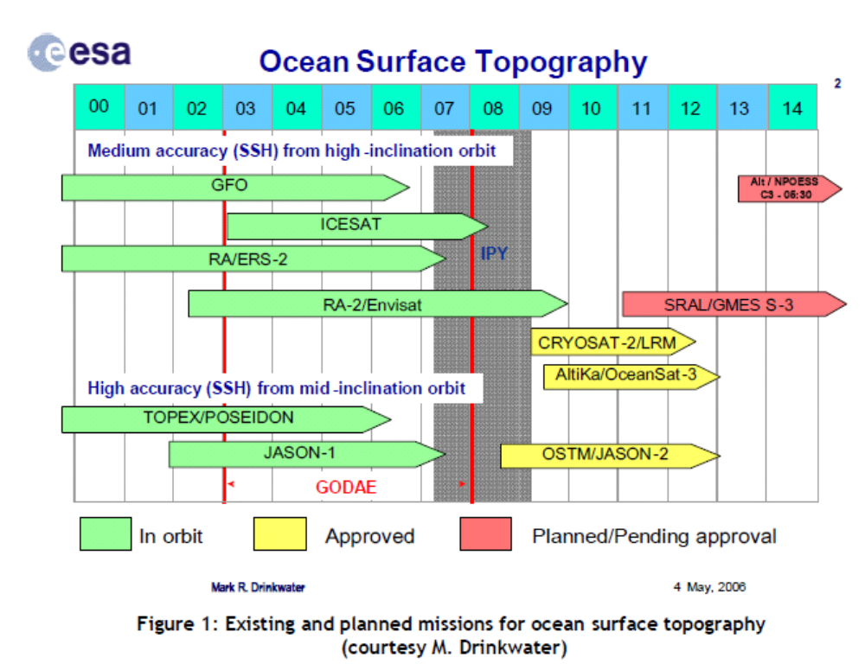
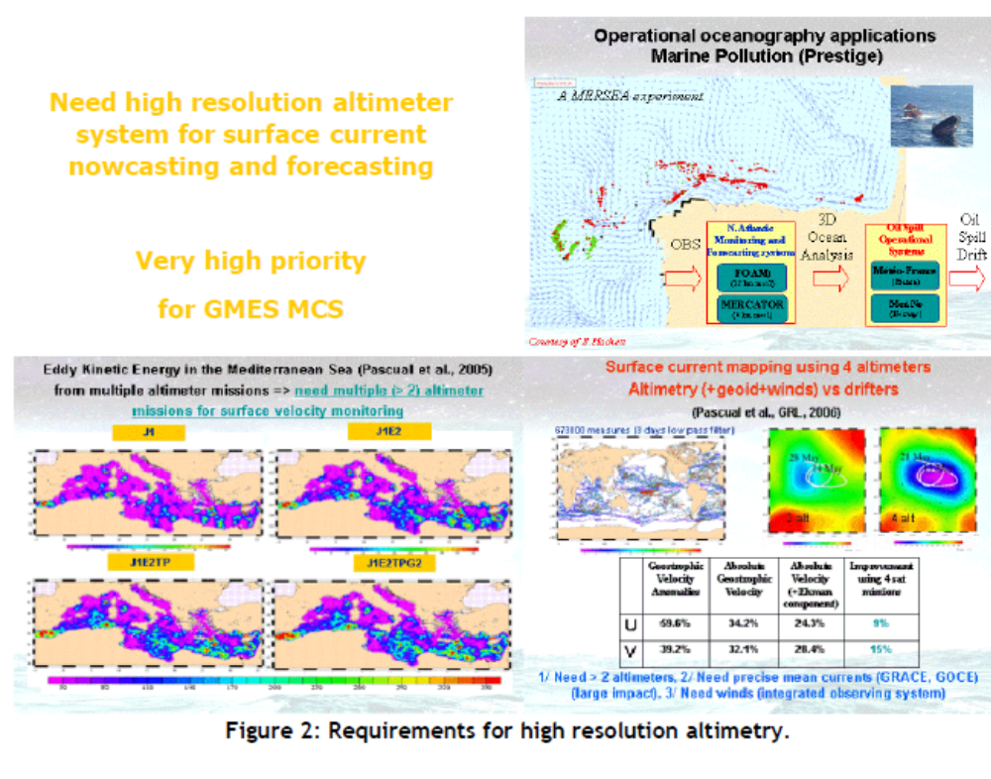
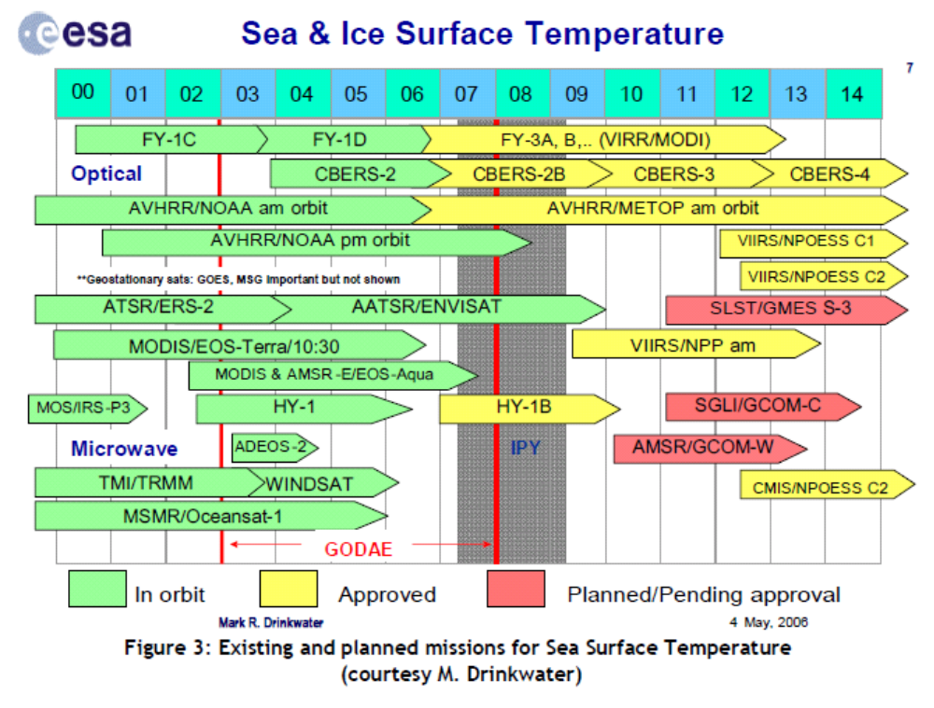
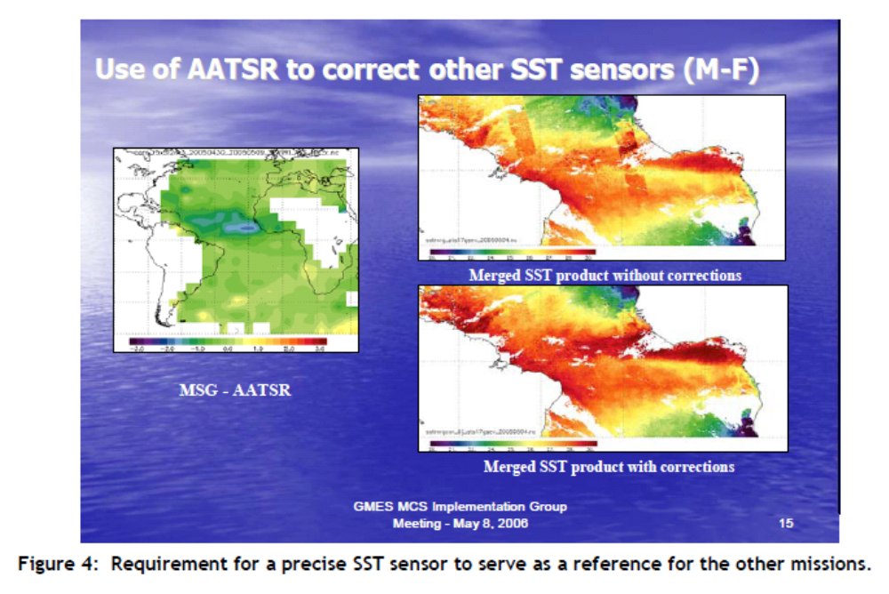
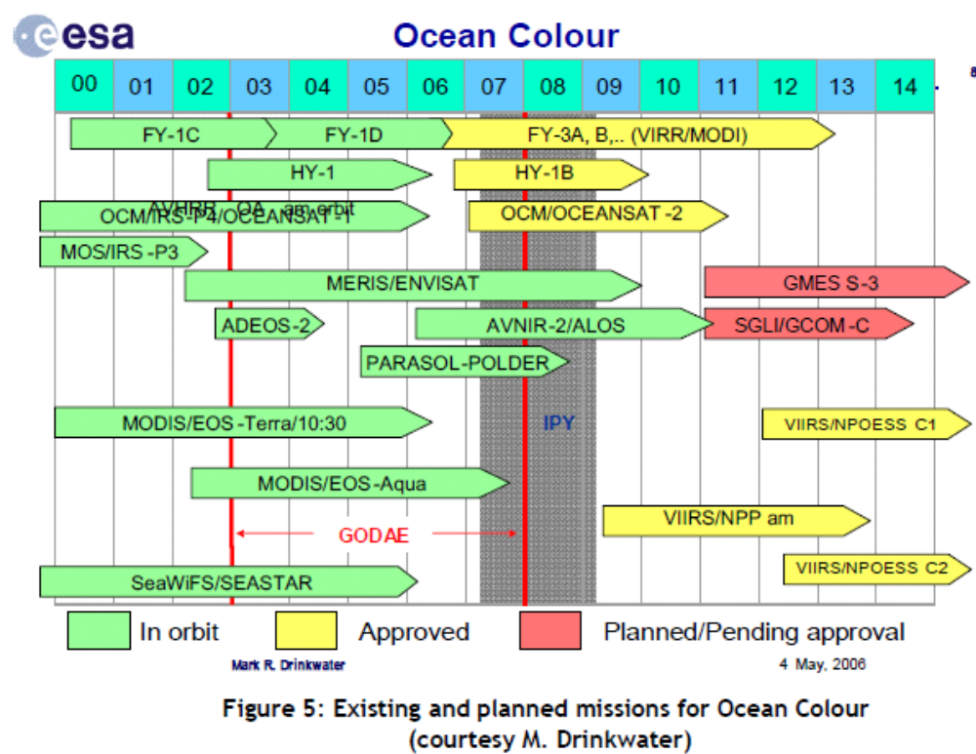
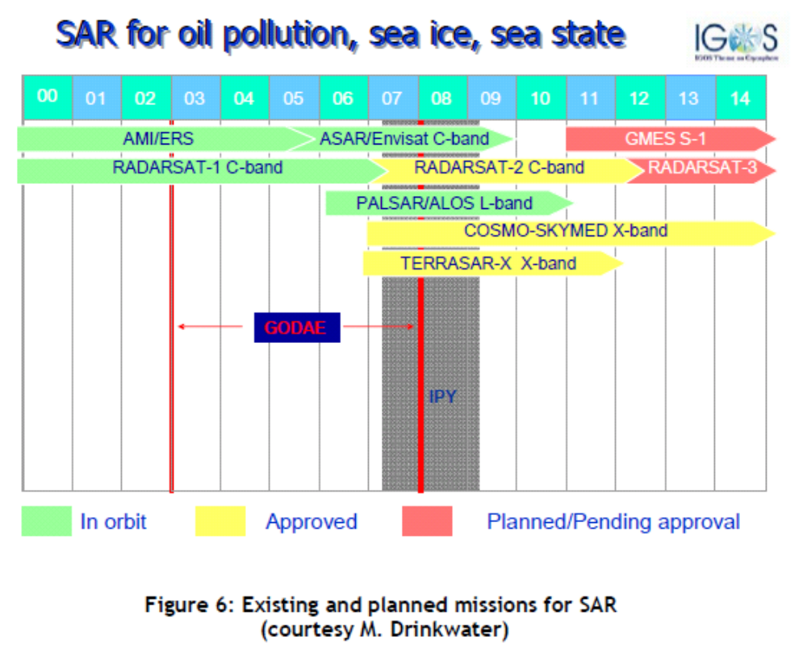
Adopted Report of the In situ Infrastructure Working Group
While satellites provide a global view of the surface of the oceans, in situ systems provide complementary data, primarily by monitoring their interiors, although valuable surface measurements are made too. In the context of the MCS, global to regional scale observations are required to constrain the models at depth & provide surface calibration and verification data. The primary MCS requirement for in situ measurements at present is for the physical state variables of temperature, salinity & currents and for verification of the forcing wind and wave properties at the surface. However the cost of deployment is generally high, so where possible, it makes sense to make biological and chemical measurements at the same time, provided this does not create a disproportionate cost for the observing system itself.
The candidate observing system technologies for in situ measurements required by the MCS comprise:
- Drifting Argo Floats for the measurement of temperature and salinity profiles to ~2000 m and, by tracking them, mean subsurface currents.
- Research vessels which deliver complete suites of multidisciplinary parameters from the surface to the ocean floor, but with very sparse and intermittent spatial coverage and at very high cost of operations.
- XBTs launched by research vessels and ships of opportunity underway for the measurement of temperature and salinity profiles to ~450-750 m depth.
- Surface Moorings capable of measuring subsurface temperature profiles in particular continuously over long periods of time. Currents are often monitored and meteorological measurements are usually made too. Biofouling restricts the range of measurements that can be made from long deployments in the photic zone but surface salinity and biogeochemical measurements are attempted.
- Ferry-Box and other regional ship of opportunity measurement programmes for surface transects which may include temperature, salinity, turbidity, chlorophyll, nutrient, oxygen, pH and algal types.
- The Continuous Plankton Recorder (CPR) operated by the Sir Alister Hardy Foundation for Ocean Science which is towed from merchant ships on their normal sailings in order to monitor the near-surface plankton of the North Atlantic and North Sea on a monthly basis.
- The network of tide gauges provides long term reference and validation sea level data.
- Gliders which complement floats and moorings and are able to perform transects of physical and biogeochemical parameters from the surface to 1000m at a lower cost than ships.
- Surface drifters that are cheap and light-weight platforms which passively follow the horizontal near surface flow via a drogue/sail. They complement satellites for sea surface temperature and surface current measurements.
- Long-range (up to 200 km) HF-radar monitoring systems in specific regions of national/international interest and importance, typically as part of an observatory
At present it is not realistic to define the full range of in situ measurements and the infrastructure required for down stream services; they are too diverse and in many cases too immature. Progress here will be made by the efforts such as those of the Working Group on European Marine Monitoring and Assessment (EMMA), set up by DG Environment and of the European Environment Agency, which are actively working to define needs and methods of data gathering for assessments foreseen in the (draft) European Marine Strategy Directive. The role to be played here by the MCS can be discerned however, and this has been taken into account in this Report.
There are two key considerations in designing and implementing the in situ infrastructure for the MCS: the performance and deployment of the observing systems themselves and the approach to the collection and processing of the data, at least to level 2.
Performance & deployment
Because of the costs and general difficulty of deployment, it is never sensible to use sensors of marginal sensitivity, robustness and stability over as long a period as possible. Problems are caused by biofouling in the photic zone and attention has to be paid to this in the system maintenance programme at least.
A key issue for the design of networks is the small scale of many important features in the oceans and seas (~100skm in the open ocean; ~10skm in strong flows). It is almost impossible to resolve such features using in situ methods alone; this has to be the role of remote sensing (e.g. EO) methods. The unique role of in situ networks is to augment such broad coverage of a limited set of variables by providing measurements which cannot be obtained in any other way, whilst paying attention to possible aliasing.
Network design
Observing systems differ depending on the area and the phenomena to be sampled. They are usually sorted into 3 categories:
Global: The overall system (remotely sensed and in situ) is designed to provide data from all the oceans and be capable of resolving or at least avoiding excessive aliasing of important dynamical features. Realistically this demands observation on at least the order of 100km. Typically such a system delivers surface and upper ocean observations of a limited number of parameters (Temperature, salinity, SSH, SST, currents) on a time scale from 1 day to 1 month. Such a system can only be built at the international level.
Regional: The overall system is designed to provide data in a specific area, such as a regional sea, to monitor specific dynamical phenomena and state features primarily to sustain one or more specific services (e.g. the TAO/TRITON/PIRATA buoy array for the in situ component of El Nino detection, the Arctic buoy network as a contribution to ice monitoring, etc).Again the goal is to resolve the important dynamical features which are of the order of a few tens of km in the regional seas. Collaboration between several countries (usually less than 10) is needed and the number of parameters is larger (between 10 and 20), including ocean (both physical and bio-chemical) and meteorological measurements. The temporal sampling is often at a higher rate: from hours to days.
Coastal: These observing systems are usually set up at the national level to answer very specific questions such as coastal monitoring of the water quality or wind/wave/tide monitoring in harbour areas, HF radar image acquisition, etc. There is limited collaboration among countries and these data are often used exclusively by the coastal models that have led to setting up the system. These coastal observations that do not form part of multipurpose networks are not in the scope of MCS, but assist in the delivery of downstream services

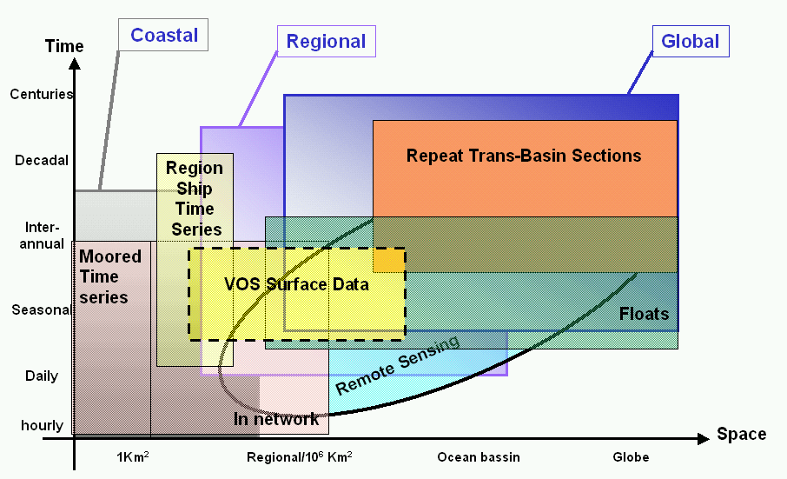

Data collection & management
There are a number of characteristics that define the fitness for purpose of any data collection scheme. These are considered in turn:
Timeliness
MCS needs two types of data. Firstly there are those data delivered in near real time that are required for daily/weekly forecasting activities that provide the common denominator data for downstream services. Secondly there are data that are subject to greater quality control and delivered in delayed mode. These are particularly valuable data for reanalysis work, & to assist seasonal forecasting and climate monitoring/prediction where long term stability is essential and signals are small.
In operational oceanography near real time has a specific meaning. The main criterion is the maximum delay between measurements and assimilation beyond which the measurement adds nothing to the performance of the model. There is no unique answer: this depends on the type of model, the variables that are assimilated, the forecast product and the application for which it is produced. For instance, assimilated information of deep ocean temperature and salinity will persist within an ocean global circulation model for weeks or months and so a delay of several days in supplying data can be acceptable. On the other hand, ocean mixed layers vary on more rapid timescales in response to the diurnal heating and to storms. The impact of such data will probably not persist more than 3-5 days after assimilation, so measurements are needed within a day. As a compromise, real time for operational oceanography generally means availability within 1 or 2 days from acquisition, to allow data centres to allow first-line quality-control of the data.
Sustainability
The observations have to be sustained because when an emergency event happens (tanker pollution, storm events, …) only very few additional useful measurements can be taken. Numerical models that are assimilating data run according to a regular repetitive pattern and require data accordingly. Datasets required to describe climatologies need to be filled on a regular reliable basis. Although it is important for a sustainable operational system to be funded in an ongoing stable manner - in particular other than through research funding - the culture and success criteria of the organisation have to be appropriate too. Services and essential support activities have to be available at all times - 24-hour/7-day-a-week. Attention must be paid to product creation and delivery chains. Services should be fit for purpose and provided efficiently; appropriate performance measures need to be in place to verify this.
All operational activities do need closely coupled R&D activities dedicated to exploiting new science, new sources of data & improved, more capable technology (particularly computer systems), in order to sustain existing services more efficiently and help deliver new and improved services.
Although not always recognised as such these are key features of sustainability.
Availability
As indicated above, data from the domain of interest need to be available in a timely manner to sustain operational services. Because of chronic under- or non optimal sampling there is always value in sharing global and regional data particularly of the state and dynamical variables that are fundamental to the MCS. A data exchange policy that facilitates this is absolutely crucial to success therefore.

Data management
In 1998 EuroGOOS issued a publication called "The science base of EuroGOOS" where some limitations related to data exchange were highlighted. The situation has improved but some statements are still relevant and targeted actions are necessary within Europe to solve them fully:
- Lack of international infrastructure for operational oceanographic data gathering, transmission, and products, (e.g. as adopted in World Weather Watch by the WMO), and consequently a lack of common standards. Although still substantially true in general, some experience on the global scale, within GODAE such as the Argo program have shown that it is possible to reach consensus on common standards (formats, real-time and delayed mode quality control, data distribution…)
- Lack of a clear right or duty to collect and transmit real-time data. In the past five years we have seen the concept of “portals” emerging with the duty to serve their user in real time: Salto/DUACS for altimetry, Medspiration/GHRSST for SST, Argo and GOSUD Global Data centres, and JCOMMOps are examples that exist nowadays.
- Lack of proper design of a service infrastructure, using, for example, multiple data inputs such as wind, waves, and currents, to generate predictions of oil spill movements. Such infrastructures are operational within the Baltic and on parts of the NW Shelf. They are being demonstrated and consolidated more generally within projects such as MERSEA, MARCOAST and Polarview.
- Imbalance between monitoring (measurement) technology and capacity for post- processing data and subsequent real time use by numerical models. In part this has required the development of data assimilation methods in ocean modelling and as that has been shown to be possible and valuable the need has begun to be met through initiatives such as the Coriolis project in France. This effort should be sustained and expanded in the future.
A data management system for operational oceanography must provide quality controlled data, in a timely way, on a regular basis, according to procedures that are clearly documented and evolve upon common agreed decisions between user and provider. There are three fundamental characteristics that define such a system

A4.4. Data access
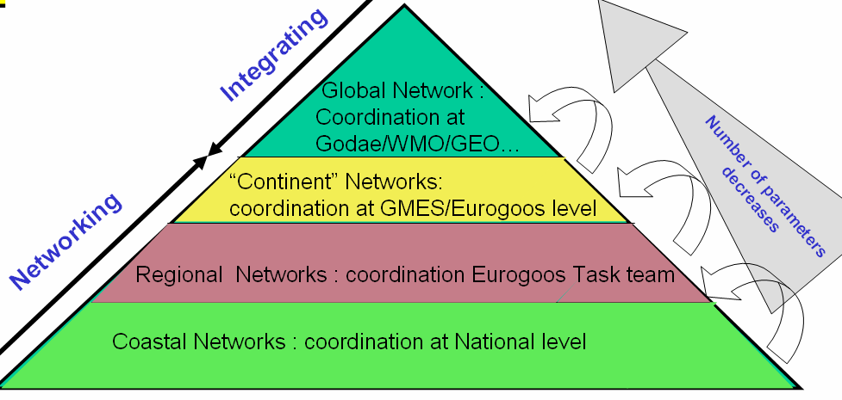

It has been demonstrated that professional users of data need portals that build the connection to all the relevant datasets and provide access to these data as if they were all in a single place. Data are acquired at coastal, regional, pan-continent, global levels and together they enable the overall operational system needed by users. More parameters are usually monitored and needed at the coast than on the global scale. In Europe, EuroGOOS Task Teams and then regional Operational Oceanographic Systems or Networks such as NOOS, BOOS and MOON are coordinating data exchange to sustain coastal and regional services. In principle the regional operational systems could organise data exchange between themselves and contribute to data exchange at the global level. Such coordination would complement initiatives like ESEAS for sea level, SeaDataNet for data infrastructure, DMAC in USA, Argo or GHRSST for GODAE, etc.

Quality control
Quality control of data exchanged in near real-time must be automated leading to the rejection of outliers. In delayed mode, more scientific expertise is applied to the data and error estimations can be provided with the data.
Data quality control is a fundamental component of any ocean data assimilation system because accepting erroneous data can cause incorrect forecasts, but rejecting extreme data can also lead to erroneous forecasts by missing important events or anomalous real features. The challenge of quality control is to check the input data against prior information and either reject or accept them. That prior information may include the historical error characteristics of such measurements and earlier forecasts for the data time, knowing the error characteristics of such forecasts. As most of the data are processed by different actors, but used all together by operational models, clear documentation of the quality control procedures, a homogenisation of the quality flags, and the reliability of different actors in applying these rules are required.
Standardisation
Data must be preserved in such a manner that their usefulness will be retained, essentially for all time. They must also be distributed so that a user can easily merge them with other relevant datasets. They must be catalogued in a way which will facilitate their use. This is the purpose of correctly defining data formats as well as maintaining metadata (data on the data) that need to be preserved for future processing.
Data formats have always been a nightmare both for users and data managers and they all search for the "Esperanto" of data formats. Computer technology has improved the situation in the past decade and we are slowly moving from ASCII formats (easy to use by human eyes but not for software), to binary format (easy for software but not shareable among platforms (Windows, Unix, etc), to self-descriptive, multiplatform formats (Netcdf, Hdf, etc) that allow more flexibility in sharing data among a network and are read by all software that are in common use.
A common vocabulary to record metadata is required. This should be easy to achieve for a specific community such as physical operational oceanography as the number of parameters is small, but it starts to be a bit more difficult when multidisciplinary datasets are addressed. To help in this area some metadata standards are emerging for the marine
community with Marine XML in Europe, CF/COARDS convention in USA, and ISO19115 norm.

GAC(2005)12 - Workshop on GMES Marine Core Service, Brussels – October 27-28, 2005: a report by P. Ryder, J.-F. Minster, N. Pinardi, K. Resfnes, M. Bell and J. Johannessen
See section 6.1
The Maritime Policy Green Paper has emphasised that commercial sectors such as shipping, fishing, oil exploration, offshore construction, aquaculture, and tourism, and public sectors such as coastal protection, defence, search and rescue, R&D and government policy making all need dataon past, present and future meteorological, oceanographic, hydrographic and ecological state of the seas and the oceans. Global-scale monitoring is required to meet this need and the EU is being encouraged to set up a European Marine Observation & Data Network to provide sustainable, improving access to information.
Here we mean the physical, biological and chemical state of the environment, in general. The need for the biological component is likely to be expressed in terms of the state of ecosystems, and habitats; the chemical component in terms of pollutants and nutrients
In practice, the actual intermediate users may be contactors appointed by the listed agencies or institutes
Some moorings and the Ferry Box technology are capable of near real time biogeochemical reporting. New technologies such as gliders and ARGO floats can also collect biogeochemical data and are very promising for the provision of near real time data
In general such models need to embrace the important, relevant processes on/in the land, sea, cryosphere and atmosphere, and interactions between them.
Here we mean having guaranteed 24 hour / 7 days a week availability
According to its Mandate (especially Art 3, Council Regulation (EEC) No 1210/90 of 7 May 1990) EEA plays a key role in the European in-situ monitoring community. In July 2004 EEA outlined its view of the objectives and role of in-situ monitoring within GMES (GAC (2004)6), followed by a first progress report on the development of the GMES in-situ monitoring component in November 2004 (GAC(2004)21
COM(2005)505 final
The Marine Regions are specified as the Baltic, North East Atlantic and Mediterranean, coinciding with the three of the regions of the MCS
Held at the EEA, Copenhagen, 23-24 October 2006
based on a paper provided by Mr. Kimmo Kanto of the Finnish Funding Agency for Technology and Innovation and material from references and the Polar View website
B Dickson, ‘The Integrated Ocean Observing System (iAOOS): an AOSB-CliC Observing plan for the International Polar Year’, Oceanologia, 48(1), 2006, pp 5-21.
CEOS has defined a number of data/product levels for use in Earth Observation. It is helpful to use a common nomenclature in discussing data processing. Level 0 Data: Raw data after restoration of the chronological data sequence for each instrument, i.e. after demultiplexing of the data by instrument, removal of any data overlap due to the data dump procedure and relevant quality checks. Raw instrument data information (telemetry packets) is maintained during this process. Level 1a Data: Instrument data in full resolution with radiometric and geometric (i.e. Earth location) calibration computed and appended but not applied. Level 1b Data: Calibrated, earth located and quality controlled data, expressed as radiance or brightness temperature, in the original pixel location, and packaged with needed ancillary, engineering and auxiliary data. Level 1c Data: In case of the IASI spectra, level 1b data after application of the apodisation function. Level 2 Product: Earth located pixel values converted to geophysical parameters, at the same spatial and temporal sampling as the level 1b data. Level 3 Product: Gridded point geophysical products on a multi-pass basis. Level 4 includes the use of other data sources, e.g. model results etc.

