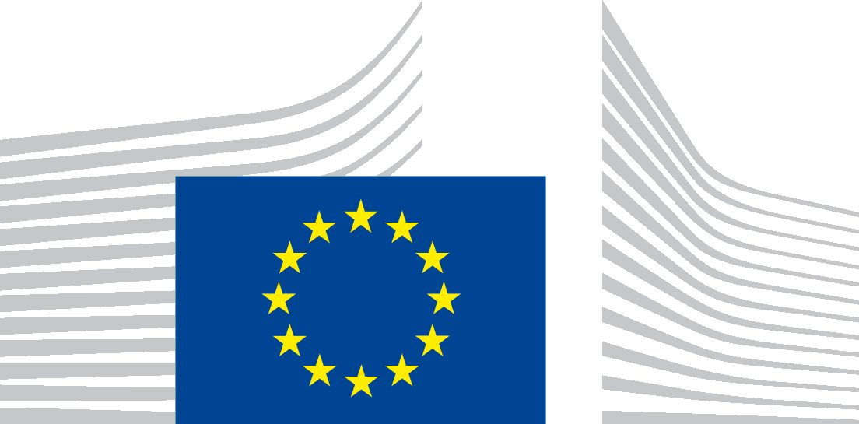 | EUROPEAN COMMISSION  DIRECTORATE-GENERAL FOR MARITIME AFFAIRS AND FISHERIES
Brussels,

MARE A.1
Kick-off meeting of the marine knowledge expert group
Friday, the 19th of January 2018
DG MARE, Brussels

Summary report
The main objective of the meeting was to familiarise Members of the group with each other, with main EU Marine Knowledge initiatives, and to obtain preliminary indications on how these programmes such as the European Marine Observation and Data Network (EMODnet) and the Copernicus Marine Service (CMEMS) could move closer to the needs of industry.
All presentations and a list of participants are on the maritime forum. This summary is intended to cover the main points raised by the group.

Welcome and introduction by Mr. Haitze Siemers, DG MARE
The aim of the marine knowledge expert group is to contribute collectively to sustainable blue growth and to work in collaboration to advance EU marine data programmes and services to the next stage. We can only make progress and achieve innovation when accurate data are available. The output and delivery of this expert group can help ensure that what we are developing is fit for purpose.
In this meeting we can get to know each other and understand industry needs, best practices, and problems by addressing the below questions:
- How can EMODnet/CMEMS provide services, tools for industry and business operators?
- Which tools would make your life easier (best fit for purpose)?
- What are the interests and needs of your community regarding data?
- How do you use EMODnet/CMEMS?
- Which products of EMODnet/CMEMS to move forward?
- What needs to be improved?
- How could you sell EMODnet/CMEMS and turn it into a market blockbuster?
- How can you best contribute to a sustainable EMODnet/CMEMS?

Rules of procedure
You may find the rules of procedure on the maritime forum. Please send your comments in written by email to MARE-A1-EXPERTS@ec.europa.eu before 1 February 2018. After this date, the rules of procedure will be considered approved.

Tour de table – Introduction by each participant
The Commission services expressed satisfaction at having gathered such a diverse and knowledgeable group.

Presentation of EU initiatives

EMODnet by Mr. Jan-Bart Calewaert, EMODnet Secretariat
EMODnet currently entails more than 150 organisations working together to assemble and provide access to well described marine data, data products such as maps and a range of data services. These are delivered via a central portal, eight thematic data portals, six regional sea basin checkpoints or data stress tests, a data ingestion portal and a secretariat.

Copernicus Marine Service by Ms. Laurence Crosnier, Mercator Ocean
The Copernicus Marine Service is one component of the Copernicus Earth observation programme, to provide operational space-based services in the field of the environment, civil protection and civil security tailored to the needs of core users (Union institutions and bodies, European, national, regional or local authorities). Copernicus services are also available largely full, free and open ot other users such as research users, education organisations, commercial and private users or charities, non-governmental organisations and international organisations. In the marine field, CMEMS provides an interactive catalogue of environmental services and hosts a single portal with a portfolio of 152 products. The programme at large and CMEMS also specifically, have user's uptake activities with online tutorials and showcase for use cases as to develop markets and generate concrete impact on end –markets for example in line with the commercial and industrial sectors

Discussions about access to data: How EU initiatives can help industry?

5.1 What are your specific needs related to EMODnet and Copernicus data, functionalities and products?
Discussions in four roundtable groups to have a first brainstorming on the key topics and issues to be dealt in the coming years and to identify interest, needs and potential contribution of experts.

Points made by members of group
- Some of the participants had little knowledge of EMODnet and CMEMS. We need to spread the word, to create more visibility, to consult users, to engage actively with private sector stakeholders (e.g. via professional associations), to attend relevant business events, etc.
- Work with users’ communities in a more structural way: identification of their needs, overlaps and improvements (e.g. pop –up voluntary short survey/feedback for users to improve services (e.g. exportability, usefulness) questionnaires, open users forum, FAQ, helpdesk …).
- EMODnet and CMEMS are mostly used during the initial phase of planning to give a baseline. Often more data collection and research is required afterwards.
- There is particular need for better data, improvement of data (real time data as well as archive) and products in following categories:
- Nautical charts (e.g. Open Sea Map – EMODnet could support it);
- Wind (e.g. wind speed, direction above sea level);
- Environment impact assessment (level);
- VMS and AIS data, useful for mapping shipping densities;
- Waves (seawater currents);
- Tides;
- Shallow water bathymetry, shallow water coastal areas;
- Coastal data;
- Fish, fishing gears in use and fisheries (e.g. develop a FishDataPortal);
- Sea bottom (incl. wrecks, bombs);
- High resolution bathymetry;
- Biological data;
- Biodiversity held in marine protected areas e.g. map biodiversity in MPAs, not solely the MPA boundaries);
- Marine spatial plans;
- Integrated Spatial ecosystem modelling (e.g. should integrate ecosystem and food web dynamics);
- Cables and pipelines.
- Data should be more accessible and fast to download.
- There is a need to better explain the difference between all systems such as CMEMS EMODnet, WISE Marine, etc: who does what? (Perception of overlapping).
- Need to clarify: what kind of data can be found in which portals and where? (e.g. search functionalities without too many data). How data quality is ensured in EMODnet? Can EMODnet cover DG RDT funded projects' data (of relevance)?
- The focus should be on improving the current services (providing easy access to data) rather than creating more data products.
- Create a mapping of existing local networks of data providers in order know which gaps to fill.

What are the positive aspects and the problems you have encountered while using EMODnet or CMEMS?
Discussions in four roundtable groups to have a brainstorming on the positive aspects and the problems the experts encounter.
- Positive aspects:
- Wide range of information and vast amount of data.
- Data free and open (cost saving in term of licensing).
- Easy access to near-real time data in CMEMS.
- Satellite models and in situ date available in one place in CMEMS
- Good Bathymetry portal in EMODnet.
- Physics portal has huge potential in EMODnet.
- The tools are user-friendly.
- Negative aspects:
- Lack of visibility: need to better reach out the stakeholders (e.g. via trade organisations, presentation of the EU programmes, identification of the needs of the sectors, awareness raising of the potential, environment committee instead of General assembly). More personal and pro-active approach to promote and engage instead of relying only on emails.
- Need to improve the involvement of universities and students (trainings –link ocean literacy).
- Data are hard to gather, metadata are tedious to retrieve. Need to deliver them in a more friendly way.
- Problems with data compatibility and format (e.g. exportable in shapefiles, excel, word, graphs, binary data, vector format, etc.). Need to export them in different ranges of formats e.g. Global Mapper is a program that exports in several formats could be used as a good reference.
- The performance of the system is too slow and the technology of some EMODnet portals could be improved (e.g. zoom in and zoom out is too slow). Some parts are designed mostly from a researcher's point of view. Currently companies hire intermediaries to re-package open data, thus also EMODNet data, to make it work fast (e.g. put it in tiles) and re-sell it.
- Need for more machine-to-machine interfaces and compatibility.
- Hesitation to become data providers because of the lack of tracking system and record of who is using the data. Need for user analytics (for data suppliers this is important in terms of outreach and funding/financing).
- These tools are made by researchers, for researchers. Companies need to repackage the data.
- Need to present the results of public (national and EU) funded projects in a more useful way (currently perceived as not effective). Reports should be more accessible to the wider community.
- Need for more interactions with users, to have more usable products (Perception that the portals are created more for data providers).
- The information is not always well organised (e.g. whereabouts of algae species).
EMODnet physics portal has huge potential (e.g. in context of ocean energy) but not yet fully used as data are incomplete and user services could be improved.

Presentation of EU initiatives
6.1 Data ingestion by Mr. Jan-Bart Calewaert, EMODnet Secretariat
A new data ingestion facility has been built to facilitate ingestion of data that escapes national data centres and are therefore not visible in EMODnet

6.2 Ocean Commitments by Ms. Charlotte Herman, DG MARE
The commitments to concrete measures to improve stewardship of the ocean were generated during the last edition of Our Ocean conference. Unlike previous conferences there was a strong focus on the private sector: 437 tangible and measurable commitments were announced, including €.2 billion in financial pledges. Some of the 100 commitments from the private sector concerned data – the S. Volvo Ocean Race, INFOMAR, International Association of Oil and Gas Producers, Earth Twine Blockchain Solution, Saildrone, Microsoft “AI for Earth European Union Oceans Award”.

Discussion on how the industry can provide data for the common good

What are the existing good practices where the industry provided data, used in the context of EMODnet.
Points raised in discussions as to how industry could contribute data to the public good included:
- Release of non-commercial data in an open way as part of the licencing and Environmental Assessment requirements
- Need to communicate more about available tools to assist data ingestion.
- Industries need benefits for sharing data (not sharing often gives a commercial advantage).
- Doing industry projects: polling resources together. When everyone shares, everyone gains. Exchange of info between authorities and companies.
- Difficulty to obtain 30-years old data.
- Related initiatives
- Marine Data Exchange
- SIMORC (example of data sharing but not so effective);
- SUDS (procedure for planning);
- Marine Geospatial Bibliography;
- Blue Cloud;
- ZENODO provides DOI’s (repository);
- METNET fed to GTS – Marine monitoring data.

What are the incentives to provide data?
Points raised included:
- Provide assistance to share data by match-making, in order to increase the exchanges and the relevance. Act as an intermediary (matchmaker) between data seekers and data providers (e.g. “Tinder” for ocean data, virtual forum, broker).
- Overall observation: industries need more incentives and support to share their data. It is difficult to justify the process because it requires effort (money, time, resources).
- Be forced to provide data by authorities (legislation e.g. licensing conditions).
- Improve EMODnet branding and allow data contributors to include the logo of these initiatives on the website of the companies.
- Demonstrate the benefits of sharing. Increase the visibility and reputation for companies who contribute, in terms of social responsibility and public image; be granted extra information (e.g. become an EMODnet Associate partners), visibility on both websites, “Ocean data friendly” label, certification, tax reduction, Corporate Social Responsibility (CSR), bonus point in public tenders, etc.). This will only work if the branding/image identity of EMODnet becomes recognisable to industry. Increase the visibility amongst industry of both websites is a key condition to realise the latter (see above improve branding).
- Offer flexibility: some companies want to stay anonymous and other want visibility when sharing data. Publish only processed data, not raw data sets. Take into account liability issues & sensitivities for data providers.
- Releasing data to the general public can represent a risk for companies. Providing it anonymously sometimes takes away certain concerns
- Data providers want to receive information about how the data has been used (who, how, when…). This requires propose tracking system by data portals.
- Involvement of a whole sector: convincing a first organisation to contribute data is difficult. There is a need for pilot initiatives. When you have one contributor from one sector, it is an incentive for others who are in the same sector.
- Provide more guidance on how to manage the data more effectively.
- Simplify the system, portals should be easier to use.
- Highlight the potential of EMODnet for planning purposes (MSP).
- Ensure that EMODnet becomes a recognized industry data standard.
- Interoperability with global systems. Security of knowledge vs extra EU players.
- Following the need for data user analytics for some data providers, the option to provide the data user information regarding the data provider/contact information
- The permission to operate could include some obligations to provide open data. To have contractual conditions to share data.
- To have data publish for free in data papers when sharing. EMODNet could serve as data depositary. Data paper = outcome for data provider.
- Providing Digital Object Identifiers (DOI) as a unique stamp that allows you to reference a dataset.

Conclusions and next meeting
- Please send your reimbursement forms as soon as possible by email with a bank stamp and signature or a bank statement (original documents are not needed).
- One or two meetings a year are expected. The next meeting would probably be mid-year.
- Send industry events where EMODnet and Copernicus could be discussed to DG-MARE
- Deliver any data requirements of particular industrial sectors to DG-MARE
- Recall of the two objectives of the expert group:
- Make sure the EU Commission and EU data programmes meet the needs of the industry.
- Engaging industries and encourage them to provide data.
- The output of this group will be best practices and ideas to improve.
- Identification, by a participant, of top sectors to keep an eye on
- Shipping
- Fishing
- Oil and gas
- Aquaculture
- Dredging & Cables
- Cruise tourism
- Off-shore energy and wind
- Different events to keep in mind:
- EOOS conference on the 21-23th of November 2018 in Brussels.
- Next edition of the Open Sea Lab hackathon in spring 2019.
- Commitment before the next meeting: Please identify at least one workshop, conference or event that could be useful to attend in order to present EMODnet and Copernicus and gather feedbacks and insights.

regulation (EU) No 377/2014 , repealing Regulation (EU) No 911/2010)

