Content
- Add other content type
- Page

Insert your title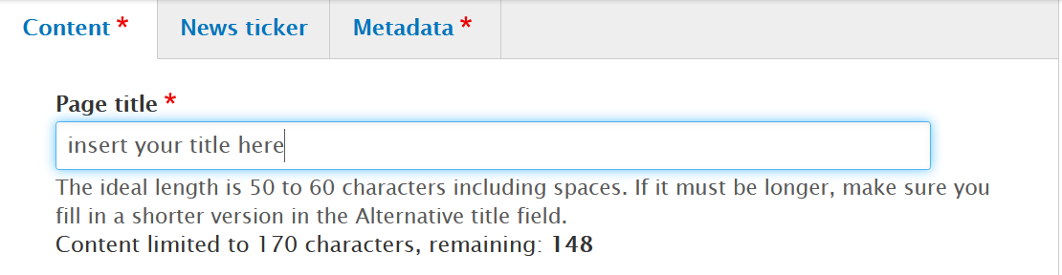
Fill in the introduction
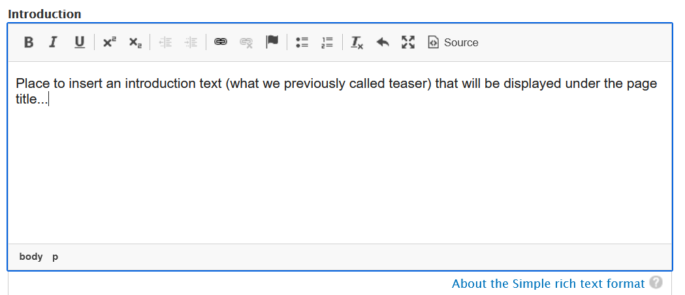
Copy the text of the introduction field to the teaser field (obligatory field)
Start the body text with inserting a picture
then introduce your article
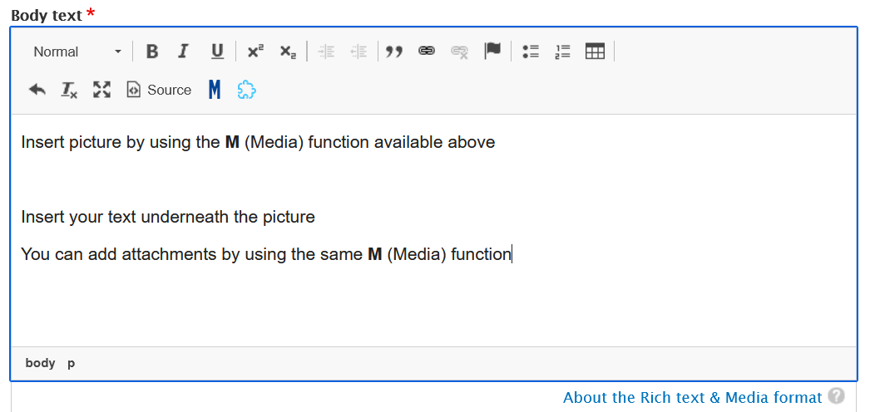

Under Metadate tag, add integrated maritime policy as subject
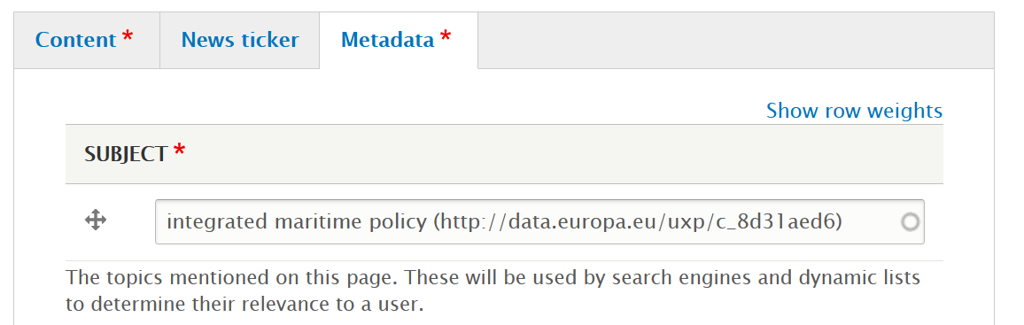
You can use tags for your article, e.g. map of the week (for the Atlas of the Seas)
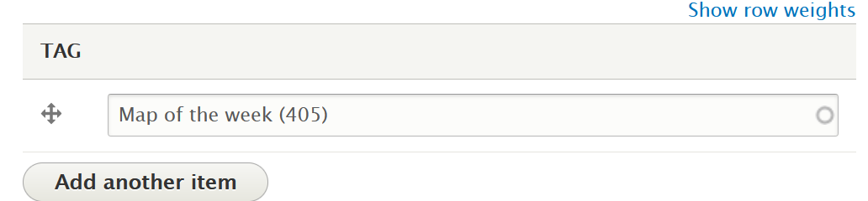
Do not forget to specify your community under Theme
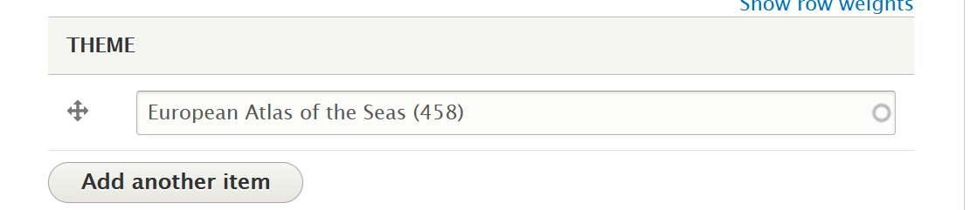
Leave authors field by default
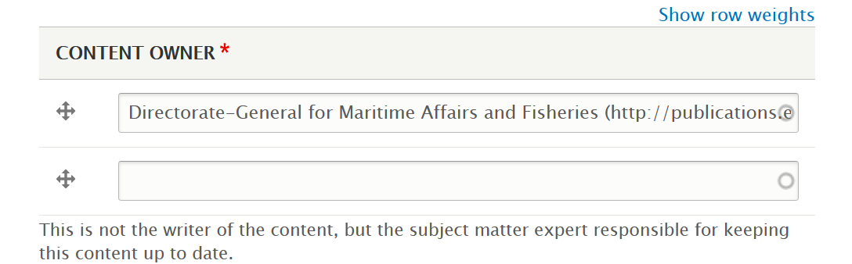

Click on “Save”
Check your work (you can still modify by doing an Edit draft) and if you are satisfied, push it to publication.

