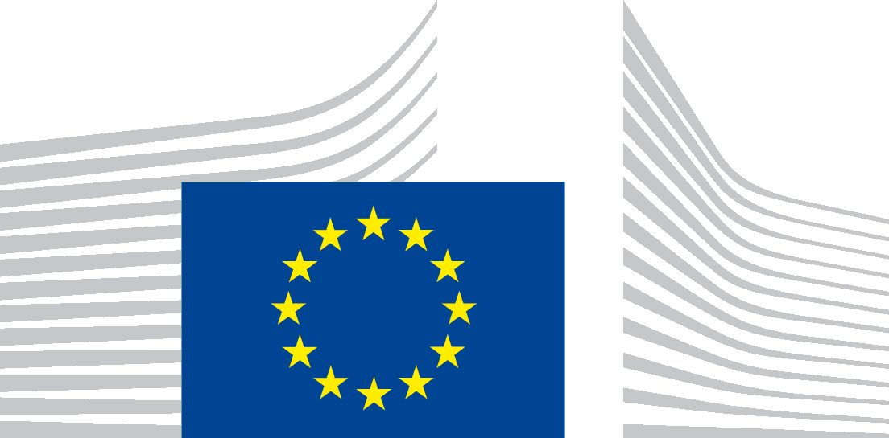 | EUROPEAN COMMISSION  Directorate-General for Employment, Social Affairs and Inclusion

CONSENT FORM

FOR PROCESSING PERSONAL DATA BY THE EUROPEAN COMMISSION

EUROPEAN YEAR OF SKILLS

The European Commission (hereafter ‘the Commission’) is committed to protecting your personal data and to respecting your privacy. The Commission collects and processes personal data in accordance with the Regulation (EU) 2018/1725 of the European Parliament and of the Council of 23 October 2018 on the protection of natural persons with regard to the processing of personal data by the Union institutions, bodies, offices and agencies and on the free movement of such data (repealing Regulation (EC) No 45/2001).

We will keep your personal details provided in the present form as proof of your consent for maximum 2 years after the end of the European Year of Skills. You can freely withdraw your consent at any time by sending an e–mail to EMPL-SHARE-YOUR-SKILLS-STORY@ec.europa.eu . The withdrawal will not affect the lawfulness of the processing carried out before you have withdrawn your consent. You can always consult the specific privacy statement for more information as regards the processing of your personal data and exercise your rights by using the contact details provided therein.

In this consent form you have the option to provide consent to either one or more personal data processing activities. If you are sharing personal data of other people, please ask for their consent before submitting.

◻ | I consent to the use of text and audio-visual content, including pictures and videos submitted to EMPL-SHARE-YOUR-SKILLS-STORY@ec.europa.eu be used on the European Year of Skills website, on the social media channels of the European Commission and during flagship events organised in the context of the European Year of Skills.
◻ | I consent that my name and contact details are included in a contact list shared internally among the services of the European Commission, Directorate – General for Employment, Social Affairs and Inclusion, and with the communication contractors in charge of communication activities linked to the European Year of Skills: ICF Next / Rainbow Consortium and Ecorys for the purpose of promoting EU activities/events and disseminating information linked to the European Year of Skills.
◻ | I consent to participating in interviews and news items which showcase activities linked to the Year of Skills.
In order for organisers to follow up your consent, please give your name and organisation along with your signature.
NAME:
ORGANISATION :
DATE:
SIGNATURE:

THANK YOU FOR YOUR INTEREST & PARTICIPATION!

