How to embed an Atlas map in a Maritime Forum page

Go to Content tab of your page
Create a add Iframe in your content items
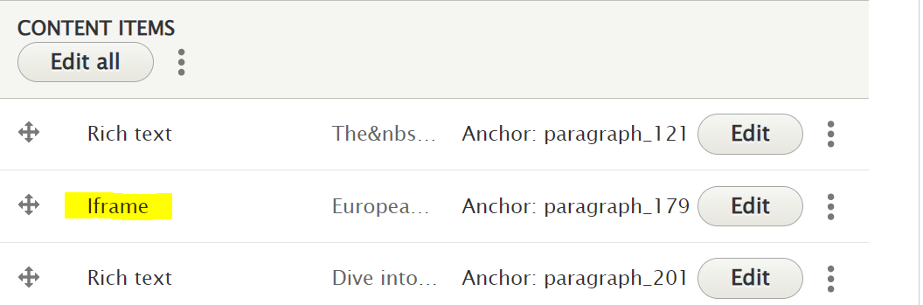
For this you click on the Add button and select Add Iframe from the dropdown list
Fill in your title and click on Select iframe
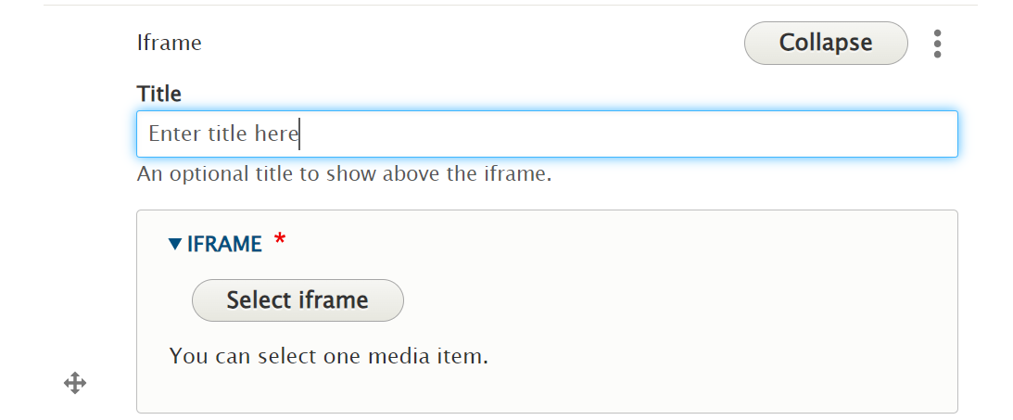
Go to New iframe, insert Name, iframe title and select Standard iframe from dropdown menu
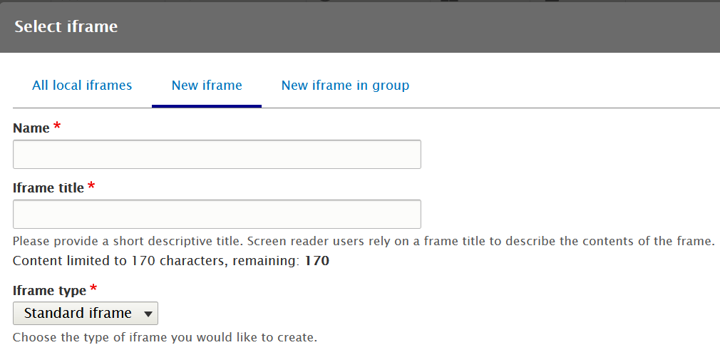
Copy and paste the embedding code from the Atlas in this frame
For this end, launch the European Atlas of the Seas, select your map(s), go to the “Share options” function, click on the Embed tag and Copy
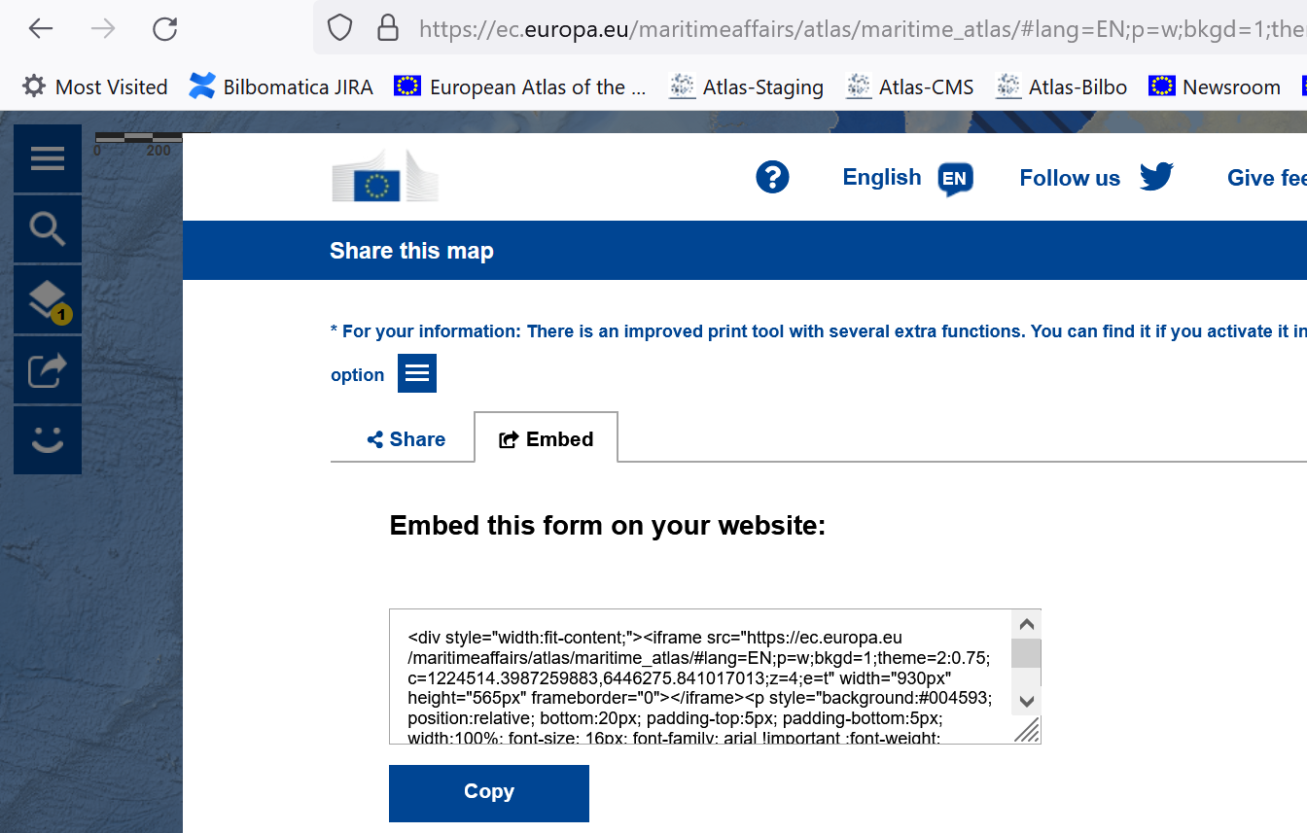
Return back to your draft in Maritime Forum and paste the code in the Iframe field
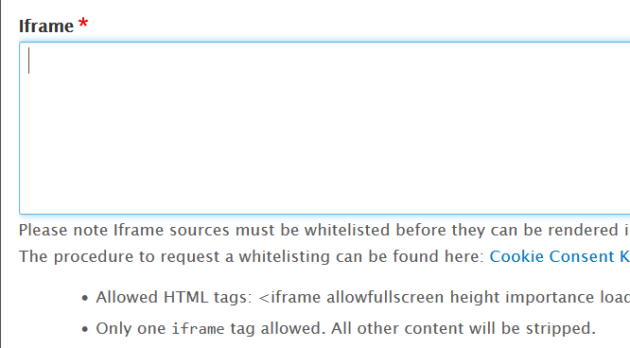
Put ratio to 4:3
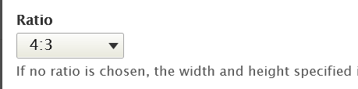
Click on Save iframe
Click on Collapse and save your draft.

