Contribute to the Maritime Forum Newsletter

Go to Newsroom and connect with your EU login. Select “Maritime Forum” as universe.

Step 1: in the Newsroom Task Pane, click on New item in the Content tab.
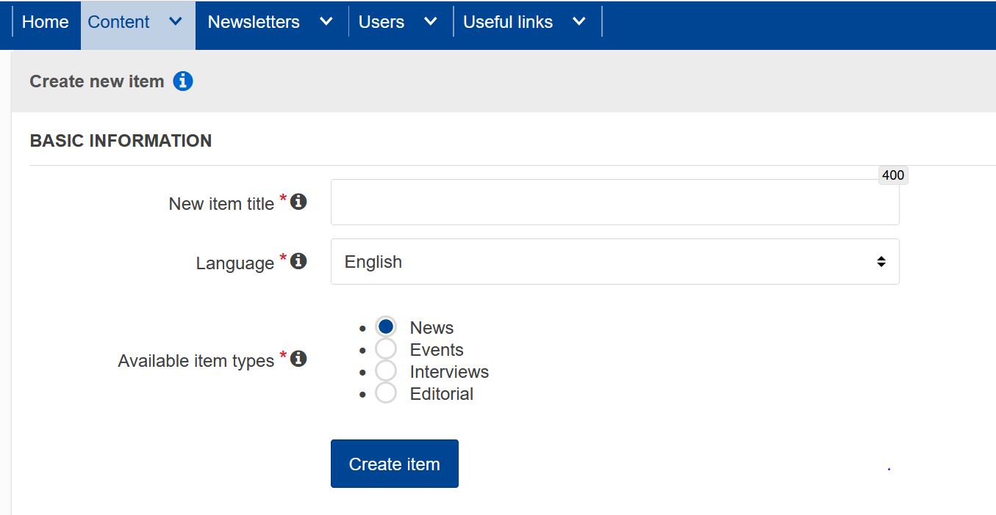
Enter title name and select amongst the available types, either News or Events depending on your type of contribution.
Click on the Create item button.

A new window opens to add content.
Step 2: add picture (by drag and dropping the file and submit)
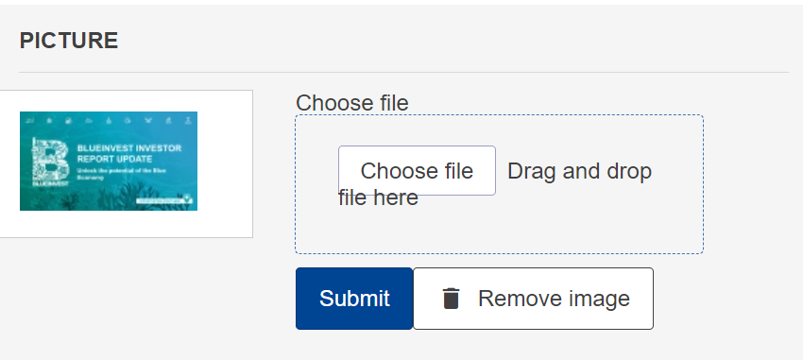

Step 3: click on the “Edit” button to enter text for the teaser (obligatory field)
Keep teaser text limited to a few lines to incite readers to continue reading under “More” content. The newsletter looks much better is a more or less same number of lines reflects each article.
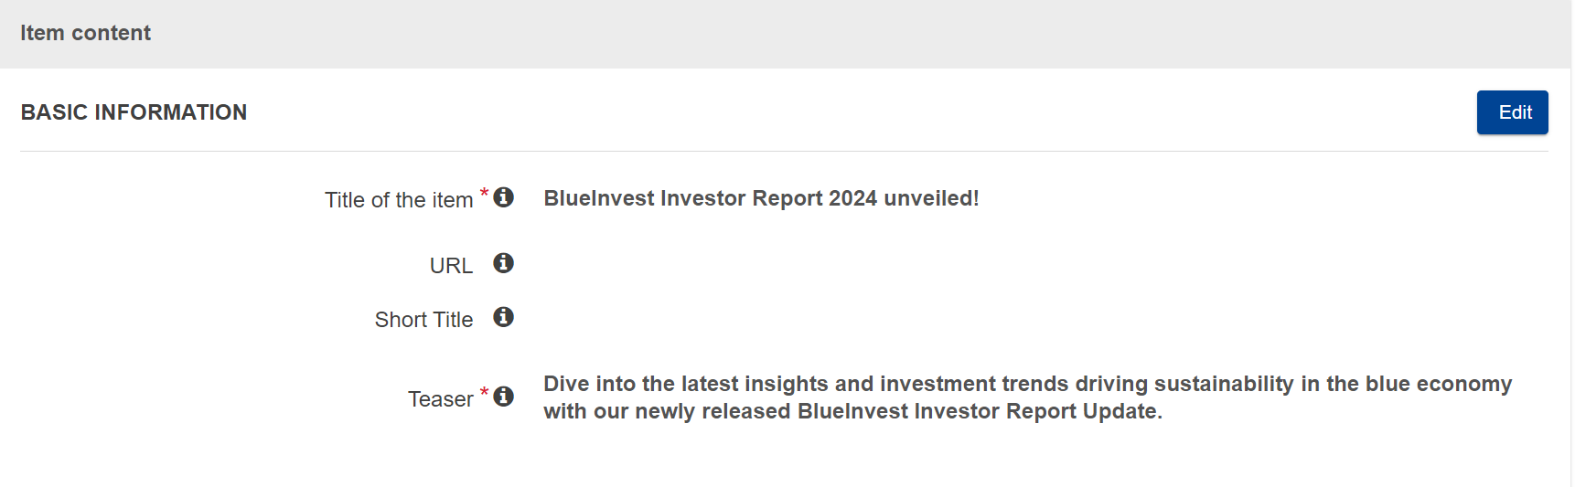
Step 4: enter your article under Full content (access via “Edit” button) and use the Full Item Content field. You can add links and use the available editing options. We do advice to keep default look as much as possible to produce a homogenous newsletter.
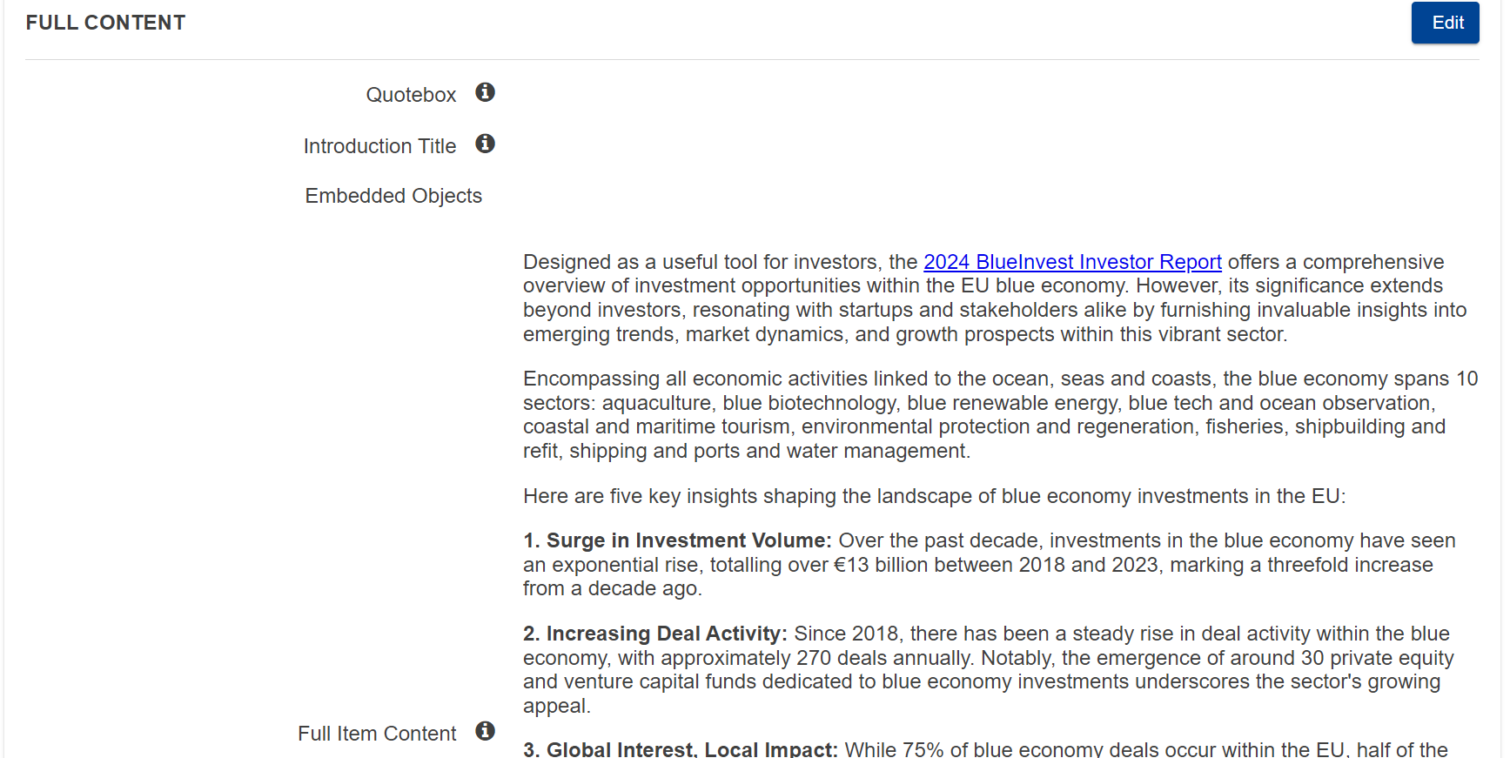

If you are working on an event, pay attention to the item date. By default the date of creation is put. Change it to the date of the start of your event as this will appear in the newsletter!
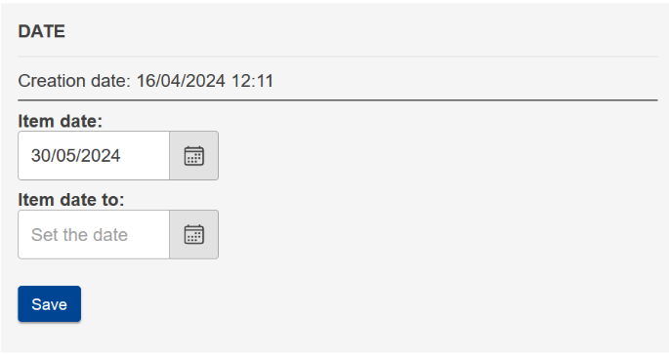

Step 5: associate your article/event with the Maritime Forum newsletter – template
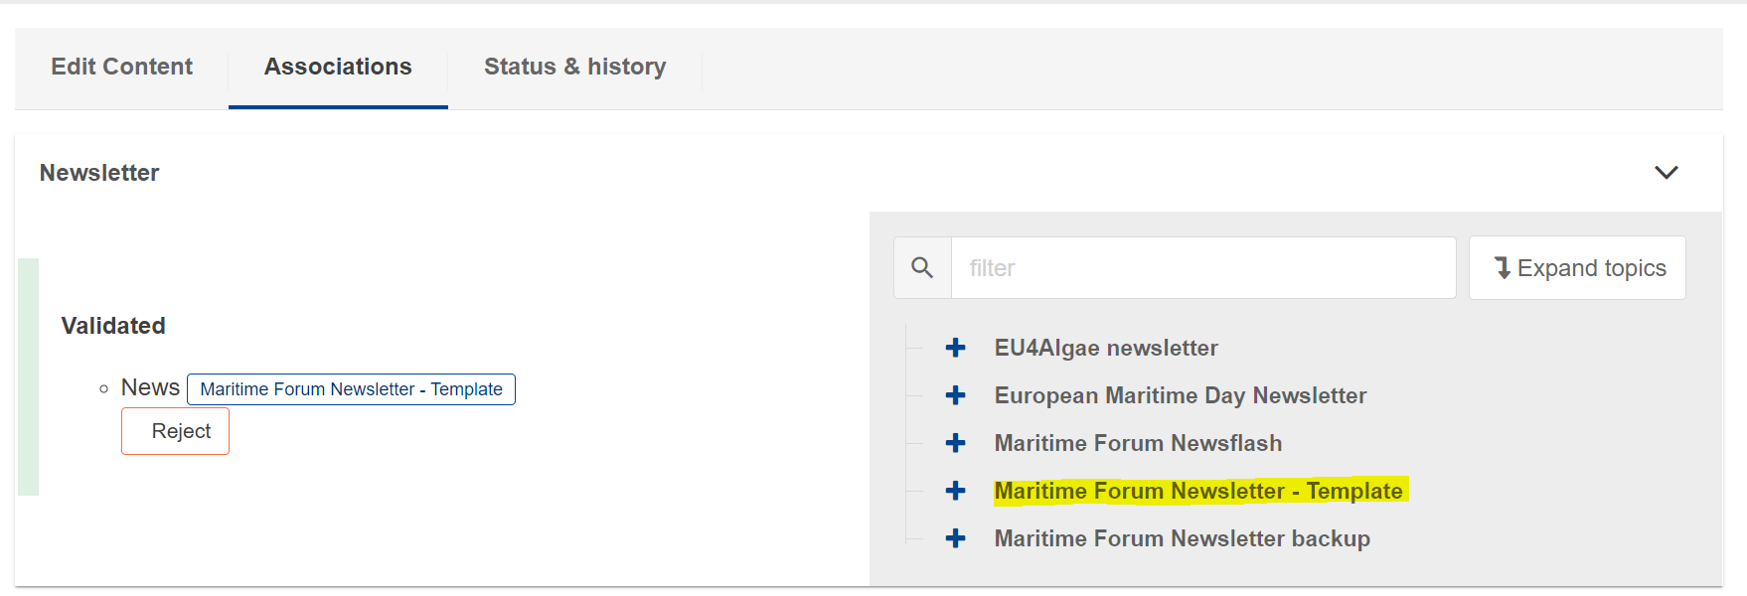
Please do not associate it to multiple templates as this gives some issues in further treatment.

Step 6: click on submit item

Thank you in advance for your collaboration. Do not forget that step 5 is essential to be able to trace back your contribution and integrate it in the newsletter.

